LAB ASSIGNMENT – 7 ADVANCED SOFTWARE ENGINEERING

SERVLETS

* This application intends to have CRUD Operations using MongoDB.
* The user creates an account to login to the application (Create Operation)
* The user can also change the password whenever required. (Update Operation)
* The details of the registered users are displayed. (Read Operation)
* The user can delete the account (Delete Operation)

**Screenshots**:

1. Login

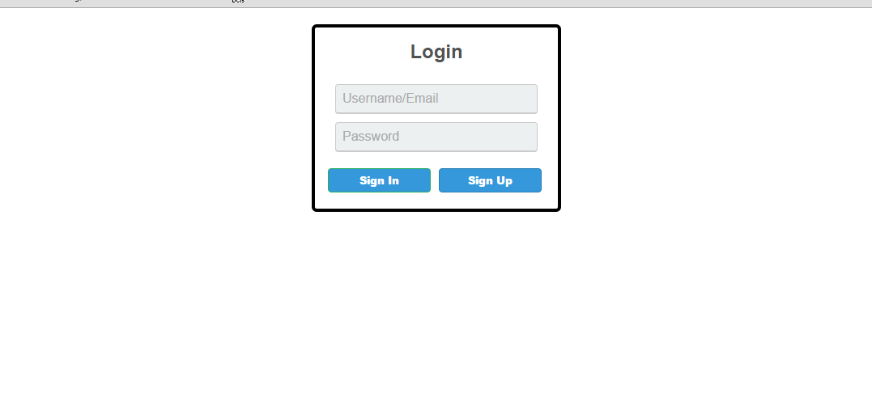

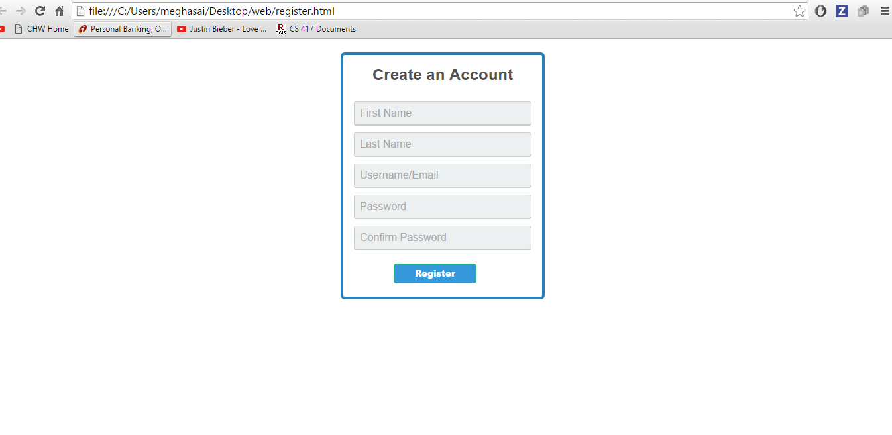

1. The details are inserted into the database from registration page

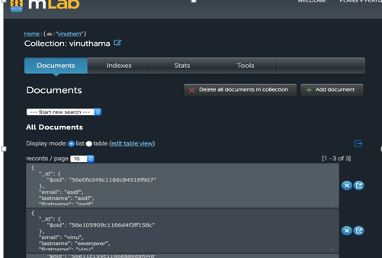

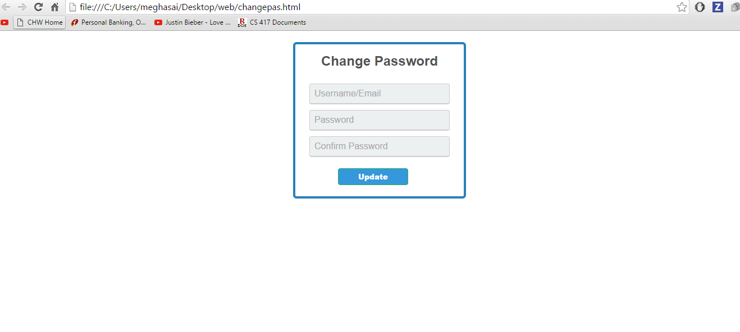

The database

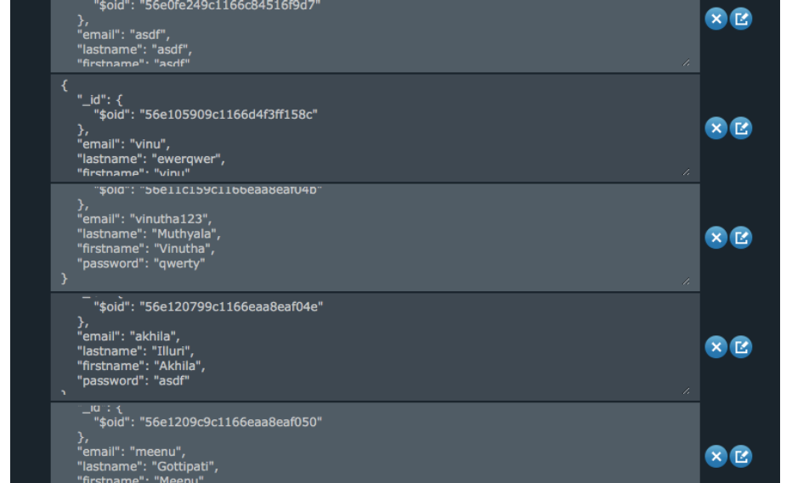

Deleting the record

