END-TO-END-RETAIL-DATA-ENGINEERING-PIPELINE

SCREENSHOTS

1. ARCHITECTURE

The project follows a modern Lakehouse architecture where retail data is ingested from AWS S3 and PostgreSQL into Databricks using Change Data Capture (CDC). Data is transformed through Bronze, Silver, and Gold layers using dbt and orchestrated end-to-end with Apache Airflow.

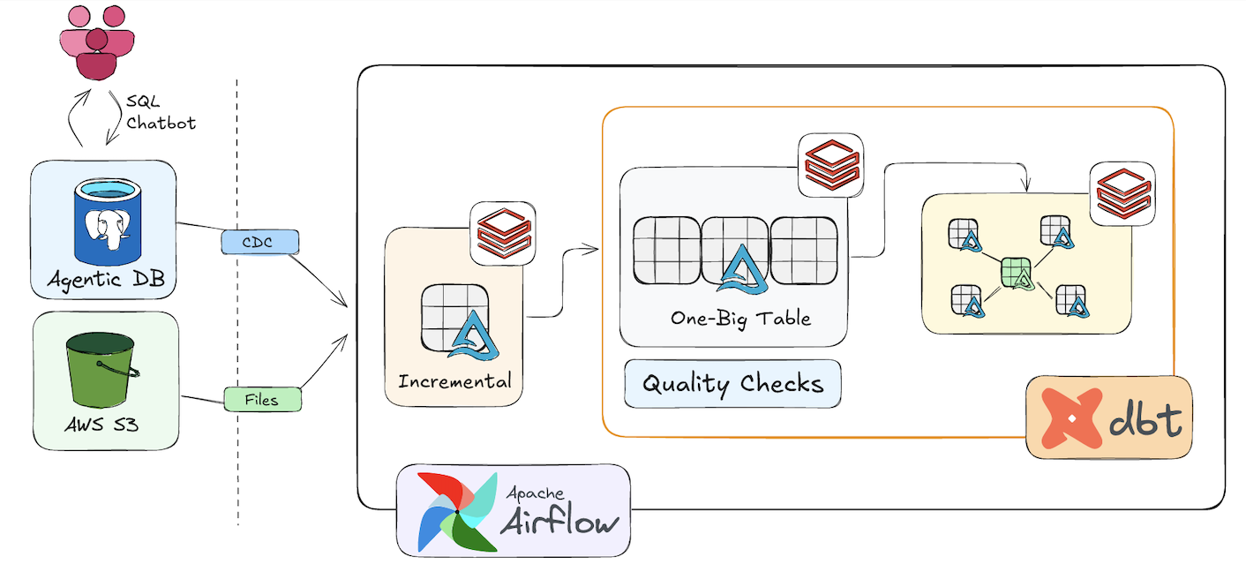

2. AIRFLOW DAG

Apache Airflow orchestrates the complete workflow including: - CDC ingestion - Source freshness checks - Silver transformations - Data quality tests - Gold layer creation - Star Schema generation
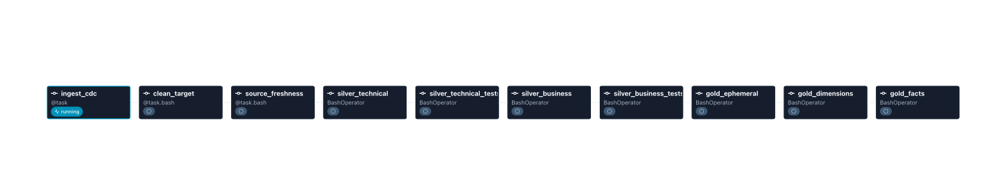

3. DATABRICKS CATALOG

Lakehouse Structure - The Databricks Unity Catalog contains separate Bronze, Silver, and Gold schemas following the Medallion Architecture. - Bronze: Raw ingestion - Silver: Cleaned & transformed data - Gold: Analytics-ready dimensional model

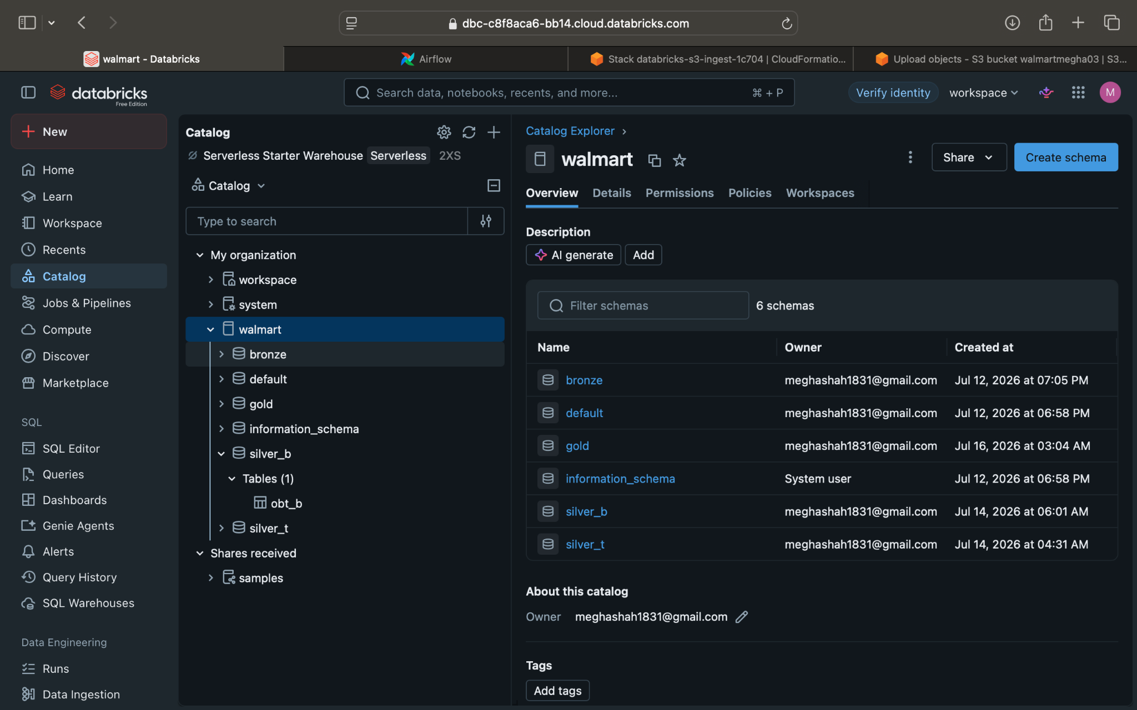

4. DATABRICKS JOBS & PIPELINES

Automated ingestion jobs execute incremental data loads from AWS S3 into Delta Lake using Databricks Jobs.

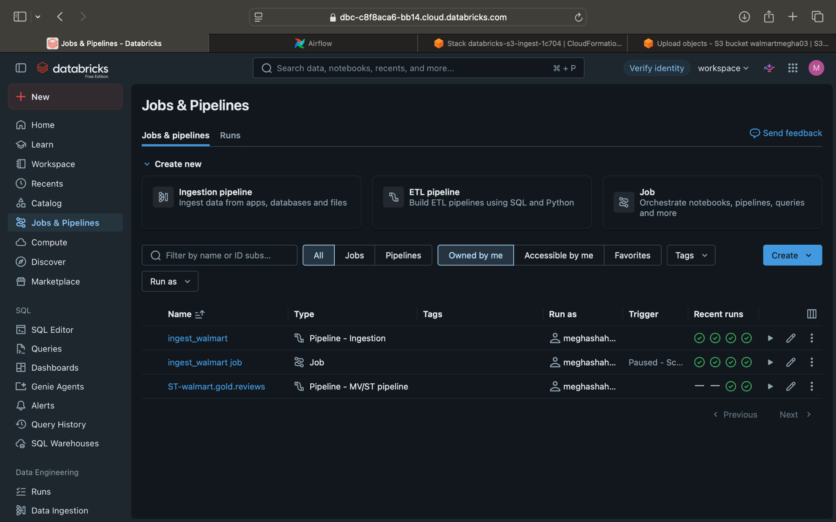
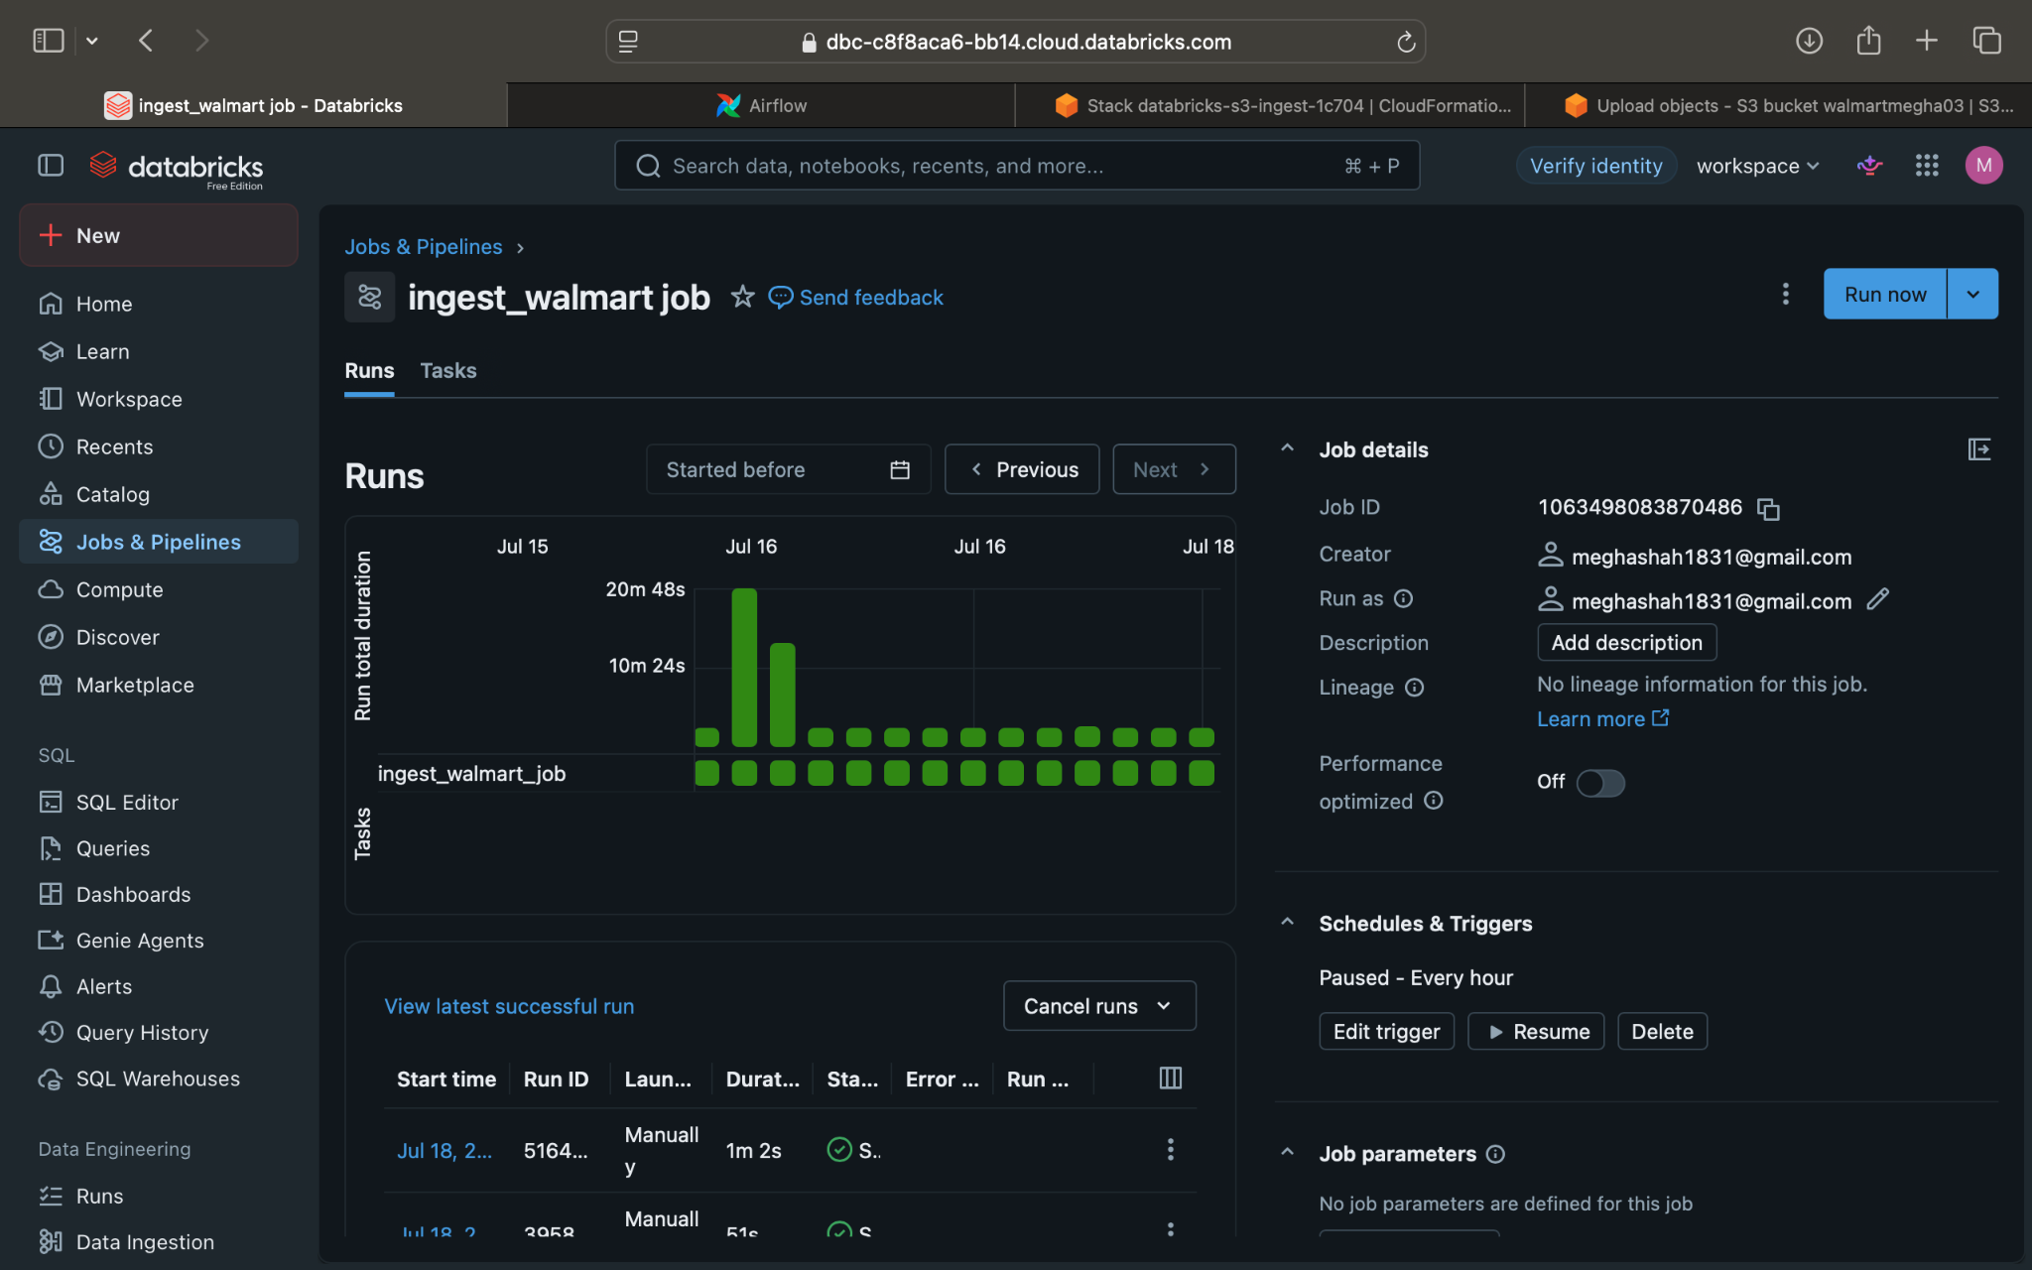

5. SUCCESSFUL AIRFLOW RUN

The entire pipeline completes successfully from ingestion to Gold layer creation using Apache Airflow.
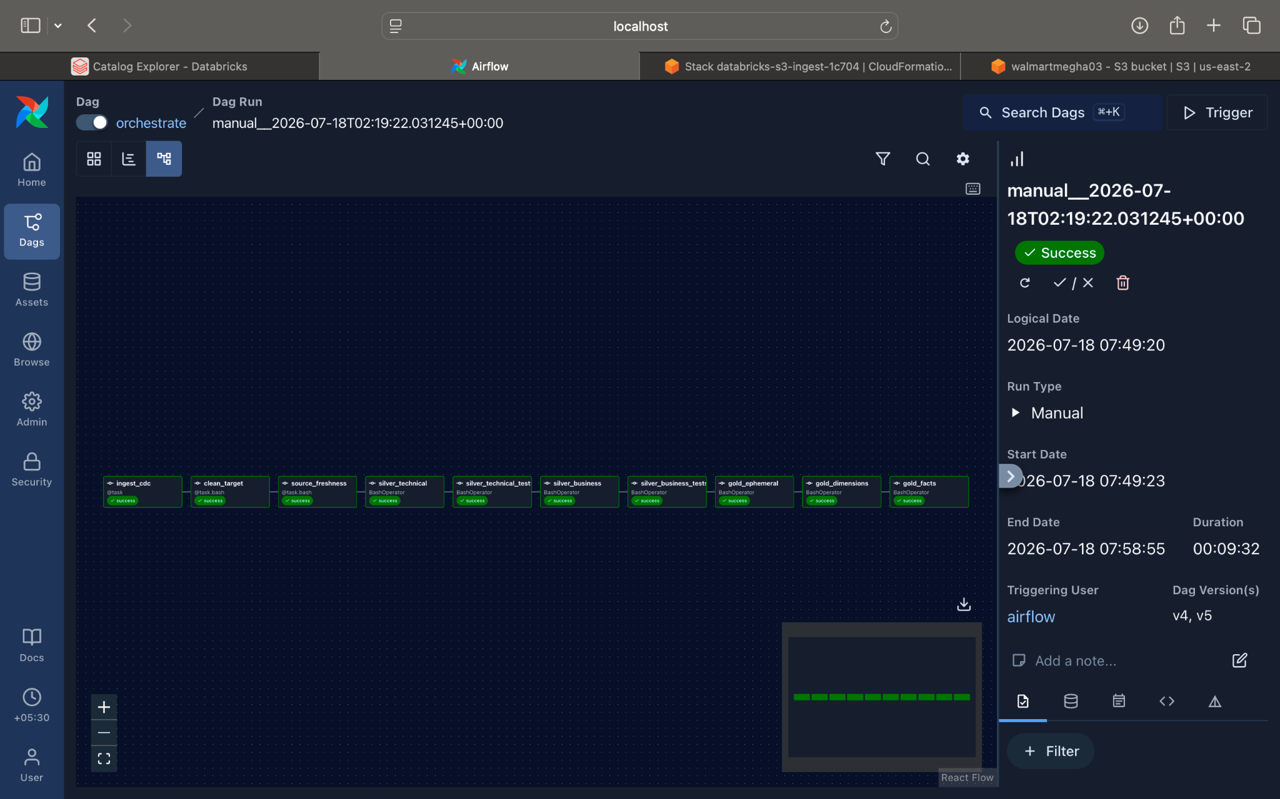

6. AWS S3

Retail datasets are stored in Amazon S3 and serve as the landing zone for the ingestion pipeline.
