**Assignment 7**

**Final Updations, Risk & Competitive**

**Assessment & Sensitivity Analysis**

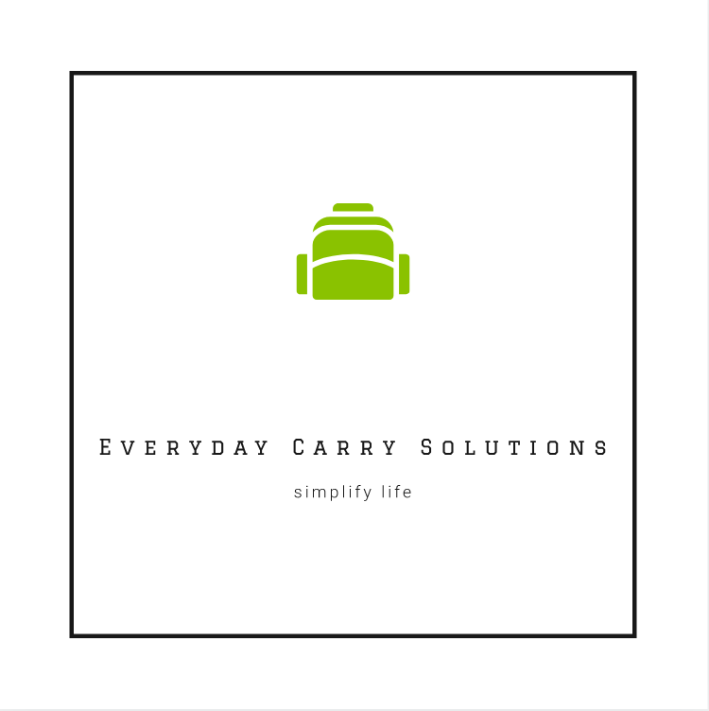

Rico Holganza | Guraz Buhariwala| Varuna Paul Jeeva | Ramana Killi | Megha Sharma

Table of Contents

1 Updated 2 x 2 Matrix 3

2 Updated TAM, SAM and Target Market 4

3 Risk Assessment 5

4 Competitor Assessment 6

5 Project Assumptions 7

6 Costed Bill of Material 8

7 Business Case and NPV Tradeoff (Sensitivity) Analysis 9

8 Proof of Concept / Prototype 11

# Updated 2 x 2 Matrix

The 2 x 2 matrix was updated in terms of selecting the right axes in order to find the gaps and discover opportunities relating to comfort and access

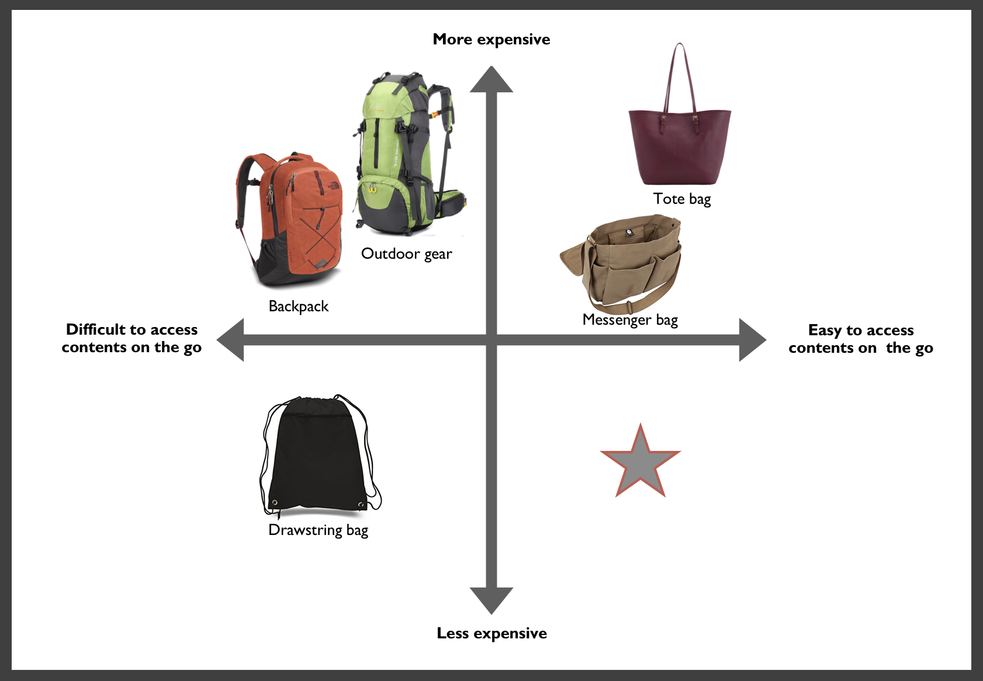

# Updated TAM, SAM and Target Market

We have first used to Bottom Up Approach to calculate the TAM, SAM and the target market followed by the Top Down Approach

**Bottom Up Approach**

* **Total Addressable Market (TAM)**

Total World Population - 7.62 Billion

People falling between the age group of 7 to 60 - 5 Billion

% People who would be interested in the product - 10%

Average amount a customer would be willing to pay for the solution - $10

**Total Addressable Market - $5 Billion**

* **Served Addressable Market (SAM)**

Total U.S. Population - 326 Million

People falling between the age group of 7 to 60 - 238 Million

% People who would be interested - 35%

Average amount a customer would be willing to pay for the solution - $15

**Served Addressable Market - $1.25 Billion**

* **Target Market - Students**

People falling in the age group between 18 to 28 - 30 Million

% People who would be interested - 50%

Average amount a customer would be willing to pay for the solution - $15

**Target Market - $225 Million**

**Top Down Approach**

* **Total Addressable Market (TAM)**

Revenue generated in the Backpack and Accessories segment

In the world per year - $66.3 Billion

Revenue generated only in Accessories (approx.. 7.5%) - $ 4.97 Billion

% People who would use the product - 60%

**Total Addressable Market - $2.98 Billion**

* **Served Addressable Market (TAM)**

Revenue generated in the Backpack and Accessories segment

In the United States per year - $13.2 Billion

Revenue generated only in Accessories (approx.. 7.5%) - $ 1.32 Billion

% People who would use the product - 60%

**Served Addressable Market - $792 Million**

* **Target Market - Students**

Considering 30% of the people (SAM) would try the product,

**Target Market - $237.6 Million**

# Risk Assessment

|  |  |  |  |  |
| --- | --- | --- | --- | --- |
| RISK | PROBABILITY OF OCCURRENCE | IMPACT OF RISK ON PROJECT | PROBABILITY * IMPACT | MITIGATION PLAN |
| Supply chain risk- delay in delivery of material | 3 | 5 | 15 | Monitor supplier performance, availability and delivery of materials, flexibility in sourcing |
| Breaking through into an emerging market | 3 | 5 | 15 | Play-to-win strategy, Targeted marketing strategy |
| Operational risks in development, planning, production, and distribution | 4 | 5 | 20 | Collaboration within and outside of the organization; Hiring experienced project managers; |
| Functional risks related to financial investments | 3 | 4 | 12 | Monitor a control system to review the financial strategy, costs and benefits |
| Inaccurate demand forecast | 4 | 4 | 16 | Invest in demand forecasting technologies |
| Product copied by larger, more established manufacturers | 4 | 4 | 16 | Retain competitive advantage through product differentiation via customization and quickly adapting to new customer needs. |
| Change in customer needs | 4 | 5 | 20 | Developing idealized designs and competing in advance |
| Manufacturing skills gap | 3 | 5 | 15 | Providing training and engage existing workforce. |
| Third-party risks such as product life cycle management and recycling | 3 | 4 | 16 | Internal and external audit for quality and recycling management. |

From the colour map above, red means those risk factors have a significant impact on the business whereas the lighter colours have a lesser risk associated with it.

# Competitor Assessment

|  |  |  |  |
| --- | --- | --- | --- |
| **FACTORS** | **OUR**  **PRODUCT** | **COMPETITOR 1 Shacke shoulder strap for bags** | **COMPETITOR 2**  **Amazon Basics Messenger Bag** |
|  |  |  |  |
| **Key Competitive Advantage** | Customized shoulder pad straps for bags to provide comfort and easy access on the go together | Shoulder pad straps for bags to provide comfort | A bag that provides access on the go. |
| **Target Market** | $225 Million | $225 Million | $195 Million |
| **Products and services** | 2 customized shoulder straps for any bag | 1 shoulder strap for backpack | 1 messenger bag |
| **Pricing** | MSRP $15 for 2 straps | $10 for one shoulder strap | $13 for 1 messenger bag |
| **Distribution Channels** | Wholesale and online | Online only | Online only |
| **Strengths** | - Is comfortabtle  - Easy access on the go  - Can be used on any bag  - Customization Possible | - Is comfortabtle  - Easy access on the go | - Easy access on the go |
| **Weakness** | - Since we are outsourcing the product, trade barriers may add to overhead costs | - Comes in only one color  - Not as strongly padded | - Insufficient padding causes stress on shoulders making it difficult to carry for longer periods. |
| **Opportunities** | - Create a market for young professionals, students, athletes and travelers | - Create a market of people who want to make carrying a bag comfortable | - Create a market of students and young working professionals |
| **Threats** | - Design is easy to copy  - Quality might be compromised | - Market Competition | - Retail Market Competition  - Does not address changing customer needs |

# Project Assumptions

**1. Manufacturing Model**

* Manufacturing will be outsourced to a company in China since the labour costs are cheap (approximately $3.35 / hour). This turns out to be cheaper than having to invest in our own fixed manufacturing assets.
* Probably in the long run, once the supply chain has been well established and the product is performing well in the U.S. market, we could consider inhouse manufacturing / assembly.
* This business being solely profitable based on economies of scale, we could look into expanding our customer base in many more countries and also establishing our own manufacturing plants in those countries.
* In the future we can add/subtract functionalities of the product or colour variations to address changing carry needs or to tailor the product to needs of local markets.

**2. Distribution Model**

* Intially we are considering to sell on Amazon.com. Our product will be stored in one warehouse at Alabama since it has the lowest of cost operations as compared to other states in the U.S. . We will transport our product from central warehouse to amazon fulfillment center based on the product demand.
* After two years we may consider to open our own online website to selling directly to customers.

**3. Marketing Model**

* We will promote our produt via facebook adds and also on the Amazon website.
* For promoting the product and creating awareness,we could give out around 100 units customized with the university logo for students and then probably sell the product in oncampus university stores.
* Once the supply chain is well established, customization could become a major part of the marketing stratergy.
* If a student is purchasing the product online by using his university email id he will be eligible for 10% discount on the product.

**4. Service Model**

* In case of any product defect we will replace the product provided within 6 months of product purchase.
* In case of any returns, customer would need to pay for shipping the product back to the company.
* Customer can order customized product in terms of design / colour, however, this is provided they are ordering in bulk quanitites.

**5. Sales Model**

* The product will be sold on amazon as well as in university book stores. This way we are targeting retail as well as online sales.
* For credible wholesaler customers, we would consider selling the product at a 10% discount provided the minimum order quantity is more than a 1000 units.
* 2 straps are sold as 1 unit and customers can choose what combination of straps they want. Additionally, the customers can also choose to go with one strap at a slightly higher cost.

# Costed Bill of Material

We looked into the material cost which we plan to buy from the Chinese market via Alibaba. The best and competitive rates for our required material is as follows :

* YKK Zipper + Chain + Teeth 🡪 $0.20 per unit (Sold In Sets of 5000)
* Ballistic Nylong 🡪 $5.00 / meter (Minimum order qty 1000 Mts.)
* Memory Foam 🡪 $0.5 / sq. meter (Minimum order qty 1000 sq. meter)
* Velcro 🡪 $0.10 / meter (Minimum order qty 1000 Mts.)
* Mesh 🡪 $0.50 / meter (Minimum order qty 1000 Mts.)
* Thread 🡪 $0.40 (5000 yards) (Minimum order qty 500 Pieces)

Considering the above rates, the costed bill of material is as follows :

|  |  |  |  |  |  |
| --- | --- | --- | --- | --- | --- |
| **Item** | **Component** | **Quantity** | **Unit of Measurement** | **Unit Cost** | **Total Cost** |
| 10 | Ballistic Nylon  (Main Body)  13" x 8.5" | 2 | EA | $0.60 | $1.20 |
| 20 | Ballistic Nylon  (Card Pocket)  4.7" x 3.3" | 2 | EA | $0.50 | $1.00 |
| 30 | Memory Foam  13" x 3.1" | 2 | EA | $0.13 | $0.250 |
| 40 | YKK Zipper (Slider), Chain and Teeth | 1 | EA | $0.20 | $0.200 |
| 50 | Velcro  12.5" Length x Standard Width | 2 | EA | $0.15 | $0.300 |
| 60 | Pocket Mesh  4.7" x 3.3" | 1 | EA | $0.35 | $0.350 |
| 70 | Thread  (41" Perimeter Length) | 2 | NO | $0.13 | $0.250 |

**Note – The product will be sold in a set of 2 straps. Therefore the total material cost for 1 Set comes out to be $3.55. This is the cost considering the supply chain has been well established which we assume to be around Q4 2021 in our business case.**

# Business Case and NPV Tradeoff (Sensitivity) Analysis

**1. Business Case ( Excel Sheet 1)**

Break-even : Q3 2019

NPV at the end of 2021 : $4,420,240.30

Due to the nature of the industry, the profit margin on the product increases as the supply chain is established even though asking price decreases to increase the scope of the market.

Our product is cheap and the margins on it are also very less, therefore, to sustain our business we have to achieve certain quantity. Economy of scale would help us to achieve break even with in two years. If we are not able to achieve our projected sales as projected then we are not going to make any profit. Considering above fact we have taken sales and product cost as variables for sensitivity analysis, i.e.

* NPV Impact of a 10% decrease in Product Sales
* NPV Impact of a 10% increase in Product Cost

If sales are dropping by 10%, it is not going to impact our business drastically, still we can able to break even at the same quarter with less profits. Consequently, if the product cost is increased slightly above 15$  then our sales will be dropped due to high cost and our break even quarter will be pushed to next year. We have to balance the price of the product to achieve the high volume sales, over a period of supply chain efficiencies would help us to profitable in the long term.

**2. NPV Impact of a 10% decrease in Product Sales (Excel Sheet 2)**

Break-even : Q3 2019

NPV at the end of 2021 : $3,933,404.51

A drop in sales of 10% does not change the break-even point.

**3. NPV Impact of a 10% increase in Product Cost (Excel Sheet 3)**

Break-even : Q1 2020

NPV at the end of 2021 : $2,900,875.14

This is the most significant change as the breakeven quarter is pushed further out.





# Proof of Concept / Prototype

