**OCR APPLICATION**

GUI application which allows you to print text from your input image

**INSTALLATION**

You need to have the following installed on you PC:

* Python 3.6.8
* OpenCV library
* Tesseract OCR library
* Tkinter library

**Features**

* Auto Crop
* Manual Crop
* Detected Text
* Original image
* Save Image
* Blur Image
* OCR
* Show text

**Auto Cropping**

The App detect the four points of image and give us a cropped image

**Manual Cropping**

The App also allows us to crop images at the four corners manually

**Detected Text**

The App uses the Tesseract OCR detect the text on the input image and give us the inscripted text in textbox

**Original Image :**

It gives our original image after using various features

**Save Image:**

It saves our image in our directory

**Blur Image:**

It changes the pixels of the image

**OCR:**

It reads the data inscripted in the image and highlights them

**Show text:**

It shows the text of input image and displays it in textbox

**IMAGES:**

**Auto Crop**

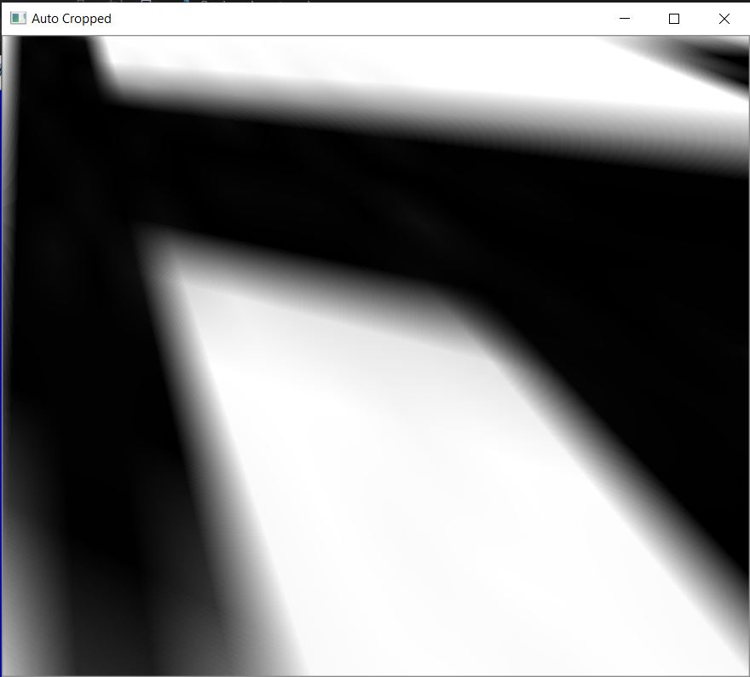

**Manual Crop:**

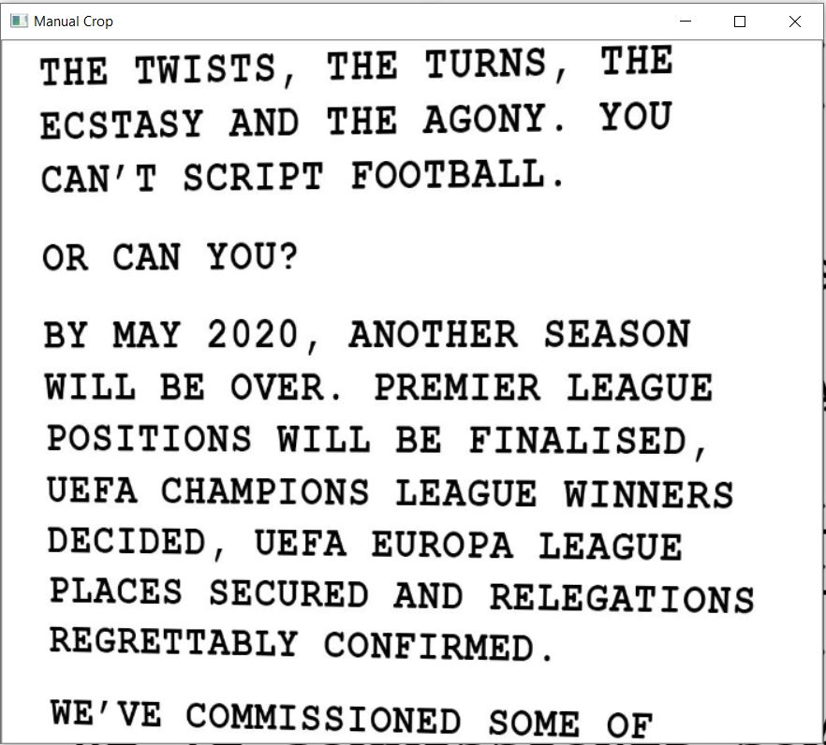

**Blur Image**

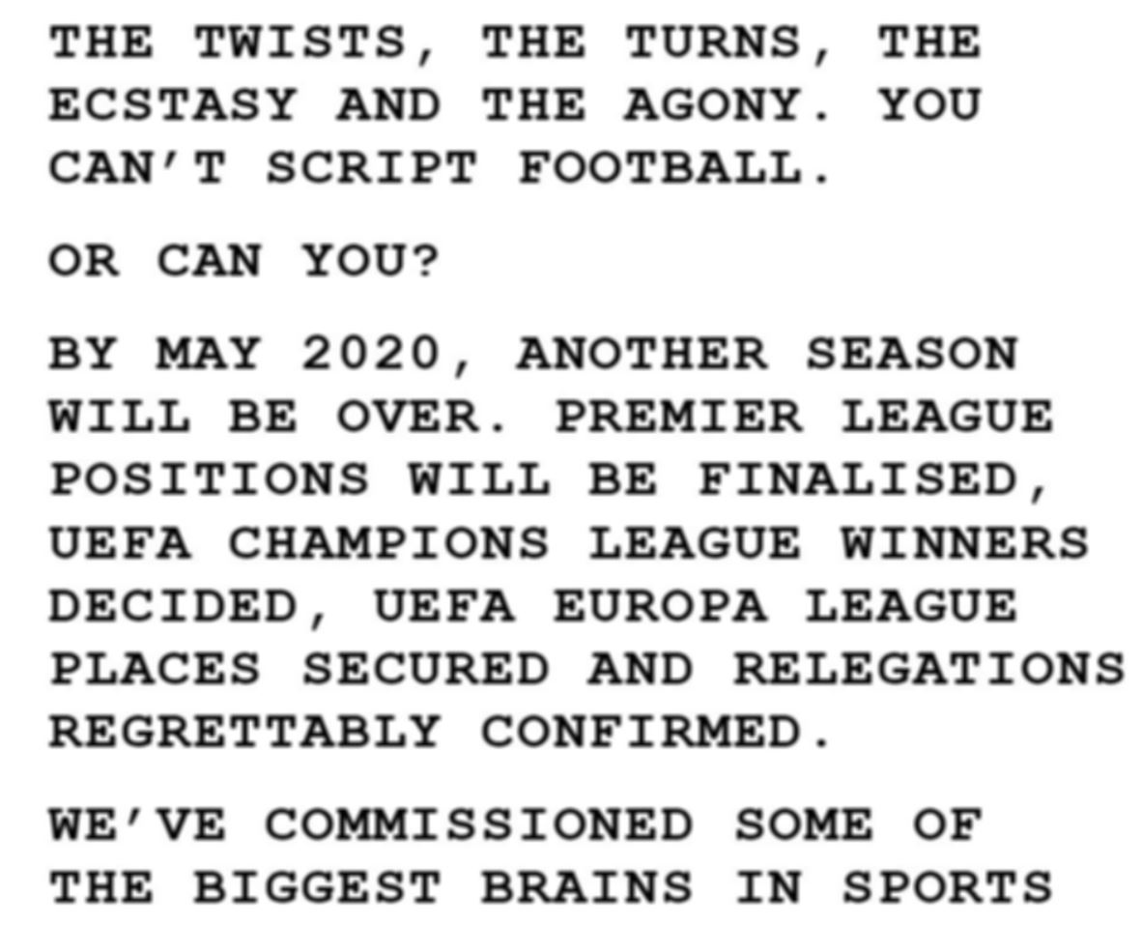

**Original Image:**

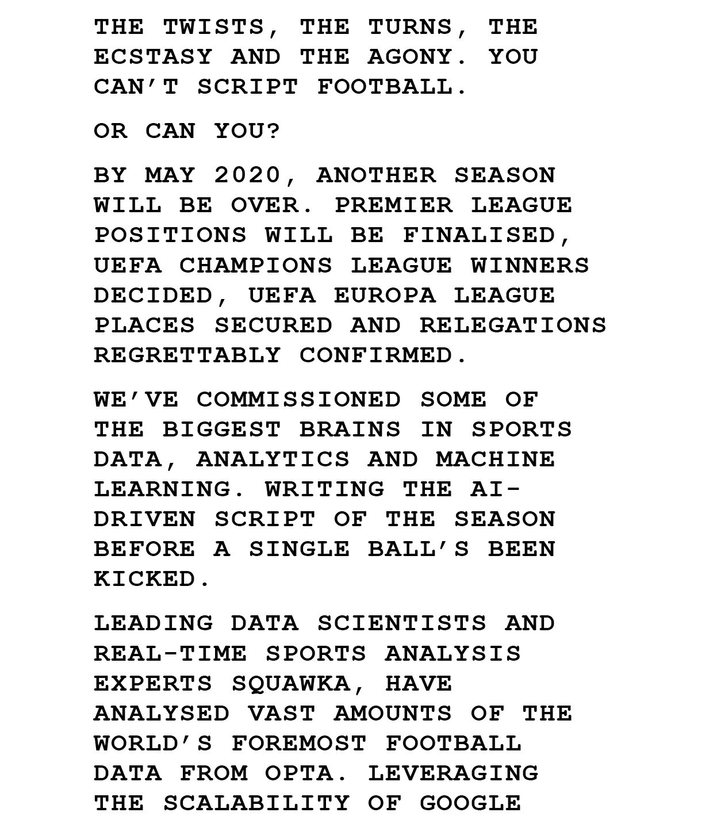

**OCR Image:**

