REPORT

Not-Profit-Organization: After School Care Program

Organization name: [Foot Prints Education](https://www.footprintseducation.in/program-after-school-care)

1. **Summary**

The **After School Care** program by Footprints Education offers a structured, safe, and engaging environment for children after regular school hours. Their curriculum is on the High Scope Learning Model, focusing on child-led activities that enhance cognitive and social development. They prioritize safety with dedicated security measures and emphasize a balanced schedule of academic support, extracurricular activities, and recreational time.

**Recommendations:**

To further enhance their program, Footprints could expand resources for parents to track children's progress and introduce more individualized learning plans to cater to diverse developmental needs.

1. **Sitemap**

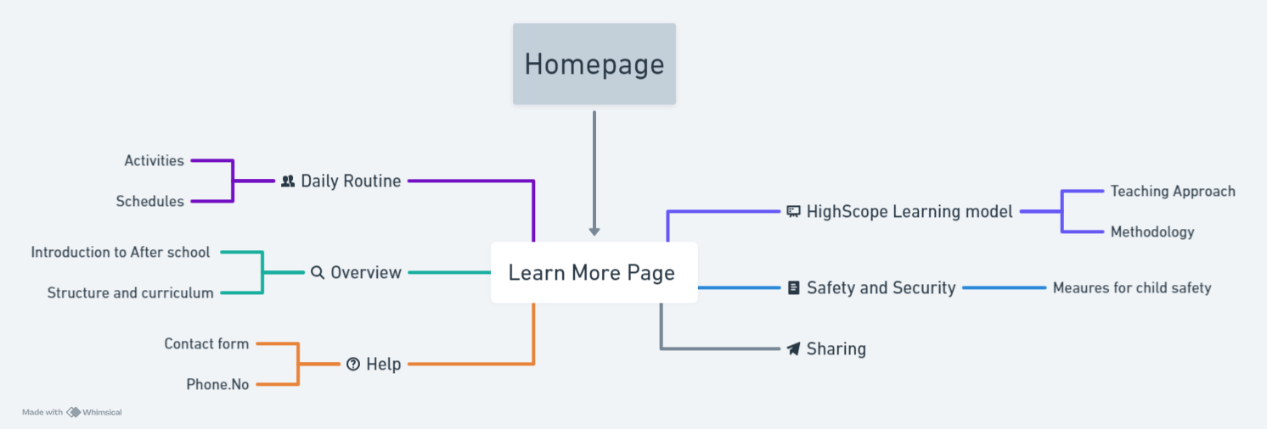

1. **User Flow**

