1. **C Code:**

#include <stdio.h>

#include<string.h>

#include<stdlib.h>

int main()

{

FILE *fptr;

char input[1500];

char *buf;

char *args[2]={0,0};

int p=0,count=0;

fptr=fopen("input.txt","r");

while(fgets(input,1500,fptr) != NULL)

{

buf=strtok(input,",");

if(count>0)

printf("Welcome, ");

while(buf != 0 && count>0)

{

args[p]=buf;

p++;

buf=strtok(0,",");

}

if(args[0]!= NULL && args[1]!=NULL)

printf("%s %s \n ",strtok(args[1],"\r\n"), args[0]);

count++;

p=0;

}

fclose(fptr);

return 0;

}

**Screenshot of result:**

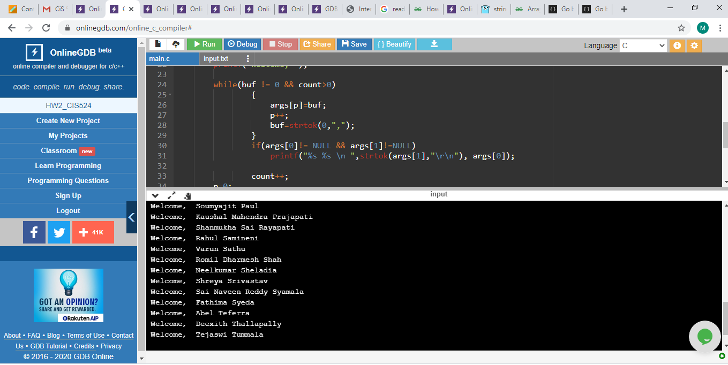

1. **Java Code**

import java.io.File;

import java.util.Scanner;

class helloprogram

{

public static void main(String args[]) throws Exception

{

File file= new File("C:\\Users\\srava\\OneDrive\\Desktop\\input.txt");

Scanner sc=new Scanner(file);

while(sc.hasNextLine())

{

//System.out.println(sc.nextLine());

String[] name=sc.nextLine().split(",");

if(name[0].equals("Last Name") == false)

System.out.println("Welcome,"+name[1]+" "+name[0]);

}

}

}

**Screenshot of result:**

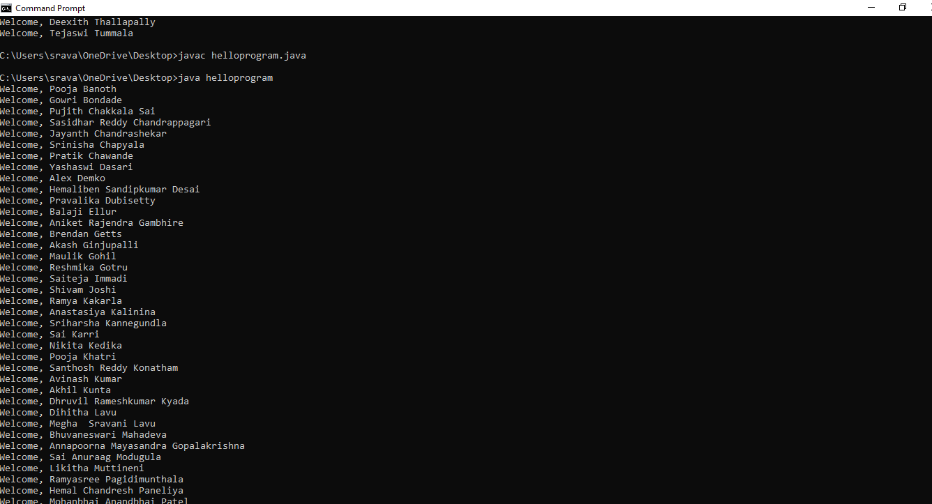

1. **R Code**

# read.csv function will read the data from the csv file into data frame type

data <- read.csv("C:\\Users\\srava\\OneDrive\\Desktop\\input.csv")

i<- 1

#nrow calculates the number of rows

# paste function is used to combine the arguments

while(i<= nrow(data))

{

a<-"Welcome, "

c <-data[c(i),c(1)]

b <-data[c(i),c(2)]

print(paste(a,b,c))

i=i+1

}

**Screenshot of result:**

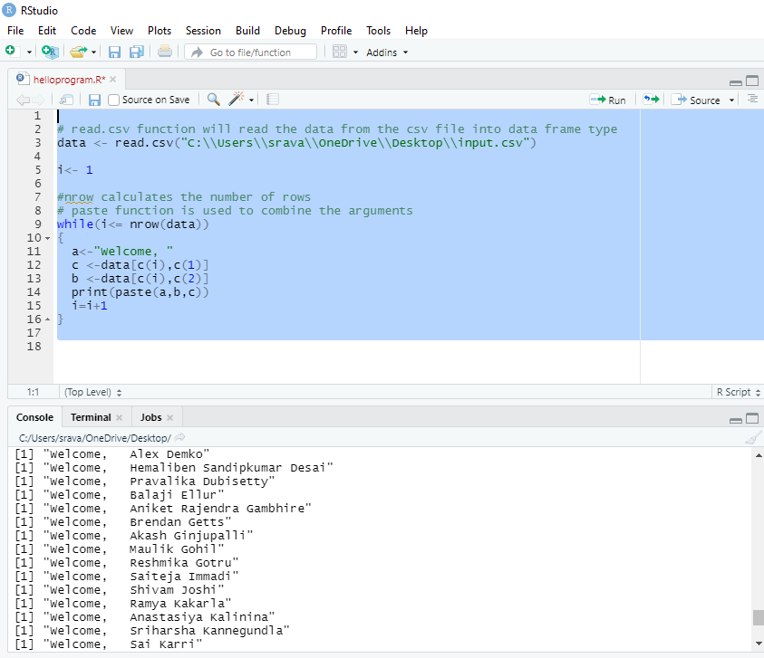

1. **Ruby Code**

line=IO.readlines("input.csv")

$count= line.length

$i=1

while $i < $count do

names=line.at($i).split(",")

fname=names[1].split("\r\n")

print("\nWelcome, ")

print(fname[0]+" ")

print(names[0])

$i =$i+ 1

End

**Screenshot of result:**

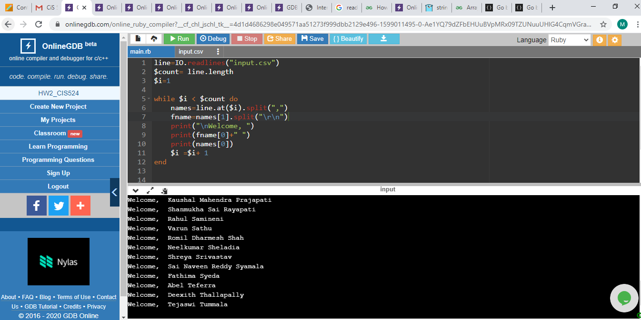

1. **Python Code**

file=open("input.txt","r")

lines=file.readlines(1500)

i=1

while(i< 53):

names=lines[i].split(",")

lname=names[0]

fname=names[1].split("\n")

print("Welcome, "+fname[0]+" "+lname)

i=i+1

**Screenshot of result:**

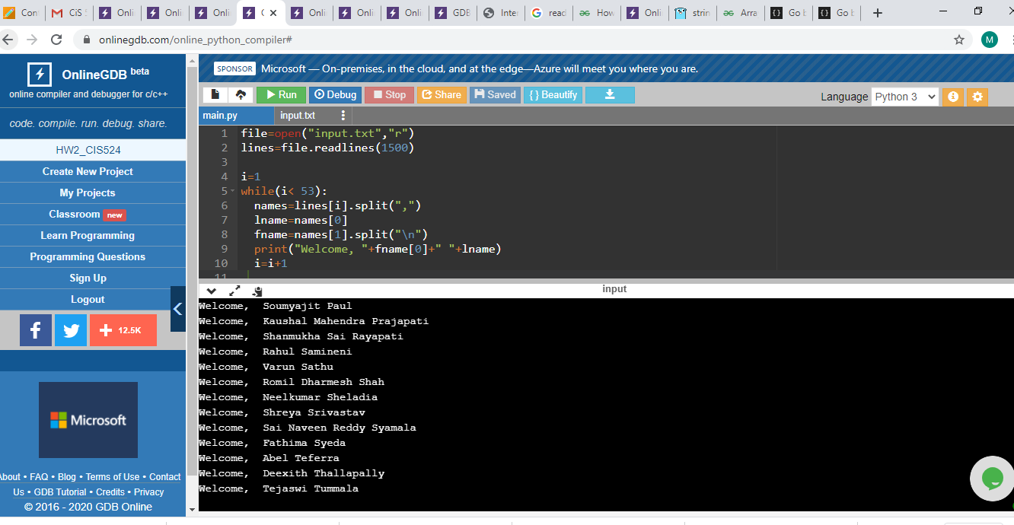

1. **PHP Code**

<?php

$line= file_get_contents("input.csv");

$fname=preg_split("/[,|\r\n|]+/",$line);

for($i=2; $i < count($fname); $i++)

{

echo "Welcome, ";

echo $fname[$i+1];

echo " ";

echo $fname[$i];

$i++;

echo "\n";

}

?>

**Screenshot of result:**

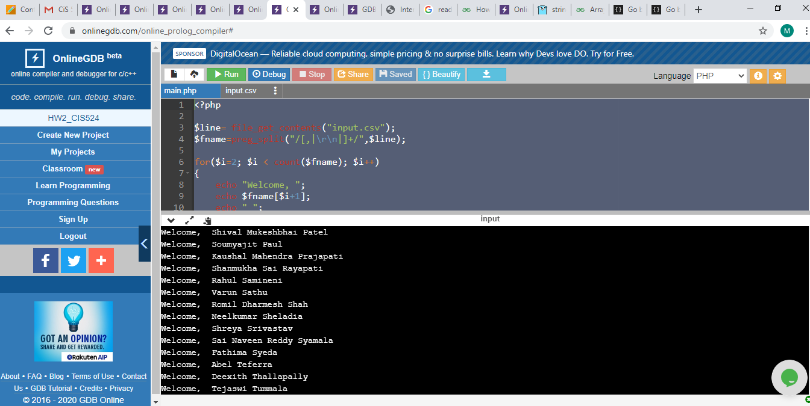

1. **Perl Code**

open (file, '<', 'input.txt');

my @ names = <file >;

$length = @names;

$i = 1;

while ($i < $length)

{

my @ sname = split (',', $names[$i]);

my $fname = $sname[0];

@lname = split ('\r\n', $sname[1]);

print ("Welcome, ");

print ($lname[0]);

print (" ");

print ($fname);

print ("\n");

$i = $i + 1;

}

close (file)

**Screenshot of result:**

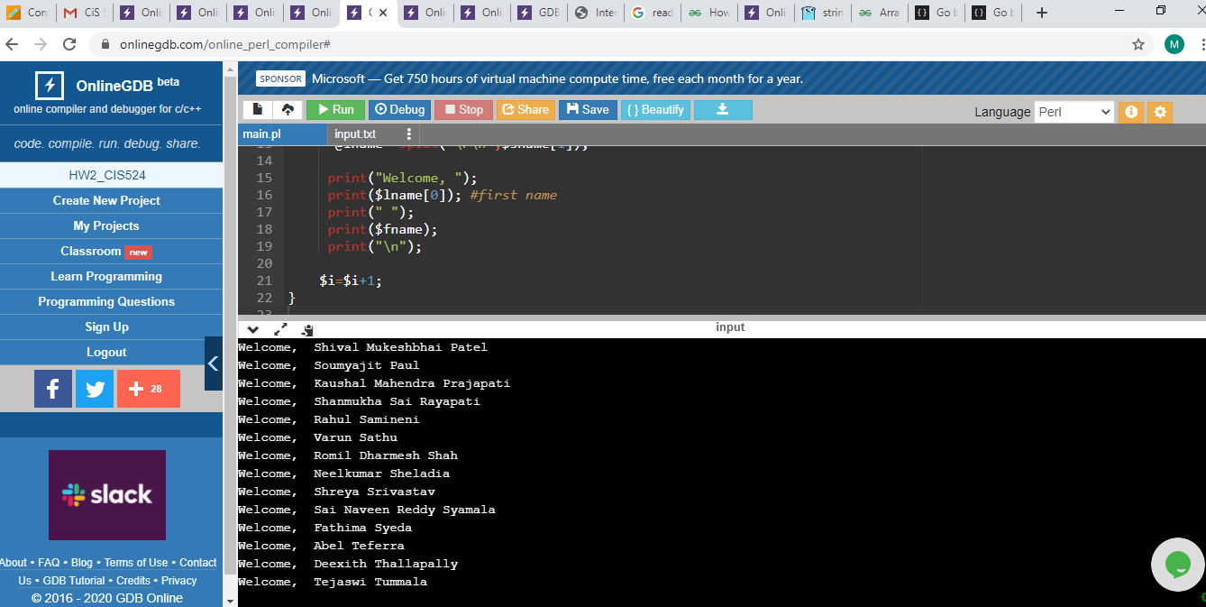

1. **C++ Code**

#include <iostream>

#include <string>

#include <bits/stdc++.h>

using namespace std;

string str;

int main ()

{

ifstream file;

file.open("input.txt");

vector <string> tokens;

vector <string> names;

while (getline(file, str))

{

// cout << str << "\n";

stringstream check(str);

string inter;

while(getline(check, inter, ','))

{

tokens.push_back(inter);

}

}

string name[500];

for(int i = 0; i < tokens.size(); i++)

{

name[i]=tokens[i];

}

for(int i = 2; i < tokens.size(); i++)

{

cout << "Welcome, ";

cout << name[i+1] <<"\t\t\t\t";

cout<< name[i] <<"\n";

i++;

}

return 0;

}

**Screenshot of result:**

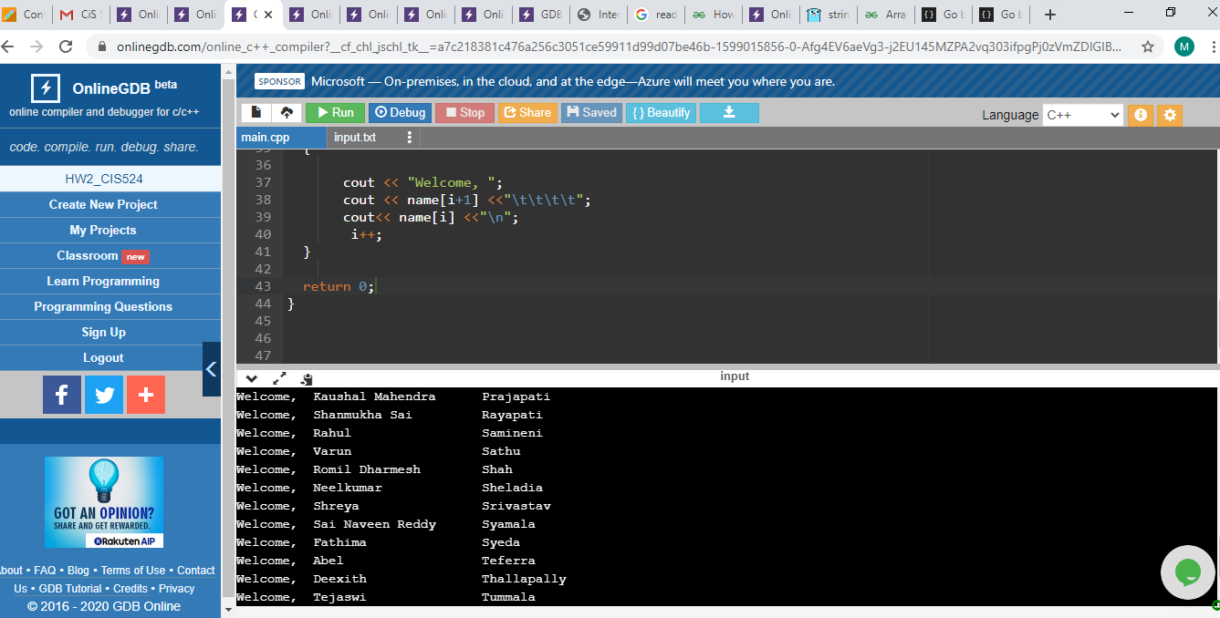

1. **C# Code**

using System;

class HelloWorld {

static void Main() {

System.IO.StreamReader file= new System.IO.StreamReader("input.txt");

string line;

int i=0;

while((line=file.ReadLine()) != null)

{

if(i!=0)

{

string[] names=line.Split(',');

Console.Write("Welcome,"+names[1]+" "+names[0]+"\n");

}

i++;

}

}

}

**Screenshot of result:**

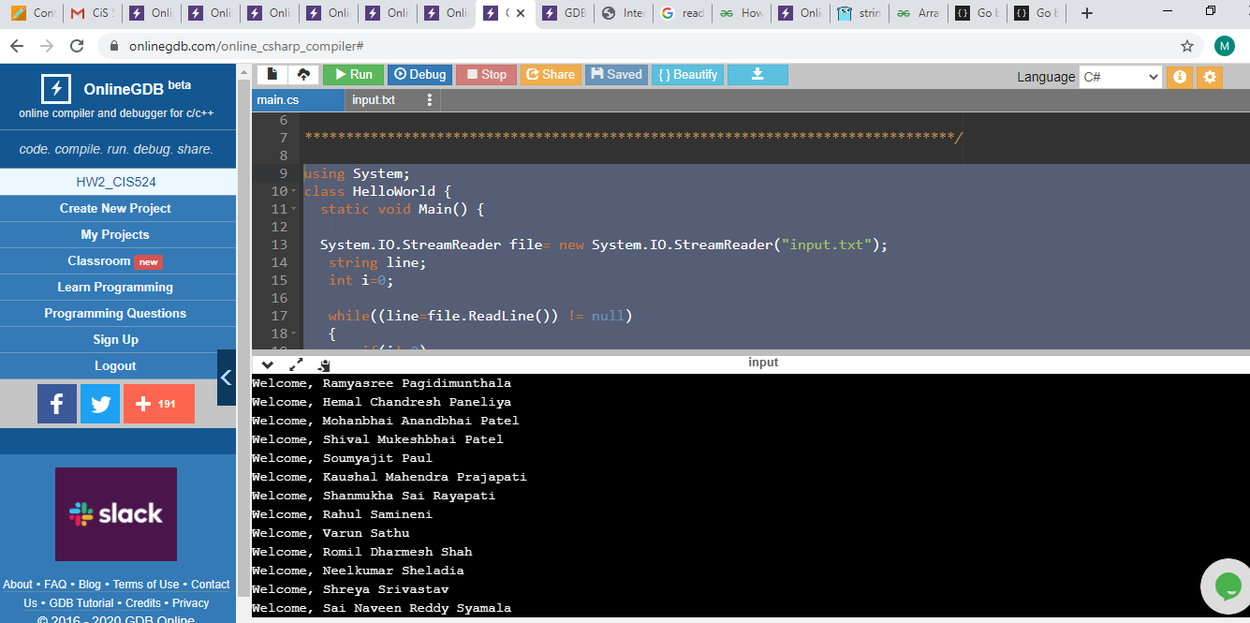

1. **Go Code**

package main

import (

"bufio"

"fmt"

"log"

"os"

"strings"

)

func main() {

file,error := os.Open("input.txt")

if error != nil {

log.Fatalf("unable to open the file")

}

scanner := bufio.NewScanner(file)

scanner.Split(bufio.ScanLines)

var text []string

for scanner.Scan() {

text = append(text, scanner.Text())

}

var a int=1;

for _, line := range text {

// fmt.Println(line)

if a!=1 {

s := strings.Split(line, ",")

fmt.Print("\nWelcome,");

fmt.Print(s[1]+" ");

fmt.Print(s[0]);

}

a++;

}

file.Close()

}

**Screenshot of result:**

