Cube Deployment:

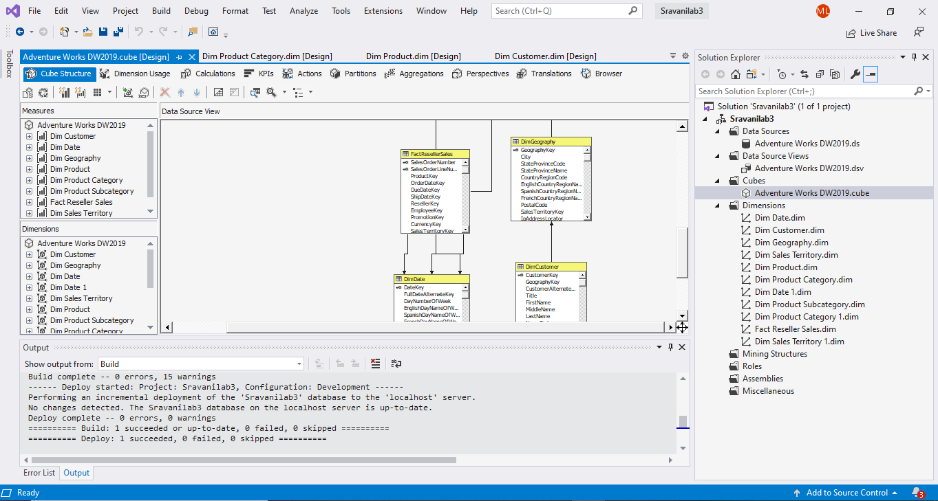

Dim Date Dimensions & Hierarchy:

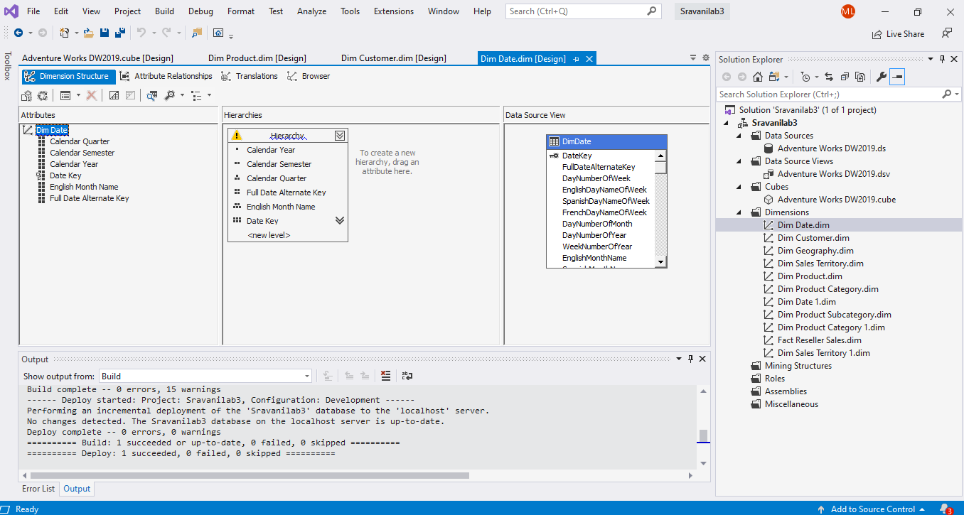

Dim Customer Dimensions & Hierarchy:

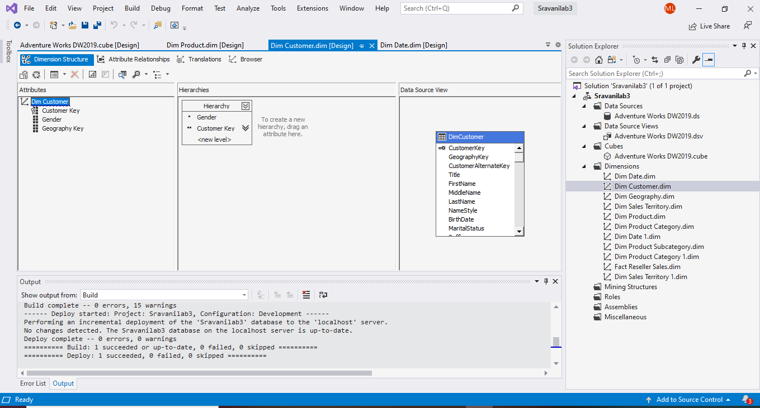

Dim Geography Dimensions & Hierarchy:

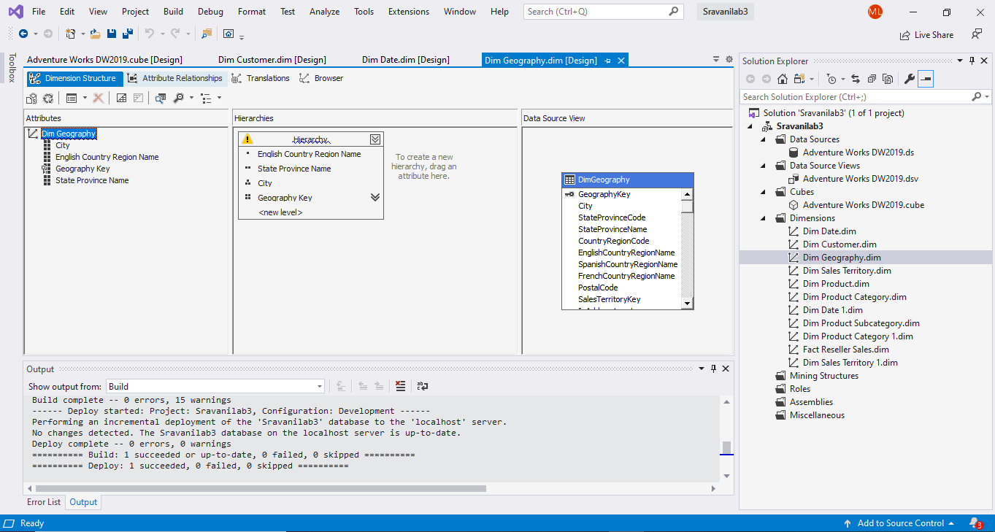

**MDX Query:**

--query1

Select ([Measures].[Sales Amount])on 0,

filter([Dim Geography].[City].children, [Measures].[Sales Amount]> 1000000) on 1

from [Adventure Works DW2019]

where [Dim Geography].[English Country Region Name].&[United States];

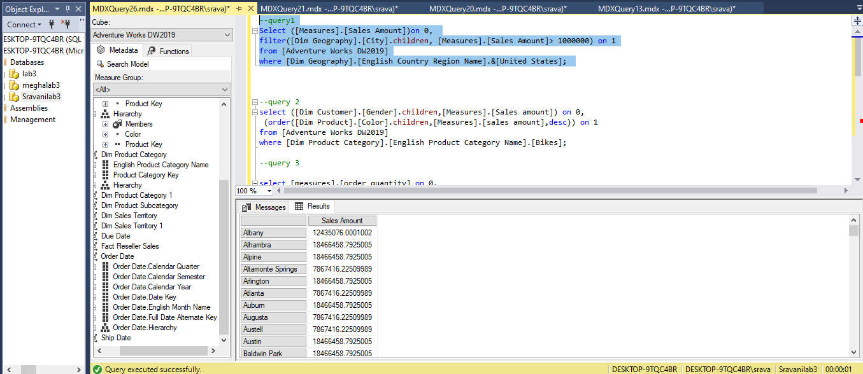

--query 2

select ([Dim Customer].[Gender].children,[Measures].[Sales amount]) on 0,

(order([Dim Product].[Color].children,[Measures].[sales amount],desc)) on 1

from [Adventure Works DW2019]

where [Dim Product Category].[English Product Category Name].[Bikes];

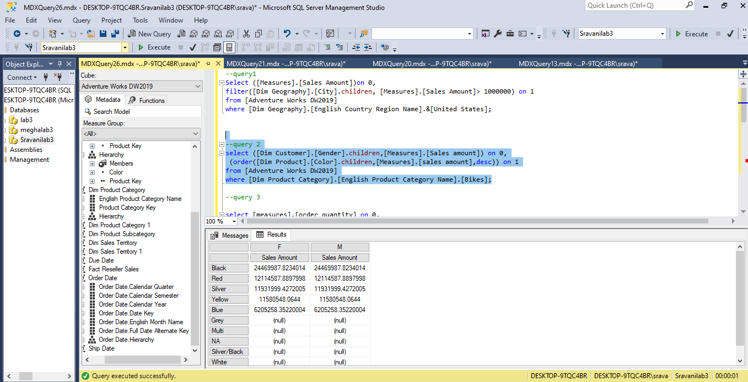

**Conclusion:**

From the above table, we can say that the black color sales are more. We cannot predict the color of bike sales depending on gender as we don’t have a relationship between these two attributes.

--query 3

select [measures].[order quantity] on 0,

TopCount

({[dim Geography].[city].children * [dim date].[calendar year].[2014]} ,5 ,[measures].[order quantity] ) ON 1

from [Adventure Works DW2019]

where [Dim Product Category].[English Product Category Name].&[Bikes];

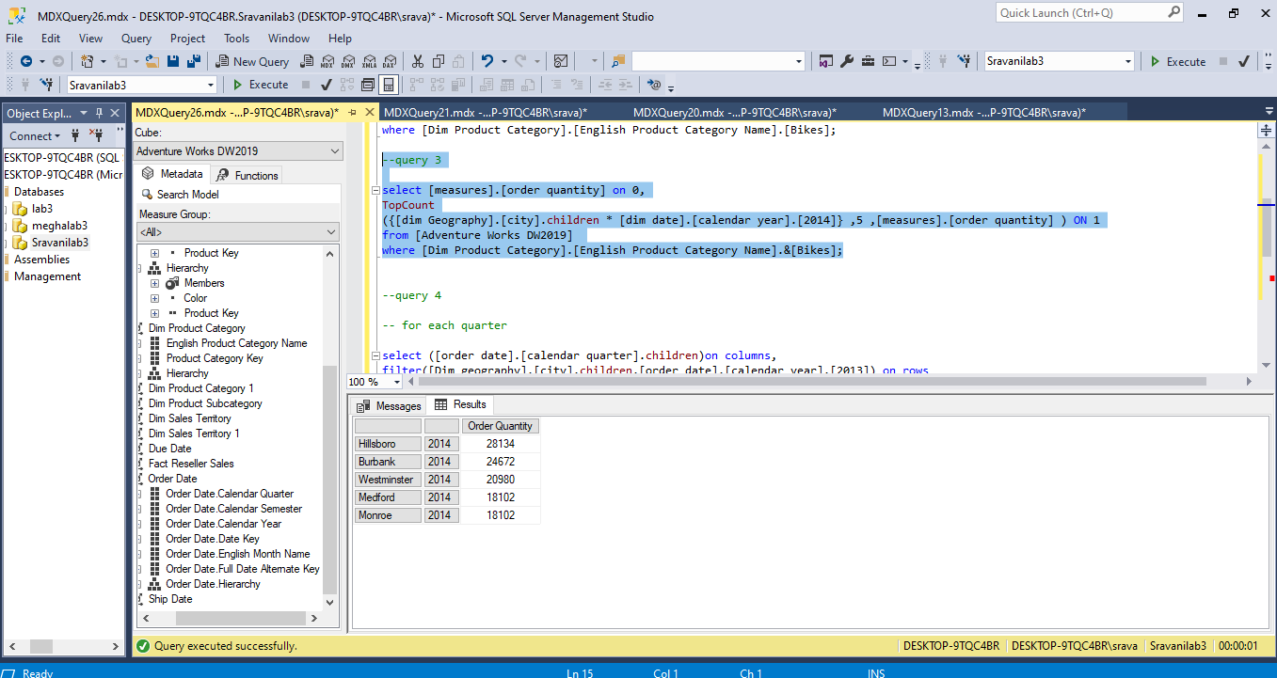

--query 4

-- for each quarter

select ([order date].[calendar quarter].children)on columns,

filter([Dim geography].[city].children,[order date].[calendar year].[2013]) on rows

from[Adventure Works DW2019]

where([measures].[sales amount])

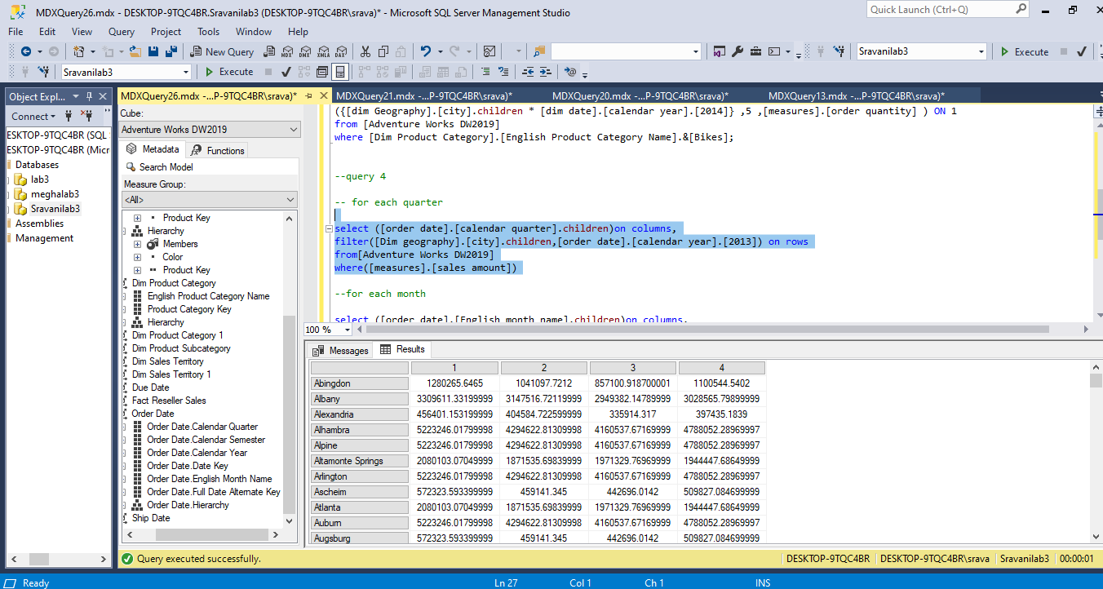

After exporting the data into excel and sorting the data from largest to smallest,

Generated a line graph for sales in top 10 cities

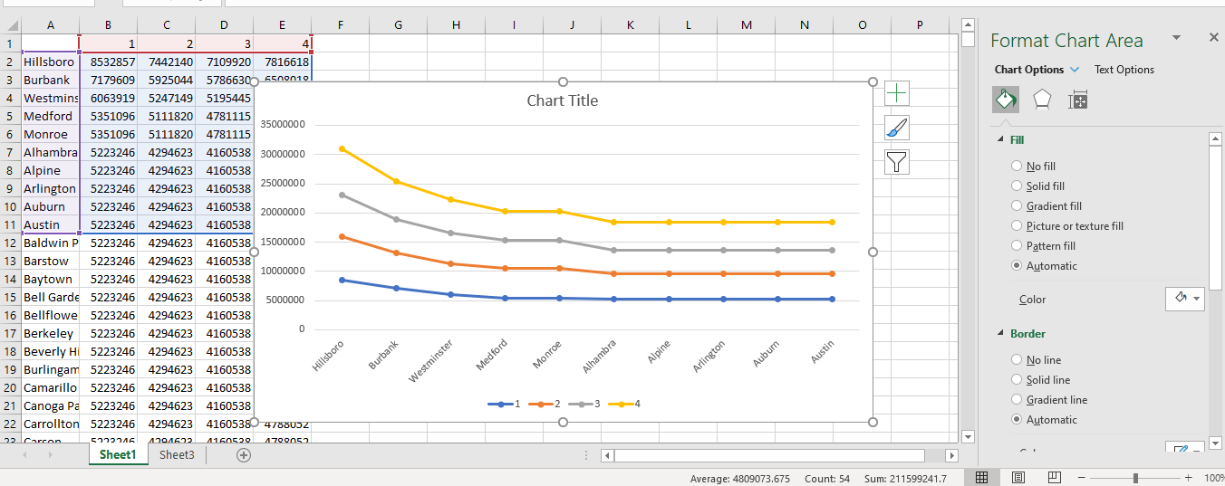

**Conclusion:**

From the above line graph, we can say that for each calendar quarter the sales amount in Hillsboro city is more, Followed by Burbank, Westminster, Medford, Monroe, Alhambra…

The sales are high in Q4.

--for each month

select ([order date].[English month name].children)on columns,

filter([Dim geography].[city].children,[order date].[calendar year].[2013]) on rows

from[Adventure Works DW2019]

where([measures].[sales amount])

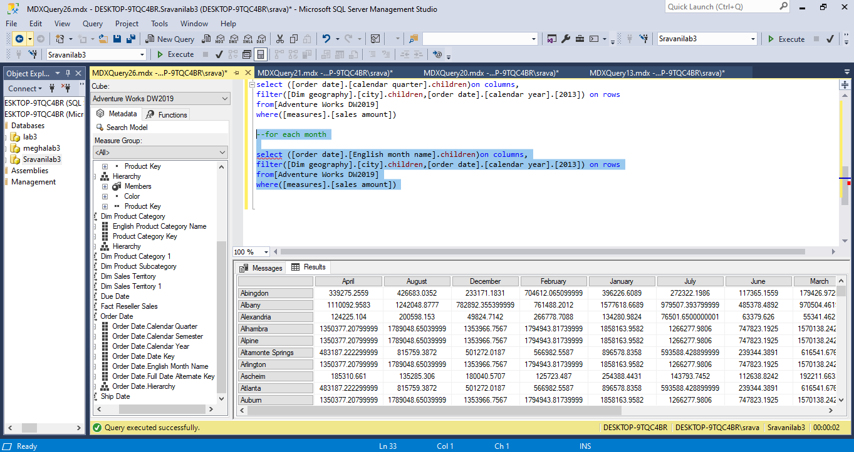

After exporting the data into excel and sorting the data from largest to smallest,

Generated a line graph for sales in top 15 cities

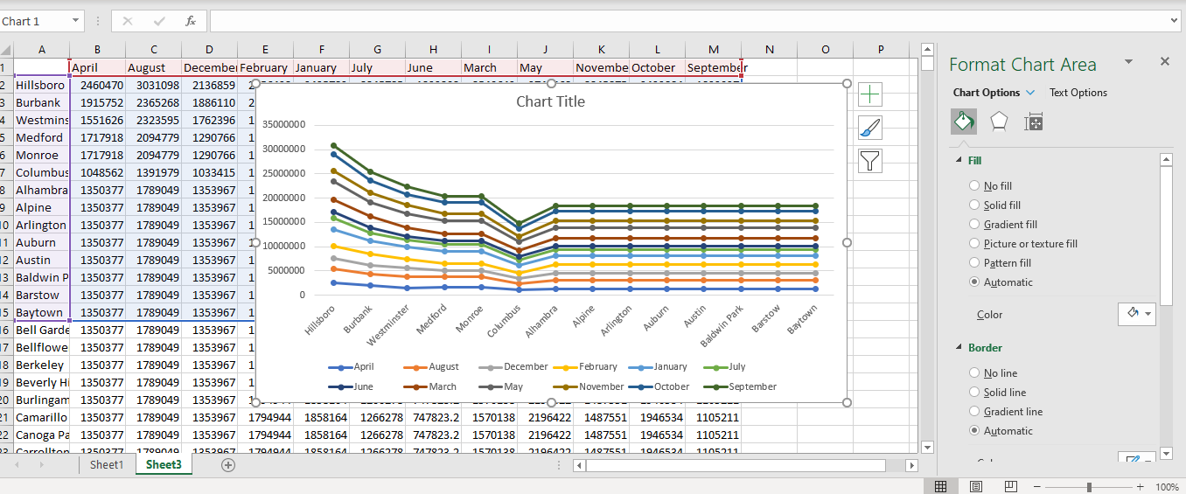

**Conclusion:**

From the above line graph, we can say that for each calendar month the sales amount in Hillsboro city is more, Followed by Burbank, Westminster, Medford, Monroe, Alhambra…

Also, the sales are high in September calendar month.