Technology used: Python, Django

Database used: Sqlite as it is default database in django. On larger scale mysql as our data is in structured format

Database schema:

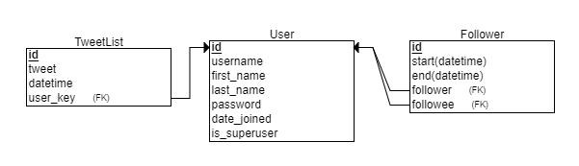

Application fail point: If schema and features of this application remains same, less chances of failing.

Limiting factors: Currently this application is working on “asia/Kolkata” time zone, for worldwide use we can set local time of request user with ip address.

Enhancement: I have built API with django templates for client side. Can be converted into REST API with JSON response.