* What is the purpose continue statement in python?
Ans The continue statement is a loop control statement in Python that is used to skip the current iteration of a loop and move on to the next iteration
* Write python program that swap two number with temp variable and without temp variable?

Ans with temp variable

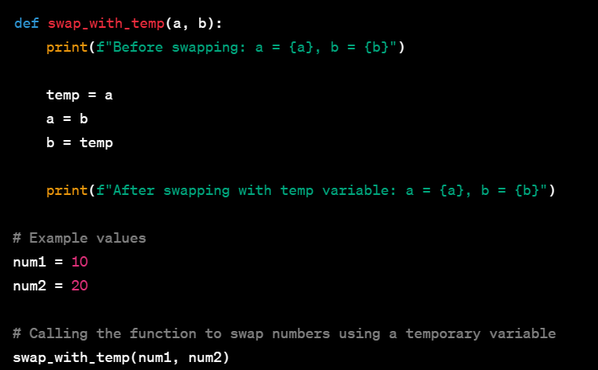

Without temp variable

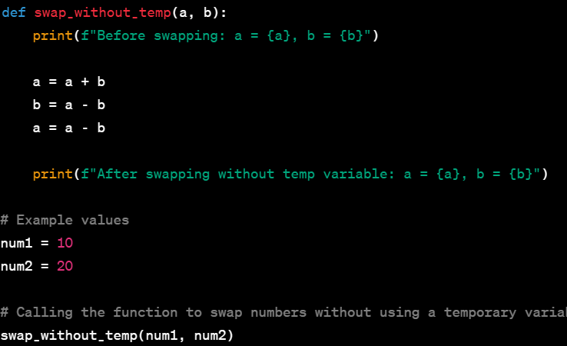

* Write a Python program to find whether a given number is even or odd, print out an appropriate message to the user?
Ans 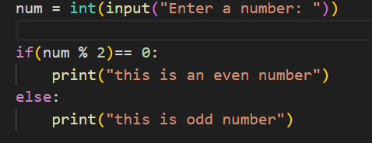

* Write a Python program to test whether a passed letter is a vowel or not?

Ans 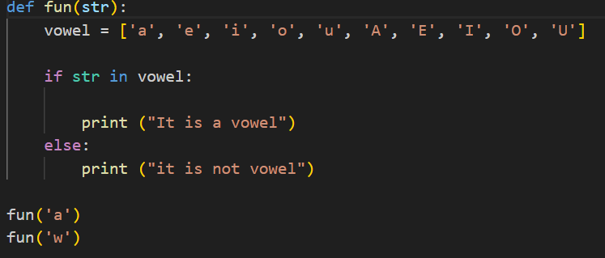

* Write a Python program to calculate the length of a string.
Ans 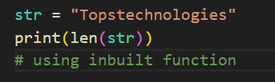
* Write a Python program to count the number of characters (character frequency) in a string
Ans
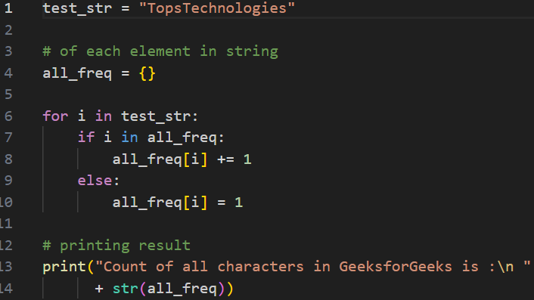
* What are negative indexes and why are they used?
Ans Negative index is used to acess the element from a sequence from the end .

* Write a Python program to count occurrences of a substring in a string.
Ans 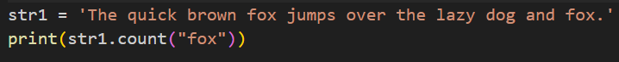

- Write a Python program to count the occurrences of each word in a given sentence
Ans 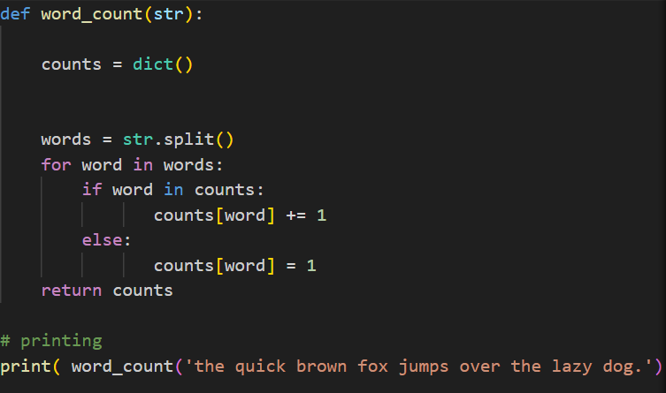
- Write a Python program to get a single string from two given strings, separated by a space and swap the first two characters of each string.
Ans 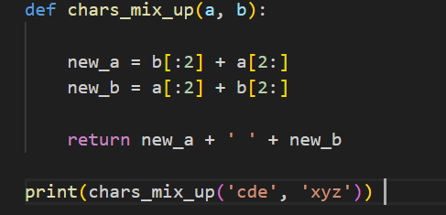

- Write a Python function that takes a list of words and returns the length of the longest one

Ans