Design Document

E-Auction Application
Revision 1.2

Table of Contents
Table of Contents ii
Revision History iii
1. Introduction 1
1.1 Purpose 1
1.2 System Overview 1
2. Design Considerations 1
2.1 Assumptions 1
2.2 Risks & Mitigation 1
2.3 Dependencies 1
2.4 Design Metrics 2
2.4.1 Security 2
2.4.2 Scalability 2
2.4.3 Availability 2
2.4.4 Performance 2
2.4.5 Resilience 2
3. Architecture 3
3.1 Microservices 3
3.2 Database 3
3.3 Message Broker 3
3.4 Design Patterns 4
3.5 Testing 4
3.6 Others 4
4. User Interface 5
4.1 Design 5
4.2 Testing 5
5. Cloud 6
5.1 Architecture 6
5.1.1 UI Architecture 6
5.1.2 API Architecture 7

Revision History
Version | Name | Reason For Changes | Date
1.0 | Meghdut Choudhury | Initial Revision – API Design Documentation | June 11, 2022
1.1 | Meghdut Choudhury | Added UI Documentation | June 25, 2022
1.2 | Meghdut Choudhury | Added Cloud Documentation | July 5, 2022

Introduction

Purpose
This design will detail the design methodologies followed in the delivery of the E-Auction Application.

System Overview
E-Auction Application is a microservice based Cloud Native Application. The main purpose of E-Auction is to provide the ability to initiate sale, purchase and bid for a product by the customer. The core modules of E-Auction app are:

- Put a new product on auction with starting bid price.
- Bid for the product.
- Update the bid price.
- Enlisting of bids placed on any product.

Design Considerations

Assumptions
To simplify the CQRS implementation and constrain the scope of the design to the requirements, the application has been configured on a singular database instance instead of provisioning separate write instances and read replicas.

Risks & Mitigation
No security risks to highlight with current implementation. The API is backed by a JWT based authentication mechanism, and can protect against XSS attacks as well.

Dependencies
The application is dependent on availability of a persistent store (MongoDB) and message queue (RabbitMQ) service to be able to retrieve and save updates to application data. Any outages to these services may result in application down time. To mitigate the impact, all traffic to these services may be routed via a load balancer to allow redirection to an alternative failover cluster if the primary nodes are down.

Design Metrics

Security

The application is backed by a JWT authorization token to ensure the legitimacy of all incoming requests. There is also XSS protection to guard against Cross-Site Scripting (XSS) Attacks.

Scalability

The application uses a CQRS design pattern with separate microservices for commands (writes) and queries (reads). The implementation is backed by an event store (MongoDB using Axon) and message store (RabbitMQ). Due to this, the application can be scaled efficiently determining on application usage density (reads vs writes).

Availability

The application follows a microservice design pattern that can be run on independent primary compute nodes behind a load balancer. Downtime on few instances will not bring down the application since the load balancer will redirect traffic to the healthy nodes. For large scale failures on the primary cluster, a failover cluster may be brought up immediately and traffic can be re-routed to the latter cluster to immediately restore services to the application user.

Performance

Since the application follows the CQRS design pattern, for write heavy workloads in a given time, the command microservices can be scaled up accordingly. This gives us fine control over the application performance by allowing us to dynamically scale our cluster up or down depending on temporal application usage patterns.

Resilience

The application is resilient against catastrophic system failures due to the persistent event store backed by MongoDB (using Axon framework) and message store by RabbitMQ. No transactional data will be lost on system outage since the queued events will be able to continue processing on service restoration. To provide even better tolerance against failures, we may define a failover cluster that will be brought up if the failures on the primary cluster cross a certain threshold as per defined metrics.

Architecture

Microservices
The design pattern being used in CQRS. The application uses a Eureka service for discovery, Spring Cloud API Gateway to serve as the composite / front for all API operations, a Command layer to process write operations, and a Query layer to handle read requests to the application data.

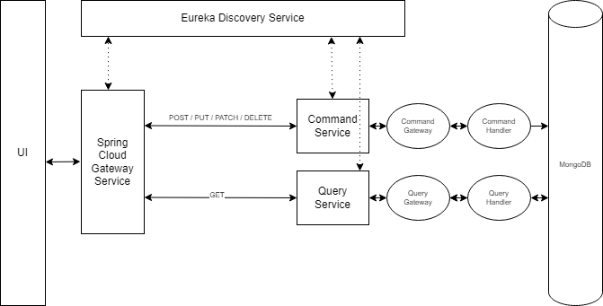

Database
The database provider is MongoDB – with a singular database e-auction and collections products and bids. The database will be deployed on a single node. Even though the microservices follow a CQRS design pattern, no read replicas are being provisioned to simplify the implementation and constrain the design to the given requirements only. Both Command and Query services will interact with the singular database instance.

Message Broker
The message broker being used in RabbitMQ. Additionally, to support the CQRS pattern, we are using the Axon framework leveraging MongoDB as an event store. Only the bid posting and listing has been designed to follow the gateway – handler design as per the requirements.

Design Patterns
The creational design pattern has been used for composing the model object in the show bids response is Builder pattern. This pattern has been chosen due to the large number of object properties which would make the process of constructing an object using constructors or setters too verbose, cumbersome and inefficient in terms of performance.

Testing
The controller and service classes in Command and Query API containing business logic has been tested with Junit 5 test suite, using Mockito to stub dependencies. All scenarios including context load and exception cases have been tested.

Code coverage has been generated using JaCoCo – Java Code Coverage tool. Report can be directly downloaded as a Gitlab job artifact.

CI/CD has been configured for the API project with stages: build & test. The runner being used is a gitlab-runner docker instance configured to run on the VDI itself.

Performance test suite has been developed using Apache JMeter for login, getting products and getting bids for product functionality since these are the endpoints that may see the highest traffic. The file has been uploaded in Gitlab (link in Deliverables section).

Others
- The application uses Java Collections and Streams as per their best usage policies.
- Spring Actuator has been used for monitoring and health reporting of API instances.
- The fetch bids API have support for filtering, sorting and pagination.
- The REST endpoints are documented by Open API and are consolidated under the Cloud API Gateway.
- No inter-microservice calls were required.
- Service discovery has been achieved by Eureka and Circuit Breaker has been applied only at Cloud API Gateway level by using Hystrix.
- The 2 security OWASP recommendations implemented are:
  - Prevention of Cross-site Scripting (XSS) using Spring security
  - Strict access control through authenticated access to application data using JSON Web Token (JWT)

User Interface

Design
- The UI has been developed using Angular 13 in Typescript language. The UI elements and styles are backed by Bootstrap 5.
- The gang of four design pattern “builder pattern” has been used for composing data using typescript
before presenting on UI. SOLID principles have been followed as per guidelines.
- The approach for client-side optimization of Bootstrap that has been done is minification of styles and scripts during deployment, to minimize the page resource size as well number of network calls made to initialize and render the pages.
- To improve UI performance, Ahead-of-Time (AOT) compilation has been enabled as is the default for the Angular 13 framework. This will improve the runtime performance by compiling everything ahead of time.
- Prevention of XSS attacks is taken care of by Angular implicitly by sanitizing and escaping untrusted values, thereby preventing a potential injection and execution of a malicious script.

Testing
- The application testing framework used consists of Jasmine, Karma and Protractor. Unit, integration and end-to-end tests have been written, including exception cases.
- Code coverage is also being reported. Both test case results and coverage percentages are directly integrated and viewable under the CI/CD > Jobs section of Gitlab.
- ELK Stack has been deployed using the public docker image sebp/elk. The application has been integrated with the Elasticsearch service running at port 9200, to connect and upload the protractor e2e test results using the Winston library, and the same is viewable on the Kibana Web Interface.

Cloud

Architecture
The below AWS technologies have been used in the design of this application on cloud side. The deployment and design has been depicted in the given diagrams.

- Elastic Container Registry
- Elastic Container Service
- Elastic Beanstalk
- EC2, ASG & ELB
- Lambda Functions
- Step Functions
- API Gateway
- Cognito
- Amazon MQ
- Document DB
- CloudTrail
- CloudWatch
- Virtual Private Cloud
- SNS, SQS, SES

UI Architecture

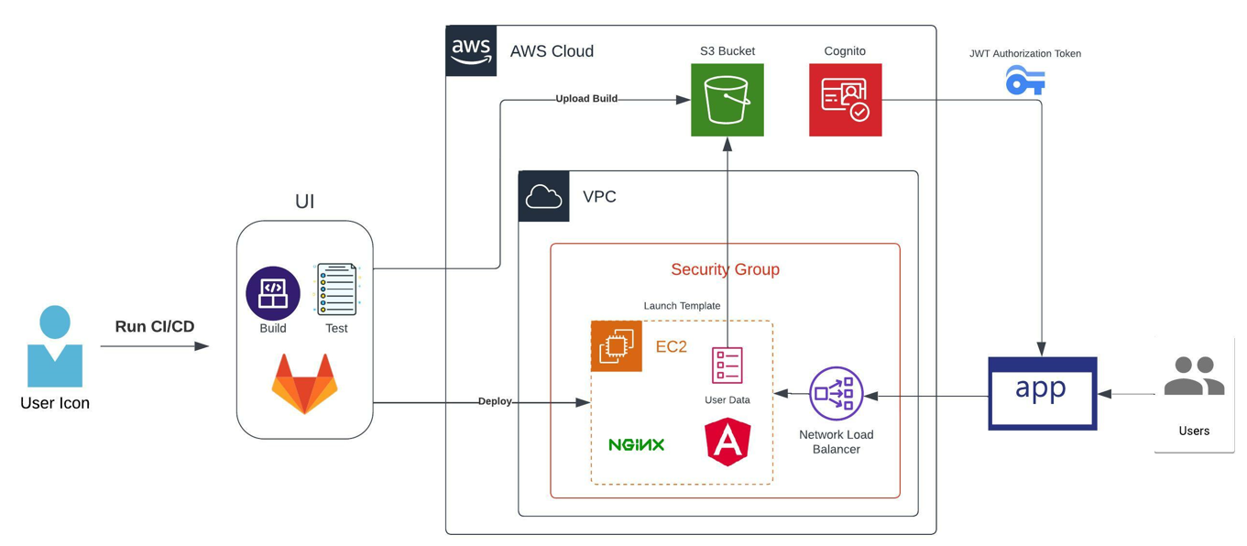

API Architecture

