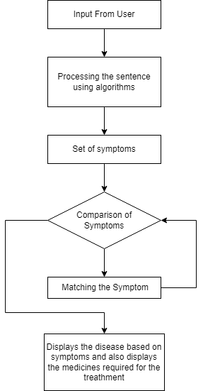

**Flowchart for Medibot**

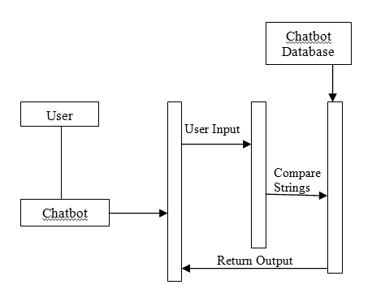

**Sequence Diagram**

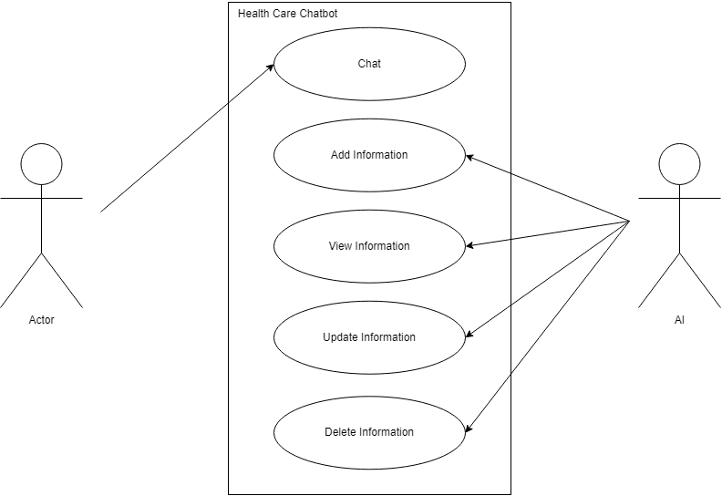

**Use Case Diagram**

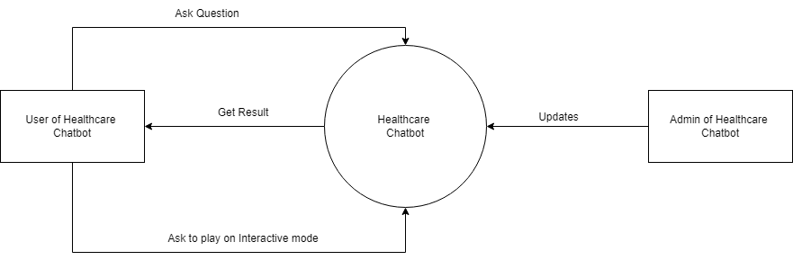

**DFD Level 0 for MediBot**

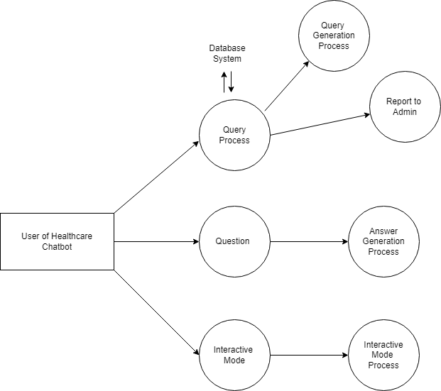

**DFD level 1 for Medibot**