Propulsion Technology — Services Manual
This manual provides a clear and visually guided explanation of the services offered by Propulsion Technology. It takes the visitor through the full Services section, showing how each service appears on the website and explaining the key features and purpose of every service. The manual also includes a walkthrough of the detailed service view and the interactive forms such as 'Schedule a Demo' and 'Ask an Expert'.

1. Services Overview
Visitors arriving on the Services page are greeted with a clean, modern layout showcasing a wide range of solutions — from digital marketing and creative design to advanced development and enterprise systems. Each service is represented through a card that contains an icon, title, and short description, making it easy to understand what Propulsion Technology offers.
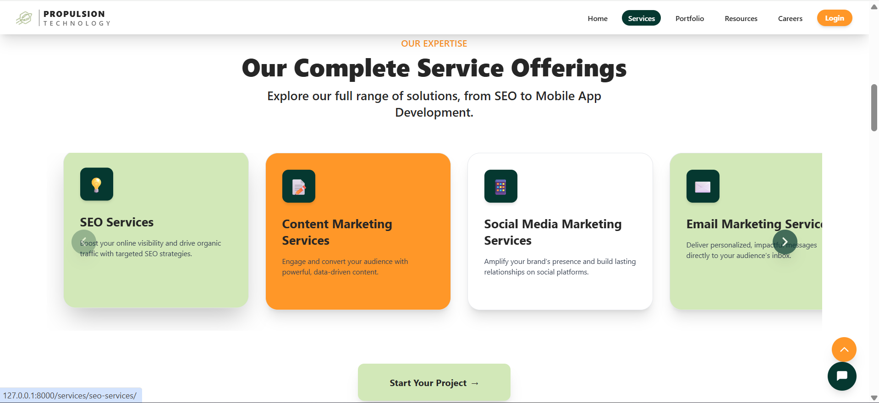
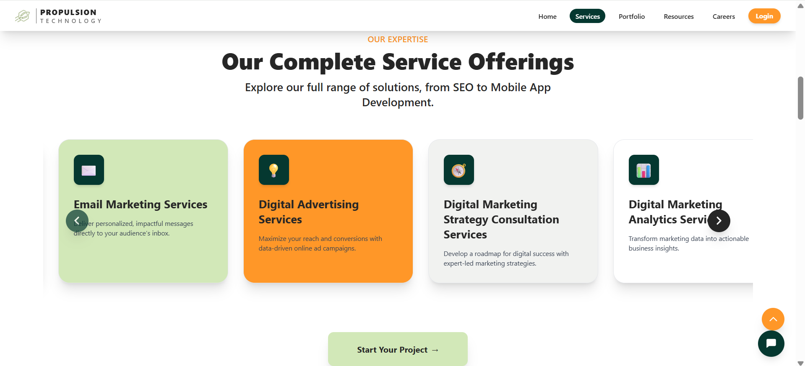
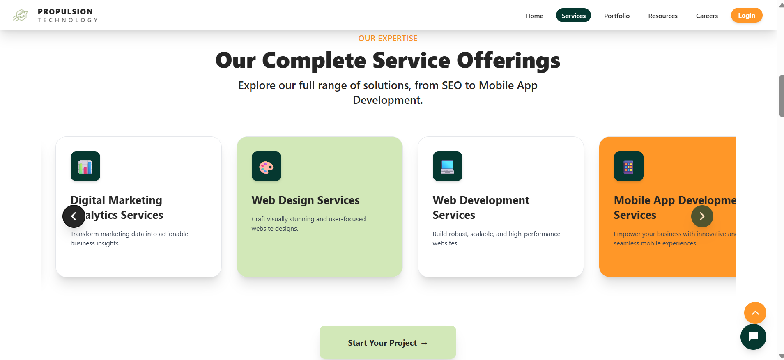
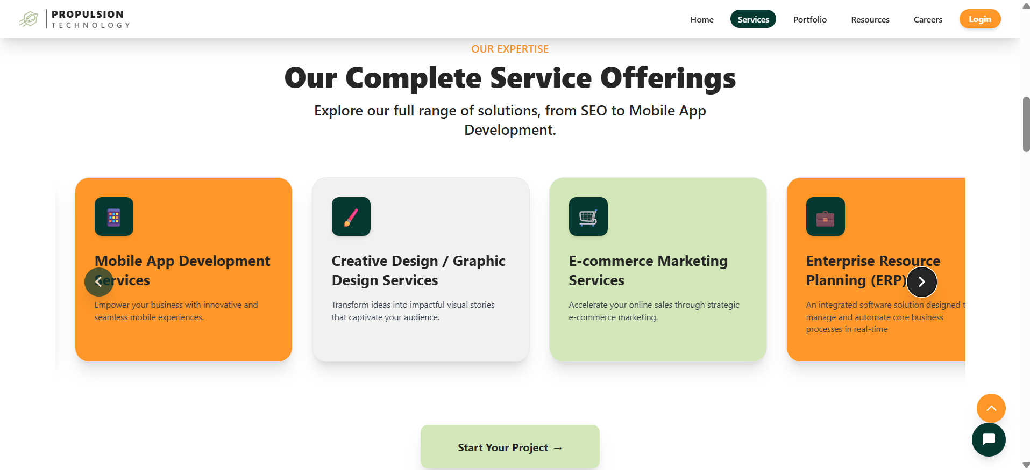
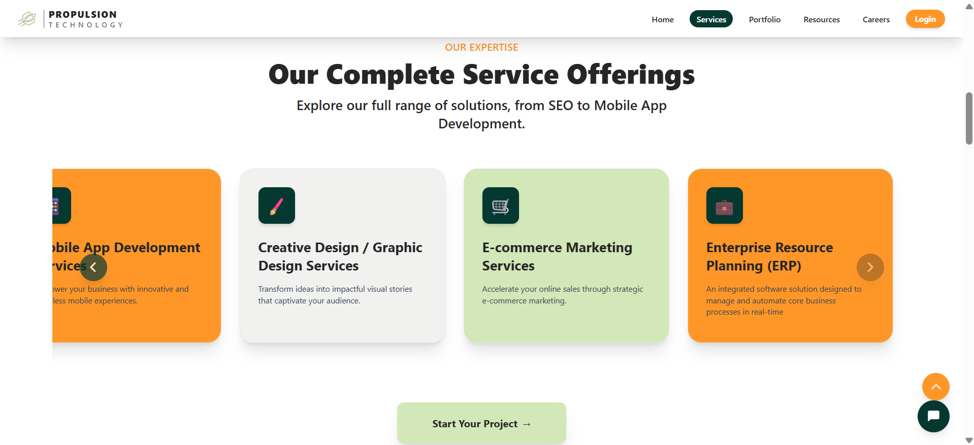

2. Service Descriptions
Below is a quick overview of each service offered by Propulsion Technology. These brief summaries help visitors quickly identify the service they need.

SEO
Helping your website show up higher on Google so people can find your business easily.

Content Marketing
Creating useful blogs, articles, and content that helps people understand your brand and builds trust.

Social Media Marketing
Managing and growing your presence on platforms like Instagram, Facebook, and LinkedIn.

Email Marketing
Sending well-designed emails to your customers for updates, promotions, and communication.

Digital Advertising
Running paid ads on Google, Facebook, Instagram, and more to reach new customers quickly.

Digital Marketing Strategy
Planning how your business should grow online with a clear step-by-step roadmap.

Marketing Analytics
Tracking and studying how people interact with your website and campaigns to understand what works.

Web Design
Creating the visual look of your website so it feels modern, clean, and easy to use.

Web Development
Building the actual website so it functions smoothly and loads fast on all devices.

Mobile App Development
Creating mobile apps that work on Android and iOS for your customers or business use.

Graphic Design / Creative Work
Designing visuals like logos, banners, posters, and graphics that represent your brand.

E-commerce Marketing
Helping online stores get more visitors, show products better, and increase their sales.

ERP (Enterprise Resource Planning)
A system that connects your business operations — like inventory, finance, and HR — into one dashboard.

3. Detailed Service View
When a visitor clicks on a service, they are taken to a dedicated page that explains that specific offering in detail. The page begins with a clear header and a hero image that visually represents the service. Just below it, the visitor can read a short introduction followed by a more complete explanation of what the service includes. The layout is clean and easy to understand, helping users learn about the service without confusion. On the same page, two main action buttons — “Schedule a Demo” and “Ask an Expert” — are placed prominently. These options allow visitors to quickly contact the team, request guidance, or book a demonstration whenever needed.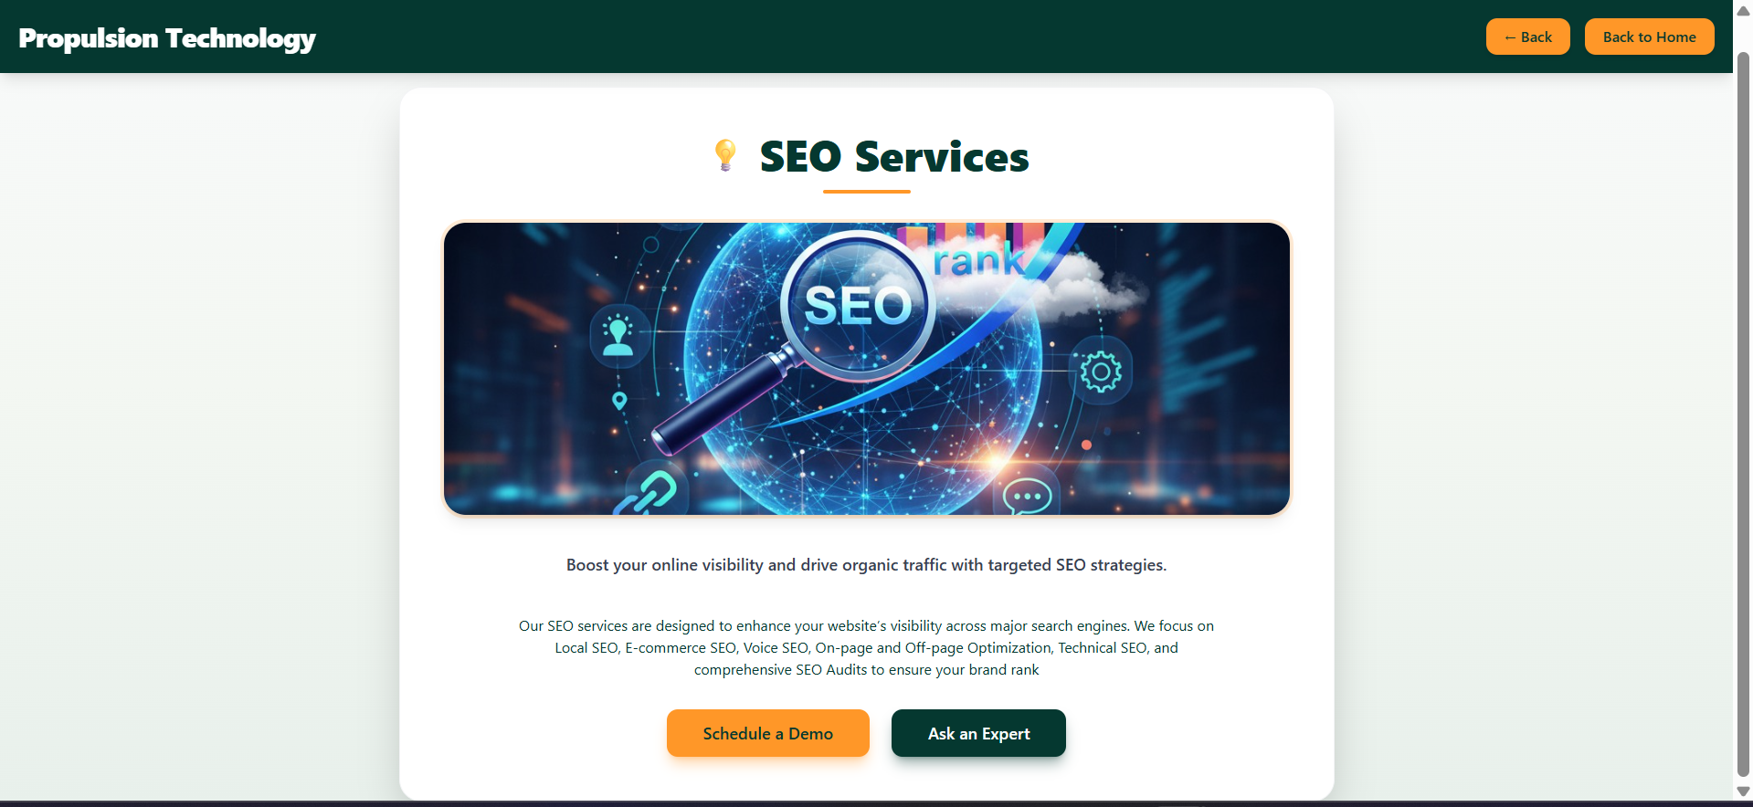

4. Schedule a Demo Form
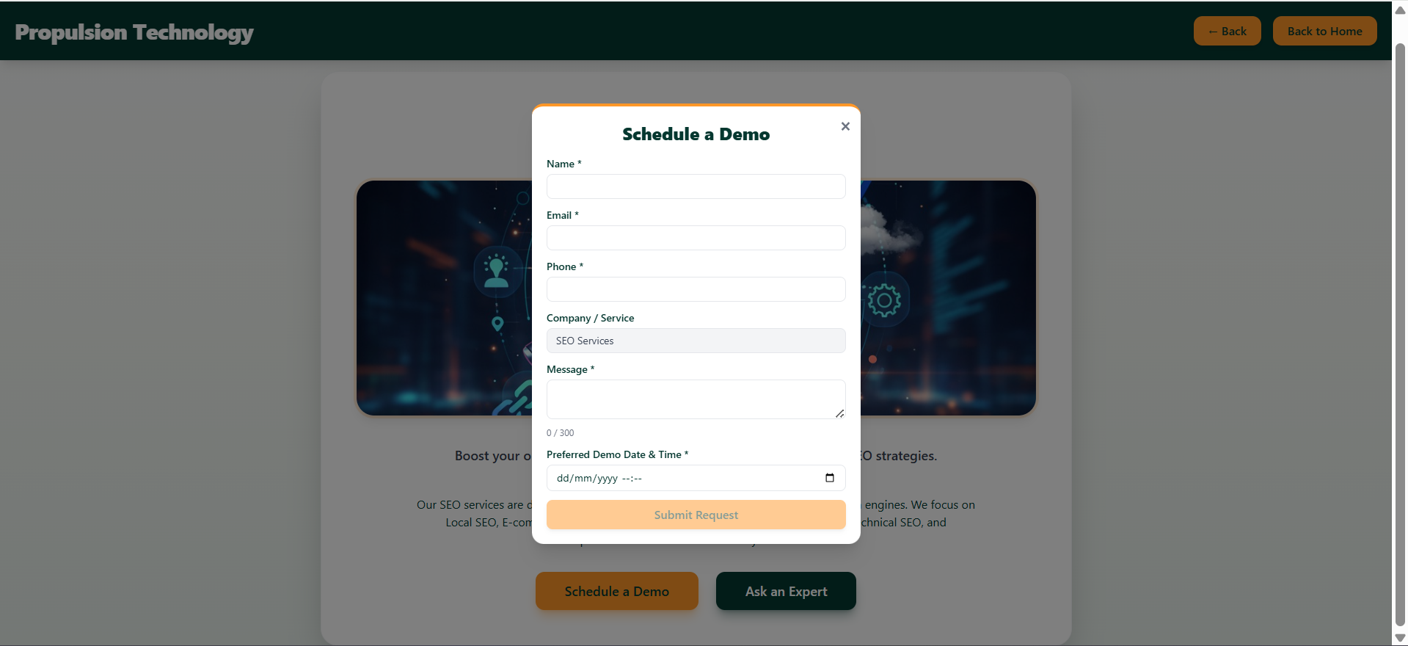
The 'Schedule a Demo' form allows customers to request a live demonstration of the service or product. This form captures essential visitor details, including:
- Name
- Email
- Phone
- Company/Service
- Message
- Preferred Date & Time

5. Ask an Expert Form
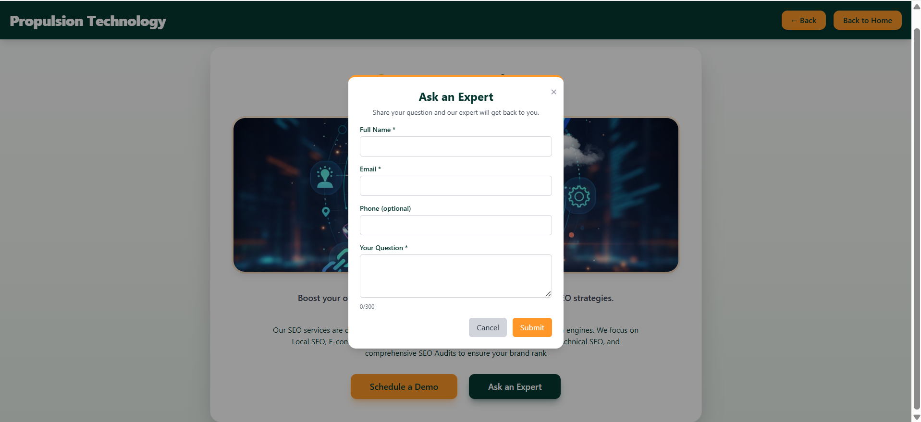
The 'Ask an Expert' form provides visitors with a quick channel to ask specific questions. It is designed to collect information such as:
- Full Name
- Email
- Phone (Optional)
- Your Question

6. Summary
This manual helps visitors understand the full range of Propulsion Technology services and how to navigate the detailed service pages and interactive forms. It can be used for onboarding, training, or customer communication.

