**Module-1) Software Engineering**

**Q-1. What is software? What is software engineering?**

# Software

Software is a **set of instructions** and data that tell a computer how **to perform task**. We cannot use any device or computer without software.

There are two main types of software

1. System Software
2. Application Software

**1.System Software** - System software is the software that manages the basic functions and resources of a device. Like Windows, Linux, macOS, all these are system software of computer.



**2. Application Software** - These are software programs that are designed to perform a particular task. Such as Microsoft Word, Microsoft Excel, Google Chrome, YouTube etc. This software is made for our daily computer use.

# Software Engineering

Software engineering is the study of methods, principles, and techniques for creating and maintaining computer software. The main objective of software engineering is to create high-quality software and maintain it well. It focuses on different stages of software development such as analysis, design, coding, testing, and maintenance. If the software is developed keeping in mind all these stages, it can be done in a short time with high quality and cost-effective.

In short Software engineering means the process of developing and maintaining high-quality software.

# Q-2. Explain types of software

There are different types of software that help our computers or electronic devices perform different functions. Here are some major types of software:

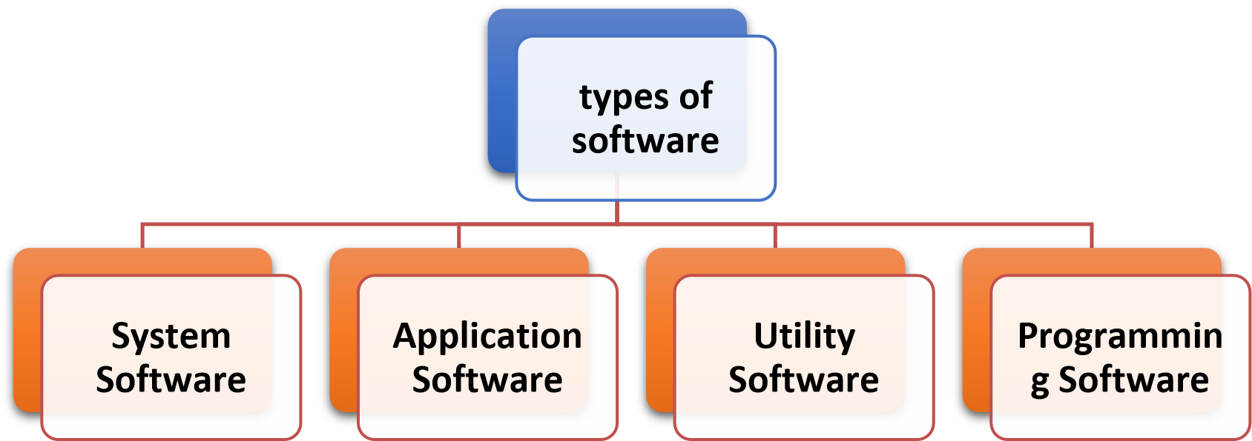

**1.System Software -** This software controls the basic systems and hardware of the computer. Such as operating systems (OS) such as Windows, MacOS, Linux. Without OS, computers and other devices cannot run because they communicate with the hardware and provide an interface to the user.

1. **Application Software -** This software is used to perform specific tasks. Like Microsoft Word, Excel, Photoshop, or video editing software like Adobe Premiere. Every application software has its own specific purpose.
2. **Utility Software -** This software is used to improve the performance of our computer or device and handle specific tasks. Like antivirus software, disk cleanup utilities, or file compression software.
3. **Programming Software -** This is for software developers or programmers, who create new software or applications. Like Integrated Development Environments (IDEs) like Visual Studio, Eclipse, or code editors like Sublime Text, Atom.

# 3. What is SDLC? Explain each phase of SDLC

**Software Development Life Cycle** (SDLC) is a process used by software development team to design, develop, test, and deploy high-quality software.

The main objective of SDLC is to produce high quality software that meets the needs of its users. By following a structured process, SDLC helps reduce risks, improve efficiency, and ensure software projects are delivered on time and on budget.

The Software Development Life Cycle (SDLC) usually involves the following stages:

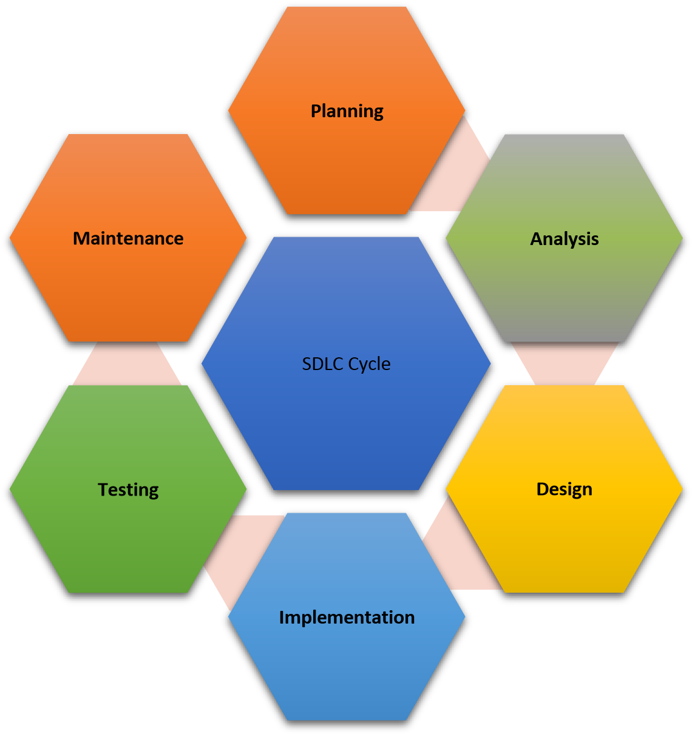

## 1. Planning & Requirement gathering

This phase involves defining the project's objectives, identifying key stakeholders, and developing a detailed project plan.

## 2. Analysis

During this phase, the collected requirements are analyzed in detail. This includes understanding the functionalities to be performed by the software, user interface requirements, and any other relevant aspects.

## 3. Design

In the design phase, the system architecture and software design are planned out based on the requirements gathered and analyzed. This includes creating high-level and low-level design documents.

## 4. Implementation

Also known as the coding phase, this is where the actual software development takes place. Developers write code based on the design documents prepared in the previous phase.

## 5. Testing

In this phase, the developed software is tested rigorously to ensure it meets the specified requirements and functions correctly. Testing can include unit testing, integration testing, system testing, and user acceptance testing.

## 6. Maintenance

After deployment, the software enters the maintenance phase. During this phase, any issues discovered post-deployment are addressed, updates and patches are released, and ongoing support is provided to ensure the software continues to function effectively.

The SDLC is a structured Process for software development teams to produce high-quality software that meets user needs.

# 4. What is DFD? Create a DFD diagram on Flipkart

DFD stands for Data Flow Diagram, which is a graphical representation of how data moves through a system, including its sources, destinations, and changes. This tool is widely used to visualize and comprehend intricate systems, such as online shopping platforms like Flipkart.



FlipKart

Website



User



Administration



Delivery Service



Ware House



Payment Gateway

**Level 0 DFD (Data Flow Diagram) Of Flipkart**

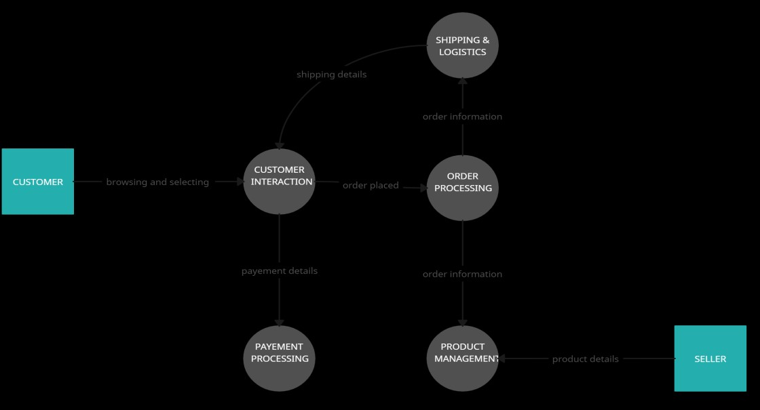

# 5. What is Flow chart? Create a flowchart to make addition of two numbers

A flowchart is a graphical representation of a process or algorithm, using standard symbols to illustrate the steps involved and the logic behind them. It is like a map for computer programs or any process that requires clear instructions.



Start



Input first number



Input

second number



Addition Numbers



display Result



End

**6. What is Use case Diagram? Create a use-case on bill payment on paytm.**

A Use Case Diagram is a diagrammatic representation of how actors (users or external systems) interact with a system to achieve specific goals. It shows the functionalities provided by the system and the actors involved in these functionalities. Use case diagrams are extensively used in software engineering to model the system's behavior from a user's perspective.

User



User



Bill



Payment



Payment



Login/Register



View Bills



Pay Bills



View Payment

