PROJECT TITLE
Heterogeneous Distributed Database Systems and Query Processing in Modern Enterprise

A
PROJECT REPORT

Submitted by
Harsh Mehta IM2007029
Soham Mody IM2007032
Dhrumil Joshi IM2007022

As the partial fulfillment of the requirement for the degree of Bachelor in Information Technology

Guided by
Prof. VinayaSawant
Prof.NehaMendjoge


Department of Information Technology
D. J. Sanghvi College of Engineering,
Mumbai – 400 056

Shri Vile Parle KelvaniMandal’s
D. J. Sanghvi College of Engineering
Mumbai – 400 056

CERTIFICATE

This is to certify that the following students have successfully completed the project
Titled

Heterogeneous Distributed Database Systems and Query Processing in Modern Enterprise

At D. J. Sanghvi College of Engg., Mumbai as a partial fulfillment of the requirement for the degree of Information Technology (Semester VIII) of University of Mumbai in the year 2010 – 2011.
Student Name Roll Number

Harsh Mehta IM2007029
SohamMody IM2007032
Dhrumil Joshi IM2007022

Internal Guide
Prof. VinayaSawant

Internal Examiner External Examiner

Vice Principal (Acad) and HOD, IT Dept. Principal
(Prof. A. R. Joshi) (Dr. HariVasudevan)

ACKNOWLEDGEMENT

We thank the Management of the Dwarkadas J. Sanghvi College of Engineering and our respected Principal Dr. HariVasudevan for providing us with all the facilities to complete the project. We would like to convey our heartfelt gratitude to our Prof. AbhijitJoshi,Vice Principal and Head of IT Department for accepting our project and inspiring us to take up this project.
We would like to extend our gratitude to our Project guide Prof. VinayaSawant.Her valuable guidance and timely support without which we would have never been able to complete the project cannot be forgotten.
We would also like to take this opportunity to thank Ms. NehaMendjoge for guiding us throughout the research of the project.
Finally, we would like to express our gratitude to the faculty of Information Technology Department of Dwarkadas J. Sanghvi College of Engineering for their co-operation and timely assistance and our loved ones for their moral support.

Table of Contents
LIST OF FIGURES 2
LIST OF TABLES 2
1. ABSTRACT: 2
2. EXISTING SYSTEM: 2
3. PROBLEM DEFINITION WITH SCOPE OF PROJECT: 2
4. PROPOSED SYSTEM 2
5. PROJECT MANAGEMENT 2
5.1 SCHEDULE 2
5.1.1 TASK NETWORK 2
5.2 PROJECT RESORUCES 2
5.2.1 HARDWARE RESOURCES 2
5.2.2 SOFTWARE RESOURCES 2
5.3 ESTIMATION 2
5.3.1 COCOCMO 2
6. PROJECT DESIGN 2
6.1 SYSTEM ARCHITECTURE 2
6.2 DESIGN DIAGRAMS 2
6.2.1 USE CASE DIAGRAM 2
6.2.2 CLASS DIAGRAM 2
6.2.3 ACTIVITY DIAGRAM 2
6.2.4 SEQUENCE DIAGRAM 2
6.2.5 COMPONENT DIAGRAM 2
6.2.6 DEPLOYENT DIAGRAM 2
6.3 INTERFACE DESIGN 2
6.3.1 USER INTERFACES 2
6.4 MODULE DESCRIPTION 2
7. PROJECT TESTING 2
7.1 TEST PLAN 2
7.2 TEST CASES 2
7.3 TYPES OF TESTING 2
8. MAINTENANCE 2
8.1 MANUAL 2
8.1.1 USER MANUAL 2
8.1.2 TECHNICAL MANUAL 2
8.2 CONSTRAINTS FOR USE OF PRODUCT 2
9. CONCLUSION 2
10. FUTURESCOPE 2
11. REFERENCES 2

LIST OF FIGURES
Figure 2-1 Centralized database system 2
Figure 5-1 Task Network 2
Figure 6-1 Peer-to-peer network 2
Figure 6-2 Architecture Layers 2
Figure 6-3 UseCase Diagram 2
Figure 6-4 ClassDiagram 2
Figure 6-5 Activity Diagram for Fragmentation 2
Figure 6-6 Activity Diagram for Replication 2
Figure 6-7 Sequence Diagram for Fragmentation 2
Figure 6-8 Sequence Diagram for QueryProcessing 2
Figure 6-9 Component diagram 2
Figure 6-10 Deployment Diagram 2
Figure 6-11 Main Form 2
Figure 6-12 Fragmentation Form Step 1 2
Figure 6-13 Fragmentation Form Step 2 2
Figure 6-14 Replication Form Step 1 2
Figure 6-15 Replication Form Step 2 2
Figure 6-16 Setup Form Step 1 2
Figure 6-17 NodeSearch Setup Form step 3 2
Figure 6-18 QueryProcessing Form 2
Figure 8-1 Setup Form 2
Figure 8-2 Setup Form step 2 2
Figure 8-3 NodeSearch Setup 2
Figure 8-4 Fragment Form 2
Figure 8-5 Fragment Form Step 2 2
Figure 8-6 Replication Form 2
Figure 8-7 Replication Form 2
Figure 8-8 Query Form 2

LIST OF TABLES
Table 1 Cocomo 2
Table 2 Test Case 1 2
Table 3 Test Case 2 2
Table 4 Test Case 3 2
Table 5 Test Case 4 2
Table 6 Test Case 5 2
Table 7 Test Case 6 2
Table 8 Test Case 7 2
Table 9 Test Case 8 2
Table 10 Test Case 9 2
Table 11 Test Case 10 2

ABSTRACT:
Due to the heterogeneity and transparency, the software is able to surpass the existing system, i.e the centralized database system. The major disadvantage of the existing system is that the database cannot be accessed for the remote location and the failure rate is high. The purpose of the software is that it allows the potential user to work in the heterogeneous environment. The potential user can access the database remotely. The software provides three major features namely, fragmentation, replication and query optimization. This software provides the potential user to fragment the data and store it at different sites, to replicate the data and store it at different sites and lastly it enables user to fire a query from a remote pc and can obtain the desired result set [1].The user can fire a single query on different databases in different data formats i.e. sql, oracle,ms access and retrieve result. To implement the specified modules, the following data is used. The configuration file consists of the data of the database and the list of ip address where the respective databases are stored. This file is transferred before transferring the actual database. The communication module is used for communication between sites and data transfer over the LAN. As the software is made in JAVA therefore it is platform independent.

EXISTING SYSTEM:
In the traditional enterprise computing model, an Information Systems department maintains control of a centralized corporate database system as shown in figure below. Mainframe computers, usually located at corporate headquarters, provide the required performance levels. Remote sites access the corporate database through wide-area networks (WANs) using applications provided by the Information Systems department.
Majority of industries use a centralized database system with data stored at a central location which is available for access to other clients. Centralized database ensures that there will no longer be the requirement of searching each developer's workstations for the required data set. Also data integrity is improved [2]. In centralized database systems data redundancy is eliminated. There is only one valid data set. No longer should duplicate versions of the same identical data set exist on each and every workstation.

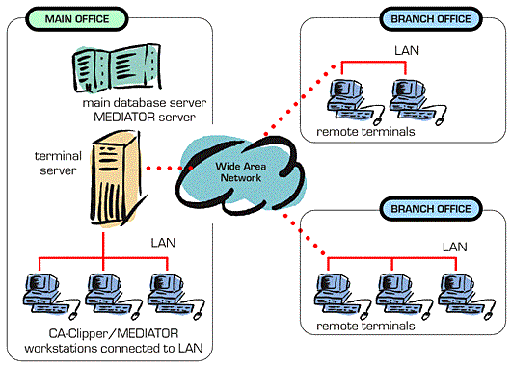
Figure 2-1 Centralized database system

PROBLEM DEFINITION WITH SCOPE OF PROJECT:
A small/medium sized growing company is faced with the problem of integrating its homogeneous/heterogeneous databases as the company grows .They may approach IT companies for integrating their data which may be situated at different locations/computers or in different formats .Most companies would end up moving to one centralized server which may not be efficient/cost effective for companies .Also they may need to integrate their legacy systems with the new database causing a lot of problems for the smooth working of the data.
Many companies may have their databases at different locations and would want to get useful info from them remotely using a single application for mining purposes.
Today any company facing the above problems would have to acquire IT solutions which would be static i.e. tailored for their use and for their situation without generality .This means that if the company grows and again face the same problem at some different location they again have the approach the Technology department [3].
Fragmentation of data is not allowed on homogeneous databases and they do not support heterogeneous query processing. The backend user does not have any control over remote databases nor is he able to manage them remotely .This leads to maintaining multiple database administrators at various location.
The initial setup is done by the technology department hence people at companies would have no knowledge of how to setup the system in case of a crash, failure etc.

PROPOSED SYSTEM
- Designing of a database which is distributed in nature to remove the disadvantages of centralized system.
- Replication of available data on remote servers for greater availability of data.
- Fragmentation of data for greater speed, availability of data .Fragmentation of data depending on the user’s choice i.e. Horizontal, Vertical or Mixed.
- A dynamic system to handle different databases MS access, MS SQL, Oracle and supports various types of scenarios i.e. not tailored for a specific company. A system which can be used either in colleges, universities, companies etc.
- A system that empowers the users to extract information from the databases as the user desires and allows the user to manage the databases remotely.
- A system that maintains data integrity, location transparency, replication transparency, fragmentation transparency.
- A system allows the user to perform heterogeneous query processing with minimal knowledge of sql.
- A system that is dynamic enough to be integrated with any database and with multiple applications, smart enough to perform initialization setup between multiple hostswith minimal knowledge of remote host.
- The system will be designed for back-end users who basically manage databases.

PROJECT MANAGEMENT

5.1 SCHEDULE

5.1.1 TASK NETWORK
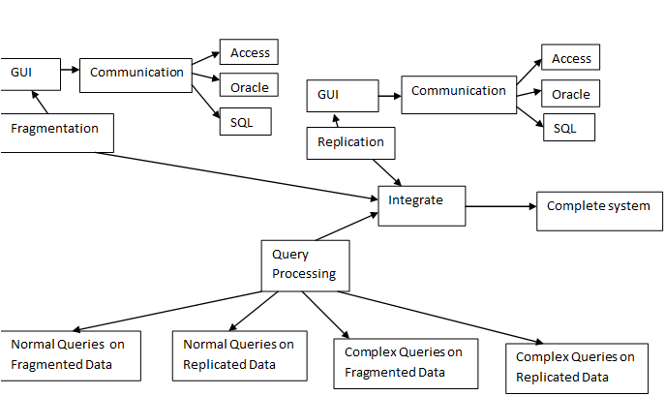
Figure 5-1 Task Network
In figure 5-1 the different task to be performed in the project are shown .Each task is broken down into its sub-task for simplicity of work. Task Network shows three main modules of project which are Fragmentation, Replication and QueryProcessing.

5.2 PROJECT RESORUCES

5.2.1HARDWARE RESOURCES
- CPU
- LAN wires
- Switch

5.2.2 SOFTWARE RESOURCES
- MS ACCESS
- MS SQL
- ORACLE
- JAVA

5.3 ESTIMATION
The different cost estimation techniques used are:-
- COCOMO
- Functional Point analysis
- Earned Value Analysis
Out of the above mentioned cost estimation model, our project used COCOMO for cost estimation.

5.3.1 COCOCMO
The model estimates cost using one of three different development modes: organic, semidetached and embedded. Here is a summary of how Boehm describes the modes:
Organic
In the organic mode, relatively small software teams develop software in a highly familiar, in-house environment. Most people connected with the project have extensive experience in working with related systems within the organization, and have a thorough understanding of how the system under development will contribute to the organizations objectives. Very few organic-mode projects have developed products with more than 50 thousand delivered source instructions (KDSI).
Semidetached
The semidetached mode of software development represents an intermediate stage between the organic and embedded modes. "Intermediate" may mean either of two things:
- An intermediate level of project characteristic.
- A mixture of the organic and embedded mode characteristics.
The size range of a semidetached mode product generally extends up to 300 KDSI.
Embedded
The major distinguishing factor of an embedded-mode software project is a need to operate within tight constraints. The product must operate within (is embedded in) a strongly coupled complex of hardware, software, regulations, and operational procedures, such as an electronic funds transfer system or an air traffic control system.
Because COCOMO is well defined, and because it doesn't rely upon proprietary estimation algorithms, it offers these advantages to its users:
- COCOMO estimates are more objective and repeatable than estimates made by methods relying on proprietary models
- COCOMO can be calibrated to reflect your software development environment, and to produce more accurate estimates

Table 1Cocomo
Inputs
Development
Delivered Source Instructions (thousands) (KDSI)
Development Mode
Average Cost Rate (RS/PM)
Maintenance
KDSI added (annual)
KDSI modified (annual)
Average Cost Rate (RS/PM)

Effort |  | person-months (PM)
Schedule |  | months
Development Cost
Productivity |  | instructions per person-month
Average Staffing |  | full-time-equivalent software personnel
Annual Maintenance Effort |  | person-months
Annual Maintenance Cost

Phase Distribution
 | Effort (PM) | Schedule (mo.) | Staff (avg.) | Cost
Plans and requirements *
Product Design
Programming
Detailed Design
Code and unit test
Integration and test
* The plans and requirements phase is calculated in addition to the nominal COCOMO estimate for effort and schedule.
Activity Distribution (Staff) by Phase
 | Phase
Activity | Plans and Requirements | Product Design | Programming | Integration and Test | Maintenance
Requirements Analysis
Product Design
Programming
Test Planning
Verification and Validation
Project Office
CM/QA
Manuals
TOTAL

PROJECT DESIGN

6.1 SYSTEM ARCHITECTURE

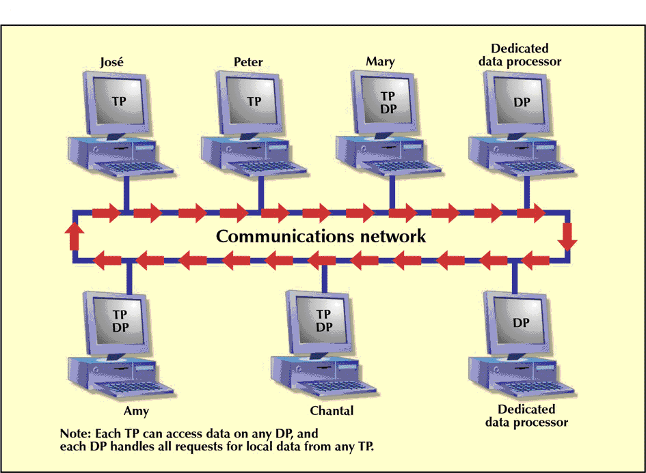
Figure 6-1Peer-to-peer network
Figure 6-1 shows the architecture of the system. The system is peer-to-peer work with every node connected to every another node.

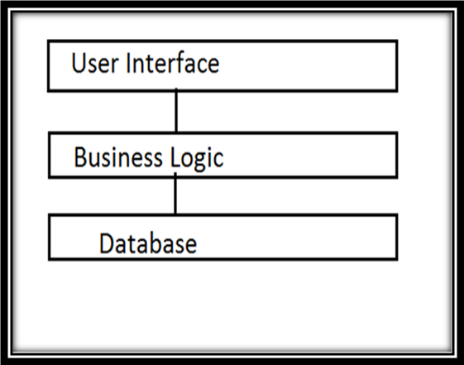
Figure 6-2Architecture Layers
Figure 6-2 shows the architectural layers contained in each node.Each node may contain the database layer or may not contain depending whether the node contains any database’s or not.
Modules
The business logic will contain the logic for
- Fragmentation
- Replication.
- Distributed Query Processing
- Communication
- Query Validation and Database Initialization.
User Interface will have the logic for the look, aesthetic feel of the Application.
Database layer will have different database systems
- Oracle
- Sql and Access
DESCRIPTION
Peer-to-peer architecture (Figure 6-1)waschosen keeping in mind the scalability of the application.It will allow two users to use this system without others requiring this application.Anyone who wishes to join just needs to perform setup on their machines and they will be on the systems network.Peer-to-peer is advantageous in terms of client-server architecture since it doesn’t affect the system even if the server fails. Also since databases could be residing on any computer,and users also could anywhere, the computers behave as servers and clients for different operations of the system [4].

6.2 DESIGN DIAGRAMS

6.2.1 USE CASE DIAGRAM

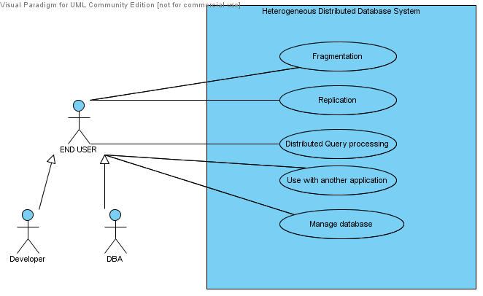
Figure 6-3UseCase Diagram

In the figure 6-3 above actorsareadministrators and developers who will be able to integrate their system with our system. Database administrators are the users who will use the system and will be able to perform functions like fragmentation,replication, manage databases and retrieve data from homogeneous/heterogeneous databases remotely.

6.2.2 CLASS DIAGRAM
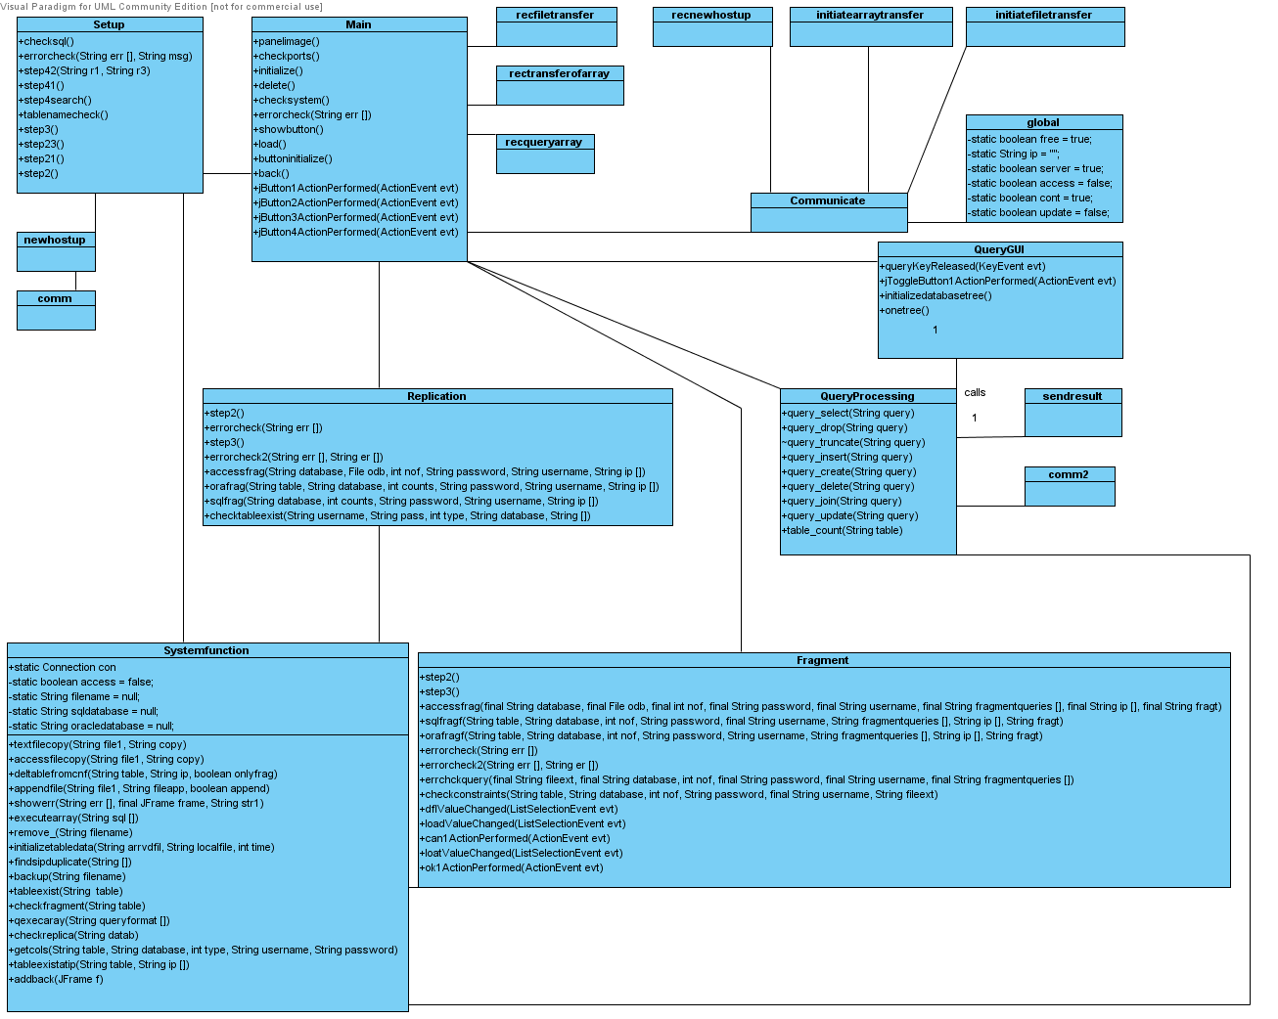
Figure 6-4ClassDiagram

Class diagramrepresents the association between the different classes and threads. The Main class is the class that interacts with all other classes. It is used to call other classes and represents the Mainform of the application.

6.2.3 ACTIVITY DIAGRAM
Figure 6-5Activity Diagram for Fragmentation

Description of Activity for Fragmentation
The activity diagram of fragmentation shows the series of actions that are performed when the user interacts with the system and the response of the system.
Step1: Select the database
Step2: Select the table to be fragmented.
Step3: Select the number of fragments.
Step4: Select the type of fragmentation.
Step5: Enter the IP Address.
Step6: If the database is in sql or oracle then the array of query and database is transferred and executed and if the database is in Access then the database is sent in the form of the file.
Step7: If the success is received, then the configuration file is sent else if the abort message is received then the rollback mechanism is performed.
Figure 6-6Activity Diagram for Replication

Description for Activity for Replication
The Activity diagram 6-5 of replication shows the series of activities performed by the user and the system for the process of replication.

Step1: Select the database
Step2: Select the table to be replicated.
Step3: Select the number of replicas.
Step4: Enter the IP Address.
Step5: If the database is in sql or oracle then the array of query and database is transferred and executed and if the database is in Access then the database is sent in the form of the file.
Step6: If the success is received, then the configuration file is sent else if the abort message is received then the rollback mechanism is performed.

6.2.4 SEQUENCE DIAGRAM
Figure 6-7Sequence Diagram for Fragmentation

The sequence diagram shows the communication between the different nodes of the system during the process of fragmentation.
Initially the database is selected and the table to be fragmented is selected. The number of fragments are entered. The IP addresses are entered. If there is SQL or Oracle database then the array of query is transferred together with the database else the file is sent. If the execution is successful then the configuration file is sent else the rollback mechanism is performed.
Figure 6-8Sequence Diagram for QueryProcessing

Description for Sequence Diagram for QueryProcessing

The sequence diagram shows the communication between the different nodes of the system during the process of query processing of a select query fired by a back-end user.
When the select query is fired, the software checks if the query is correct. If not then the query needs to be reentered. The software checks if the tablename exists locally or not. If yes then the query is executed locally and the result is displayed. If the tablename is located remotely then the query is sent to the remote node. The query is then executed on the remote node and the result to sent in the temp.txt file. Then the result is displayed. If the execution is not successful then the error message is displayed.

6.2.5 COMPONENT DIAGRAM

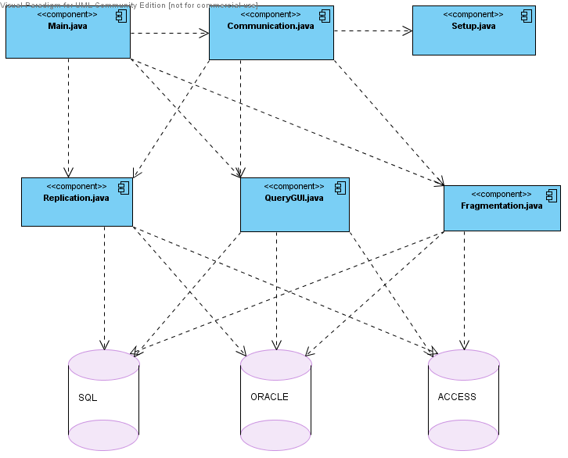
Figure 6-9Component diagram
The component diagram shows the interaction between the components of the system i.e the different files and their access to the different databases of SQL, Oracle and Access.These components are deployed in a jar file on each node and the databases can be situated on the same node or some other node on the network.

6.2.6 DEPLOYENT DIAGRAM

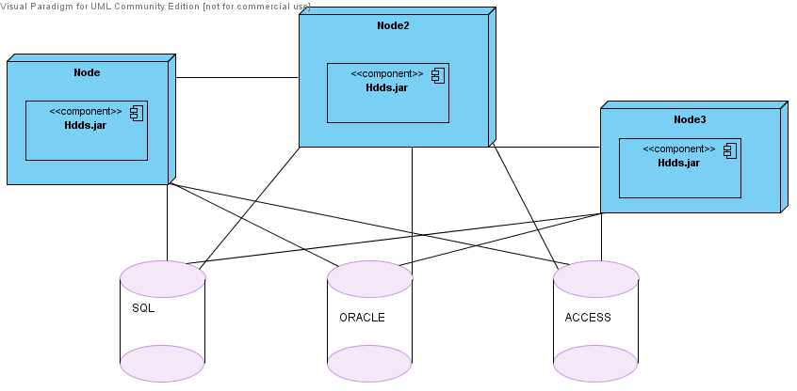
Figure 6-10Deployment Diagram
Deployment diagram shows the interaction among the different nodes in the system. The nodes interact with the databases of SQL, Oracle and Access. Each node has an HDDS.jar component deployed on them that consists of java classes. These java classes implement the logic of the system and also store the configuration files needed by the system.

6.3 INTERFACE DESIGN

6.3.1 USER INTERFACES
Figure 6-11Main Form

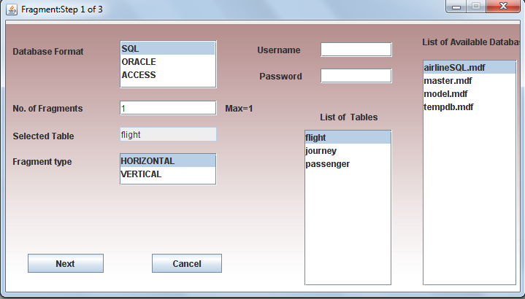
Figure 6-12Fragmentation Form Step 1

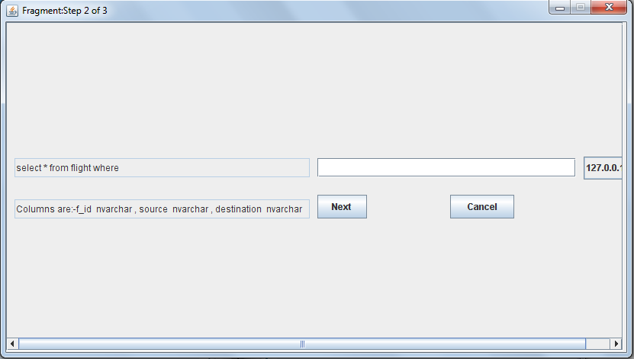
Figure 6-13Fragmentation Form Step 2

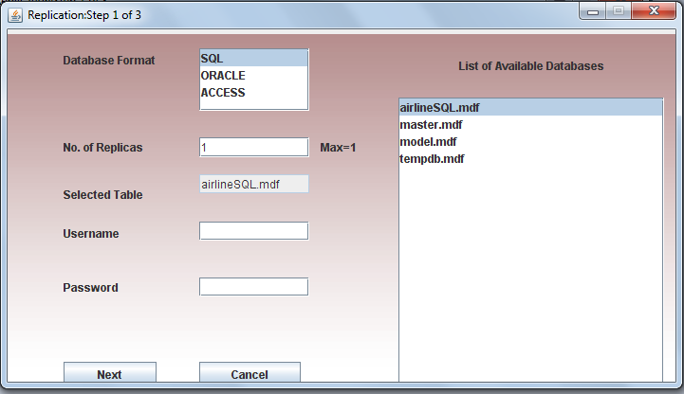
Figure 6-14Replication Form Step 1

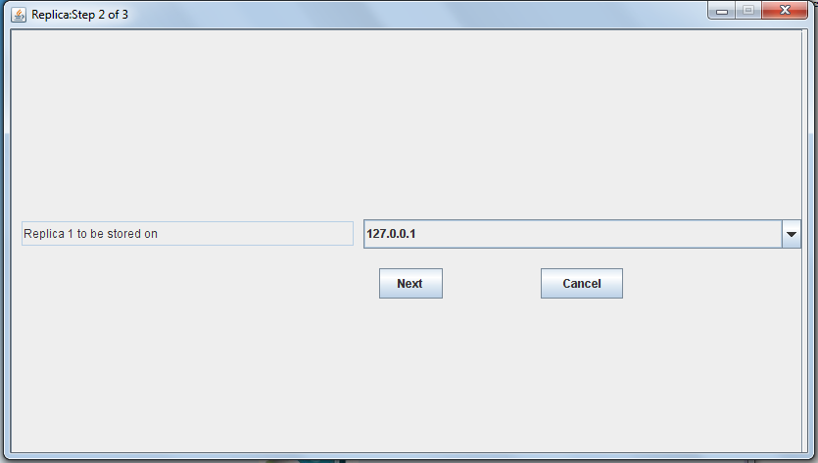
Figure 6-15Replication Form Step 2

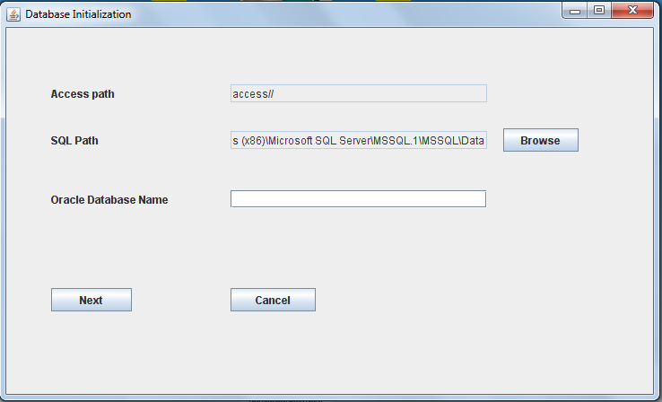
Figure 6-16Setup Form Step 1

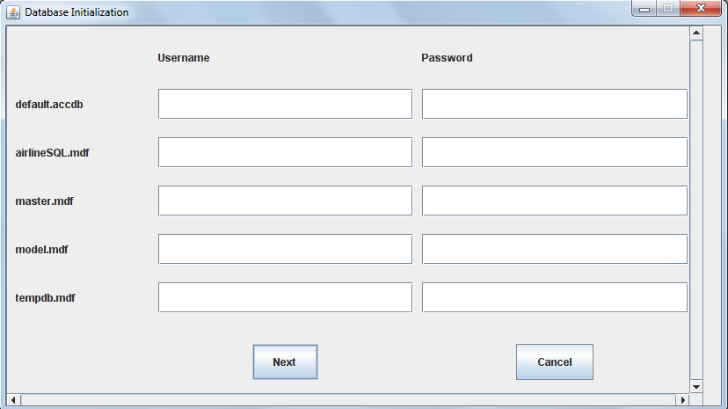
Figure 6-3-1-7 Setup Form Step 2

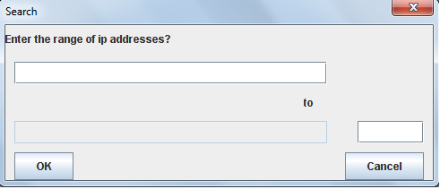
Figure 6-17NodeSearch Setup Form step 3

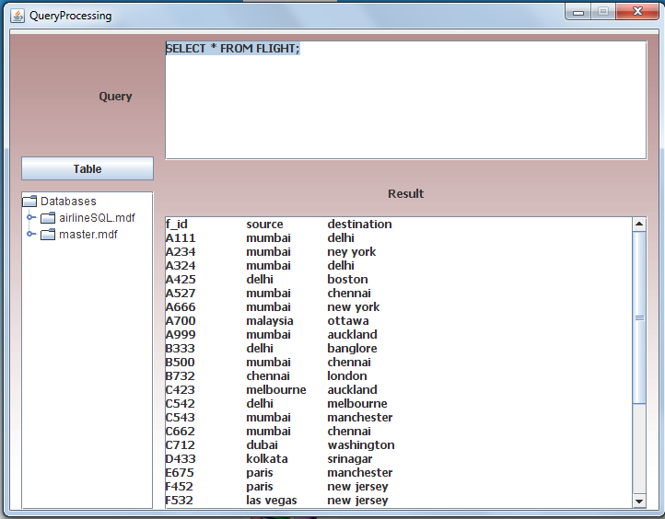
Figure 6-18QueryProcessing Form

6.4 MODULE DESCRIPTION
MAIN MODULE
This module is used to initialize the system .It checks whether all communication ports are available i.e. 5555-5561.It has functions to check whether the system has all configuration files, cleans up temporary files,checks for drivers required. It sets the user directory so that system can perform its operations from anywhere.
Some of the important functions are
- panelimage()
Loads the background image, icon images from the ‘pics’ folder to the main form.
- checkports()
Checks if ports are free to be used
- delete()
Deletes the temporary files.
- Initialize()
Initializes the ports for file transfer,array transfer and server for listening commands from other host

Flow of Class
Checkports() --- initComponets() ---- panelimage() --- initialize() --- delete() ---- showbutton() --- buttoninitialize() --- back().

COMMUNICATION MODULE
It is the most important module of the system since it is used for communicating commands between host and is also used for transferring and receiving of files ,arrays .It has functions to check whether other systems are up and ready on the network .This module has a Communicate class which is the server and is used to call other functions .If the Communicate class cannot be started during starting of application then application will fail to load and will close .All classes are written as thread hence multi-threading concept has been used[5].
Classes
- Communicate
Is bound to port 5555.Used for receiving commands during fragmentation and replication and setupsearch .It basically implements two phase roll-back if any of the above operations fails during a multi-host update/fragment/replicate.
- Initiatefiletransfer
Is bound to port 5556.Used for sending files to other host. It can send access as well as text files .Is used while fragmentation .replication and setupsearch ,update.
- Initiatearraytransfer
Is bound to port 5558.Used for sending arrays while fragmentation/replication to remote host .Used only when table is in sql/oracle format.
- Newhostup
Bound to port 5557.Is used to search which remote host has the system running on them .If it find a remote host it requests that host to send its configuration files .This
Host will receive them, add its own information to those files and then send to all remote host found in iplist.txt file.
- Recnewhostup
Bound to port 5557.Used for sending the configuration files to the host who requested the files.

- rectransferofarray
Bound to port 5558.Used for receiving the array from the remote host.
- Rectransferoffile
Bound to port 5556.Used for receiving the access/text file from the remote host.
- Comm and Comm2
Used for checking the remote host has the system running on it .Difference is that comm2 doesn’t check itself for the system.

QueryGUI Class
It is used to initialize the gui of the query module. It is used for taking inputs from the user in the form of queries. It functions to initialize the database tree and the table tree from the cnffile.txt.
The database tree is initialized by the initializetree() function and shows all the databases and the table on the network.
The table tree is initialized by the onetree() function and shows all the tables and their columns as one database on the network hiding the different databases the tables belong to.
The querykeypressed() function is used to pass the query to the queryprocessing class for processing the result.It converts the query to lower case and displays the result after the query has been executed.

QueryProcessing Module
This class is used for processing the queries inputted by the user. It has functions for different types of queries such as select,delete,truncate,drop,join,update and tablecount.
Functions
- Query_select()
Used for selecting data from different tables on the network. Accepts keywords as loc:,local:,org: just before the tablename.The loc:,local: are used to specify to retrieve data from the local table if it exist else goes to the original table.The org: keyword is used to specify directly go to original table for retrieving data.The result is retrieved and stored in a result.txt file which is then shown to the user.The results are transferred in the form of files so that any developer can integrate our application into their application.
- Query_insert()
Used for inserting data into all instances of the table on the network .It modifies the query as per the columns present at each location of the table and then sends it to all the remote host for processing .It implements the two phase roll back algorithm.
The queries are modified by referring to the cnffile.txt stored in system folder of the application.
- Query_truncate
Used for truncating data from the table. Accepts keyword ‘frag:’ before the tablename to specify to truncate only the fragments of the table and not the original table .If the keyword is not specified truncates the original as well as the fragments of the table.
- Query_drop
Used for dropping tables from the network .Accepts keywords ‘frag:’ to drop only fragments of the table.If the keyword is not specified then drops the original as well as the fragments of the table and updates the cnffile.txt accordingly and sends it to all remote host found in the iplist.txt file
- Query_create
Used for creating new tables on the local host. Accepts keyword ‘oracle:,sql:,access: ‘before the tablename to specify the format of the table being created. Bydefault if no keyword is specified then creates a table in access format. After creation of table the cnffile.txt is updated and is sent to all remote host found in the iplist.txt file.
- Query_delete
Used for deleting row/rows depending on the condition specified .If the table is horizontally fragmented then queries are not modified and are sent to remote host who have the tables. If the table is vertically fragmented then the query is sent to the original table to retrieve the primary keys affected by the query by converting the query to select query .The primary keys affected are retrieved and then appended to the delete query and the delete query is also modified depending on the columns at each location. The result is displayed to the user.
- Query_update
Used for updatingrow/rows depending on the condition specified .If the table is horizontally fragmented then queries are not modified and are sent to remote host who have the tables. If the table is vertically fragmented then the query is sent to the original table to retrieve the primary keys affected by the query by converting the query to select query .The primary keys affected are retrieved and then appended to the update query and the update query is also modified depending on the columns at each location. The result is displayed to the user.
- Query_join
Used for performing homogeneous as well as the heterogeneous joins. If a heterogeneous join is specified then the table with the least no of columns selected is selected for execution .The joining column and other columns from the first table are retrieved and the query is modified to generate multiple queries for each result retrieved .The modified query is sent to the 2nd table and the result is retrieved. Joins are performed by sending the queries to original tables of the two tables. It doesn’t matter if a table has 2 instances of original table or more than two or if the table is fragmented.
- Table_count
Used for counting the instances of the table on the network by referring to the cnffile.txt file.
All the above functions implement two phase roll back mechanism for data integrity.

Recqueryarray Class
Bound to port 5559.Used for receiving queries for query processing from remote host or even itself.This port is initialized during loading of application.

SendResult Class
Bound to port 5561.Used for sending the result of the select query to the host who requested it. The result is sent in the form of a text file to the remote host.

Systemfunction Module
This class has a wide range of functions which are used again and again for variety of purposes. It has functions for
1.File functions-Copy, Appending , deleting
2.Execution of queries.
3.Checking of fragment/replica tables.
4.Backing up of configuration files.
5. Deleting table from cnffile.txt, columns of a table,Initializationof table,adding background image to frames.
Initialization of table is used when a remote host request configuration files. It determines which tables are horizontally, vertically fragmented and which are original.
This class has static variables which are used for two phase roll back mechanism and these variables are used in Communicate in communication module.
Global Class
This class is store static/global variables which are used by the system to indicate it is in which state.It is used to indicate whether the system is free, is a server ,or is the system in between a fragmentation / replication / update process

Setup Class
It is used to initialize the configuration files.The user has to specify which databases his or computer supports and then the system automatically find all the databases and the tables and stores them in the cnffile file.The cnffile file stores information in the following format
**************
Tablename,Database
Username,Password
Fragmentation type,Number of fragments
Column names,Ip address
Table type,No of replicas if table type replica
****************
Table type can be
P-Primary table
R-Replicated table
F-Fragmented table

The setup class also creates aiplist file which stores all the ip’s of the host having the application. Initially it stores only the local computer’s IP address.
The setup file also creates a inf.txt which stores the database supported by the host corresponding to the ip address in the iplist file.

Format of inf.txt file
******
1,2,3
*********
1-SQL
2-Access
3-Oracle

The setup class also creates a info.txt files where the pathnames for sql databases,access databases and oracle database name is stored in the order specified respectively.

SetupSearch
Once the setup for the local host is done, the user is asked if he wishes to find more nodes which has the application.The user is supposed to enter the range of ip addresses and the application performs a search.If a node is found with the application then the newhostup function on the localhost and recnewhostup on remote host is performed concurrently.

Replication Module
Used for replication of databases. The user has to choose the database to be replicated and
Specify the ip’s addresses where he wishes to store the replicated copy.Only those ip’s are shown that support the database to be replicated that is if database sql then nodes having sql are only shown.
The replicated copy is an online copy and a synchronous replicated copy.

Fragmentation Module
Use for fragmentation of tables. The user has to choose the table that he wishes to fragment.
Only nodes supporting the table format are shown. The user is asked to input conditions for each of the fragments that he wishes to make.

The replication and fragmentation module both have 2 phase roll back mechanism and handle all the file transfers of the databases/tables and the configuration files.During these processes the host is the server and is blocked to receive any request from any other nodes.

PROJECT TESTING

7.1 TEST PLAN

- Test Plan identifier : 01
- Introduction: The project will have three levels of testing, Unit, System/Integration and Acceptance. The details for each level are addressed in the approach section and will be further defined in the level specific plans. The estimated time line for this project is very aggressive (six (6) months), as such, any delays in the development process or in the installation and verification of the third party software could have significant effects on the test plan. The acceptance testing is expected to take one (1) month from the date of application delivery from system test and is to be done in parallel with the current application process.
- Approach :
  - Testing levels: UNITTesting will be done by the developer and will be approved by the development team leader. Proof of unit testing (test case list, sample output,data printouts, defect information) must be provided by the programmer to the team leader before unit testing will be accepted and passed on to the test person. All unit test information will also be provided to the test person.
SYSTEM/INTEGRATION Testing will be performed by the test manager and development team leader with assistance from the individual developers as required. No specific test tools are available for this project. Programs will enter into System/Integration test after all critical defects have been corrected. A program may have up to two Major defects as long as they do not impede testing of the program (I.E. there is a work around for the error).
ACCEPTANCE Testing will be performed by the actual end users with the assistance of the test manager and development team leader. The acceptance test will be done in parallel with the existing manual ZIP/FAX process for a period of one month after completion of the System/Integration test process.
3.2 Configuration management/change control:
All changes, enhancements and other modification requests to the system will be handledthrough the published change control procedures. Any modifications to the standard
procedures are identified in the project plan change control section

3.3 Meetings:
The test team will meet once every two weeks to evaluate progress to date and to identify
error trends and problems as early as possible. The test team leader will meet withdevelopment and the project manager once every two weeks as well. These two meetings willbe scheduled on different weeks. Additional meetings can be called as required for emergency situations.

- Test deliverables:
- Acceptance test plan
- System/Integration test plan
- Unit test plans/turnover documentation
- Screen prototypes
- Report mock-ups
- Defect/Incident reports and summaries
- Test logs and turnover reports

- Schedule: Time has been allocated within the project plan for the following testing activities. The specific dates and times for each activity are defined in the project plan time line. The persons required for each process are detailed in the project time line and plan as well. Coordination of the personnel required for each task, test team, development team, management and customer will be handled by the project manager in conjunction with the development and test team leaders.

7.2 TEST CASES

Table 2 Test Case 1
Purpose | To check for Foreign key reference
Unit to test | Fragment, Drop and truncate table
Assumption | Trying to drop or fragment a table which is related to some other table
Steps to be executed | In the query processing window write a query to fragment, truncate or drop a table which is referenced by some other table
Actual result | Shows an error of foreign key integrity

Table 3 Test Case 2
Purpose | To check fragmentation of fragmented table
Unit to Test | Fragmentation
Assumption | Trying to fragment a table which is already fragmented
Steps to be executed | In the fragmentation window select a table which is already fragmented
Actual result | It would display an error showing “table already fragmented”

Table 4 Test Case 3
Purpose | To check for replication of replicated database
Unit to test | Replication
Assumption | Trying to replicate a table which is already replicated
Steps to be executed | In the replication window select a database which is already replicated
Actual result | Shows an error showing “table already replicated”

Table 5 TestCase 4
Purpose | To check for storing a database on node which has a database of the same name
Unit to test | Fragmentation
Assumption | Trying to store a table which is already stored in on the node with the same name
Steps to be executed | In the window to select the node where we want to store the database select a node which contains the table with the same name as the one to be stored
Actual result | Shows an error showing “table with same name exist on the node”

Table 6 Test Case 5
Purpose | To check for deletion of non-existing fragments
Unit to test | Query processing
Assumption | Trying to drop a table which is not fragmented
Steps to be executed | In the query processing window write a query to drop the fragmented tables as drop table frag:<table-name>
Actual result | Shows an error of “table does not exist”

Table 7 Test Case 6
Purpose | To access local table
Unit to test | Query Processing
Assumption | Trying to select the local table and display the result.
Steps to be executed | In the query processing window write a select query to access the local table by Shows an error of foreign key integrityprefixing the table name by “loc:”
Actual result | Displays the content of the local table.

Table 8 Test Case 7
Purpose | To display all the records pertaining to the table name.
Unit to test | Query Processing
Assumption | Trying to display all the content of tables having same table name
Steps to be executed | In the query processing window write a select query to access the content of table.
Actual result | Displays the content of all the tables with same table name.

Table 9Test Case 8
Purpose | To create a table in oracle
Unit to test | Query Processing
Assumption | Trying to create a table in oracle. If no type is mentioned, by default access table is created.
Steps to be executed | In the query processing window write a create query to create a table and prefix “oracle:” before table name.
Actual result | Creates a table in oracle.

Table 10 Test Case 9
Purpose | To perform heterogenous joins
Unit to test | Query Processing
Assumption | Trying to join to table of different database format.
Steps to be executed | In the query processing window write a heterogenous join query.  select a.aid,b.pid from table1 as a,table2 as b where a.aid=b.pid;
Actual result | Displays the content by retrieving the data from two different locations and joining it.

Table 11 TestCase 10
Purpose | To Truncate the data from fragments
Unit to test | Query Processing
Assumption | Trying to truncate the fragment’s data only
Steps to be executed | In the query processing window write a truncate query and mention “frag:” before the table name
Actual result | Truncates the data only from the fragment and not from the original table.

7.3 TYPES OF TESTING

- Unit testing: Testing of individual software components or modules. Typically done by the programmer and not by testers, as it requires detailed knowledge of the internal program design and code may require developing test driver modules or test harnesses.
Different modules are tested:-
- Fragmentation module: Different test cases are designed to test the fragmentation module.
- Replication Module: Different test cases are designed to test the replication module.
- Query Processing: Different test cases are designed to test the Query Processing module.
- Integration testing:Testing of integrated modules to verify combined functionality after integration. Modules are typically code modules, individual applications, client and server applications on a network, etc. This type of testing is especially relevant to client/server and distributed systems.
Different modules are integrated and combined functionality is tested:-
- Firstly, the table is fragmented using fragmentation module and the select query is fired on the fragmented table to test whether the fragment is displayed. Here, the fragmentation module and query processing module is integrated and tested for combined functionality.
- Similarly the replicated and query processing module is integrated and tested for combined functionality.

- End to End Testing:Similar to system testing, involves testing of a complete application environment in a situation that mimics real-world use, such as interacting with a database, using network communications, or interacting with other hardware, applications, or systems if appropriate.
A real time scenario is considered like a banking application that mimics the real world use. The software is tested and the queries are fired similar to the one fired in the banking application. The software is tested on:-
- Its interaction with different databases, which in other words is the heterogenous environment.
- Its performance in network communication, that is during configuration file transfer between nodes on LAN and during transfer of result sets during query processing.
- Its performance in a different computer having no support of database.
- Load testing:It’s a performance testing to check system behavior under load. Testing an application under heavy loads, such as testing of a web site under a range of loads to determine at what point the system’s response time degrades or fails.
Load testing is done on the software to check how the software handles the load:-
- The size of the database is increased and then it is transferred to check how much time the software takes to transfer the tables having huge amount of data.
- The network traffic is increased to check the performance of the software under network load.

MAINTENANCE

8.1 MANUAL

8.1.1 USER MANUAL

  - SetupModule

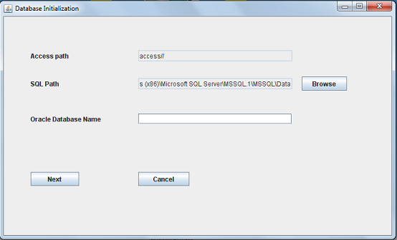
Figure 8-1Setup Form

Steps
- The user who wants to access the database first clicks on the setup icon.
- Then we need to specify the database names of oracle, access and SQL databases respectively.
Figure 8-2Setup Form step 2
- Click next. Then specify the user name and the password for the databases.
- Click next. Search the new nodes in the network. If no other nodes exist click cancel.
Figure 8-3NodeSearch Setup
- Select a range of IP addresses to search for the nodes.
- It would automatically search for nodes in the network.

  - Fragment Module

Figure 8-4Fragment Form

Steps

- Click on the fragmentation icon.
- Select the database of the table to be fragmented. Select the table from the above selected database. Select the number of fragments to be made. Select type of fragmentation as Horizontal or Vertical.
Figure 8-5Fragment Form Step 2
- For horizontal fragmentation select the rows to be selected and the IP addresses of the nodes where the fragments are to be copied.
- For vertical fragmentation write the condition for fragmentation of the table and the IP addresses of the nodes where you want the fragments to be copied.
- The process would be successfully done if all the fragments are copied properly to all the nodes else the process would be rolled back.

  - Replication Module

Figure 8-6Replication Form
Steps

- For replication select on the replication icon.
- Select the database of the table to be replicated. Select the table from the above selected database. Select the number of replicas to be made.
Figure 8-7Replication Form
- Select the IP addresses of the nodes where the replicas are to be copied.
- The process would be successfully done if all the replicas are copied properly to all the nodes else the process would be rolled back.

  - QueryProcessingModule

Figure 8-8Query Form
Steps
- Select the query processing icon on the main form.
- Click on the databases then it would display the list of all the databases in the network. Click on the tables tab to show the list of all the tables in the respective databases.
- Write the queries which are to be executed.
- The result would be displayed or an error would be shown.

8.1.2 TECHNICAL MANUAL

Any developer who wishes to integrate this application can access by importing the queryprocesing class into their product. They may need to import the setup module depending on whether they are providing their configuration files or using the applications. They may use the setup module to generate the configuration files.

8.2 CONSTRAINTS FOR USE OF PRODUCT
- Host must be having latest version of java virtual machine.
- If using access then Microsoft access 2007 or above.
- Databases must be either in sql,oracle or access format.
- IP addresses of the host on the network shouldn’t change.If it changes then setup has to be performed on all hosts.
- Tables cannot have user defined types, clobs, blobs.
- Oracle tables are taken from scott schema hence account must be unlocked.
- User must have basic knowledge of SQL.

CONCLUSION

This software overcomes most of the drawbacks of the existing system i.e. Centralized Database system. The problems with the Centralized System are:-
- A centralized data server can become a bottleneck as a large user community contends for data server access.
- Data is unavailable when a failure occurs on the network
- As the data is located at a single location, loss of data in that place would result in permanent loss of data. Also the central server can become a bottle-neck and it may not be able to handle excessive load. Also data duplication can be a major problem.
The software provides access to the remote database. It can perform query optimization on any type of database. This software can be used for heterogeneous environment. It provides various advantages over Centralized System:-
- A big advantage of distributed DBMSs over centralized ones is that of scalability. Growth can be sustained more gracefully in a distributed system.
- Heterogeneous databases such as sql,oracle and access can be managed simultaneously.
- Greater Availability of data through replication.
- Integrated Database feel.
- Lesser storage space at site.
- Crash Recovery easy with no extra storage or backup.
- Fragmentation and Replication for databases as per user’s needs.
- Two phase roll back for data Integrity
Thus the system allows backend users to manage, integrate databases on the network. It helps companies to use the system as per their needs without requiring the need of an IT professional for deployment.

FUTURESCOPE

- Authorization of Users: The current version of software is not secure enough to be used in a professional environment where security is a prime concern. So with authorization of users and assigning different rights to each user proper security can be assigned to the working environment.
- Support of additional database formats such as DB2, MYSQL: With new databases being used these days, support of databases like DB2 and MYSQL would help integration with a large number of databases with data in different formats.
- Encryption of result over the LAN: Taking the security measures a bit ahead the result of the queries and could be encrypted while being sent to the destined user. This would avoid tampering of the data while it is being transmitted. Also encryption of data using password and usernames can be used.
- Support for user defined attributes in tables.
- Support for Clobs and Blobs: Character large object, a collection of character data in a database management system. A blob known as a binary large object, basic large objectis a collection of binary data stored as a single entity in a database management system. Support for clob and blobwould allow more flexibility with data to be stored in the databases.
- Automatic query generation would reduce human interaction and would generate queries automatically. Thus the administrator need not be expert with sql queries and would reduce its work load as well as make the software more user-friendly and efficient.

REFERENCES

[1] H. GARCIA-MOLINA AND B. LINDSAY.“Research Directions for Distributed Databases,” IEEE Q. Bull. Database Eng., Vol. 13, No. 4, December 1990, pp. 12–17
[2] M.T. ÖZSU AND P. VALDURIEZ.Principles of Distributed Database Systems.Englewood Cliffs, NJ: Prentice-Hall
[3] A.K. ELMAGARMID AND C. PU (eds). ACM Comp. Surv. Special Issue on Heterogeneous Databases, Vol. 22, No. 3, September 2008
[4] C. FREYTAG. “A Rule-based View of Query Optimization,” In Proc. ACM SIGMOD Int. Conf. on Management of Data, San Francisco, 2008, pp. 173– 180.
[5].CZEJDO, B., RUSINKIEWICZ, M., AND EMBLEY, D. 1987. An approach to schema integration and query formulation in federated database systems. In Proceedings of the 3rd International Conference on Data Engineering (Feb.), pp. 477-484.

