Week 3 Report
This week we learnt about the ensembling algorithms, Random Forest, AdaBoost and XGBoost.
Ensembling: Instead of relying on one model, we combine multiple models to make a better prediction.
- Bagging [ Bootstrap aggregating ] : Final prediction is the majority prediction by number of decision trees (50,100,etc)
- Boosting: Every new model learns from its mistakes, hence the trees are independent.
RANDOM FOREST:
Decision Trees works great with the data used to create them, but they are not very useful when it comes to classifying new samples. Hence, we use Random Forest.
Bootstrapped dataset:
Allowed to select the same data more than once.
Typically 1/3 of the data doesn’t come in the bootstrapped dataset (Out of the bag dataset)
oob_score=True: Uses out-of-the-bag samples to estimate model performance
ADABOOST:
AdaBoost uses multiple stumps(one node two leaves)
Stumps are technically weak learners, we combine multiple “week learners” to make an accurate prediction.
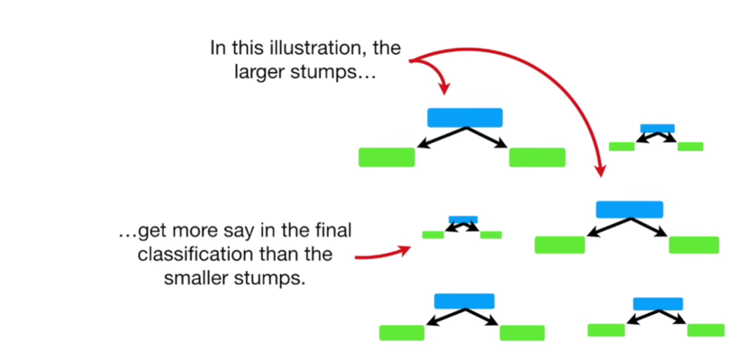
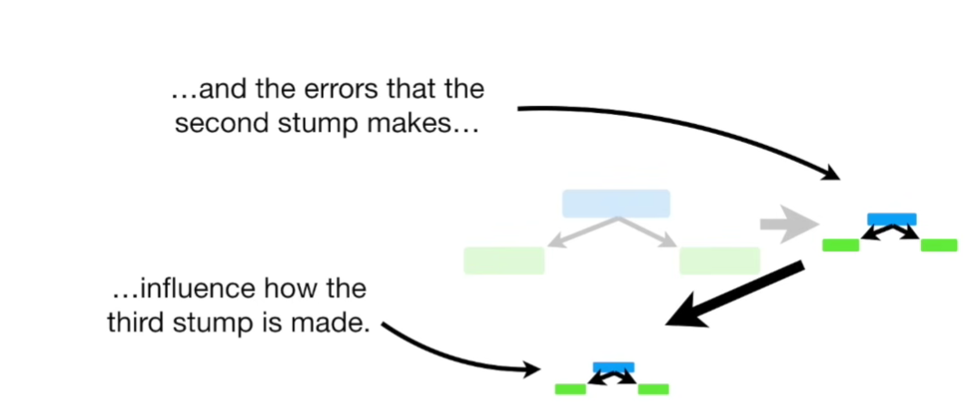
(BOOSTING)
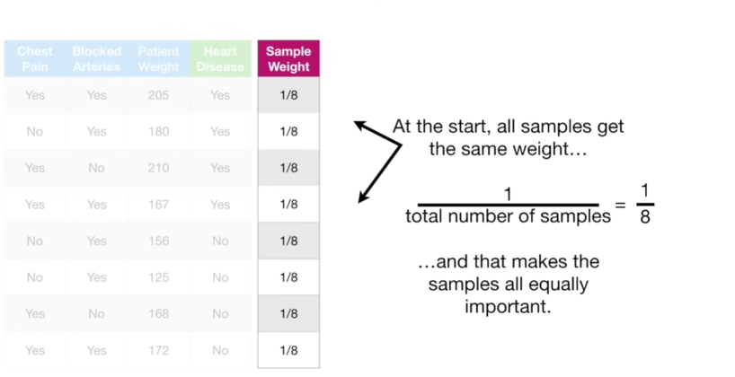

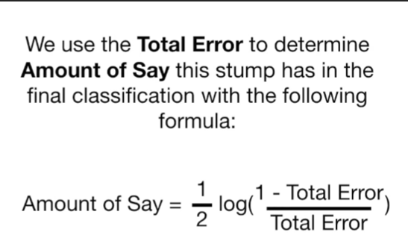
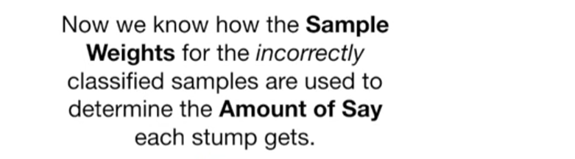
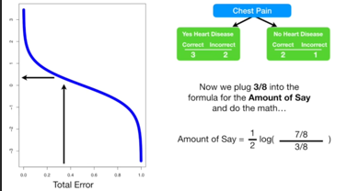
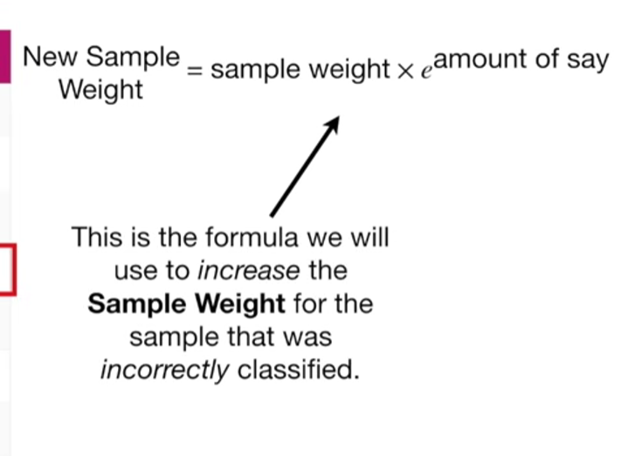
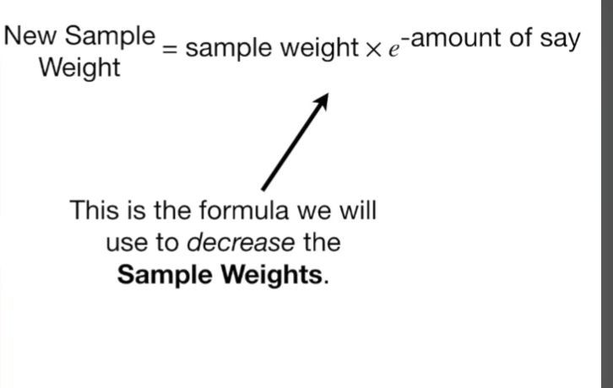
- Learning Rate (learning_rate): Controls how much each new tree contributes to improving the model. A smaller learning rate learns more slowly but often gives better accuracy (usually with more trees).
- Max Depth (max_depth): Specifies the maximum depth of each decision tree. Larger values make trees more complex and can improve learning, but they also increase the risk of overfitting.
XGBOOST
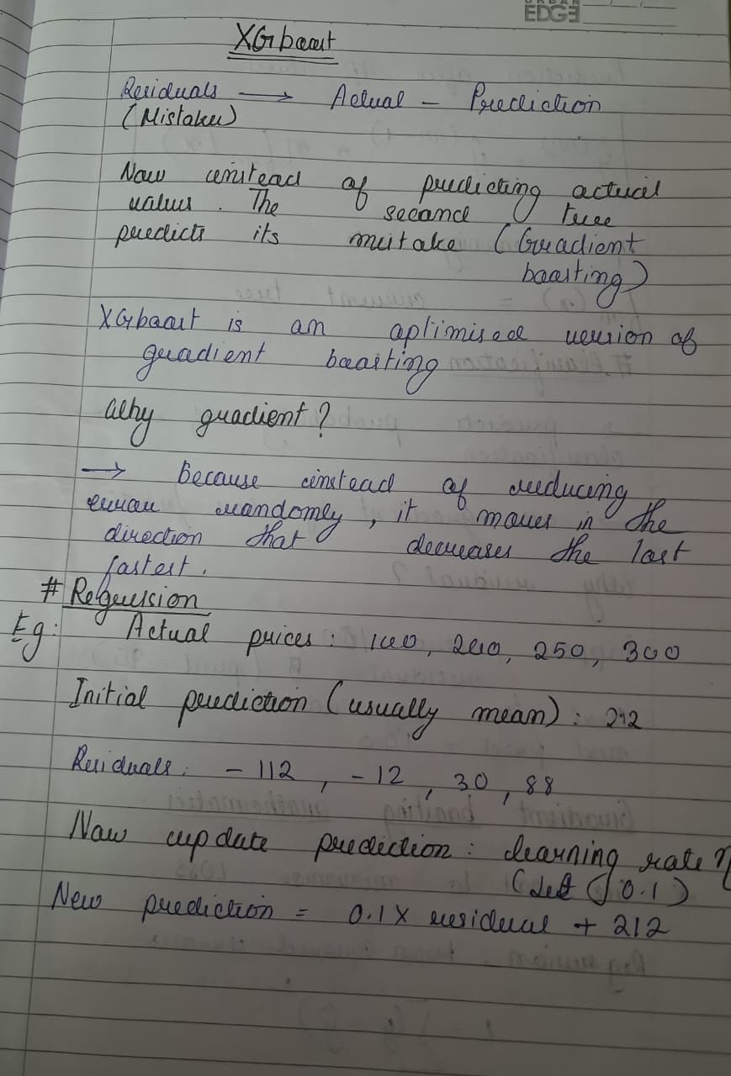
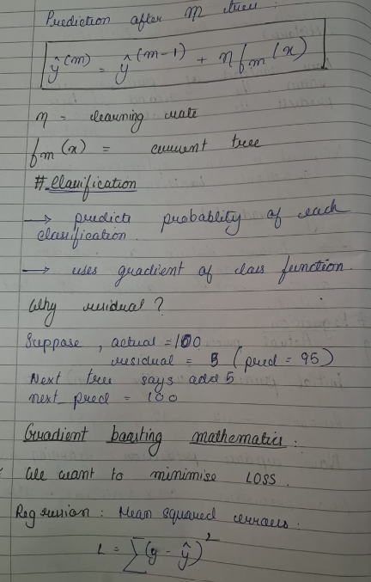
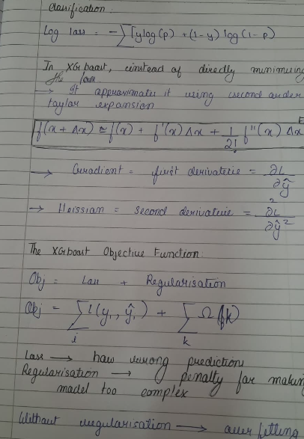
Mean Absolute Error: Average error, Lower is better.
Mean Squared error: Squares the error, Lower is better
Root Mean Square error: Square root of MSE, Lower is better.

