**JAVA PROGRAMMING**

**20 DEC 2018**

**NAME: Meghna Lohani**

**REG NO: 16BCE1395**

**Problem**

**Write a Java program that computes sum and average of values stored in an array of type int.**

**Code**

package javaarrays;

import java.util.Scanner;

public class JavaArrays {

public static void main(String[] args) {

// TODO code application logic here

Scanner sc=new Scanner(System.in);

System.out.print("Enter number of elements in an array : ");

int n=sc.nextInt();

int i,s=0;

int a[]=new int[n];

for(i=0;i<n;i++)

{System.out.print("Enter number : ");

a[i]=sc.nextInt();

s=s+a[i];

}

System.out.println("Sum = "+s);

System.out.println("Average = "+(s/n));

}

}

**Output**

run:

Enter number of elements in an array : 10

Enter number : 3

Enter number : 4

Enter number : 7

Enter number : 3

Enter number : 8

Enter number : 10

Enter number : 12

Enter number : 11

Enter number : 8

Enter number : 9

Sum = 75

Average = 7

BUILD SUCCESSFUL (total time: 16 seconds)

**Screenshot**

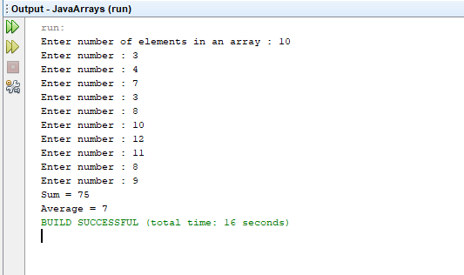

**Problem**

**Write a Java program to sort a numeric array and a string array.**

**Code**

package javaarrays;

import java.util.Scanner;

import java.util.Arrays;

public class Sort {

public static void main(String[] args)

{Scanner sc=new Scanner(System.in);

System.out.print("Enter the size of numeric array : ");

int n1=sc.nextInt();

int i;

int a1[]=new int[n1];

for(i=0;i<n1;i++)

{System.out.print("Enter number : ");

a1[i]=sc.nextInt();

}

System.out.print("Enter the size of string array : ");

int n2=sc.nextInt();

String a2[]=new String[n2];

for(i=0;i<n2;i++)

{System.out.print("Enter string : ");

a2[i]=sc.next();

}

System.out.println("-----NUMERIC ARRAY------");

System.out.println("Unsorted Array : ");

for(i=0;i<n1;i++)

System.out.print(a1[i]+" ");

System.out.println();

Arrays.sort(a1);

System.out.println("Sorted Array : ");

for(i=0;i<n1;i++)

System.out.print(a1[i]+" ");

System.out.println();

System.out.println("-----STRING ARRAY-----");

System.out.println("Unsorted Array : ");

for(i=0;i<n2;i++)

System.out.print(a2[i]+" ");

System.out.println();

Arrays.sort(a2);

System.out.println("Sorted Array : ");

for(i=0;i<n2;i++)

System.out.print(a2[i]+" ");

System.out.println();

}

}

Output  
run:

Enter the size of numeric array : 5

Enter number : 12

Enter number : 11

Enter number : 56

Enter number : 34

Enter number : 98

Enter the size of string array : 5

Enter string : Apple

Enter string : Coffee

Enter string : Bat

Enter string : Dog

Enter string : Physics

-----NUMERIC ARRAY------

Unsorted Array :

12 11 56 34 98

Sorted Array :

11 12 34 56 98

-----STRING ARRAY-----

Unsorted Array :

Apple Coffee Bat Dog Physics

Sorted Array :

Apple Bat Coffee Dog Physics

BUILD SUCCESSFUL (total time: 27 seconds)

**Screenshot**

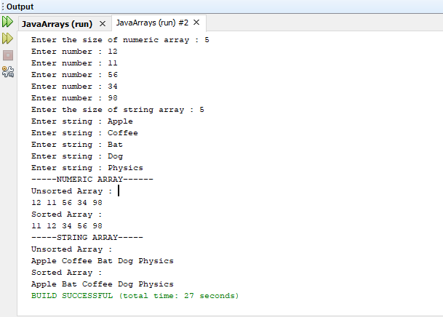

**Problem**

**Write a Java program to remove a specific element from an array.**

**Code**

package javaarrays;

import java.util.Scanner;

import java.util.Arrays;

public class Remove {

public static void main(String[] args)

{Scanner sc=new Scanner(System.in);

System.out.print("Enter the size of the array : ");

int n=sc.nextInt();

int a[]=new int[n];

int i,pos=-1;

for(i=0;i<n;i++)

{System.out.print("Enter number : ");

a[i]=sc.nextInt();}

System.out.print("Enter number to be deleted : ");

int d=sc.nextInt();

for(i=0;i<n;i++)

{if(a[i]==d)

{ pos=i;

break;}

}

if(pos==-1)

System.out.println("Number not present in the array ");

else

{for(i=pos;i<n-1;i++)

a[i]=a[i+1];

}

System.out.println("Array after deletion : ");

for(i=0;i<n-1;i++)

System.out.print(a[i]+" ");

}

}

**Output**

run:

Enter the size of the array : 10

Enter number : 4

Enter number : 2

Enter number : 8

Enter number : 10

Enter number : 11

Enter number : 45

Enter number : 23

Enter number : 55

Enter number : 12

Enter number : 34

Enter number to be deleted : 8

Array after deletion :

4 2 10 11 45 23 55 12 34 BUILD SUCCESSFUL (total time: 19 seconds)

run:

Enter the size of the array : 10

Enter number : 3

Enter number : 4

Enter number : 2

Enter number : 6

Enter number : 7

Enter number : 1

Enter number : 12

Enter number : 34

Enter number : 33

Enter number : 2

Enter number to be deleted : 5

Number not present in the array

BUILD SUCCESSFUL (total time: 15 seconds)

**Screenshot**

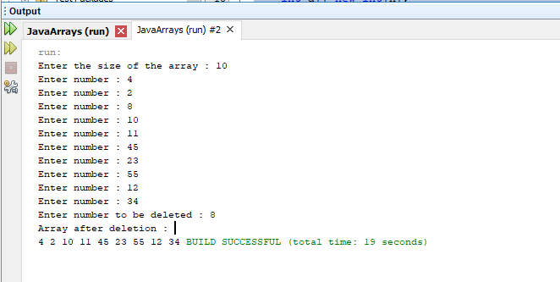

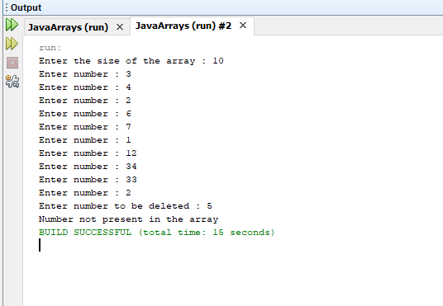

**Problem**

**Write a Java program to create array with i’th row has i columns, i.e., first row has 1 element, second row has two elements and so on.**

**0**

**1 2**

**3 4 5**

**6 7 8 9**

**10 11 12 13 14**

**Code**

package javaarrays;

import java.util.Scanner;

public class Pattern {

public static void main(String[] args)

{

Scanner sc=new Scanner(System.in);

System.out.print("Enter the value of i : ");

int n=sc.nextInt();

int c=0,i,j;

int a[][]=new int[n][n];

for(i=0;i<n;i++)

{for(j=0;j<=i;j++)

{a[i][j]=c++;

}}

for(i=0;i<n;i++)

{for(j=0;j<=i;j++)

{System.out.print(a[i][j]+" ");

}

System.out.println();}

}

}

**Output**

run:

Enter the value of i : 5

0

1 2

3 4 5

6 7 8 9

10 11 12 13 14

BUILD SUCCESSFUL (total time: 3 seconds)

**Screenshot**

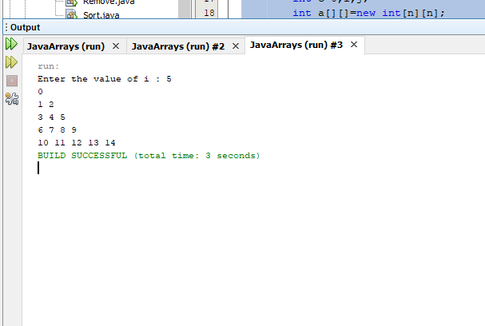

**Problem**

* **If there are 4 batches in BTech(IT) learning ‘ITE2005’ course, read the count of the students who have scored <25, in each batch.**
* **Tutors should be assigned in the ratio of 1:4**
* **For every 4 students who have scored <25, there should be one tutor.**
* **Determine the number of tutors for each batch.**
* **Create a 2-D jagged array with 4 rows to store the count of slow learners in the 4 batches.**
* **The number of columns in each row should be equal to the number of groups formed for that particular batch**
* **Eg., If there are 23 slow learners in a batch, then there should be 6 tutors and in the jagged array, the corresponding row should store 4, 4, 4, 4, 4,3.**
* **Use for-each loop to traverse the array and print the details. Also print the number of batches in which all tutors have exactly 4 students.**

**Code**

package javaarrays;

import java.util.Scanner;

public class JaggedArray {

public static void main(String[] args)

{ Scanner sc=new Scanner(System.in);

int a[][]=new int[4][];

int i,j,s,t,b=0;

for(i=0;i<4;i++)

{System.out.print("Enter the number of slow learners in Batch "+i+" ");

s=sc.nextInt();

int n2=s/4;

if(s%4!=0)

n2++;

a[i]=new int[n2];

j=0;

while(s>4)

{

a[i][j]=4;

s=s-4;

j++;

}

if(s!=0)

a[i][j]=s;

}

for(i=0;i<4;i++)

{System.out.println("Batch "+(i+1));

System.out.println("Number of tutors "+(a[i].length));

for(j=0;j<a[i].length;j++)

{System.out.print(a[i][j]+" ");

if(a[i][j]==4)

b++;

}

System.out.println();

}

System.out.println("Number of batches with exactly 4 tutors "+b);

}

}

**Output**

run:

Enter the number of slow learners in Batch 0 23

Enter the number of slow learners in Batch 1 24

Enter the number of slow learners in Batch 2 21

Enter the number of slow learners in Batch 3 30

Batch 1

Number of tutors 6

4 4 4 4 4 3

Batch 2

Number of tutors 6

4 4 4 4 4 4

Batch 3

Number of tutors 6

4 4 4 4 4 1

Batch 4

Number of tutors 8

4 4 4 4 4 4 4 2

Number of batches with exactly 4 tutors 23

BUILD SUCCESSFUL (total time: 9 seconds)

**Screenshot**

