**JAVA PROGRAMMING**

**10 JAN 2019**

**NAME: Meghna Lohani**

**REG NO: 16BCE1395**

**Problem**

**Write a Java program using all the String Manipulation functions**

**Code**

package stringhandling;

import java.util.Scanner;

public class AllFunctions {

public static void main(String[] args)

{

Scanner sc=new Scanner(System.in);

System.out.println("Enter a string");

String s=sc.next();

if(s.isEmpty())

System.out.println("String is empty");

else

System.out.println("String is not empty");

System.out.println("Trimmed string : "+s.trim());

System.out.println("Length of the string : "+s.length());

System.out.println("Converting the string to char array : ");

System.out.println(s.toCharArray());

System.out.println("String in lowercase : "+s.toLowerCase());

System.out.println("String in uppercase : "+s.toUpperCase());

System.out.print("Enter a string for comparison : ");

String s2=sc.next();

int c=s.compareTo(s2);

if(c>1)

System.out.println("s1>s2");

else if (c==0)

System.out.println("s1=s2");

else

System.out.println("s1<s2");

System.out.println("Are s1 and s2 equal? "+s.equals(s2));

System.out.println("Are s1 and s2 equal ignoring case? "+s.equalsIgnoreCase(s2));

System.out.print("Enter a string for concatenation : ");

String s3=sc.next();

System.out.println("Concatenation : "+s.concat(s3));

int n=12;

String ns=String.valueOf(n);

System.out.println("Converted integer to string : "+ns);

System.out.print("Enter a character to be replaced in the string : ");

String c1=sc.next();

System.out.print("Enter a character to replace in the string : ");

String c2=sc.next();

String replaceString=s.replace(c1, c2);

System.out.println("String after replacement: "+replaceString);

System.out.print("Enter a sequence of characters to be searched in the string : ");

String seq=sc.next();

System.out.println(s.contains(seq));

System.out.println("Does the input string ends with \"ily\" ?"+s.endsWith("ily"));

}

}

**Output**

run:

Enter a string

Happily

String is not empty

Trimmed string : Happily

Length of the string : 7

Converting the string to char array :

Happily

String in lowercase : happily

String in uppercase : HAPPILY

Enter a string for comparison : happy

s1<s2

Are s1 and s2 equal? false

Are s1 and s2 equal ignoring case? false

Enter a string for concatenation : ok

Concatenation : Happilyok

Converted integer to string : 12

Enter a character to be replaced in the string : p

Enter a character to replace in the string : f

String after replacement: Haffily

Enter a sequence of characters to be searched in the string : ape

false

Does the input string ends with "ily" ?true

BUILD SUCCESSFUL (total time: 55 seconds)

**Screenshot**

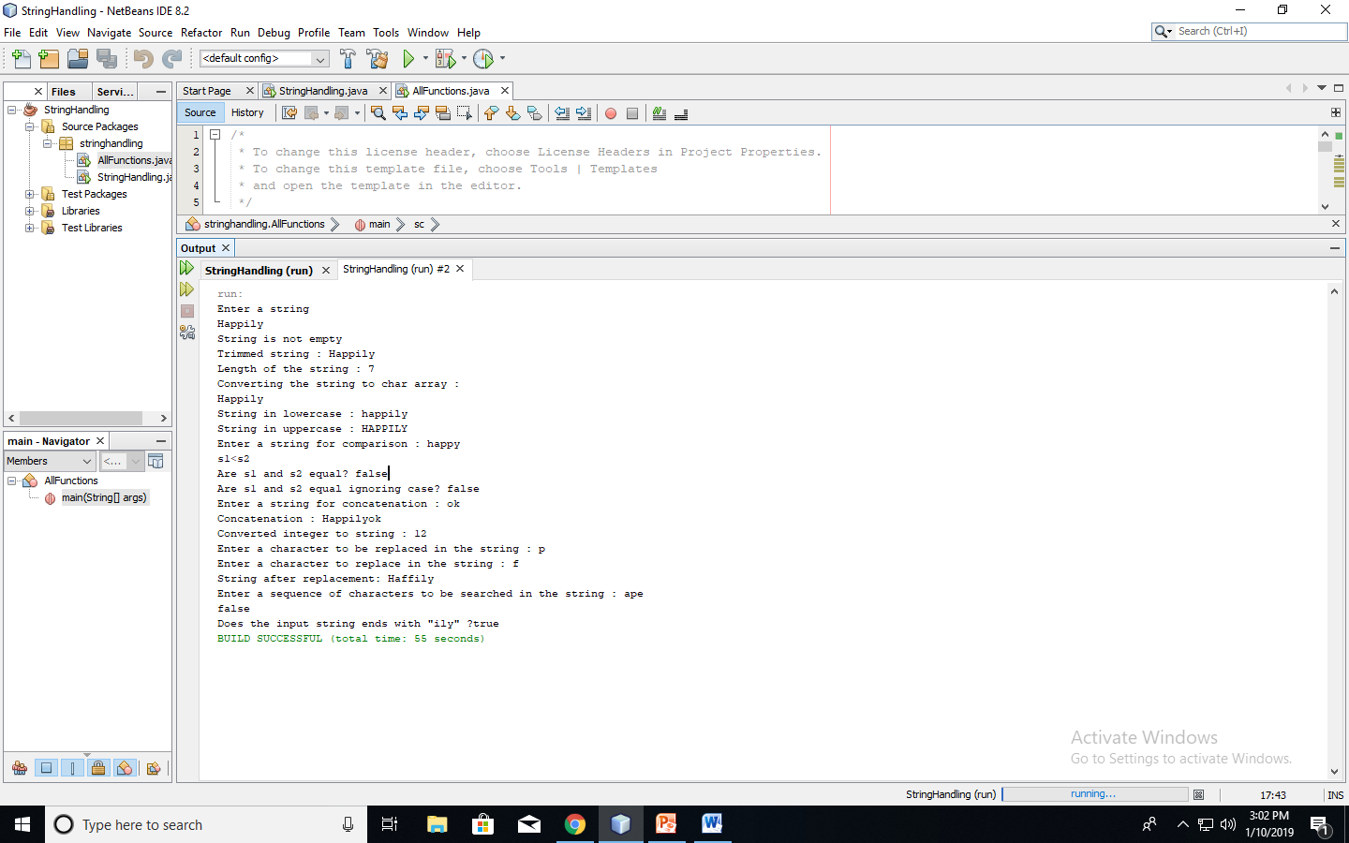

**Problem**

* **Write a program to read a chemical equation and find out the count of the reactants and the products. Also display the count of the number of molecules of each reactant and product.**
* **Eg., For the equation,**

**2NaOH + H2SO4 -> Na2SO4+ 2H2O,**

**the O/P should be as follows.**

**Reactants are 2 moles of NaOH, 1 mole of H2SO4.**

**Products are 1 mole of Na2SO4 and 2 moles of H2O**

**Code**

/*

* To change this license header, choose License Headers in Project Properties.

* To change this template file, choose Tools | Templates

* and open the template in the editor.

*/

package stringhandling;

import java.util.Scanner;

public class StringHandling {

String S;

StringHandling(String s)

{

S=s;}

public static void main(String[] args) {

// TODO code application logic here

Scanner sc=new Scanner(System.in);

System.out.println("Enter a chemical equation");

String e=sc.nextLine();

e=e.trim();

String E=e;

StringHandling obj=new StringHandling(E);

obj.removeSpaces();

obj.display();

obj.balance();

obj.display();

obj.findReactants();

obj.findProducts();

}

void removeSpaces()

{

String news="";

int i;

for(i=0;i<S.length();i++)

{if(S.charAt(i)==' ')

news=news+"";

else

news=news+S.charAt(i);

}

S=news;

}

void balance()

{String news2="";

int i;char ch;

for(i=0;i<S.length();i++)

{ch=S.charAt(i);

if(ch=='+')

{char cx=S.charAt(i+1);

if (!Character.isDigit(cx))

news2=news2+ch+"1";

}

else

news2=news2+ch;

}

S=news2;

}

void display()

{System.out.println(S);}

void findReactants()

{ boolean flag=true;

int pos=S.indexOf('-');

int spos=0;

String r="+"+S.substring(0,pos)+"+";

System.out.println(r);

int i;char ch;

while(flag)

{

int p1=r.indexOf("+",spos);

System.out.println(p1);

int j=p1;

ch=r.charAt(j+1);

if(!Character.isDigit(ch))

while(Character.isDigit(ch))

{ j=j+1;

ch=r.charAt(j);

}

int pref=Integer.parseInt(r.substring(p1+1,j+1));

System.out.println(pref);

int p2=j+1;

int p3=r.indexOf("+",j);

if(p3==r.length()-1)

break;

String reac=r.substring(p2,p3);

System.out.println(reac);

System.out.println(pref+" moles of "+reac+" required");

spos=p3;

if(spos==r.length()-1 || j==r.length()-1)

flag=false;

}

}

void findProducts()

{boolean flag=true;

int pos=S.indexOf('-');

int spos=0;

String pr="+"+S.substring(pos+1,S.length())+"+";

System.out.println(pr);

int i;char ch;

while(flag)

{

int p1=pr.indexOf("+",spos);

System.out.println(p1);

int j=p1;

ch=pr.charAt(j+1);

if(!Character.isDigit(ch))

while(Character.isDigit(ch))

{ j=j+1;

ch=pr.charAt(j);

}

int pref=Integer.parseInt(r.substring(p1+1,j+1));

System.out.println(pref);

int p2=j+1;

int p3=pr.indexOf("+",j);

if(p3==pr.length()-1)

break;

String reac=pr.substring(p2,p3);

System.out.println(reac);

System.out.println(pref+" moles of "+reac+" required");

spos=p3;

if(spos==pr.length()-1 || j==pr.length()-1)

flag=false;

}

}

**Output**

run:

Enter a chemical equation

2NaoH + H2So4 -> 2Na2So4 + 2H2o

Reactants:

2 moles of NaoH required

1 mole of H2So4 required

Produts:

2 moles of Na2So4 required

2 moles of H2o required

Reactants : 3 moles

Products : 4 moles

BUILD SUCCESSFUL (total time: 39 seconds)

**Screenshot**

