**JAVA PROGRAMMING**

**6 DEC 2018**

**NAME: Meghna Lohani**

**REG NO: 16BCE1395**

**Problem**

**Write a simple Java program to print a String.**

**Code**

package javaapplication1;

public class JavaApplication1 {

public static void main(String[] args) {

// TODO code application logic here

System.out.println("This is a simple Java program by Meghna Lohani 16BCE1395");

}

}

**Output**

run:

This is a simple Java program by Meghna Lohani 16BCE1395

BUILD SUCCESSFUL (total time: 0 seconds)

**Screenshot**

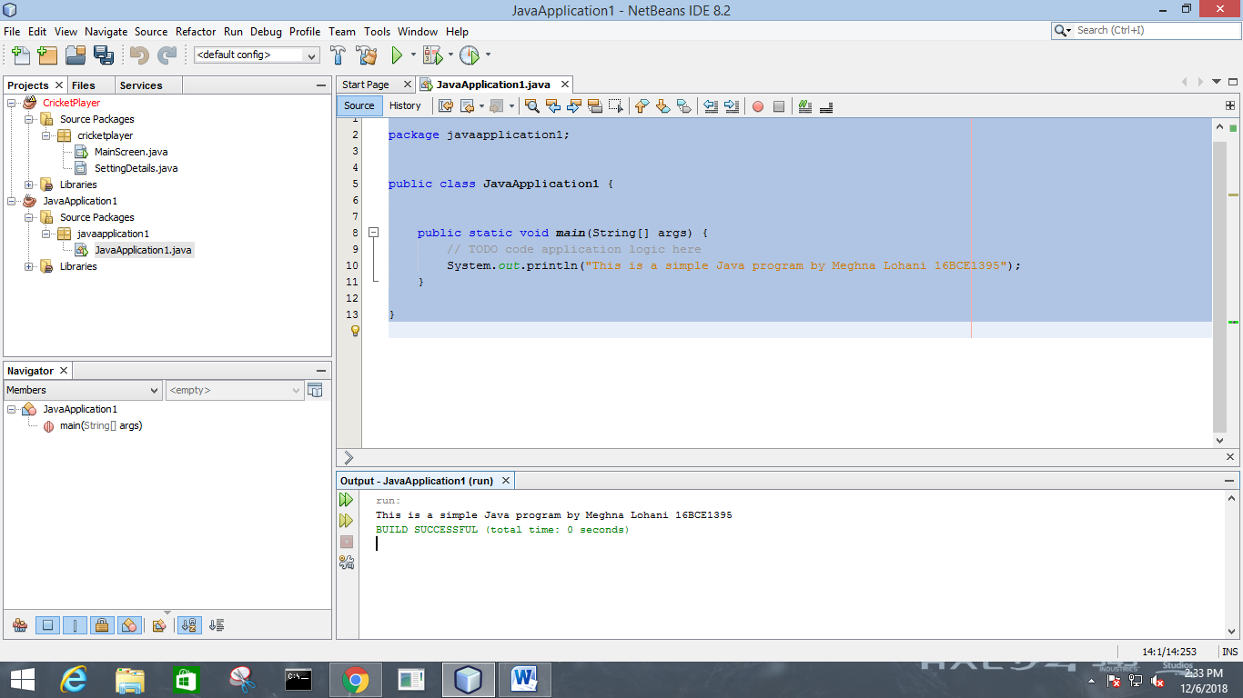

**Problem**

**Write a program to find sum of three numbers.**

**Code**

package javaapplication1;

public class JavaApplication1 {

public static void main(String[] args) {

int m=Integer.parseInt(args[0]);

int n=Integer.parseInt(args[1]);

int q=Integer.parseInt(args[2]);

System.out.println("Sum of three numbers is "+(m+n+q)+'\n');

System.out.println("Submited by Meghna Lohani");

}

}

**Output**  
run:

Sum of three numbers is 3

Submited by Meghna Lohani

BUILD SUCCESSFUL (total time: 0 seconds)

**Screenshot**

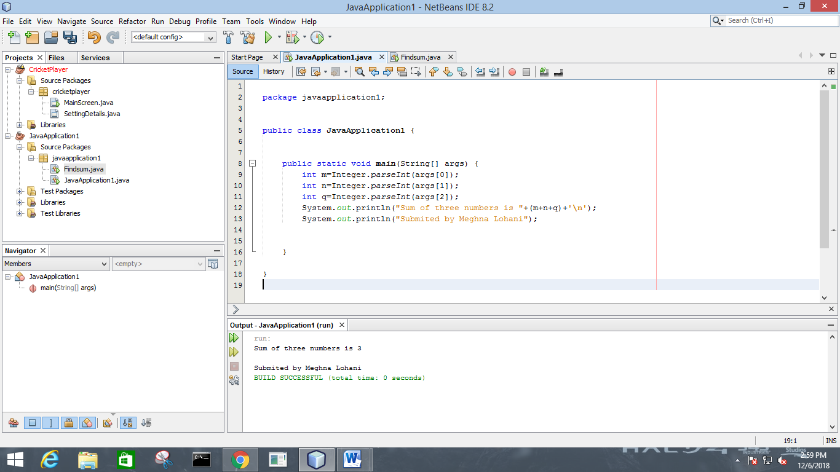

**Problem**

**Write a program to implement addition, subtraction, multiplication and division on two input numbers.**

**Code**

package javaapplication1;

import java.util.Scanner;

public class JavaApplication1 {

public static void main(String[] args) {

Scanner sc=new Scanner(System.in);

System.out.println("Enter the two numbers\n");

int a=sc.nextInt();

int b=sc.nextInt();

System.out.println("Adition "+(a+b));

System.out.println("Subtraction "+(a-b));

System.out.println("Multiplication "+(a*b));

System.out.println("Division "+(a/b));

}

}

**Output**

Enter the two numbers

10

5

Adition 15

Subtraction 5

Multiplication 50

Division 2

BUILD SUCCESSFUL (total time: 4 seconds)

**Screenshot**

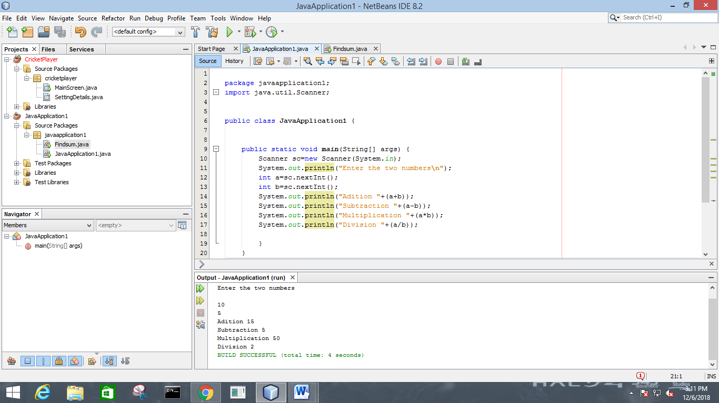

**Problem**

**To find the factorial of a given number**

**Code**

package javaapplication1;

import java.util.Scanner;

public class JavaApplication1 {

public static void main(String[] args) {

Scanner sc=new Scanner(System.in);

System.out.println("Enter a number\n");

int a=sc.nextInt();

int i,f=1;

for(i=1;i<=a;i++)

f=f*i;

System.out.println("Factorial is "+f);

}

}

//MEGHNA LOHANI

**Output**

run:

Enter a number

6

Factorial is 720

BUILD SUCCESSFUL (total time: 2 seconds)

**Screenshot**

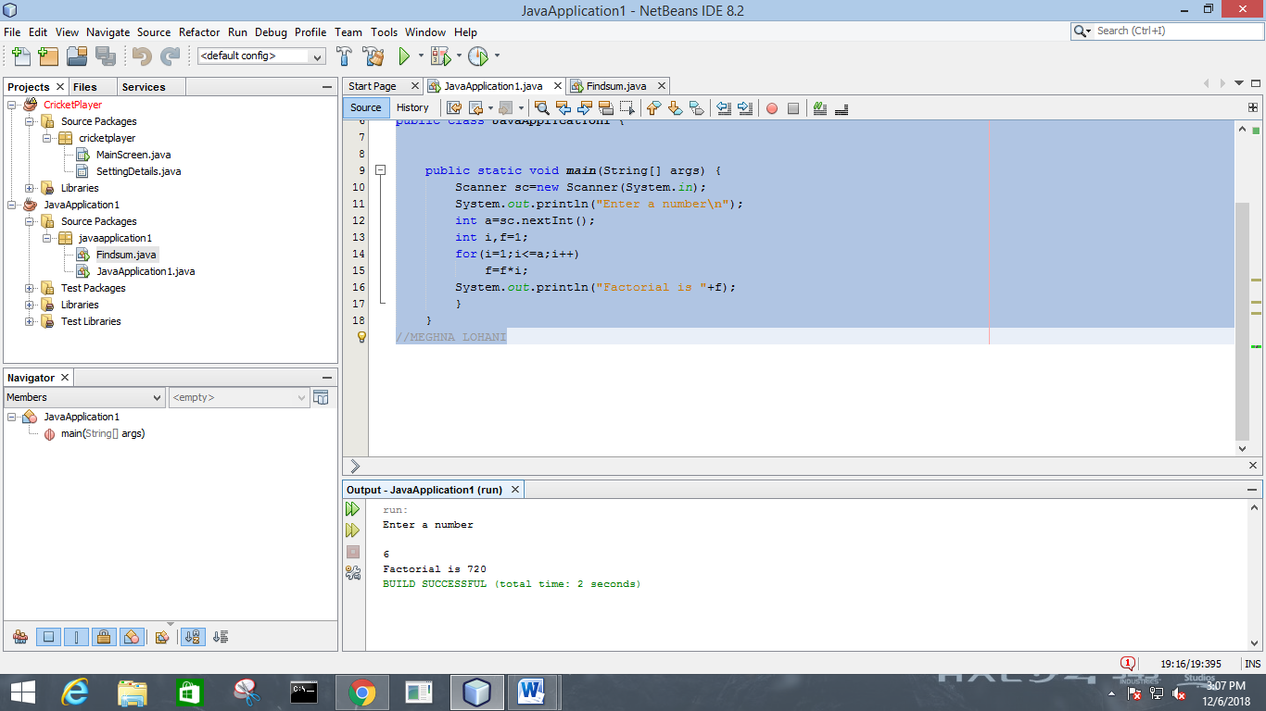

**Problem**

**To find the area, perimeter of circle, triangle, rectangle, sphere, cylinder.**

**Code**

package javaapplication1;

import java.util.Scanner;

import java.math.*;

public class JavaApplication1 {

public static void main(String[] args) {

Scanner sc=new Scanner(System.in);

System.out.println("Enter the radius of the circle\n");

int r=sc.nextInt();

System.out.println("Area of Circle: "+(3.14*r*r));

System.out.println("Perimeter of Circle "+(2*3.14*r));

System.out.println("Enter the length of the rectangle\n");

int l=sc.nextInt();

System.out.println("Enter the breadth of the rectangle\n");

int b=sc.nextInt();

System.out.println("Area of the Rectangle is: "+(l*b));

System.out.println("Perimeter of the Rectangle is: "+(2*l+2*b));

System.out.println("Enter side of the square\n");

int a=sc.nextInt();

System.out.println("Area of the square is: "+(a*a));

System.out.println("Perimeter of the square is: "+(4*a));

System.out.println("Enter the three sides of the triangle\n");

int s1=sc.nextInt();

int s2=sc.nextInt();

int s3=sc.nextInt();

int s=(s1+s2+s3)/2;

double ta=Math.sqrt(s*(s-s1)*(s-s2)*(s-s3));

System.out.println("Perimeter of the triangle is: "+(s*2));

System.out.println("Area of the triangle is: "+(ta));

}

}

**Output**

run:

Enter the radius of the circle

4

Area of Circle: 50.24

Perimeter of Circle 25.12

Enter the length of the rectangle

4

Enter the breadth of the rectangle

5

Area of the Rectangle is: 20

Perimeter of the Rectangle is: 18

Enter side of the square

7

Area of the square is: 49

Perimeter of the square is: 28

Enter the three sides of the tiangle

2

4

6

Perimeter of the triangle is: 12

Area of the triangle is: 0.0

BUILD SUCCESSFUL (total time: 21 seconds)

**Screenshot**

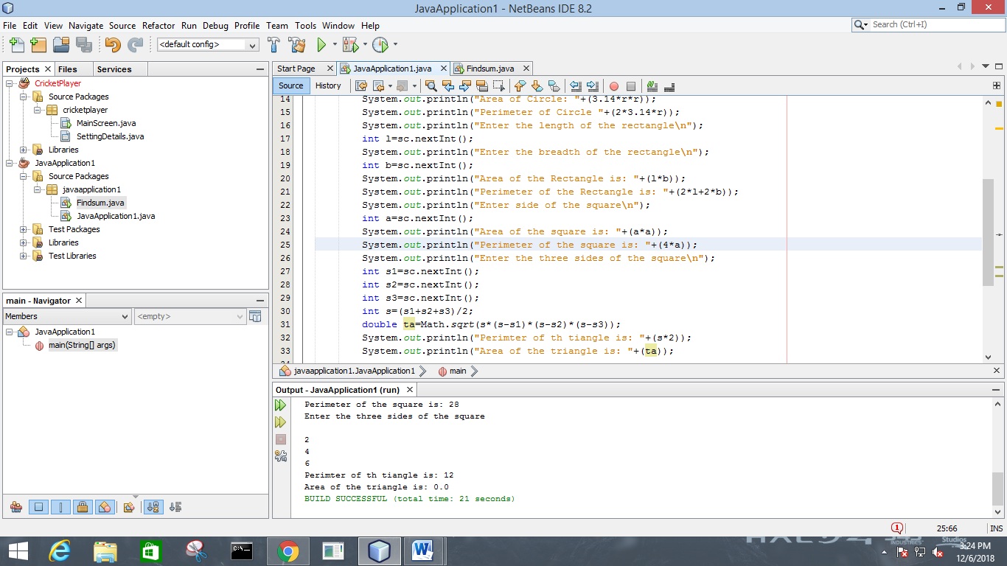

**Problem**

**Write a java program that prints even numbers and the odd numbers separately from the given numbers.**

**Code**

package javaapplication1;

import java.util.Scanner;

import java.math.*;

public class JavaApplication1 {

public static void main(String[] args) {

Scanner sc=new Scanner(System.in);

System.out.println("Enter a number\n");

int n=sc.nextInt();

int i,o=0,e=0;

for(i=0;i<=100;i++)

{

if (i%2==0)

{

System.out.println(i+" is Positive\n");

e++;}

else

{

System.out.println(i+ " is Negative\n");o++;}

}

System.out.println("Number of positive numbers"+e);

System.out.println("Number of negative numbers"+o);

}

}

**Output**

Number of positive numbers51

Number of negative numbers50

BUILD SUCCESSFUL (total time: 5 seconds)

**Screenshot**

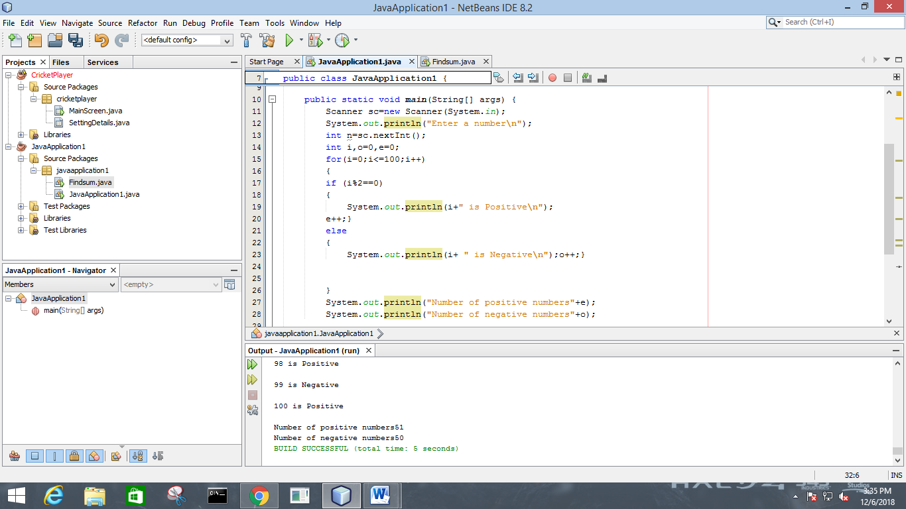

**Java Programming**

**8 Dec 2018**

**Meghna Lohani**

**16BCE1395**

**Problem**

**Find all the prime numbers in a given range**

**Code**

package prime;

import java.util.Scanner;

public class Prime {

/**

* @param args the command line arguments

*/

public static void main(String[] args) {

// TODO code application logic here

Scanner sc=new Scanner(System.in);

System.out.println("Enter the range\n");

int min=sc.nextInt();

int max=sc.nextInt();

System.out.println("Prime numbers in the range "+min+" - "+max+ " are : \n");

int i,p,n,c,j;

for(i=min;i<=max;i++)

{c=0;

for(j=1;j<=i;j++)

{if(i%j==0)

c++;}

if(c==2)

System.out.print(i+" ");

}

}

}

**Output**

Enter the range

5

20

Prime numbers in the range 5 - 20 are :

5 7 11 13 17 19 BUILD SUCCESSFUL (total time: 4 seconds)

**Screenshot**

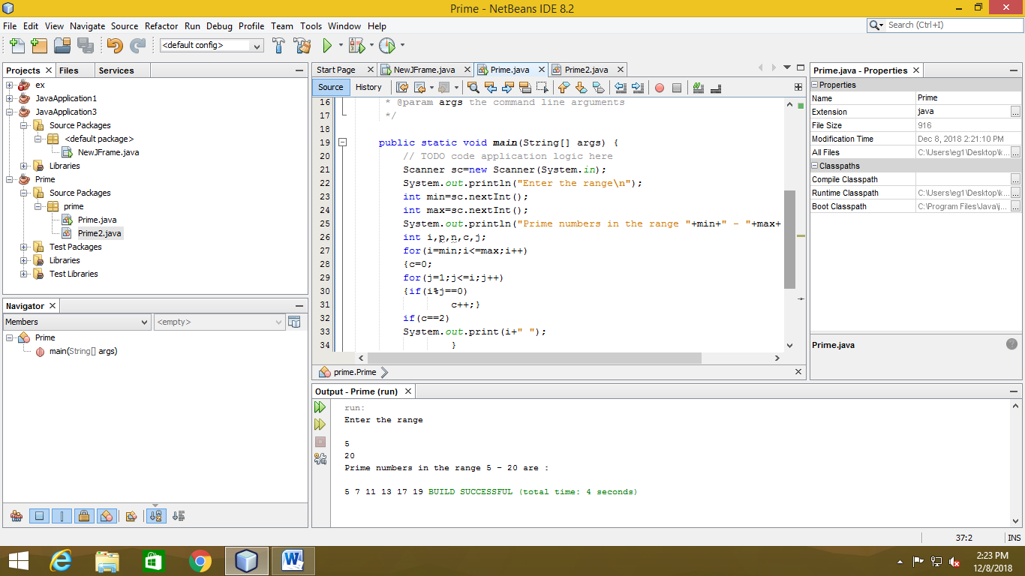

**Problem**

**Write a program to maintain a cash register to record sales value, generate change and balance of the sales.**

**Code**

package program;

import java.util.Scanner;

/**

*

* @author eg1

*/

public class Program {

/**

* @param args the command line arguments

*/

int one,two,five,ten,fifty,hun,amt,bal,camt;

public static void main(String[] args) {

Scanner sc=new Scanner(System.in);

// TODO code application logic here

Program obj=new Program();

obj.updatecash();

int flag=1,c=1;

while(flag==1)

{System.out.println("Customer "+c+" : ");

c++;

obj.recordSaleValue();

obj.giveChange();

obj.balanceEnquiry();

System.out.println("Do you wish to continue? Enter 1 for yes and 0 for no");

int opt=sc.nextInt();

flag=opt;

}

}

void updatecash()

{

Scanner sc=new Scanner(System.in);

System.out.println("--ENTER THE INITIAL STATUS OF CASH REGISTER--\n");

System.out.println("Enter the number of 1 rs. coins\n");

one=sc.nextInt();

System.out.println("Enter the number of 2 rs. coins\n");

two=sc.nextInt();

System.out.println("Enter the number of 5 rs. coins\n");

five=sc.nextInt();

System.out.println("Enter the number of 10 rs. coins\n");

ten=sc.nextInt();

System.out.println("Enter the number of 50 rs. notes\n");

fifty=sc.nextInt();

System.out.println("Enter the number of 100 rs. notes\n");

hun=sc.nextInt();

}

void recordSaleValue()

{Scanner sc=new Scanner(System.in);

System.out.println("Enter the amount to be paid\n");

amt=sc.nextInt();

System.out.println("Enter the amount paid by the customer\n");

camt=sc.nextInt();

System.out.println("Enter the count of each denomination as given by the customer\n");

System.out.print("One :");

one=one+sc.nextInt();

System.out.print("Two :");

two=two+sc.nextInt();

System.out.print("Five :");

five=five+sc.nextInt();

System.out.print("Ten :");

ten=ten+sc.nextInt();

System.out.print("Fifty :");

fifty=fifty+sc.nextInt();

System.out.print("Hundred :");

hun=hun+sc.nextInt();

}

void giveChange()

{boolean ca=true;

System.out.println(camt);

System.out.println(amt);

int no=0,nt=0,nfv=0,nten=0,nf=0,nh=0;

bal=camt-amt;

System.out.println("Change to be returned : "+bal);

if(bal==0)

System.out.println("No change required\n");

else

{

nh=bal/100;

if(nh>hun)

{nh=hun;

}

bal=bal-nh*100;

}

nf=bal/50;

if(nf>fifty)

{nf=fifty;}

bal=bal-nf*50;

nten=bal/10;

if(nten>ten)

{

nten=ten;}

bal=bal-nten*10;

nfv=bal/5;

if(nfv>five)

{nfv=five;

}

bal=bal-5*nfv;

nt=bal/2;

if(nt>two)

{nt=two;

}

bal=bal-nt*2;

if(bal>one)

{ca=false;

}

else

{no=bal;

}

if(ca)

{

hun=hun-nh;

fifty=fifty-nf;

ten=ten-nten;

five=five-nfv;

two=two-nt;

one=one-no;

System.out.println("CHANGE TO BE RETURNED--\n");

System.out.println("One :"+no+"\n");

System.out.println("Two :"+nt+"\n");

System.out.println("Five :"+nfv+"\n");

System.out.println("Ten :"+nten+"\n");

System.out.println("Fifty :"+nf+"\n");

System.out.println("Hundred :"+nh+"\n");}

else

{System.out.println("Change not available");

}

}

void balanceEnquiry()

{

System.out.println("--CASH REGISTER--\n");

System.out.println("One :"+one+"\n");

System.out.println("Two :"+two+"\n");

System.out.println("Five :"+five+"\n");

System.out.println("Ten :"+ten+"\n");

System.out.println("Fifty :"+fifty+"\n");

System.out.println("Hunderd :"+hun+"\n");}

}

**Output**

run:

--ENTER THE INITIAL STATUS OF CASH REGISTER--

Enter the number of 1 rs. coins

5

Enter the number of 2 rs. coins

5

Enter the number of 5 rs. coins

5

Enter the number of 10 rs. coins

5

Enter the number of 50 rs. notes

5

Enter the number of 100 rs. notes

5

Customer 1 :

Enter the amount to be paid

565

Enter the amount paid by the customer

600

Enter the count of each denomination as given by the customer

One :0

Two :0

Five :0

Ten :0

Fifty :0

Hundred :6

600

565

Change to be returned : 35

CHANGE TO BE RETURNED--

One :0

Two :0

Five :1

Ten :3

Fifty :0

Hundred :0

--CASH REGISTER--

One :5

Two :5

Five :4

Ten :2

Fifty :5

Hunderd :11

Do you wish to continue? Enter 1 for yes and 0 for no

1

Customer 2 :

Enter the amount to be paid

1120

Enter the amount paid by the customer

1500

Enter the count of each denomination as given by the customer

One :0

Two :0

Five :0

Ten :0

Fifty :0

Hundred :15

1500

1120

Chnage to be returned : 380

CHANGE TO BE RETURNED--

One :0

Two :0

Five :2

Ten :2

Fifty :1

Hundred :3

--CASH REGISTER--

One :5

Two :5

Five :2

Ten :0

Fifty :4

Hunderd :23

Do you wish to continue? Enter 1 for yes and 0 for no

0

BUILD SUCCESSFUL (total time: 2 minutes 22 seconds)

**Screenshot**

