**JAVA PROGRAMMING**

**13 DEC 2018**

**NAME: Meghna Lohani**

**REG NO: 16BCE1395**

**Problem 1**

**BMI Calculator**

**Code**

package bmi;

import java.util.Scanner;

public class Bmi {

/**

* @param args the command line arguments

*/

public static void main(String[] args) {

// TODO code application logic here

Scanner sc=new Scanner(System.in);

System.out.print("First name : ");

String fname=sc.next();

System.out.println();

System.out.print("Last name : ");

String lname=sc.next();

System.out.println();

System.out.print("Weight(kg) : ");

float w=sc.nextFloat();

System.out.println();

System.out.print("Height(feet) : ");

float h1=sc.nextFloat();

System.out.println();

System.out.print("Height(inches) : ");

float h2=sc.nextFloat();

System.out.println();

double h=h1*12+h2;

h=h*0.0254;

double bmi=w/(h*h);

System.out.println("BMI is : "+bmi);

if(bmi<=18.5)

System.out.println(fname+" "+lname+" : "+"Underweight");

else if(bmi>18.5 && bmi<=25)

System.out.println(fname+" "+lname+" : "+"Normal");

else if(bmi>25 && bmi<=30)

System.out.println(fname+" "+lname+" : "+"Overweight");

else

System.out.println(fname+" "+lname+" : "+"Obese Class");

}

}

**Output**

First name : Meghna

Last name : Lohani

Weight(kg) : 95

Height(feet) : 5

Height(inches) : 7

BMI is : 32.80247148598552

Meghna Lohani : Obese Class

BUILD SUCCESSFUL (total time: 15 seconds)

**Screenshot**

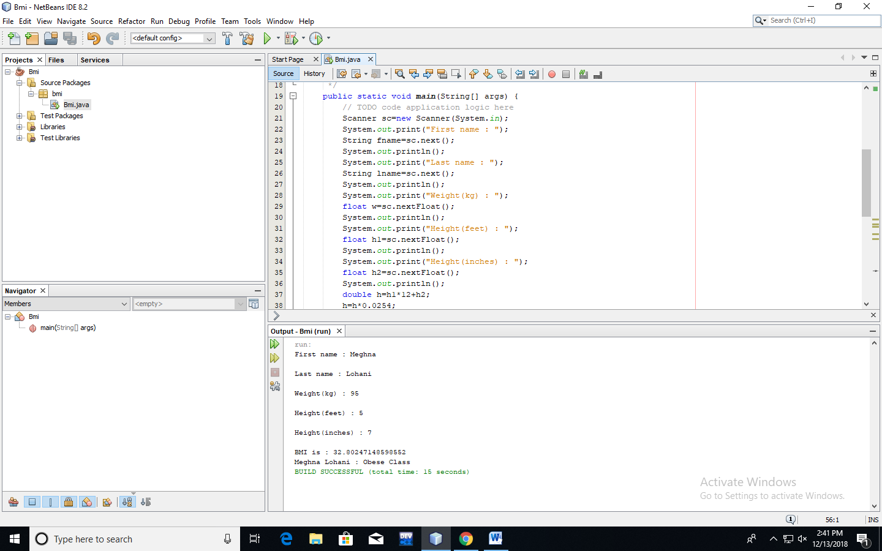

**Problem 2**

**Number Name**

**Code**

package program;

import java.util.Scanner;

public class words {

public static void main(String[] args)

{

Scanner sc=new Scanner(System.in);

String ones[]={"","one","two","three","four","five","six","seven","eight","nine"};

String tens[]={"","","twenty","thirty","forty","fifty","sixty","seventy","eighty","ninety"};

String tenth[]={"ten","eleven","twelve","thirteen","fourteen","fifteen","sixteen","seventeen","eighteen","nineteen"};

String hundred=" hundred ";

String thousand=" thousand ";

int f=1;

do

{

System.out.println("Enter a number");

int n=sc.nextInt();

int m=n;

int num[]=new int[4];

int r,pos=3,i;

String word="";

while(pos>=0)

{

num[pos]=n%10;

pos--;

n=n/10;

}

for(i=0;i<4;i++)

{int a=num[i];

if(a!=0 && i==0)

word=word+ones[a]+thousand;

else if(a!=0 && i==1)

word=word+ones[a]+hundred;

else if(a!=0 && (i==2 && a==1))

{r=num[3];

word=word+tenth[r]+" ";

i++;}

else if(a!=0 && (i==2 && a!=1))

word=word+tens[a]+" ";

else if(i==3)

word=word+ones[a]+" ";

}

System.out.println(m+" : "+word);

System.out.println("Do you wish to continue? Enter 1 for yes and 0 for no");

f=sc.nextInt();

}

while(f==1);

}

}

**Output**

run:

Enter a number

10

10 : ten

Do you wish to continue? Enter 1 for yes and 0 for no

1

Enter a number

11

11 : eleven

Do you wish to continue? Enter 1 for yes and 0 for no

1

Enter a number

13

13 : thirteen

Do you wish to continue? Enter 1 for yes and 0 for no

1

Enter a number

21

21 : twenty one

Do you wish to continue? Enter 1 for yes and 0 for no

1

Enter a number

35

35 : thirty five

Do you wish to continue? Enter 1 for yes and 0 for no

1

Enter a number

20

20 : twenty

Do you wish to continue? Enter 1 for yes and 0 for no

1

Enter a number

55

55 : fifty five

Do you wish to continue? Enter 1 for yes and 0 for no

1

Enter a number

101

101 : one hundred one

Do you wish to continue? Enter 1 for yes and 0 for no

0

BUILD SUCCESSFUL (total time: 34 seconds)

Enter a number

1234

1234 : one thousand two hundred thirty four

Do you wish to continue? Enter 1 for yes and 0 for no

1

Enter a number

1012

1012 : one thousand twelve

Do you wish to continue? Enter 1 for yes and 0 for no

0

BUILD SUCCESSFUL (total time: 12 seconds)

**Screenshot**

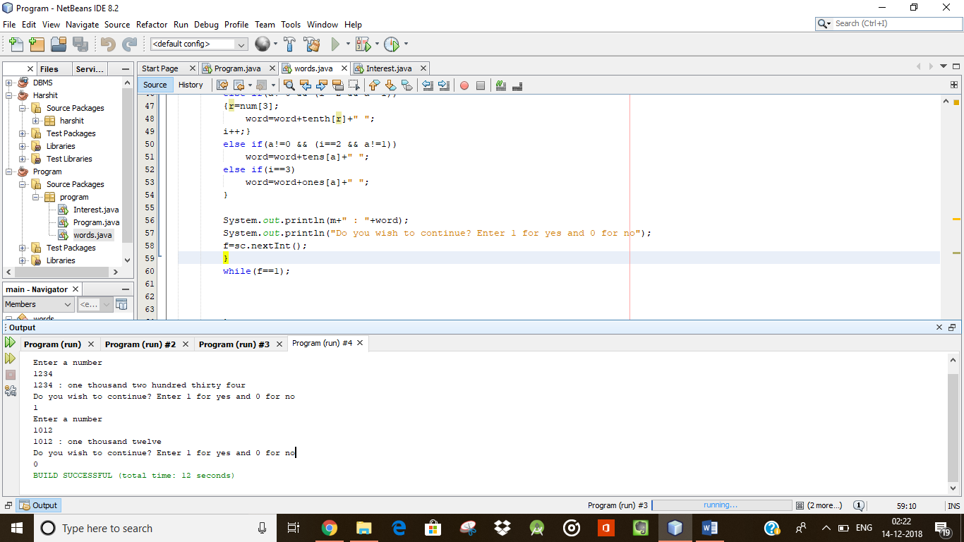

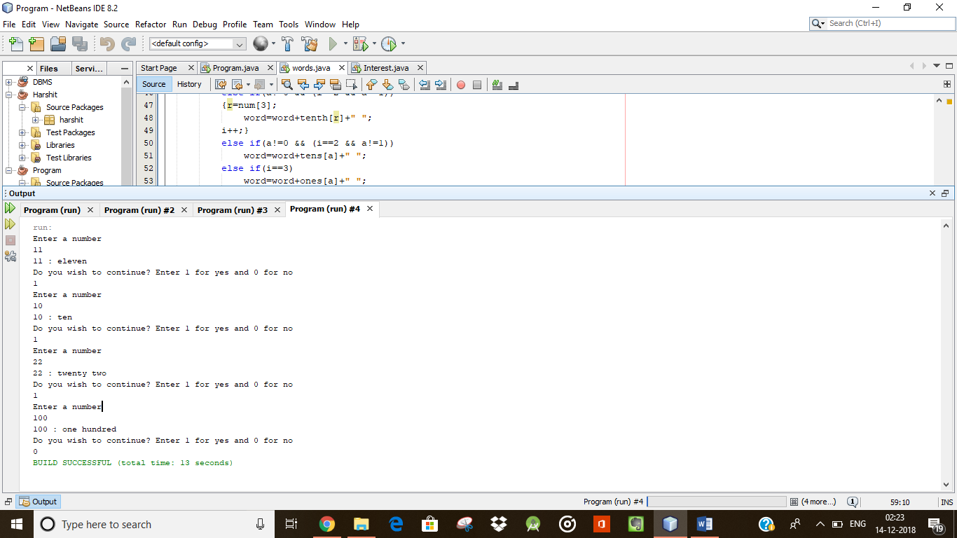

**Problem 3**

**Binary to Decimal and Decimal to Binary Conversion**

**Using pre-defined functions**

**Code**

package bmi;

import java.util.Scanner;

/**

*

* @author eg3

*/

public class BinToDec {

public static void main(String[] args)

{Scanner sc=new Scanner(System.in);

System.out.print("Enter a Decimal number : ");

int n=sc.nextInt();

System.out.println("Equivalent Binary number: "+Integer.toBinaryString(n));

System.out.print("Enter a Binary number : ");

String m=sc.next();

System.out.print("Equivalent Decimal number: ");

int x=Integer.parseInt(m,2);

System.out.println(x);

}

}

**Output**

run:

Enter a Decimal number : 12

Equivalent Binary number: 1100

Enter a Binary number : 1101

Equivalent Decimal number: 13

BUILD SUCCESSFUL (total time: 6 seconds)

**Screenshot**

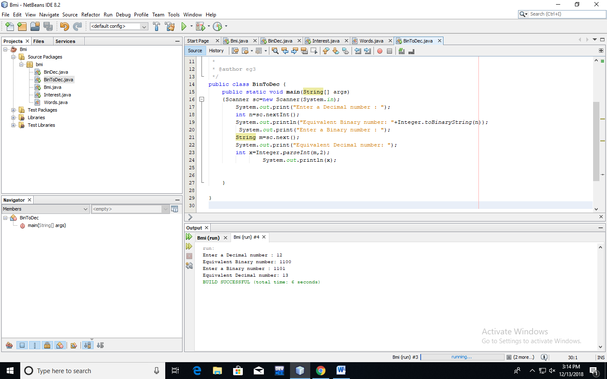

**Creating own Functions**

**Code**

package bmi;

import java.util.Scanner;

public class BinDec {

public static void main(String[] args)

{

Scanner sc=new Scanner(System.in);

System.out.print("Enter a Decimal number : ");

int n=sc.nextInt();

System.out.println();

String b="";

while(n!=0)

{

int r=n%2;

b=r+b;

n=n/2;}

System.out.println("Equivalent Binary number : "+b);

System.out.println("-------------------------------");

System.out.print("Enter a Binary number : ");

int m=sc.nextInt();

System.out.println();

int d=0,i=0,r;

while(m!=0)

{r=m%10;

d=d+r*(int)(Math.pow(2,i));

i++;

m=m/10;

}

System.out.println("Equivalent Decimal number : "+d);

}

}

**Output**

run:

Enter a Decimal number : 12

Equivalent Binary number : 1100

-------------------------------

Enter a Binary number : 1101

Equivalent Decimal number : 13

BUILD SUCCESSFUL (total time: 9 seconds)

**Screenshot**

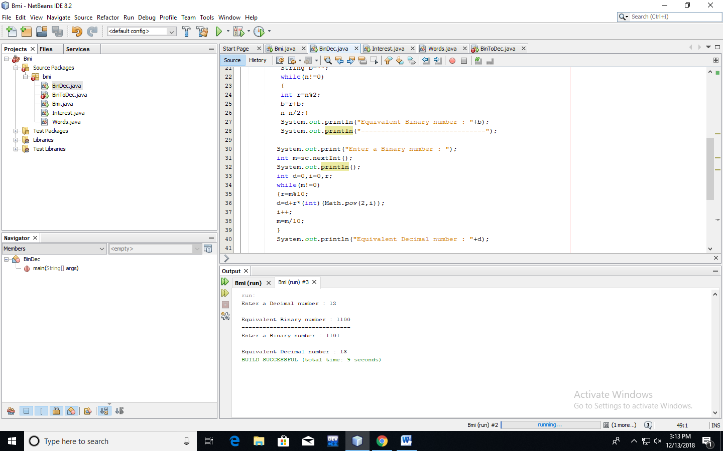

**Problem 4**

**Simple Interest Calculator**

**Code**

package bmi;

import java.util.Scanner;

public class Interest {

public static void main(String[] args)

{Scanner sc=new Scanner(System.in);

System.out.print("Principle : ");

float p=sc.nextFloat();

System.out.println();

System.out.print("Rate : ");

float r=sc.nextFloat();

System.out.println();

System.out.print("Time(years) : ");

float t=sc.nextFloat();

System.out.println();

float i=(p*r*t)/100;

System.out.println("Simple Interest : "+i);

}

}

**Output**

run:

Principle : 1000

Rate : 5

Time(years) : 5

Simple Interest : 250.0

BUILD SUCCESSFUL (total time: 9 seconds)

**Screenshot**

