Umbra: a Moon Base Proposal

Khang Duong

Virginia Aerospace Science and Technology Scholars

Abstract

Project Umbra will be a fully operational U.S. moon base by the year 2029. It will be located on Malapert Mountain (84° 54′ 0″ S, 12° 54′ 0″ E) because of its proximity to important places of interest, its line of sight towards Earth, and its access to sunlight (David, 2002). Umbra lunar buildings will be made of smelted aluminum and 3D printed regolith. This will protect Umbra crewmembers from extreme temperatures, vacuum, and cosmic rays (Diaz, 2013). It will consist of seven large 3D printed domes. Astronauts will perform studies on biology, physics, chemistry, and astronomy. They will do so with the aid of rovers, telescopes, and laboratories located in Umbra.

Umbra: a Moon Base Proposal

**Introduction:**

Moon bases have been proposed since 1954 (NASA, n.d.a). However, none have been implemented yet. Umbra will be among the first moon bases. It will be located on Malapert Mountain because of sunlight, its proximity to prime locations, and its line of sight. Construction will start in 2021, and the base will be operational by 2029. Umbra will consist of domed habitats made of smelted aluminum and 3D printed regolith. This will protect the crew from radiation, extreme temperatures, and the vacuum of space. Astronauts will perform science in many different fields during their stay.

**Timeline:**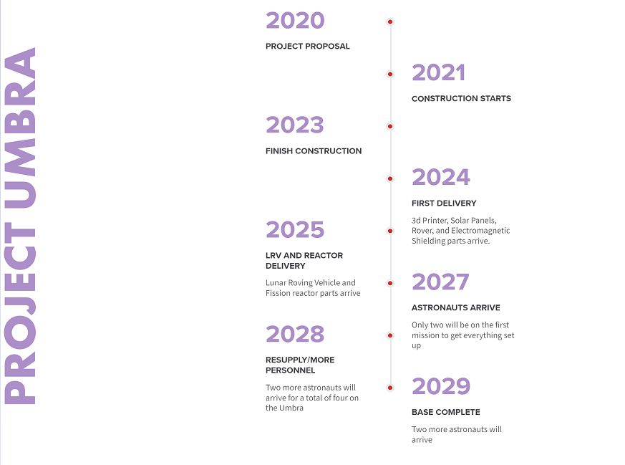

**Location: Base Site**

Umbra will be located on Malapert Mountain (84° 54′ 0″ S, 12° 54′ 0″ E) (GeoHack, n.d.). This location is ideal for a moon base because (1) it is located where sunlight hits 90% of the time, (2) the Earth is always visible from this location, and (3) it is near Shackleton crater and other areas of interest. Firstly, having sunlight almost all the time would allow a solar panel array to supply the base for most of the time (David, 2002). During the times where there is no sunlight, fission or possibly fusion reactors can power the technology (ESA, n.d.a). Secondly, because Earth is always visible, missions on the base can communicate with Earth and vice-versa in real-time. Thirdly, Malapert Mountain is close to many points of interest on the moon, including Shackleton Crater, Shoemaker Crater, and the South Pole-Aitken basin. Shackelton Crater will be a prime location for a radio telescope because it would be able to view the cosmos without noisy Earth radio waves. It could also be used to house infrared telescopes that need very cold conditions to work best (David, 2002).

**Location: Environmental Adaptations**

The Umbra crew will have to deal with a multitude of environmental threats, such as less gravity, vacuum, regolith, cosmic radiation, extreme temperatures, and an elongated day/night cycle. Firstly, because there is less gravity, astronauts will have to exercise like on the ISS (Lunar and Planetary Institute, 2008). Secondly, Umbra will keep the crew safe from the vacuum of space through its 3D printed walls (Diaz, 2013). The walls will be made of a thick layer aluminum smelted from anorthite, then thicker 3D printed regolith layer, and finally another layer of aluminum for redundancy. This process of smelting aluminum will also produce oxygen for the crew during their stay (NASA, n.d.a). Thirdly, lunar dust is abrasive. This means that EVA suits will need to be equipped with anti-abrasive materials (Soil Science Society of America, 2008). Fourth, cosmic radiation and solar wind will be mitigated by an “electrostatic radiation shield” that will protect the crew, similar to Earth’s magnetic field (ASRC Aerospace Corporation, n.d.). One downside of this is that a device like this will need a lot of power for a sustained period of time. Another protection device for the crew will be the hull of the buildings. The aluminum and regolith 3D printed hull will protect the crewmembers from radiation and extreme temperatures as well (Diaz, 2013). Lastly, there is an elongated day/night schedule. This will not pose such a risk because of the day/night cycle on Malapert Mountain, where it is almost always sunny. Astronauts will have to sleep at regular intervals and plan each day like on the ISS however (ESA, 2014b).

**Operational Concepts:**

There will be a total of seven large 3D printed bubble-like structures. One will be for smelting the anorthite, one will be for Earth communications and life support, one for housing, one for nuclear energy, one laboratory, one for storage, one greenhouse, and one observatory. Because of its proximity to the Shackleton Crater, several rovers will be used for unmanned missions into the deep shadow of the crater (Diaz, 2002). Each bubble will be connected by insulated tubes. In addition, an infrared and radio telescope will be set up in Shackelton Crater.

**Personnel:**

Umbra will consist of U.S. astronauts only. The program will start by sending two astronauts to oversee the 3D printing of the bubble structures. After that, as many as six people may stay at Umbra at once. This means that the astronauts will have to be trained in a number of disciplines, such as astronomy, biology, physics, computer science, and chemistry. Possible candidates will be tested the same as astronauts today. Astronauts must be in good condition, have a “bachelor’s degree in engineering, biological science, physical science, computer science or mathematics,” perform “at least three years of related professional experience obtained after degree completion or at least 1,000 hours pilot-in-command time on jet aircraft,” and have an ideal personality for the mission (NASA, n.d.b). For example, an astronaut has to be level headed and optimistic if they because they will have to face extreme psychological pressures on the Moon.

**Activities:**

Crewmembers on Umbra will have to do a multitude of studies while on the Moon. They will have to maintain life support, oversee aluminum smelting, control unmanned rovers, perform EVAs, communicate with Earth, and/or drive a Lunar Roving Vehicle (LRV).

**Conclusion:**

In conclusion, Project Umbra will begin construction in 2021. It will be located on Malapert Mountain near the Moon’s south pole because of its prime location, access to sunlight, and view of Earth (David, 2002). Umbra will consist of seven large 3D printed domes. This will protect crewmembers from cosmic rays, vacuum, and extreme temperatures (Diaz, 2013). Because of its proximity to Shackleton Crater, the project will include rovers for exploration, and an infrared and radio telescope. There will only be U.S. astronauts aboard this mission. This project hopes to bridge the gap between science fiction and reality. Reaching for the stars is a daunting task, but with baby steps, the cosmos is within our grasp.