Project Ares: Phase III, Mission I

Khang Duong

Virginia Aerospace Science and Technology Scholars

**Scope Summary Page**

**Need**

**Goal**

**Objective**

**Mission Case**

**Operational Concept**

**Assumptions**

**Constraints**

**Proposal**

**Mission Statement**

Phase III, Mission I is a mission based on furthering the goal of achieving a permanent human outpost on Mars. Its focuses are surface composition data of the Arcadia Planitia and other followup experiments to previous manned Mars missions, automation of mining, and the setup of the first Mars propellant plant.

***Subject***

The subject of this mission is further operation. The crew will “permanently occupy” this Mars base established from previous missions (Larson and Pranke, 2003). Mission I will capitalize on the Arcadia Planitia region, focusing on surface composition data of key scientific ROIs (return on investment) (University of Arizona Department of Planetary Sciences, n.d.). This mission will also oversee the permanent automation of water-ice and in-situ resource mining, as well as the first propellant plant on Mars. Various experiments are planned for Phase III in fields such as plant growth, medicine, geology, and biology.

***Type***

This mission will be a space-based planetary exploration. It will be manned by 10 people.

***Users***

Users include other space agencies, like ESA, future Mars colonists, scientists of all fields and future generations to come. Other aerospace agencies would use the technology and concepts applied to Ares. Future Martian colonists would benefit from the propellant plant and chemical data from this mission. Scientists in fields as different as biology and materials science would all benefit from the technology and discoveries awaiting on Mars. There is no predicting what revolutionary discoveries could be made. Additionally, it would be another important step towards humans becoming a multi-planetary species. There are many threats to the human species. For example, nearby solar flares, Earth’s magnetic field reversing, and a global epidemic could all wipe out humanity (Urban, 2015). Colonizing Mars will be the next step in ensuring the survival of humans. It was Stephen Hawking that said, “[Humanity] face[s] a number of threats to our survival, from nuclear war, catastrophic global warming, and genetically engineered viruses; the number is likely to increase in the future, with the development of new technologies, and new ways things can go wrong … We need to expand our horizons beyond planet Earth if we are to have a long-term future, spreading out into space, and to other stars, so a disaster on Earth would not mean the end of the human race.” Therefore, Phase III, Mission I would not only serve present humans but future generations as well.

***Duration***

First, parts for the propellant plant have to be shipped as well as additional supplies. In a second rocket, the return vehicle will be shipped as well. Liftoff for the astronauts will occur in 2040, after their selection and training. Phase III will be a conjunction class mission, as opposed to an opposition class mission. This means that the round trip will be about 900 days long, with a 500-day stay on Mars (Carr, 2020). This is justified because the crew will be stressed and tired. In addition, the crew will be under Martian radiation for the entire mission. Only three years on Mars “exceeds the radiation dose limits” of NASA astronauts “for their entire career”

(Kurzgesagt – In a Nutshell, 2019). On a 500 day mission like this, crewmember’s cancer rates increase by five percent (SciNews, 2013). Therefore, every two years when the Earth to Mars window is open, the crews will be replaced (Williams, 2017). The Mission I crew will return in 2043, 900 days from first exiting Earth (Carr, 2020).

**Mission Name**

Similar to Apollo and Artemis, this mission is named based on a Greek god: Ares. Ares is the Greek god that Mars is named after. He represents war, although the missions under his name more symbolize another of his traits: action (“Ares,” n.d.). Going to Mars will not be easy, but it is necessary. It would be easier to just stay on Earth. These missions represent action, not idleness.

**Mission and System Requirements**

***Mission Requirements***

For this mission to be successful, it must achieve the following: complete propellant plant for the production of methane and water through the Sabatier process, “extend science experiments” of previous phases, and complete the full automation of on-surface mining (McCoy, 2012; Larson and Pranke, 2003). Crewmembers must return 900 days after launch (Carr, 2020). On a larger scale, Mission I will set up a more sustainable habitat for future Martian colonists.

***Elements and System Requirements***

To achieve the goals set by this mission, its systems must be fully operational. This mission requires three SLS (Space Launch System) rockets capable of sending equipment and people to Mars. The first two will be supply shipments, and the last one will contain astronauts. This mission also requires a functional Sabatier propellant plant and the hydrogen for it to work (McCoy, 2012c). It also requires the construction of a fully automated mining system, which should be sent in the shipments. For science, the main priority is surface composition. In order to gather this, the Compact Reconnaissance Imaging Spectrometer (CRISM) will be used (NASA, n.d.c). Its function is to search for past signs of water. It has the ability to check about 5.8 to 7.4 miles of land at a time. CRISM will characterize the surface of Mars around the Arcadia Planitia. Another priority will be “higher resolution of near-surface ice deposits, including spatial distribution” (University of Arizona Department of Planetary Sciences, n.d.). Instruments such as a Synthetic Aperture Radar (SAR Radar) and a higher resolution neutron spectrometer will be used. These in conjunction will help determine where and how large subsurface water-ice deposits are for in-situ resource utilization (Jet Propulsion Laboratory, n.d.; Hübscher, 2018). Also, during entry into the Martian atmosphere, a powerful aeroshell and parachute are imperative. Landing software, like one that detects where cliffs and rocks are, must be perfect. Several satellites will ensure communication with Earth while the colonists are on Mars (McCoy, 2012d). Astronauts will also need Mars-grade space suits for EVA missions. For this mission, nuclear material will also be sent to power the already present nuclear reactor. A return vehicle will be sent before the astronauts arrive. There are already Martian rovers, so only replacement parts and nuclear material for them will be sent. Some elements are already on Mars from previous missions. These include habitat, laboratory, long-distance Martian vehicle, radiation shielding, Airlock systems, EVA systems, life support, power supplies, thermal control, and communications (Virginia Aerospace Science and Technology Scholars).

**Mission Timeline**

First, supplies for Mission I will be sent in 2036 and 2038. One will bring the return vehicle, and the other will bring the supplies, including nuclear material and parts for the fuel plant. The astronaut screening process is about 18 months (NASA, 2016g). Training takes about two years. Therefore, to be able to launch in 2040, screening should start around mid-2036. 18 months after, in 2038, the 10 astronaut trainees will start their two-year-long training. The launch will be around January 2, 2040, when the Earth and Mars are closest (Williams, 2017). The 900 day round trip starts there. After 500 days on Mars, the crew will return and arrive back on Earth in late 2042, after the crew for Mission II arrives (Carr, 2020). 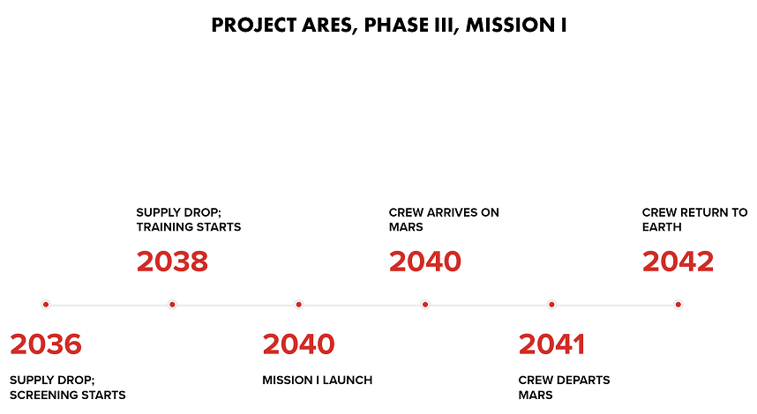

**Outpost Location**

Phase I, II, and III will be located in the Acidalia Planitia region, centered at 49° 48′ 0″ N, 339° 18′ 0″ E (GeoHack, n.d.). This location was chosen because of its unique access to water away from the poles (Gebhardt, 2019).

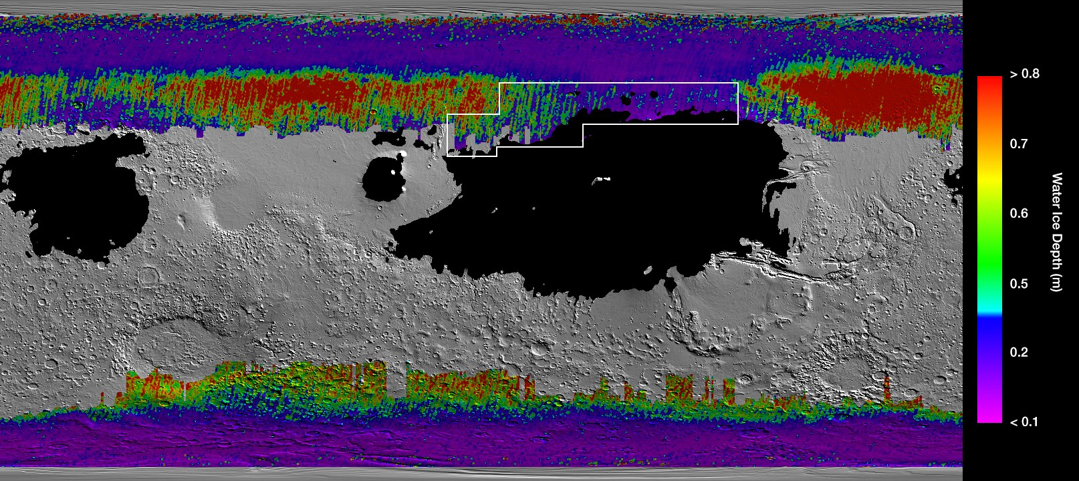

*Figure 1.* This map shows all of Mars and the prevalence of water underneath the surface. The Black represents areas that are not feasible to land. The box shows the best area to land for water and flat terrain; the Acidalia Planitia is located there (NASA, n.d.).

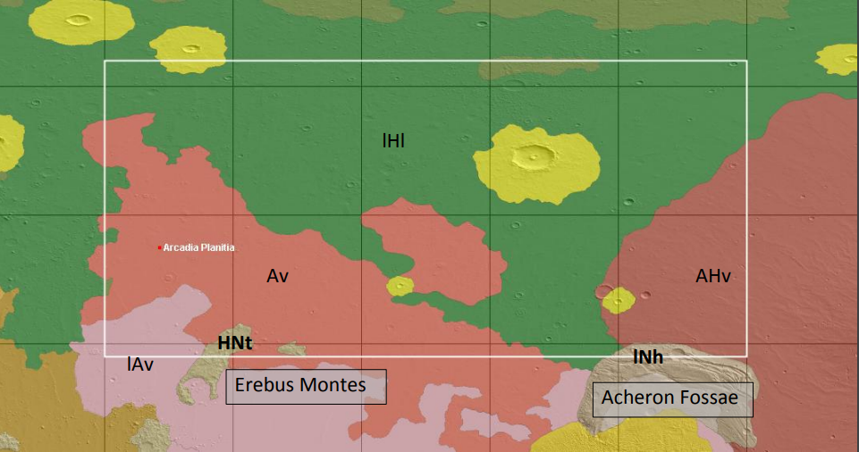*Figure 2.* The Acidalia Planitia (University of Arizona Department of Planetary Sciences, n.d.)

The Acidalia Planitia region has the most abundant sources of shallow water deposits on Mars at low latitude. Some deposits are located just 30 centimeters below the surface of Mars (University of Arizona Department of Planetary Sciences, n.d.). Water is an extremely important resource; all living creatures need it to survive (“All Living,” n.d.). It is also very heavy. The more that it can be mined in-situ, the less of it astronauts have to bring. This will cut down costs significantly or allow for other space cargo aboard NASA’s Space Launch System. In addition to that, the Arcadia Planitia has the ideal latitude elevation and thermal conditions for a permanent base. It has a “quantity for substantial production,” and is potentially “minable by highly automated systems”. The Arcadia Planitia presents useful science goals as well. It could harbor potential life, and contains a “high likelihood of surface-atmosphere exchange” and “Amazonian subsurface or high-latitude ice or sediment.” The Arcadia Planitia has two Resource ROI (return of investment) located at 39.1N, 192E, and 38.9N, 192.2E. These locations have “evidence of subsurface water ice.” There are also five Science ROIs located evenly throughout the region. The first two are located at 39.7N, 190.6E and 39.5N, 194E. Both have Hesperian-Noachian transition terrain that could be studied. Science ROI three, located at 38.5N, 192.8E harbors evidence of “Amazonian volcanism” and water ice. Lastly, Science ROIs four and five have glacial formations of interest. ROI five has additional evidence of Amazonian lava and “debris aprons'' as well. 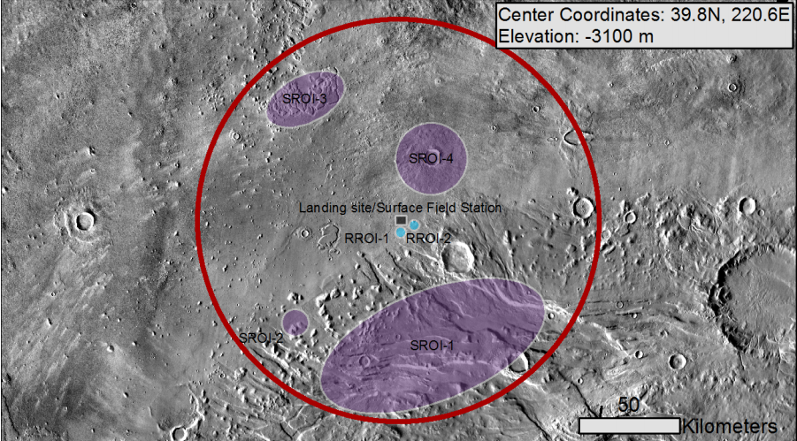 *Figure 3.* Map of Science and Resource ROIs. SROI is Science ROI. RROI is Research ROI. The circle is the exploration zone. (University of Arizona Department of Planetary Sciences, n.d.).

**Mission Constraints**

Phase III will be crewed by 10 people. This will cut the costs for housing, food, and fuel. It will launch in 2040, and when they arrive, crewmembers from Phase II will return. 2040 is chosen as a conservative date for the launch because of the preliminary supply drops on Mars. There will be two resource launches for Phase III and 2040 allows enough time to make sure both of those launches are successful. One will consist of supplies, and the other will be the return vehicle. Another constraint is launch vehicles. There is only so much in terms of supplies that can be sent. Launch vehicles are expensive, so only two will be sent. Another limitation is the size of the capsule that the crew will live on during the flight to Mars. It is not large enough to carry all supplies, hence the two cargo launches beforehand.

**Risks**

Risks include radiation, poor nutrition, and reduced gravity. Radiation can cause cancer, cell damage, cataracts, mental decay, and death (NASA, n.d.a, 2002f). 500 days on Mars alone is enough to increase the risk of cancer by 5 percent (SciNews, 2013). It also affects computers. Large doses of radiation could cause circuit malfunction, which could be mission-ending. To mitigate the risk of radiation, a diet high in antioxidants would help lower the risk of cancer. Stem cells collected from healthy bone marrow would help treat cancer if it occurs (NASA, n.d.a). A Martian outpost could have Martian regolith shielding. Alternatively, it could be built near a cliff to stop radiation from one side (NASA, 2016h, 1991e). Computers would have to carry radiation shielding to protect against malfunction. During space travel, a layer of 50-100 centimeter liquid hydrogen would protect against radiation. However, such a system would be “heavy and awkward” (NASA, 2002f). Over time, radiation also degrades nutrients in food (Lockheed Martin, 2012).

Another risk is poor nutrition. Astronauts will have to eat not only calories but the correct micro and macronutrients to survive. Currently, food on the International Space Station can survive for 1.5 years (Lockheed Martin, 2012). In a mission of 10 years, this is a major issue. Food low in nutrients could directly affect crew performance (Lockheed Martin, 2012). Not only does the food have to be nutritious, but it also has to be palatable and sustainable. If crewmembers do not like their meals, they will not eat it and miss out on vital nutrients. The solution is to grow food along the way. Plants could be grown with hydroponics. The water in the hydroponic system could double as radiation shielding and be used to raise fish (Kurzgesagt – In a Nutshell, 2019). The chosen crop would have to be water-efficient, like tomatoes, potatoes, or beans. On Mars, plants will have to be grown in pressurized modules with LEDs (Cannon, n.d.). Other meat options include lab-grown meat and insects. (Cannon, n.d.). Crewmembers must eat food that supports their bones and muscle. In a low-gravity environment, both are crucial to maintaining.

During the trip to Mars, astronauts will be under microgravity. On Mars, they will suffer the effects of reduced gravity. Long term, Microgravity weakens muscles and bones, hinders eyesight, increases the risk of kidney stones, can lead to injury and fatigue, and many other ailments, like sleep deprivation, immunodeficiency, and anemia (Howell, 2017; Sutton & Cintrn, 2005). Mars has 62.5% of Earth’s gravity (NASA, n.d.b). This means that astronauts will have to exercise on Mars as well as deep space. They will exercise for 2 hours a day, just like on the International Space Station (Howell, 2017). Some solutions include exercise equipment, specialized suits, electrostimulation, and diet and medication. Space grade exercise machines, like the CEVIS (Cycler Ergometer with Vibration Isolation and Stabilization) System, the TVIS (Treadmill with Vibration Isolation and Stabilization) System, and the ARED (Advanced Resistive Exercise Device) would mitigate the ill effects of reduced gravity. Another solution is specialized suits. One example is the “Penguin Suit” which applies stress all over the body so that certain muscle groups are used more often. Like on Earth, electrostimulation can be used in space to improve muscle growth and repair. In addition, a diet high in “calcium and Vitamin D” could “reduce bone demineralization” (Talas, 2019).

Other risks include meteoroid impact, waste mitigation, atmospheric problems, poor crew selection, and contamination (Virginia Aerospace Science and Technology Scholars, n.d.). It is important to understand the risks involved because on a mission to Mars, there is no rescue.

Another important risk is behavior. Crewmembers aboard Ares will have to live together for three years. “Social compatibility and psychological” health are key. A successful mission cannot have disputes or depression in its crewmembers. Careful screening and decision, as well as onboard communication, are two solutions (McCoy, 2012a).

**Crew Responsibilities and Functions**

Each member will have specialties. However, they will be trained in multiple roles for redundancy and safety. Specialties include EVA specialist, doctor, biologist, geologist, construction manager, nuclear reactor systems operator and scientist, pilot, botanist, and engineer. Crew would be responsible for research and resource work. Using Martian vehicles, they would “conduct field studies of Martian geology, search for evidence of past or current life, collect rocks,” control Martian rovers, and “deploy geophysical instruments.” Back at the habitat, they would perform experiments on Mars in the fields of plant growth, medicine, geology, and biology. Crewmembers would also be responsible for maintaining life support systems and performing maintenance on various mission elements. They are also responsible for exercising every day (McCoy, 2012b). Mission I crew would have to achieve their main goal: setting up automated mining and a propellant plant.

**Outreach**



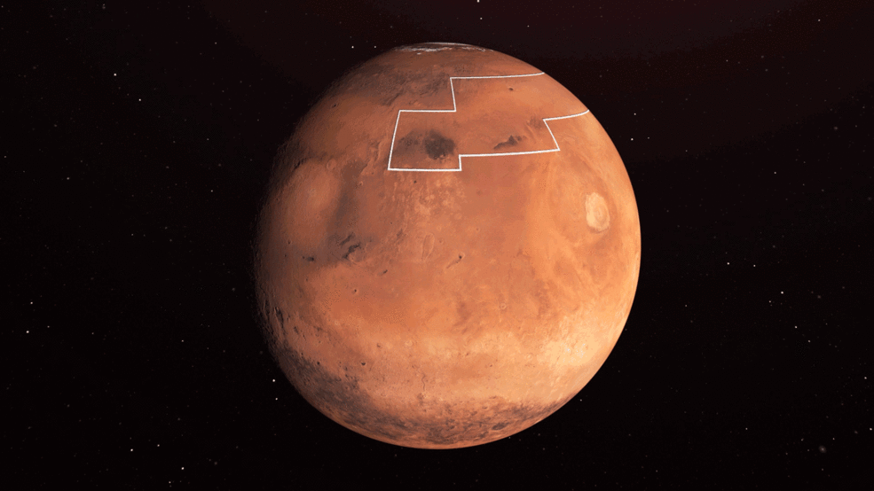

*Credit: NASA/JPL-Caltech*

NASA has just announced its plans for Ares Phase III Mars Missions, starting with Mission I. Its goals include chemical data on Mars soil, further experiments, automated mining systems, and a Martian propellant plant. Planned for launch in 2040, Mission I will investigate mysterious glaciers, volcanic formations, and mounds in a location called the Acidalia Planitia, shown above. It is a space-based planetary exploration mission crewed by 10 astronauts. Project Ares’ goal is to set up a self-sustaining Martian outpost. That way, if humans could make Mars their second home. The mission will take about 900 days from liftoff, with 500 days on Mars.

|  |
| --- |
| Why is this miQ: Why is this mission called Ares? Isn’t he the god of war?  A: Yes, Ares is the god of war. However, Project Ares represents another one of Ares’ traits: action. NASA has plans to take action, not idle around. |

For Mission I to be successful, it must complete the propellant plant, further scientific research on Mars, and finish the automatic mining system. Many systems will be used to achieve this mission. They include NASA’s Space Launch System, scientific probes, space suits, and Martian cars. Here is a timeline of NASA’s Mission I.