Mars Robotic Surface Assessment

Technical Report

Shaheer Alam

Virginia Aerospace Science and Technology Scholars

Abstract

The primary objective within this paper is to define the mission Mars Robotic Surface Assessment (MRSA) and persuade one of its significance based on the vast scientific benefits that MRSA will give. Many key aspects and details, such as location, of the mission will be identified with the purpose and necessity of the mission taking key priority in the text. The data collected will be explained to its necessity as well. This mission and paper will serve as a key initiator for discourse regarding Mars human exploration and settlement whether or not the mission is followed through. It is also important to iterate that this mission is entirely independent of the current Mars robotic exploration endeavor that is scheduled to launch later this year. Ultimately, this report aims to provide any necessary information to the public and policy makers.

*Keywords*: Mars human exploration, key aspects, details, necessity, robotic exploration

Mars Robotic Surface Assessment

Technical Report

Whether the world is ending, there is a scientific desire, and/or an economic benefit, a Mars base is crucial to humanity in some way shape or form. Mars, named after the Roman god of war, has been a fascination of those interested in space. What makes Mars especially unique is that it could have been a hospitable planet contained within the “Goldilocks zone”, a region of the solar system considered to be the perfect distance from the sun: not too hot and not too cold. In order to discover numerous truths about Mars, a mission at Northeast Syrtis Major (NESM) is absolutely necessary. Not only is this mission going to obtain critical data about NESM for NASA for a possible base, but it will also further the overall understanding of the formation of life in the universe.

**Necessity**

Although very pessimistic and somewhat unlikely, there may be a need to evacuate the Earth. Mars has been evaluated as a potential place for nearby settlement. A base for the purpose of relocation of humans is not the primary purpose of this mission, though. A base could be used for refueling, a possibility already being considered by many (Weitering, 2019). Ultimately, though, a better understanding of Mars is required. NESM is extremely important with regards to Mars geological history because it is representative of a larger ancient region (Bramble et al., 2017). MRSA will serve as a key component of also discovering the potential of life, identifying the origins of life in the universe.

**Landing Site**

NESM was one of the three final candidates for the upcoming Mars 2020 mission with the Perseverance rover but the Jezero Crater was picked instead (NASA, 2019). Because Jezero Crater has already been chosen, NESM is an excellent mission to go along with the other Mars Mission. NESM itself refers to the northeastern part of a large shield volcano, Syrtis Major (NASA, 2010). Early Noachian bedrock is exposed here, with a “diversity of hydrated minerals” where in early Mars, conditions may have been “conducive to life” (NASA, 2010). There is a possibility that life flourished there because liquid water may have been present due to ice melted from the volcanic activity (Greicius, 2017). NESM is overall an extremely well-picked choice for a landing site.

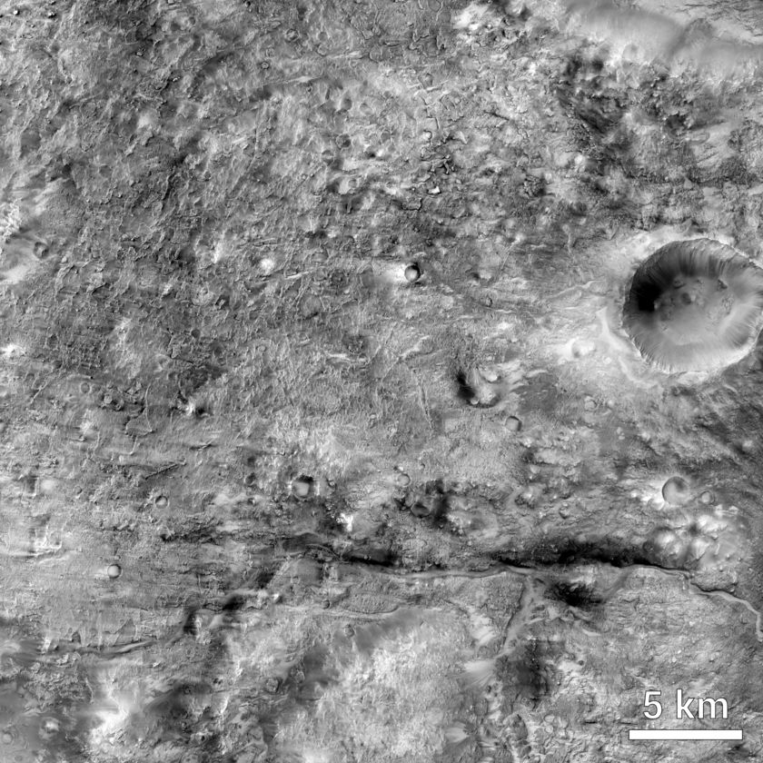

NASA / JPL-Caltech / MSSS / Tanya Harrison

Pictured above is an image of Northeastern Syrtis Major. It was taken by the Mars Reconnaissance Orbiter Context Camera, originally at a resolution of 5m/pixel.

**Stakeholders**

Private companies looking to create Mars bases have a vested interest in the data that would be gathered in MRSA, most notably SpaceX. SpaceX founder Elon Musk has already looked into the schematics of a Mars base but more critical data will further help their efforts (Weitering, 2019). Naturally, NASA and other spacefaring agencies like the European Space Agency (ESA) will also profit from these data, using the data to build a better historical context of Mars and its creation, and to better contextualize life within the universe. Extraterrestrial life may be proven to exist on the mission, so the general public also has a vested interest, funding in with tax dollars crucial to this excursion.

**Subject**

The data that will be collected will be very similar to the data collected on the Mars 2020 mission. Data regarding the geologic subsurfaces are crucial to the mission in order to contextualize Mars’s geological history and possibly biological history. The Radar Imager for Mars’ Subsurface Experiment (RIMFAX) is perhaps the most important tool for this mission, as it will accomplish many geological analyses with a structure of the subsurfaces mapped out (NASA, 2019). The Mars Environmental Dynamics Analyzer (MEDA) would be crucial for determining environmental aspects such as humidity in NESM (NASA, 2019). Scanning Habitable Environments with Raman & Luminescence for Organics and Chemicals (SHERLOC), a UV Raman spectrometer, is ideal for the detection of possible organic minerals within the surface of NESM (NASA, 2019). A SuperCam will also be applied for mineralogy and chemical composition of NESM (NASA, 2019).

**Operational Concepts**

The mission will last up to one martian year (687 Earth days). This is to maximize data and to ensure to map any annual changes in the region of interest. This time is also similar to Mars 2020, so data from both areas can reasonably be compared (NASA, 2019). It will be extremely important to make sure that the rover does not stop functioning, so a key element is to look into the martian environment and adjust the rover to fit that environment. It is possible that the rover could last longer than one martian year, and if so, it will continue sending data back to Earth through intermediary satellites. The launch will probably take place in the summer of 2024 due to the advantageous positions of Mars and Earth (Weitering, 2019). This mission could take place in the summer or fall of 2020 but this mission may interfere with the already planned Mars 2020 mission. There will be no return window for the rover; it will continue collecting and sending data back until it perishes on Mars, similar to the Opportunity rover that was recently deemed out of commission in 2019. There are no certain foreseeable events that could disrupt this mission except the possibility of a dust storm, where the rover employed on MRSA will take similar countermeasures as the Opportunity rover to avoid any damage.

**Constraints**

The mission would have to ideally be launched within a certain timeframe or year in order to best conserve fuel. Additionally, the rover would not be able to be operated at all times during the year due to possible dust storms. The rover may or may not be able to operate without sunlight due to the solar panels on the rover that provide it with power. Machinery and instrumentation also have the possibility to get damaged. Procedures that the Opportunity rover went through will be utilized to try and combat some environmental risks, such as shutting off in dust storms and maintaining power conversion at all times when any sunlight is visible.

**Scope Synopsis**

In an effort to summarize, some key details of the scope of the mission will be reiterated in this section. The necessity of MRSA is to possibly create a base and a need for understanding biological and geological possibilities outside of the Earth. A base is secondary when it comes to the knowledge that could be gained. For goals, a greater epistemological outlook on Mars and its history is important for examining other celestial bodies and their history, thus, MRSA hopes to achieve the knowledge necessary to expand human understanding. The mission will be the first step towards human expansion beyond Earth as well. Ultimately, MRSA aims to follow the footsteps of Mars 2020 but for NESM because of the differences between the locations of each mission. The rover will be launched sometime during the summer of 2024 with hourly data collected.

**Conclusion**

Humanity must always try and strive towards the pursuit of knowledge. MRSA is yet another mission from which NASA will be able to not only expand general knowledge but also apply that new knowledge to Earthly demands. There are always new avenues to be applied towards the mission, such as a venture towards Hellas, a region of Mars not distant from the landing site of MRSA that contains ice. This could be added to the mission plans and creates a more unique rover mission. Although there are still other pathways to follow, this rover mission creates a precedent for further rover -- and possibly human -- exploration of Mars.

References

Bramble, M. S., Mustard, J. F., & Salvatore, M. R. (2017). The geological history of Northeast Syrtis Major, Mars. *Icarus*, *293*, 66–93. doi: 10.1016/j.icarus.2017.03.030

Greicius, T. (2017, February 11). Scientists Shortlist Three Landing Sites for Mars 2020. Retrieved March 4, 2020, from https://www.nasa.gov/feature/jpl/scientists-shortlist-three-landing-sites-for-mars-2020

NASA. (2010, January 20). Candidate Landing Site in NE Syrtis Major – NASA's Mars Exploration Program. Retrieved March 7, 2020, from https://mars.nasa.gov/resources/7684/candidate-landing-site-in-ne-syrtis-major/

NASA. (2019, December). Mars 2020 Perseverance Rover. Retrieved March 8, 2020, from https://mars.nasa.gov/mars2020/

Weitering, H. (2019, August 15). How SpaceX's Starship Will Help Establish a Mars Base. Retrieved March 8, 2020, from https://www.space.com/spacex-starship-mars-transportation-plans.html