Scoping It Out Technical Report

Gavin J. Ruby

Virginia Aerospace Science and Technology Scholars

Abstract

The Promise rover is a new mission designed by NASA to explore the possibility of liquid water, volcanic activity, and alien life at the Martian south pole, known as Planum Australe. Launching in late 2024, it will arrive in mid-2025 and begin collecting samples of ice and rock to help better understand the composition of the Martian environment while a radar system maps out the ice cap below the surface in greater detail than ever before in its search for liquid water. Promise hopes to fulfill the MEP’s goals of looking for life on Mars, understanding Mars’ climate, and looking into the geologic processes occurring within Mars’ crust. While cost, size, and time will be problematic factors when developing Promise, the potential return in the form of sheer data will be worth the investment to the scientists, government, and American people as they analyze the data and form a better understanding of Mars and how we can adapt to survive in the harsh conditions.

Keywords: Promise, NASA, water, volcanic activity, alien life, Planum Australe, MEP, climate, geologic processes.

Scoping It Out Technical Report

In 2018, the Mars Advanced Radar for Subsurface and Ionosphere Sounding (MARSIS) discovered a lake under Planum Astrale, or, the Martian South Pole. Buried under roughly one and a half kilometers of ice, bedrock, and other material, it was not easy to find. It took the team controlling MARSIS three years of data collection, 29 scans, and three more years of analysis to definitively confirm the existence of liquid water under the ice cap (Billings, 2018). This opened the door to the question of how water could exist. It was too cold to maintain its liquid state, even with the pressure and salt dissolved in the water (Gough, 2019). The next possibility is volcanic activity. While Mars’ volcanoes have been thought to be dormant for the last billion years, there is the possibility that magma chambers are still forming under Mars’ surface. In a press release by the American Geophysical Union, the researchers responsible for the discovery suggested that within the last 300,000 years or so, a magma chamber formed under the ice cap and provided enough heat to melt the underside of the ice cap into a lake of liquid water and keep the temperature high enough to maintain its liquid state (Study Suggests Prospect of Recent Underground Volcanism on Mars, 2019). It is widely speculated that, if life were to exist on Mars, it would be underground, and the discovery of water could help aid the search for life and better our understanding of our neighboring planet. To help further the research, NASA intends to launch a mission to Mars during the 2024 Hohmann transfer orbit window to send their latest Mars Rover, Promise, to the Red Planet aboard their Space Launch System (SLS). Equipped with cutting edge technology capable of looking through the ice and mapping out the lake and surrounding ice cap, Promise will help expand and improve the data set initially recorded by MARSIS and give us a better understanding of Mars, above ground and below.

# Mission Goals

Promise looks to answer three main questions for NASA: Is there liquid water on Mars, and, if so, in what quantity? Is there active volcanic activity on Mars? And is Planum Australe a viable landing point for future colonization attempts? These questions fall in line with several of NASA’s science goals regarding Mars. Goal one, the search for life, is advanced by searching Planum Australe for water and signs of life, such as biological signatures. Goal two, the understanding of Mars’ climate, is further pursued by Promise as it continues to expand the data on Planum Australe. By studying the ice caps and potential volcanic activity, NASA is helping expand our understanding of Mars’ past and potential future climates. Goal three is one of NASA’s main focuses during Promise’s mission: geology. The potential discovery of volcanic activity under Mars’ surface could have unprecedented implications for the potential for life on Mars. Geothermal energy has already been discovered by humans, why couldn’t underground Martian civilizations cannot do the same? It would also lean toward the idea presented by Steve Clifford, a researcher at the Planetary Science Institute, that massive reservoirs exist under Mars’ surface across the planet. If volcanic activity is widespread and active, it could keep these reservoirs in a liquid state and make them easier for future colonists, or alien civilizations to support themselves. The research Promise will perform could be a massive breakthrough that provides massive insight as to the nature of Mars.

# Landing Site

Landing Site 1 (LS1) is the primary landing site of Promise. Located near the South pole, its coordinates are 85S, 45W (Mars Map, n.d). This is the location where the underground lake was detected by MARSIS. Using a similar drop cable method to Curiosity, Promise will be lowered to the ground by the lander before waking up and beginning its mission. Planum Australe is a flat, dry environment, so traversing the terrain will not be a difficulty for Promise. This ease of movement will allow it to move to different locations to study the ice composition and further map the Martian Surface. No rover has ever explored Planum Australe, so the opportunity for massive data collection is significant.

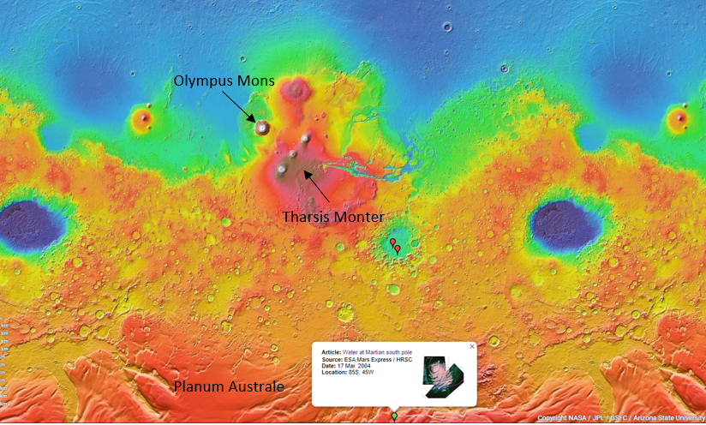

LS1 is designated by the green dot and text box in the lower middle (Mars Map, n.d).

# Operational Concept

After four years of development, Promise will launch aboard an SLS rocket from Cape Canaveral at a date near November 26, 2024 (when the 2024 Hohmann Transfer orbit begins), with optimal weather conditions for a successful launch (Hop, n.d). After roughly eight months of travel, Promise will touch down at LS1 in June of 2025. This corresponds with just after the Martian winter solstice in the southern hemisphere, so Promise will have time to analyze the ice cap at its prime and as it melts during the transition to the Martian spring and summer (Mars’ Calendar, n.d). This will allow a better understanding of the seasonal effects on Planum Australe. Promise’s minimum mission duration is one full Martian year, or 1.88 Earth years (Martian Year, n.d), but, like the Curiosity rover, NASA intends to continue operating Promise until it is no longer able to perform its research, or it becomes irrelevant. NASA’s major time-based goals include launch, entering Mars’ gravitational pull, landing, the first detection of liquid water, 30 sols on Mars, 180 sols on Mars, 334 sols, or a half of a Martian year, and 668 sols, or a full Martian year. This will mark the end of the minimum mission duration NASA hopes to achieve with Promise.

# Mission Subject

NASA is using a lot of the same technology that went into previous Mars rovers, like Curiosity. For example, the dust storms on Mars make solar panels inadequate, even for a rover, so Curiosity uses a compact nuclear reactor called the Multi-Mission Radioisotope Thermoelectric Generator (MMRTP). An MMRTP is designed to run for several years on the plutonium oxide the rover carries (LaMonica, 2015). The MMRTP will power the various tools that Promise will use to perform its research, the first of which is its compact radar system to detect the water under the ice, like the MARSIS satellite. This will be its primary data collection device. By firing radio waves down into the ice and waiting for the echo, it can gauge how deep the ice is and where different materials exist due to the variation in the echo return time. This will help NASA map out the ice caps on Planum Australe. Promise is also equipped with a device like the Heat Flow and Physical Properties Package (HP3) equipped on the InSight lander (Heat Probe, 2019). This device will use its sensors to analyze the different temperatures in Mars’ interior to try to detect any signs of volcanic activity that would create the potential for liquid water. It will be deployed in several locations across Planum Australe to help map the different heat signatures and provide NASA with a better understanding of the thermodynamics occurring within Mars. Promise will also collect samples of rock and ice from the ice cap with a small drill and collection system. These samples will be analyzed by an updated version of Curiosity’s Sample Analysis at Mars Instrument Suite (SAM). The SAM will tell NASA the exact composition of the ice and help find water ice. Using the heat from the MMRTP, Promise can melt the ice and analyze the composition of the solvents within the water to help better understand Mars’ history. These solvents are an important marker for what the water has been exposed to, like what kind of rock it was near, the potential for elements associated with geothermal activity, and if NASA is lucky, biological tracers that would point to life on Mars. The rock samples that Promise will collect could yield the same results. All these samples will help scientists get a better idea of how Mars might have been when it had an abundance of liquid water on its surface, and what kind of challenges future astronauts might encounter when trying to obtain water, etc. Atop Promise is its main camera. This will allow Mission Control to take pictures of Planum Australe and keep tabs on the state of Promise.

# Constraints

As per usual, the first constraint is cost. Rovers are multi-million dollar machines. NASA can’t produce a new rover every week because of the budget constraint, so NASA must make sure the rover can get the most bang for its buck to sell it to the higher-ups and the taxpayers paying for it. The next greatest constraint is space. A rocket can only hold so much. Curiosity weighs 2000 pounds and is nine feet by nine feet by 7 feet in size, making it as big as a car (Howell, 2018). This means that there’s a serious limit as to how much equipment NASA can put on Promise. The more Promise weighs, the more it costs to launch it, so lots of money needs to be invested in weight reduction. The last major constraint is time. The Hohmann Transfer Orbit only occurs once every 26 months (Hop, n.d). NASA’s goal is to launch during the 2024 Hohmann period. If NASA misses that mark, it risks having to wait 26 months for the next Hohmann period and setting back other important Mars-bound missions.

# Stakeholders

Promise’s stakeholders are the scientists working to better understand Mars in preparation for our eventual colonization of the Red Planet. By giving them the data that Promise collects, they will have a better understanding of what will be necessary to prepare the astronauts for. The information can also lend itself to the search for alien life. A relatively small lake on a planet dominated by dry, freezing rocks is an excellent place to start. NASA can also use this information to determine how usable Planum Australe is to future colonies. With water in such short supply, it is a potential candidate for the first Martian settlement.

The data Promise will collect about the composition of Mars’ interior and geothermal activity can help geologists determine Mars’ past when it had active volcanoes, abundant surface water, and the potential for life. These are crucial steps towards our journey out into our solar system. Promise will be the first of its kind to journey to one of the Martian poles. Three of the four cornerstone mission goals that the MEP has set to steer humanity towards a complete understanding of Mars are dramatically advanced by Promise. Promise is well worth the investment by the government, scientists, and American people to help understand our red neighbor.

# Mission Scope

**Need-**

Promise will deliver crucial information about the Martian subsurface, particularly in the Planum Australe region to help scientists better understand the history of Mars and what astronauts will need to be fully prepared to handle the harsh environment. **Goal-**

Promise intends to research the possibility of subsurface liquid water, volcanic activity, and the composition of the Martian crust to help advance MEP’s fundamental goals to explore the possibility of life, better understand the Martian climate, and investigate the geological factors present on Mars. **Objective-**

To send the rover, Promise, to Mars in 2024 to begin collecting samples of Martian soil and rock and using radar to discover any hidden water under the Planum Australe ice cap that might make it easier for astronauts to establish a permanent base on Mars or discover alien life. **Mission Case-**

No rover has explored the Martian south pole or used ground-based radar to examine permanent ice features on the surface to hunt for liquid water or volcanic activity. Both factors could be crucial to the discovery of alien life on Mars and sustained human presence.

**Operational Concept-**

An SLS rocket will launch in November of 2024 and arrive on Mars in June of 2025 with the Promise rover aboard at the coordinates 85S, 45W. Promise will begin scanning the ice cap with its radar system and analyzing samples it takes with the SAM system. Promise is expected to operate for at least 1 Martian year, but it is very feasible that it will continue to run for many more years.

**Assumptions-**

Using the technology developed for Curiosity and other rovers, Promise will be able to save money by reusing the Multi-Mission Radioisotope Thermoelectric Generator (MMRTP) and Sample Analysis at Mars Instrument Suite (SAM). The technology developed for Promise will save money for future missions in a similar fashion. NASA’s budget will allow enough money for Promise to be launch-ready by mid-2024.

**Constraints-**

Promise needs to cut as much cost as possible without breaching its viability to ensure that it is approved for development. It also needs to weigh as little as possible while still carrying the necessary equipment to perform its duty. Lastly, Promise needs to be completed by mid-2024 so it is ready for launch.

References

Anderson, P. S. (2018, July 26). Subsurface lake discovered on Mars? Retrieved from https://earthsky.org/space/mars-express-spacecraft-finds-evidence-of-subsurface-lake-on-mars

Billings, L. (2018, July 25). Mars has a giant hidden lake. Could there be life in it? Retrieved from https://www.pbs.org/newshour/science/mars-south-pole-hides-underground-lake-of-liquid-water-offering-hope-for-life

Gough, E. (2019, February 14). We Just Got Evidence That Mars Could Have Volcanic Activity. Retrieved from https://www.sciencealert.com/there-s-evidence-that-mars-is-still-volcanically-active

Heat Probe. (2019, June 18). Retrieved from https://mars.nasa.gov/insight/spacecraft/instruments/hp3/

Hop. (n.d.). Cosmic Train Schedule. Retrieved from http://clowder.net/hop/railroad/EMa.htm

Howell, E. (2018, July 17). Mars Curiosity: Facts and Information. Retrieved from https://www.space.com/17963-mars-curiosity.ht

LaMonica, M. (2015, February 17). Nuclear generator powers Curiosity Mars mission. Retrieved from https://www.technologyreview.com/s/428751/nuclear-generator-powers-curiosity-mars-mission/

Mars Education: Developing the Next Generation of Explorers. (n.d.). Retrieved from https://marsed.asu.edu/mep/ice/polar-caps/planum-australe

Mars' Calendar. (n.d.). Retrieved from https://www.planetary.org/explore/space-topics/mars/mars-calendar.html

Mars Map. (n.d.). Retrieved from https://www.google.com/mars/

Martian Year. (n.d.). Retrieved from https://mars.nasa.gov/allaboutmars/extreme/martianyear/

Study Suggests Prospect of Recent Underground Volcanism on Mars. (2019, February 15). Retrieved from https://eos.org/scientific-press/study-suggests-prospect-of-recent-underground-volcanism-on-mars

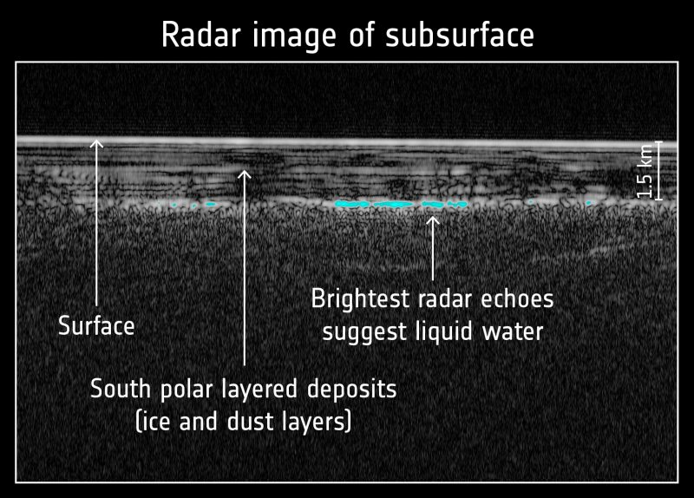

(Anderson, 2018)