create table travel

(

email varchar2(30)primary key,

address varchar2(40),

paddress varchar2(50),

destination varchar2(40)

);

insert into travel values('geeta','geeta@gmail.com','hassan','udupi');

insert into travel values('sheetal','sheetal@gmail.com','kodagu','bangalore');

insert into travel values('dev','dev@gmail.com','bangalore','dharwad');

select \* from travel;

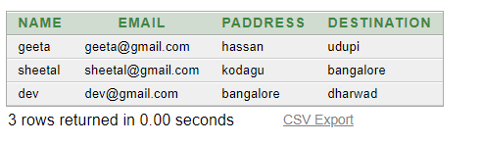

desc travel;

