Investigate Hotel Business
using Data Visualization
Exploratory Data Analysis of Hotel Booking and Cancellation Behaviour (2017-2019)

Prepared by: Meghna Tripathi
Tools: Python, Pandas, NumPy, Matplotlib, Seaborn (Jupyter Notebook)

Item | Detail
Dataset | Hotel bookings, 2017-2019 (119,390 rows x 29 columns)
Hotels | City Hotel and Resort Hotel
Rows after cleaning | 85,376
Business questions | 1. Hotel type booked most 2. Stay length vs cancellation 3. Lead time vs cancellation
Submission files | Notebook (.ipynb), this report, and the video walkthrough

1. Problem Statement

Why booking behaviour matters
A hotel earns revenue from guests who book and stay, but a share of bookings is cancelled. Understanding booking behaviour helps the hotel decide:
- Pricing: raise rates in high-demand months, offer discounts in quiet months.
- Staffing: plan staff according to expected demand.
- Overbooking: use cancellation patterns to avoid empty rooms.
- Marketing and policy: choose cancellation terms and offers that suit each guest type.

Business questions
- Q1. Which hotel type (City Hotel or Resort Hotel) do customers book most often?
- Q2. Does the length of stay affect the cancellation rate?
- Q3. Does lead time (days between booking and arrival) affect the cancellation rate?

Objective
The main deliverable is a Jupyter Notebook that cleans the dataset, uses visualizations to reveal booking and cancellation patterns, and gives the hotel manager data-driven recommendations to reduce revenue lost to cancellations.

2. Data Preprocessing
The dataset has 119,390 rows and 29 columns and covers bookings from 2017 to 2019. The columns used most are hotel, is_canceled, lead_time, arrival_date_month, stays_in_weekend_nights and stays_in_weekdays_nights.
Issue | Action | Reason
Missing: children (4) | Filled with 0 | Booking had no children
Missing: agent (16,340) | Filled with 0 | Guest booked without a travel agent
Missing: company (112,593) | Filled with 0 | Booking was not made through a company
Missing: city (488) | Filled with "Unknown" | Guest city was not recorded
Duplicate rows (33,261) | Removed; 86,129 rows left | A duplicate counts one booking twice and distorts rates
meal = "Undefined" (454) | Merged into "No Meal" | Both mean no meal package was recorded
Negative adr (1) | Removed | A room rate cannot be negative
Extreme adr = 5,400 (1) | Removed | One outlier would distort the average rate
Zero guests (165) | Removed | A booking with no guests is not useful
Zero nights (645) | Removed | A zero-night stay has no meaning in stay analysis

Final dataset: 85,376 rows.

3. Analysis

3.1 Q1: Which hotel type is booked most often?
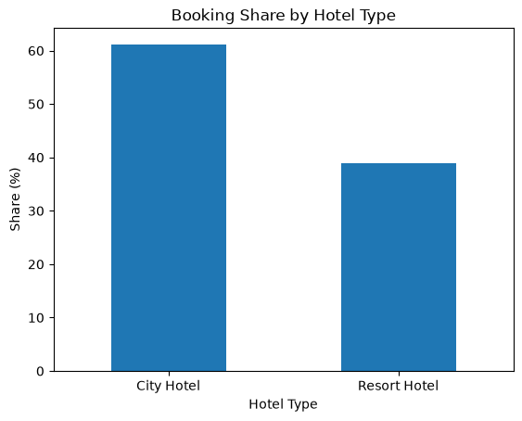
Figure 1. Booking share by hotel type. City Hotel 61.13% (52,190 bookings), Resort Hotel 38.87% (33,186 bookings).
Answer: City Hotel is booked more often, ahead of Resort Hotel by about 22 percentage points.
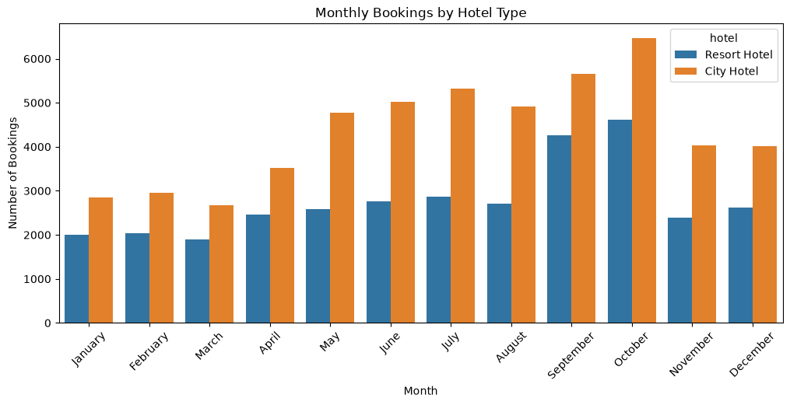
Figure 2. Monthly bookings by hotel type. October is the busiest month and March the quietest; City Hotel leads in every month.
Month | City | Resort | Total
January | 2,849 | 1,995 | 4,844
February | 2,952 | 2,044 | 4,996
March | 2,674 | 1,904 | 4,578
April | 3,514 | 2,453 | 5,967
May | 4,776 | 2,584 | 7,360
June | 5,017 | 2,756 | 7,773
July | 5,321 | 2,863 | 8,184
August | 4,908 | 2,705 | 7,613
September | 5,657 | 4,263 | 9,920
October | 6,473 | 4,615 | 11,088
November | 4,040 | 2,386 | 6,426
December | 4,009 | 2,618 | 6,627

Seasonality. Bookings are lowest from January to March and highest from May to October. Likely reasons: summer and autumn leisure travel (school holidays, pleasant weather); City Hotel also gets business and sightseeing guests all year, while Resort Hotel relies more on leisure travel and so jumps more in peak season. These are plausible explanations, not something the dataset proves.
Decisions the hotel can take: raise rates and add staff in September and October; offer discounts, packages or corporate deals from January to March; schedule maintenance in quiet months such as March.

3.2 Q2: Does the length of stay affect cancellations?
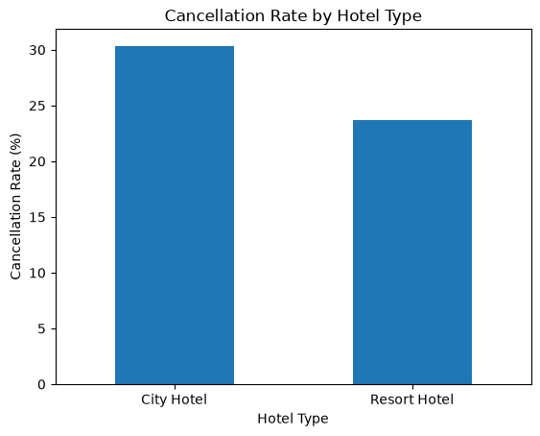
Figure 3. Overall cancellation rate by hotel type. City Hotel 30.32%, Resort Hotel 23.71%.
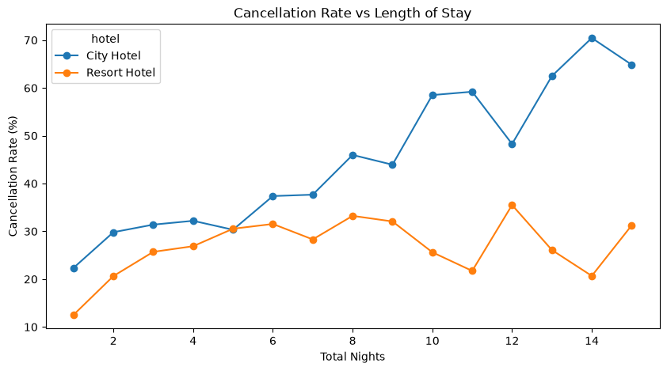
Figure 4. Cancellation rate vs length of stay (1 to 15 nights).
Nights | City Hotel (%) | Resort Hotel (%)
1 | 22.36 | 12.53
2 | 29.82 | 20.64
3 | 31.40 | 25.71
4 | 32.20 | 26.89
5 | 30.33 | 30.54
6 | 37.38 | 31.54
7 | 37.67 | 28.31
8 | 45.98 | 33.24
10 | 58.51 | 25.62
12 | 48.28 | 35.51
14 | 70.45 | 20.68

Answer: Yes, for City Hotel. Its cancellation rate rises steadily with stay length (22.36% for 1 night, 45.98% for 8 nights, 70.45% for 14 nights): a strong positive relationship. At Resort Hotel the rate rises at first and then stays roughly between 20% and 35%, so the effect is weaker. Stays longer than 10 nights are rare, so those rates are less reliable.
Possible reasons:
- Longer stays cost more and are harder to plan, so a change in leave, work or budget leads to cancellation.
- Longer stays are often booked far in advance (high lead time), giving plans more time to change.
- Some guests book several hotels or platforms and later keep only one.

3.3 Q3: Does lead time affect cancellations?
Lead time is the number of days between the booking date and the arrival date.
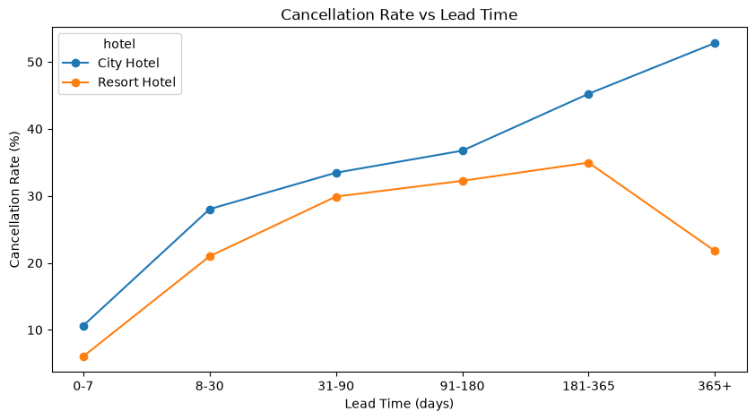
Figure 5. Cancellation rate vs lead time.
Lead time (days) | City Hotel (%) | Resort Hotel (%)
0-7 | 10.63 | 6.04
8-30 | 28.02 | 20.98
31-90 | 33.46 | 29.89
91-180 | 36.75 | 32.25
181-365 | 45.25 | 34.97
365+ | 52.82 | 21.76

Answer: Yes, for City Hotel. Its cancellation rate rises steadily with lead time, from 10.63% (0-7 days) to 52.82% (365+ days). Resort Hotel is more stable and stays at or below about 35%. Cancellations are lowest for last-minute bookings at both hotels and highest for City Hotel bookings made more than a year ahead.
Possible reasons: City Hotel serves many business and short city trips, where plans change often and free cancellation is common. Resort guests tend to plan vacations in advance and are more committed. The drop at Resort Hotel for 365+ days may reflect a different type of booking, as very early bookings are few; this could not be confirmed from the data.

4. Summary and Recommendations

Key findings
- Hotel type: City Hotel 61.13% of bookings, Resort Hotel 38.87%.
- Seasonality: October busiest (11,088), March quietest (4,578).
- Stay duration: City Hotel cancellations rise sharply with longer stays; the effect is weaker at Resort Hotel.
- Lead time: City Hotel cancellations rise from 10.63% to 52.82%; Resort Hotel is more stable.
- Overall cancellation: City Hotel 30.32%, Resort Hotel 23.71%.

Recommendations
Hotel type and seasonality
- Grow Resort Hotel in the off-season (January to March) with packages and discounts.
- Raise rates and increase staffing in peak months (September and October).
Stay duration
- At City Hotel, require an advance payment or deposit for stays longer than 7 nights.
- Offer long-stay discounts only when the booking carries strict cancellation terms.
Lead time
- For bookings made more than 90 days ahead, send reminder emails and ask guests to reconfirm a few weeks before arrival.
- At City Hotel, apply a small deposit or less flexible cancellation terms to far-ahead bookings.

Highest-impact recommendation
Introduce a deposit or reconfirmation step for far-ahead (180+ days) and long-stay bookings at City Hotel. Evidence: City Hotel cancellations are 45.25% for 181-365 days and 52.82% for 365+ days, against 10.63% for 0-7 days (Figure 5); the stay chart shows the same pattern, rising from 22.36% at 1 night to 45.98% at 8 nights (Figure 4). This is where the cancellation risk is greatest, so action here protects the most revenue.

Limitation
In the deposit data, 98.7% of bookings are "No Deposit", and Non-Refund bookings show a 94.84% cancellation rate that this dataset cannot explain. The deposit suggestion is therefore a measure to test, not a proven fix.

