**Q1 Run the following Tobit model.**

**PROC** **QLIM** data=credit;

model profit = age ttrans rewards climit numcard

ds ts net quantum platinum gold sectorB sectorC sectorD sectorE sectorF;

endogenous profit ~ censored (lb=**0**);

**Run**;

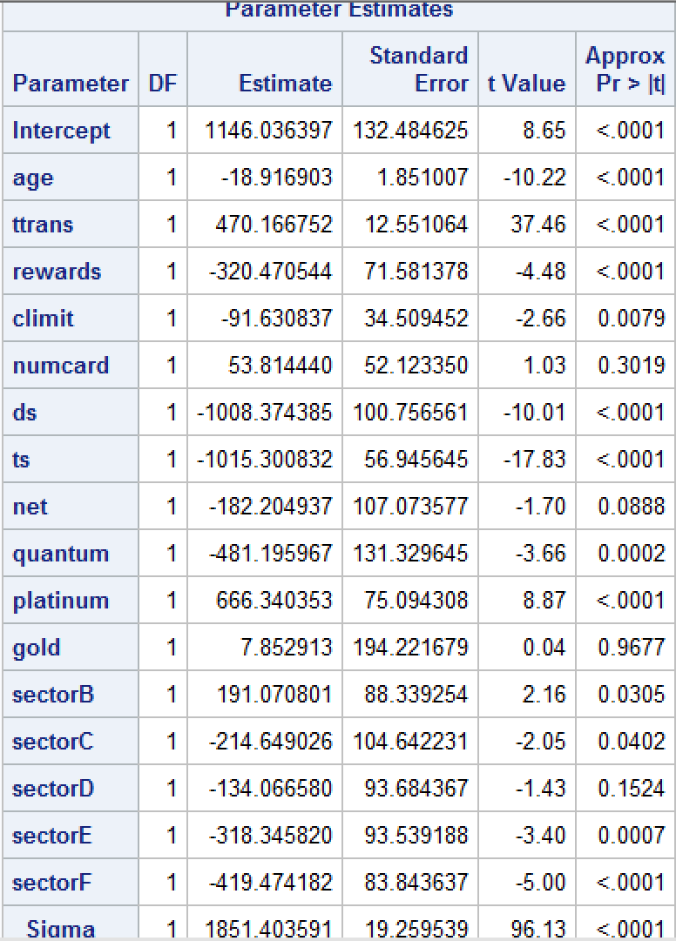

**Write a summary of the results. Focus on important effects, interpretation, model fit etc.**

**Insignificant variables:**

numcard, net, gold, sectorD.

**Coefficient Interpretation:**

* 1-year increase in age decreases profit by about $19.
* 1 unit increase in ttrans(or $10000 increase in tottrans) increases profit by $470.
* A customer with rewards card generates $320 less profit than a customer with no reward card.
* 1 unit increase in climit(or $10000 increase in limit) decreases profit by $92.
* A customer acquired through direct selling generates $1008 less profit than a customer acquired through direct mail.
* A customer acquired through telephone selling generates $1015 less profit than a customer acquired through direct mail.
* A customer with quantum card generates $481 less profit than a customer with standard card.
* A customer with platinum card generates $666 more profit than a customer with standard card.
* A Customer with Affinity card B generates $191 more profit than a customer with no affinity card.
* A Customer with Affinity card C generates $214 less profit than a customer with no affinity card.
* A Customer with Affinity card E generates $318 less profit than a customer with no affinity card.
* A Customer with Affinity card F generates $419 less profit than a customer with no affinity card.

**Which mode of acquisition generates the highest profit?**

DM, customers acquired through direct mail generate the highest profit.

**Order the modes of acquisition from high to low in terms of profit.**

1. DM
2. NET
3. DS
4. TS

**Q2 Run a selection model (Use PROC QLIM)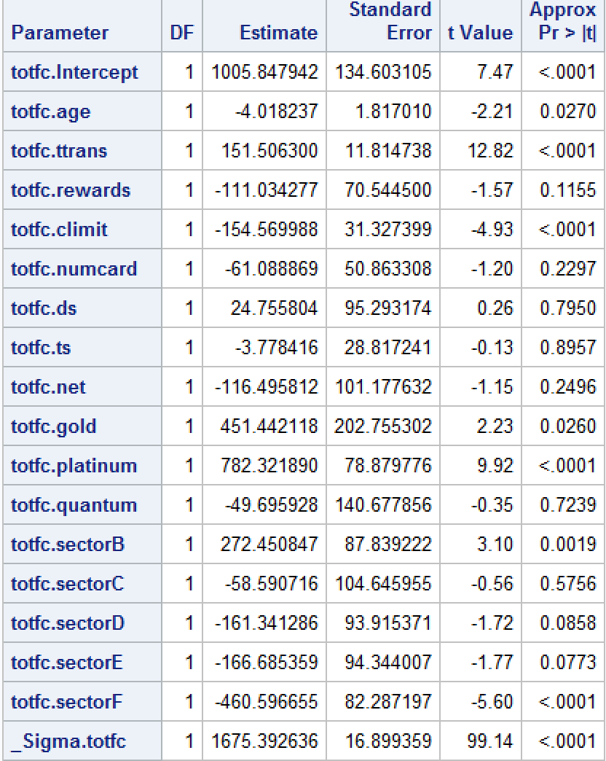.**

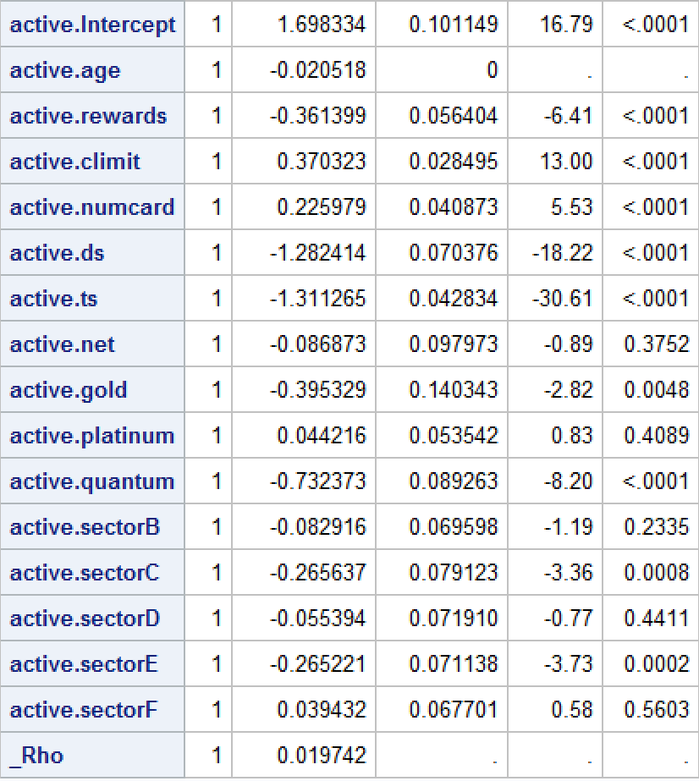

**proc** **QLIM** data=credit;

model active = age rewards climit numcard ds ts net gold platinum

quantum sectorB sectorC sectorD sectorE sectorF/discrete;

model totfc = age ttrans rewards climit numcard ds ts net gold platinum

quantum sectorB sectorC sectorD sectorE sectorF/ select(active=**1**); **run**;

**Outcome equation:**  
Model totfc = age, ttrans, rewards, climit, numcard, modes of acquisition, type of card, types of affinity

**Selection equation:**Model active = age, rewards, climit, numcard, modes of acquisition, type of card, types of affinity.

**Rho** is correlation between errors of outcome equation and selection equation, Rho in this model is significant, we reject that the rho = 0, this means we should use sample selection model on this data.

**Coefficient interpretation:**

If a variable appears only in the outcome equation the coefficient on it can be interpreted as the marginal effect of that variable on Y. if a variable in outcome equation is also seen in the selection equation, then the interpretation changes. Adding beta + inverse mills ratio gives adjusted beta value.

Totfc.ttrans: 1 unit increase in ttrans increases the totfc by $151.

From the outcome model, sectorB creates most totfc, since profit is derived from totfc and tottrans, sectorB creates most profit, C, D, E, F being next in order.

**3. Survival analysis**

**data** creditcard;

set credit;

if dur = **37** then censor = **1**; else censor = **0**;

**run**;

**proc** **phreg** data = creditcard;

model dur*censor(**1**) = age ttrans rewards climit numcard ds ts net

gold platinum quantum sectorB sectorC sectorD sectorE sectorF;

**run**;

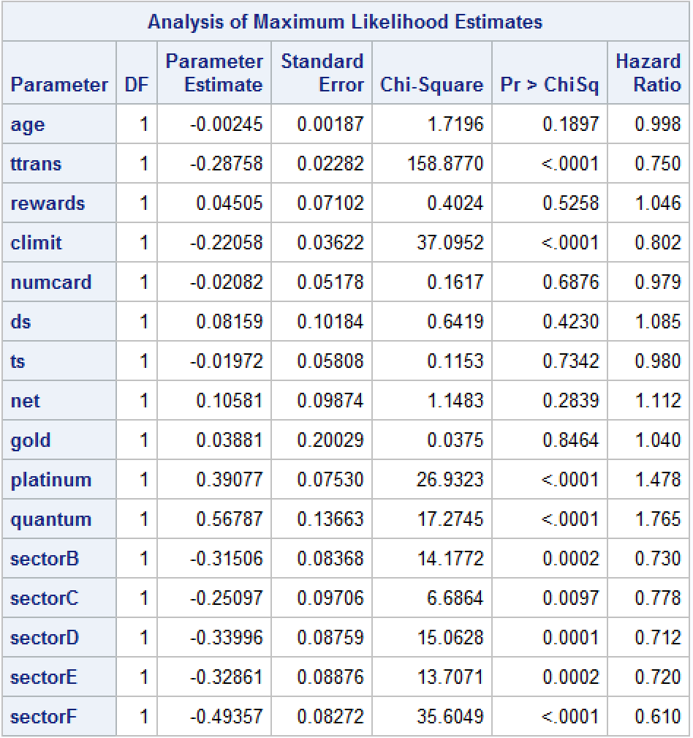

**Insignificant variables:**

Age, rewards, numcard, ds, ts, net, gold.

**Interpretation:**

* One unit increase in ttrans will decrease the hazard rate by 29%.
* One unit increase in climit will decrease the hazard by 22%.
* Platinum cards have 39% more hazard rate than standard cards.
* Quantum cards have 57% more hazard rate than standard cards.
* SectorB affinity cards have 31% less hazard rate than sectorA(no affinity card).
* SectorC affinity cards have 25% less hazard rate than sectorA(no affinity card).
* SectorD affinity cards have 34% less hazard rate than sectorA(no affinity card).
* SectorE affinity cards have 33% less hazard rate than sectorA(no affinity card).
* SectorF affinity cards have 50% less hazard rate than sectorA(no affinity card).

Adding covariate censor(1) improved -2 LOG L and AIC values compared to no covariate.

**4. Run the same model as above using PROC LIFEREG with Weibull distribution.**

**proc** **lifereg** data = creditcard;

model dur*censor(**1**) = age ttrans rewards climit numcard ds ts net

gold platinum quantum sectorB sectorC sectorD sectorE sectorF/dist = weibull;

**run**;

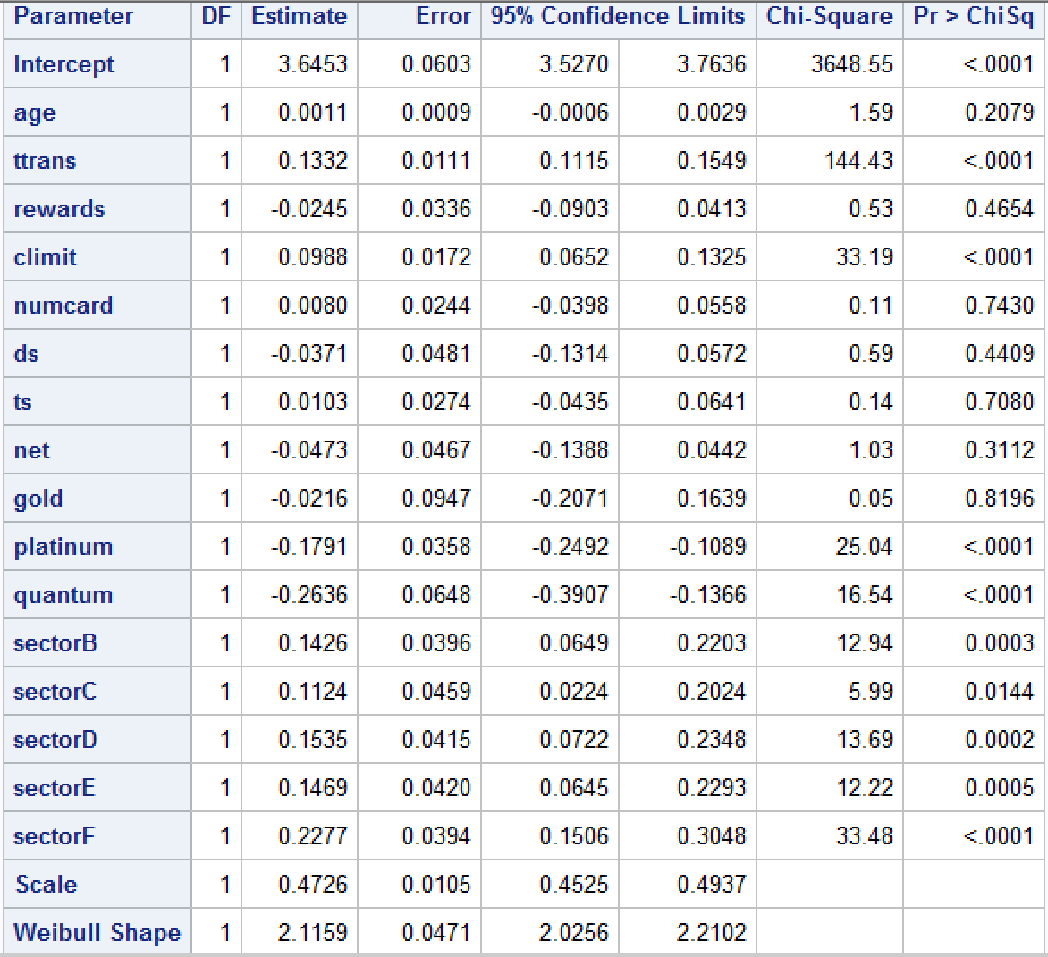

**Coefficient Interpretation:**

exp(β) gives the ratio of the expected survival times for the two groups if the X variables is binary. For a continuous variable, 100(exp(β)-1) gives the percent increase in expected survival time for each unit increase in the variable.

**Insignificant variables:**

Age, rewards, numcard, ds, ts, net, gold.

* Customers with higher ttrans have better survival time, one unit increase in ttrans will increase the survival time by 14.2%. ((exp(0.1332)-1)*100).
* Customers with higher climit have better survival time, one unit increase in climit will increase the survival time by 10.4%.
* Customers with platinum card have less survival time than customers with standard card, Survival time of platinum card users is 0.83(exp(-0.1791)) of survival time of standard card users.
* Customers with quantum card have less survival time than customers with standard card, Survival time of quantum card users is 0.76(exp(-0.2636)) of survival time of standard card users.
* Customers with Affinity cardB have more survival time than customers with No Affinity card, Survival time of Affinity cardB users is 1.15 times(exp(0.1426)) the survival time of standard card users.
* Customers with Affinity cardC have more survival time than customers with No Affinity card, Survival time of Affinity cardC users is 1.11 times(exp(0.1124)) the survival time of standard card users.
* Customers with Affinity cardD have more survival time than customers with No Affinity card, Survival time of Affinity cardD users is 1.16 times(exp(0.1535)) the survival time of standard card users.
* Customers with Affinity cardE have more survival time than customers with No Affinity card, Survival time of Affinity cardE users is 1.16 times(exp(0.1469)) the survival time of standard card users.
* Customers with Affinity cardF have more survival time than customers with No Affinity card, Survival time of Affinity cardF users is 1.2 times(exp(0.2277)) the survival time of standard card users.

Weibull shape parameter tells the failure rate behavior. Since, the value in this model is greater than 1, the failure rate increases with time.

**Q5 Use PROC LIFETEST to test whether survivor function of affinity groups are significantly different from that of non-affinity groups. (that is compare sectorA with other sectors).**

**proc** **lifetest** data = creditcard plots=(s);

time dur*censor(**1**);

strata sectorA;

**run**;

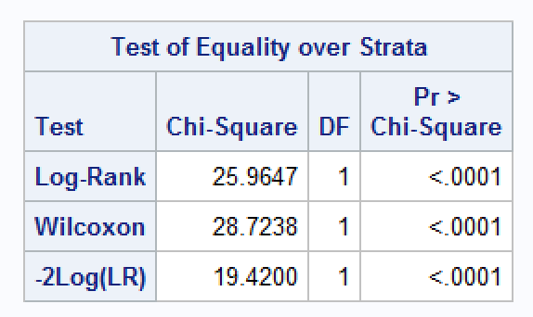

In the test of Equality over strata, the p value is significant, which indicates that there is a significant difference among the survival curves (survivor function) of two groups (Affinity and No Affinity).

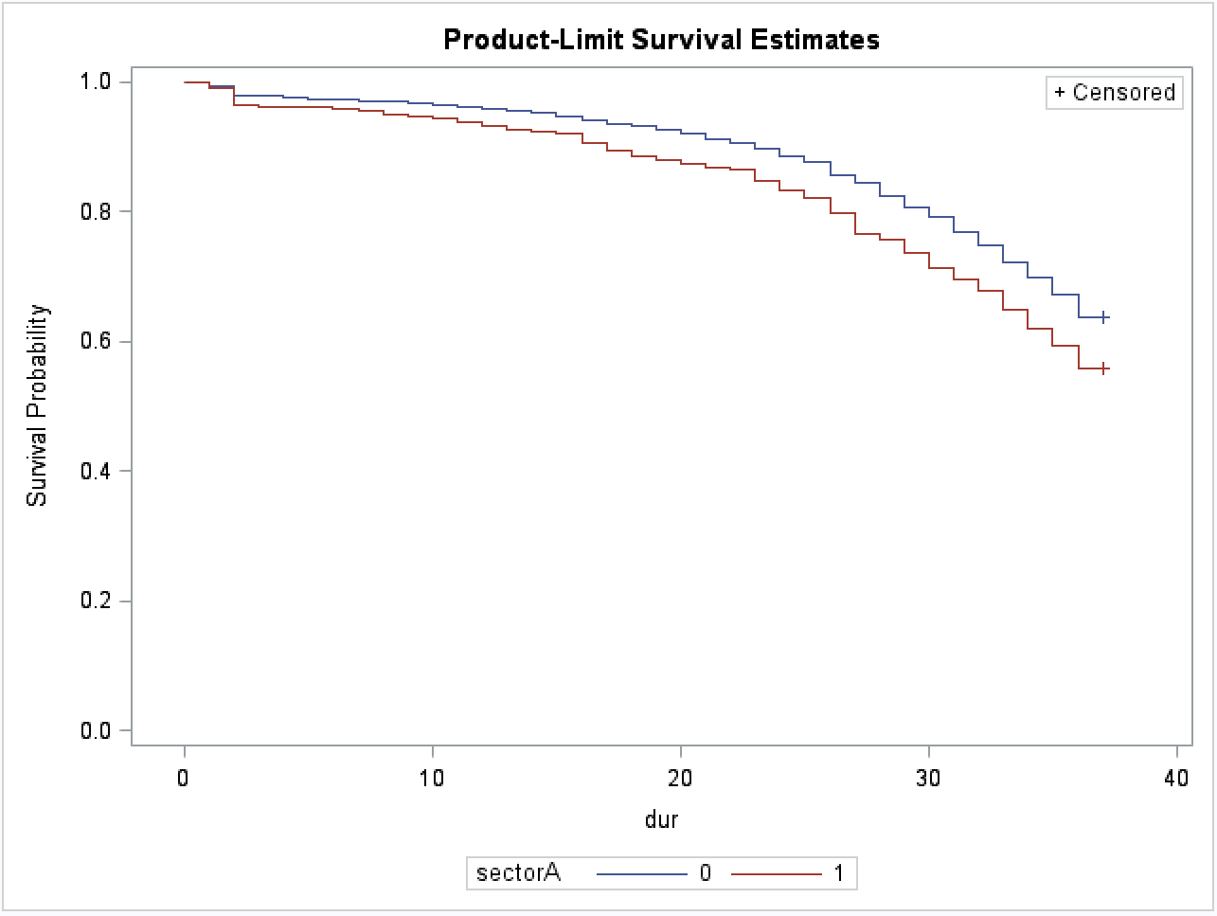

SectorA = 1 indicates no affinity card. (Red curve)  
SectorA = 0 indicates affinity card. (Blue curve)

From the graph above, we can conclude that as the duration increases, the probability of survival decreases for both the groups, customers with affinity card have higher chance of survival than the customers with no affinity card.