**MACHINE LEARNING AND ITS APPLICATIONS**

**NAME : MEGHANA P**

**SECTION : ECE-AIML(3rd year)**

**SECTION : BU22EECE0100339**

**"Birds 20 Species Image Classification"**

**AIM :** To develop and evaluate machine learning models for image classification by recognizing and differentiating between 20 species of birds based on their images**.**

**Tools Required:**

* Spyder
* Spyder Libraries: pandas, scikit-learn, numpy, matplotlib
* Dataset

**THEORY**

* We teach a computer to recognize birds from pictures.
* The computer learns by looking at many bird images.
* A special AI model called CNN helps find shapes, colors, and patterns.
* We use smart models (like ResNet or VGG16) to make learning faster.
* We change images a little (flip, rotate) so the model gets better.
* We check how well it works using accuracy and mistakes.
* This helps in birdwatching, research, and saving birds!

**OBJECTIVES**

**1.Develop an Image Classification Model**

* + Train a machine learning or deep learning model to accurately classify images of birds into 20 different species.

1. **Enhance Computer Vision Capabilities**
   * Improve image recognition techniques by applying Convolutional Neural Networks (CNNs) or other deep learning architectures.
2. **Support Biodiversity and Conservation Efforts**
   * Assist in the identification of bird species for ecological research, conservation, and environmental monitoring**.**
3. **Benchmark Performance of Classification Algorithms**
   * Compare different classification techniques such as CNNs, Transfer Learning (e.g., VGG16, ResNet, EfficientNet), and traditional machine learning approaches.
4. **Improve Model Generalization**
   * Ensure that the trained model performs well on unseen bird images, reducing overfitting and increasing real-world applicability**.**
5. **Facilitate Data-Driven Research**
   * Provide researchers and AI practitioners with a structured dataset to study automated species identification and improve AI-based image classification.
6. **Encourage Kaggle Community Participation**
   * Enable data scientists and enthusiasts to experiment, share notebooks, and refine classification models using this dataset.

**GOALS**

1. Achieve High Classification Accuracy
2. Develop a Robust and Scalable Model
3. Utilize Transfer Learning for Better Performance
4. Enable Real-World Application in Ornithology and Conservation
5. Optimize Model Performance with Hyperparameter Tuning
6. Encourage Open-Source Contributions and Learning
7. Deploy a Functional Classification System
8. Advance AI Research in Fine-Grained Image Classification.

**1.Hidden Markov Model**

**DEFINATION :** A Hidden Markov Model (HMM) is a statistical model that represents a system with hidden states where the system evolves over time, and the observer can only see some output that depends on the hidden state.

An HMM consists of two types of variables: hidden states and observations.

* The hidden states are the underlying variables that generate the observed data, but they are not directly observable.
* The observations are the variables that are measured and observed.

The Hidden Markov Model (HMM) algorithm can be implemented using the following steps:

* Step 1: Define the state space and observation space: The state space is the set of all possible hidden states, and the observation space is the set of all possible observations.
* Step 2: Define the initial state distribution: This is the probability distribution over the initial state.
* Step 3: Define the state transition probabilities: These are the probabilities of transitioning from one state to another. This forms the transition matrix, which describes the probability of moving from one state to another.
* Step 4: Define the observation likelihoods: These are the probabilities of generating each observation from each state. This forms the emission matrix, which describes the probability of generating each observation from each state.
* Step 5: Train the model: The parameters of the state transition probabilities and the observation likelihoods are estimated using the Baum-Welch algorithm, or the forward-backward algorithm. This is done by iteratively updating the parameters until convergence.
* Step 6: Decode the most likely sequence of hidden states: Given the observed data, the Viterbi algorithm is used to compute the most likely sequence of hidden states. This can be used to predict future observations, classify sequences, or detect patterns in sequential data.
* Step 7: Evaluate the model: The performance of the HMM can be evaluated using various metrics, such as accuracy, precision, recall, or F1 score.

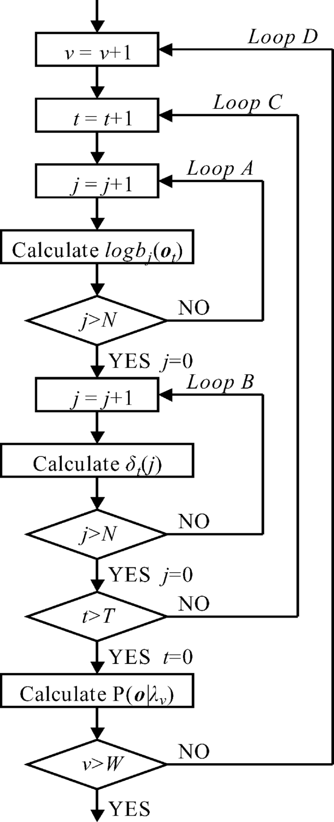

**FINAL CODE**

import os

import numpy as np

import pandas as pd

import matplotlib.pyplot as plt

import seaborn as sns

from sklearn.metrics import accuracy_score, classification_report, confusion_matrix

from google.colab import files

import zipfile

from sklearn.model_selection import train_test_split

from sklearn.mixture import GaussianMixture

from sklearn.preprocessing import LabelEncoder

from skimage.feature import hog

from PIL import Image

# Upload file in Colab

uploaded = files.upload()

# Extract uploaded zip file

for filename in uploaded.keys():

extract_path = 'data'

with zipfile.ZipFile(filename, 'r') as zip_ref:

zip_ref.extractall(extract_path)

train_path = os.path.join(extract_path, 'train')

valid_path = os.path.join(extract_path, 'valid')

test_path = os.path.join(extract_path, 'test')

# Function to extract HOG features from an image

def extract_hog_features(image_path):

image = Image.open(image_path).convert('L').resize((150, 150))

features = hog(np.array(image), pixels_per_cell=(8, 8), cells_per_block=(2, 2), feature_vector=True)

return features

# Load images and extract features

train_features, train_labels = [], []

for bird_class in os.listdir(train_path):

bird_folder = os.path.join(train_path, bird_class)

for img_file in os.listdir(bird_folder):

img_path = os.path.join(bird_folder, img_file)

train_features.append(extract_hog_features(img_path))

train_labels.append(bird_class)

valid_features, valid_labels = [], []

for bird_class in os.listdir(valid_path):

bird_folder = os.path.join(valid_path, bird_class)

for img_file in os.listdir(bird_folder):

img_path = os.path.join(bird_folder, img_file)

valid_features.append(extract_hog_features(img_path))

valid_labels.append(bird_class)

# Encode labels

label_encoder = LabelEncoder()

train_labels = label_encoder.fit_transform(train_labels)

valid_labels = label_encoder.transform(valid_labels)

# Train HMM using Gaussian Mixture Model (GMM-HMM approach)

hmm_models = []

unique_labels = np.unique(train_labels)

for label in unique_labels:

label_data = np.array([train_features[i] for i in range(len(train_labels)) if train_labels[i] == label])

model = GaussianMixture(n_components=4, covariance_type='diag', n_init=3)

model.fit(label_data)

hmm_models.append((model, label))

# Prediction function

def predict_hmm(features):

scores = [model.score(features.reshape(1, -1)) for model, _ in hmm_models]

return hmm_models[np.argmax(scores)][1]

# Evaluate model

predictions = [predict_hmm(np.array(f)) for f in valid_features]

# Calculate accuracy

accuracy = accuracy_score(valid_labels, predictions)

print("Test Accuracy:", accuracy)

# Classification report

print("Classification Report:\n", classification_report(valid_labels, predictions, target_names=label_encoder.classes_))

# Confusion matrix

conf_matrix = confusion_matrix(valid_labels, predictions)

plt.figure(figsize=(10, 8))

sns.heatmap(conf_matrix, annot=True, fmt='d', cmap='Blues', xticklabels=label_encoder.classes_, yticklabels=label_encoder.classes_)

plt.xlabel('Predicted Label')

plt.ylabel('True Label')

plt.title('Confusion Matrix-bu22eece0100339-Meghana P')

plt.show()

# Save performance metrics to an Excel file

performance_data = {

'Metric': ['Accuracy'],

'Value': [accuracy]

}

performance_df = pd.DataFrame(performance_data)

performance_df.to_excel('performance_metrics_hmm.xlsx', index=False)

print("Performance metrics saved to performance_metrics_hmm.xlsx")

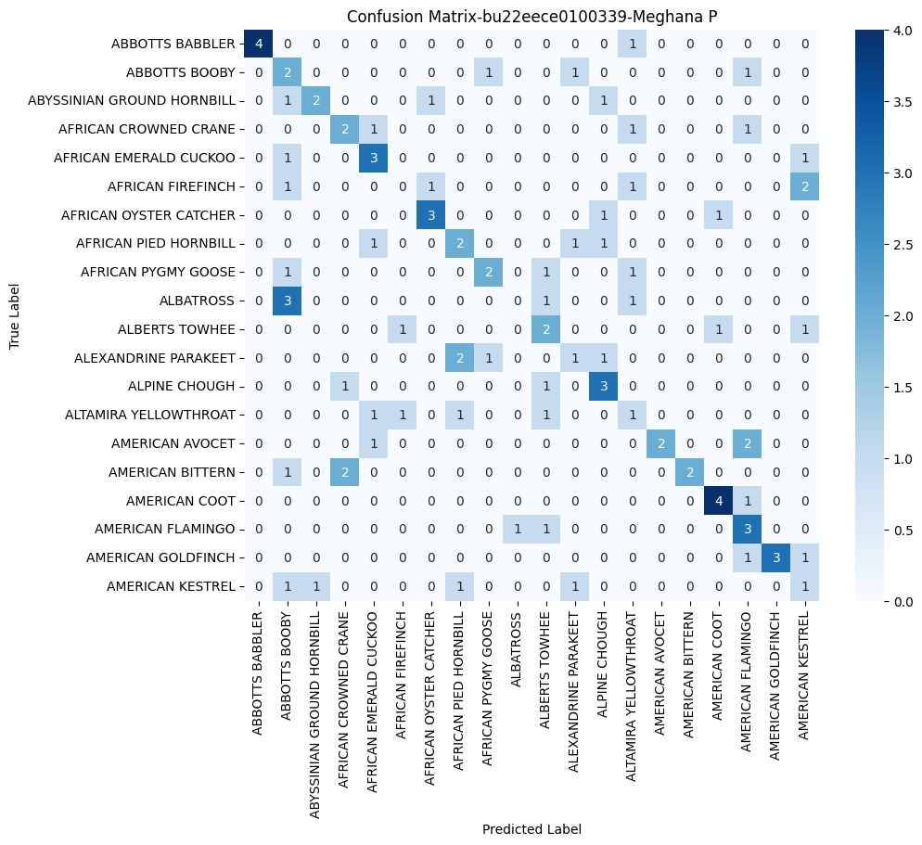

**Classification Report:**

precision recall f1-score support

ABBOTTS BABBLER 0.50 0.60 0.55 5

ABBOTTS BOOBY 0.60 0.60 0.60 5

ABYSSINIAN GROUND HORNBILL 0.43 0.60 0.50 5

AFRICAN CROWNED CRANE 1.00 0.60 0.75 5

AFRICAN EMERALD CUCKOO 0.44 0.80 0.57 5

AFRICAN FIREFINCH 0.71 1.00 0.83 5

AFRICAN OYSTER CATCHER 0.62 1.00 0.77 5

AFRICAN PIED HORNBILL 1.00 0.40 0.57 5

AFRICAN PYGMY GOOSE 0.62 1.00 0.77 5

ALBATROSS 0.80 0.80 0.80 5

ALBERTS TOWHEE 1.00 0.80 0.89 5

ALEXANDRINE PARAKEET 1.00 0.80 0.89 5

ALPINE CHOUGH 1.00 1.00 1.00 5

ALTAMIRA YELLOWTHROAT 0.80 0.80 0.80 5

AMERICAN AVOCET 1.00 0.60 0.75 5

AMERICAN BITTERN 1.00 0.80 0.89 5

AMERICAN COOT 1.00 0.80 0.89 5

AMERICAN FLAMINGO 0.80 0.80 0.80 5

AMERICAN GOLDFINCH 1.00 0.60 0.75 5

AMERICAN KESTREL 0.67 0.40 0.50 5

**accuracy 0.74 100**

**macro avg 0.80 0.74 0.74 100**

**weighted avg 0.80 0.74   0.74       100**

**2.k-nearest neighbors(KNN)**

**Definition :** In the k-Nearest Neighbours (k-NN) algorithm k is just a number that tells the algorithm how many nearby points (neighbours) to look at when it makes a decision.

**Distance Metrics Used in KNN Algorithm**

**1. Euclidean Distance**

Euclidean distance is defined as the straight-line distance between two points in a plane or space. You can think of it like the shortest path you would walk if you were to go directly from one point to another.

distance(x,Xi)=∑j=1d(xj–Xij)2]distance(*x*,*Xi*​)=∑*j*=1*d*​(*xj*​–*Xij*​​)2​]

**2. Manhattan Distance**

This is the total distance you would travel if you could only move along horizontal and vertical lines (like a grid or city streets). It’s also called “taxicab distance” because a taxi can only drive along the grid-like streets of a city.

d(x,y)=∑i=1n∣xi−yi∣*d*(*x*,*y*)=∑*i*=1*n*​∣*xi*​−*yi*​∣

**3. Minkowski Distance**

Minkowski distance is like a family of distances, which includes both **Euclidean** and **Manhattan distances** as special cases.

d(x,y)=(∑i=1n(xi−yi)p)1p*d*(*x*,*y*)=(∑*i*=1*n*​(*xi*​−*yi*​)*p*)*p*1​

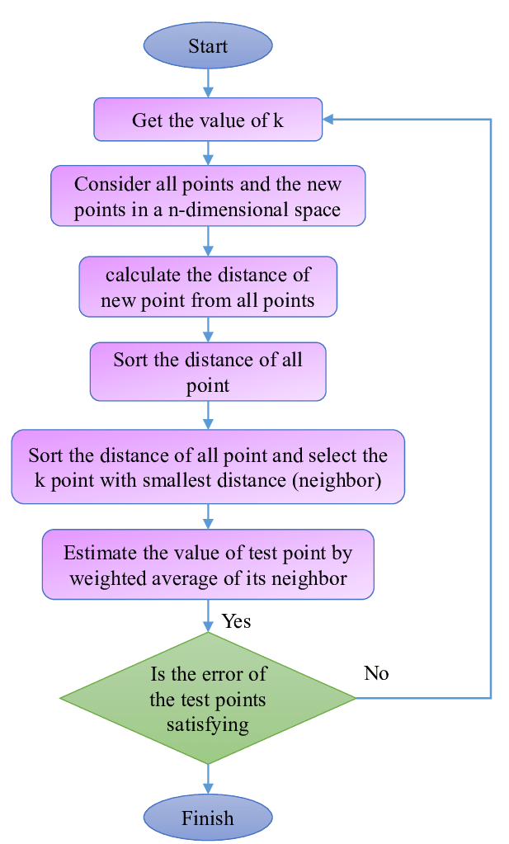

**FINAL CODE**

import os

import zipfile

import numpy as np

import cv2

import shutil

from sklearn.model_selection

import train_test_split

from sklearn.preprocessing import StandardScaler

from sklearn.decomposition import PCA

from sklearn.neighbors import KNeighborsClassifier

from sklearn.metrics import accuracy_score, classification_report, confusion_matrix

import matplotlib.pyplot as plt

import seaborn as sns

from skimage.feature import hog

# Path to ZIP file

zip_path = r"C:\Users\mpara\Downloads\archive (1).zip"

extract_folder = r"C:\Users\mpara\OneDrive\Documents\ML\extracted_data"

# Extract ZIP file

if not os.path.exists(extract_folder):

os.makedirs(extract_folder)

with zipfile.ZipFile(zip_path, 'r') as zip_ref:

zip_ref.extractall(extract_folder)

# Define dataset paths after extraction

train_path = os.path.join(extract_folder, "train")

valid_path = os.path.join(extract_folder, "valid")

test_path = os.path.join(extract_folder, "test")

predict_path = os.path.join(extract_folder, "images to predict")

# Function to extract HOG features from an image

def extract_hog_features(image):

gray = cv2.cvtColor(image, cv2.COLOR_BGR2GRAY)

hog_features, _ = hog(gray, pixels_per_cell=(8,8), cells_per_block=(2,2), visualize=True)

return hog_features

# Function to load images and extract features

def load_images_from_folder(folder):

features, labels = [], []

for class_name in os.listdir(folder): # Assumes subfolders are class labels

class_path = os.path.join(folder, class_name)

if os.path.isdir(class_path): # Ensure it's a folder

for img_name in os.listdir(class_path):

img_path = os.path.join(class_path, img_name)

# Read image and resize

img = cv2.imread(img_path, cv2.IMREAD_COLOR)

img = cv2.resize(img, (128, 128)) # Higher resolution

if img is not None:

feature_vector = extract_hog_features(img) # Extract HOG features

features.append(feature_vector)

labels.append(class_name) # Class label from folder name

return np.array(features), np.array(labels)

# Load train and validation data

X_train, y_train = load_images_from_folder(train_path)

X_valid, y_valid = load_images_from_folder(valid_path)

# Combine train and validation sets

X = np.vstack((X_train, X_valid))

y = np.concatenate((y_train, y_valid))

# Apply PCA to reduce dimensions while preserving key features

pca = PCA(n_components=100) # Reduce to 100 key features

X = pca.fit_transform(X)

# Split into final training and test sets

X_train, X_test, y_train, y_test = train_test_split(X, y, test_size=0.2, random_state=42)

# Standardize features

scaler = StandardScaler()

X_train = scaler.fit_transform(X_train)

X_test = scaler.transform(X_test)

# Train optimized KNN model

k = 5 # Optimized number of neighbors

knn = KNeighborsClassifier(n_neighbors=k, metric='manhattan', weights='distance') # Use weighted distance

knn.fit(X_train, y_train)

# Make predictions

y_pred = knn.predict(X_test)

# Evaluate accuracy

accuracy = accuracy_score(y_test, y_pred)

print(f'Optimized KNN Accuracy: {accuracy:.2f}')

# Display classification report

print("Classification Report:")

print(classification_report(y_test, y_pred))

# Display confusion matrix

cm = confusion_matrix(y_test, y_pred)

plt.figure(figsize=(6, 4))

sns.heatmap(cm, annot=True, cmap='Blues', fmt='d')

plt.xlabel('Predicted')

plt.ylabel('Actual')

plt.title('Confusion Matrix')

plt.show()

# Predict on new images

def predict_new_images(folder, model, scaler, pca):

X_new, filenames = [], []

for img_name in os.listdir(folder):

img_path = os.path.join(folder, img_name)

img = cv2.imread(img_path, cv2.IMREAD_COLOR)

img = cv2.resize(img, (128, 128)) # Resize

if img is not None:

feature_vector = extract_hog_features(img) # Extract HOG features

X_new.append(feature_vector)

filenames.append(img_name)

if X_new:

X_new = np.array(X_new)

X_new = pca.transform(X_new) # Apply PCA

X_new = scaler.transform(X_new) # Standardize

predictions = model.predict(X_new)

for fname, pred in zip(filenames, predictions):

print(f"Image: {fname} -> Predicted Class: {pred}")

else:

print("No images found for prediction.")

# Run predictions on new images

predict_new_images(predict_path, knn, scaler, pca)

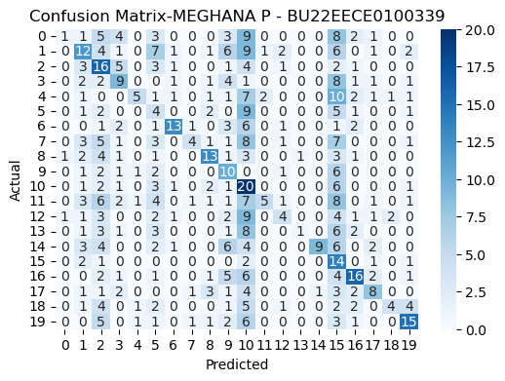

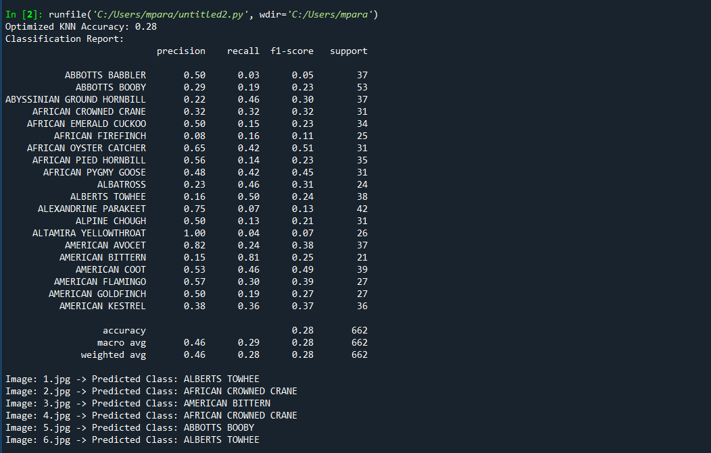

**3.DECISION TREES**

**DEFINITION :** It isa supervised learning algorithm used for both classification and regression tasks, where data is split based on features to create a tree-like structure for prediction.

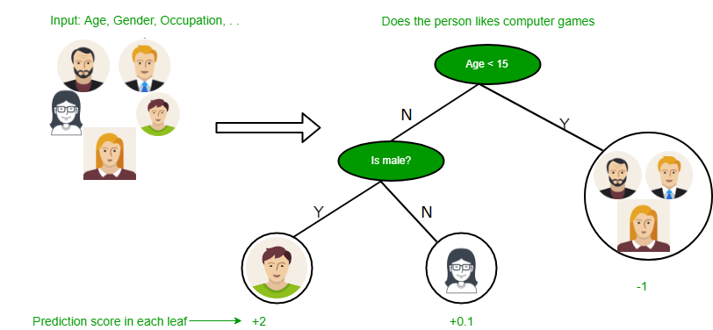

**Example: Predicting Whether a Person Likes Computer Games**

Imagine you want to predict if a person enjoys computer games based on their age and gender. Here’s how the decision tree works:

1. Start with the Root Question (Age):
   * The first question is: *“Is the person’s age less than 15?”*
   * If Yes, move to the left.
   * If No, move to the right.
2. Branch Based on Age:
   * If the person is younger than 15, they are likely to enjoy computer games (+2 prediction score).
   * If the person is 15 or older, ask the next question: *“Is the person male?”*
3. Branch Based on Gender (For Age 15+):
   * If the person is male, they are somewhat likely to enjoy computer games (+0.1 prediction score).
   * If the person is not male, they are less likely to enjoy computer games (-1 prediction score)

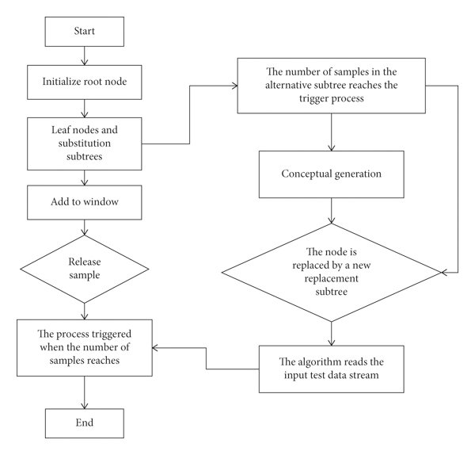

**FINAL CODE**

import os

import zipfile

import numpy as np

import cv2

import shutil

from sklearn.model_selection import train_test_split

from sklearn.preprocessing import StandardScaler

from sklearn.decomposition import PCA

from sklearn.tree import DecisionTreeClassifier

from sklearn.metrics import accuracy_score, classification_report, confusion_matrix

import matplotlib.pyplot as plt

import seaborn as sns

from skimage.feature import hog

# Path to ZIP file

zip_path = r"C:\Users\mpara\Downloads\archive (1).zip"

extract_folder = r"C:\Users\mpara\OneDrive\Documents\ML\extracted_data"

# Extract ZIP file

if not os.path.exists(extract_folder):

os.makedirs(extract_folder)

with zipfile.ZipFile(zip_path, 'r') as zip_ref:

zip_ref.extractall(extract_folder)

# Define dataset paths after extraction

train_path = os.path.join(extract_folder, "train")

valid_path = os.path.join(extract_folder, "valid")

test_path = os.path.join(extract_folder, "test")

predict_path = os.path.join(extract_folder, "images to predict")

# Function to extract HOG features from an image

def extract_hog_features(image):

gray = cv2.cvtColor(image, cv2.COLOR_BGR2GRAY)

hog_features, _ = hog(gray, pixels_per_cell=(8,8), cells_per_block=(2,2), visualize=True)

return hog_features

# Function to load images and extract features

def load_images_from_folder(folder):

features, labels = [], []

for class_name in os.listdir(folder): # Assumes subfolders are class labels

class_path = os.path.join(folder, class_name)

if os.path.isdir(class_path): # Ensure it's a folder

for img_name in os.listdir(class_path):

img_path = os.path.join(class_path, img_name)

# Read image and resize

img = cv2.imread(img_path, cv2.IMREAD_COLOR)

img = cv2.resize(img, (128, 128)) # Higher resolution

if img is not None:

feature_vector = extract_hog_features(img) # Extract HOG features

features.append(feature_vector)

labels.append(class_name) # Class label from folder name

return np.array(features), np.array(labels)

# Load train and validation data

X_train, y_train = load_images_from_folder(train_path)

X_valid, y_valid = load_images_from_folder(valid_path)

# Combine train and validation sets

X = np.vstack((X_train, X_valid))

y = np.concatenate((y_train, y_valid))

# Apply PCA to reduce dimensions while preserving key features

pca = PCA(n_components=150) # More components for better accuracy

X = pca.fit_transform(X)

# Split into final training and test sets

X_train, X_test, y_train, y_test = train_test_split(X, y, test_size=0.2, random_state=42)

# Standardize features

scaler = StandardScaler()

X_train = scaler.fit_transform(X_train)

X_test = scaler.transform(X_test)

dt_model = DecisionTreeClassifier(criterion='entropy', max_depth=30, min_samples_split=5, min_samples_leaf=2, random_state=42)

dt_model.fit(X_train, y_train)

y_pred_dt = dt_model.predict(X_test)

# Evaluate Decision Tree

accuracy_dt = accuracy_score(y_test, y_pred_dt)

print(f'🔹 Decision Tree Accuracy: {accuracy_dt:.2f}')

print("\n🔹 Decision Tree - Classification Report:")

print(classification_report(y_test, y_pred_dt))

# Confusion Matrix for Decision Tree

cm_dt = confusion_matrix(y_test, y_pred_dt)

plt.figure(figsize=(6, 4))

sns.heatmap(cm_dt, annot=True, cmap='Blues', fmt='d')

plt.xlabel('Predicted')

plt.ylabel('Actual')

plt.title('Confusion Matrix - Decision Tree - MEGHANA P - BU22EECE0100339')

plt.show()

# Predict on new images

def predict_new_images(folder, model, scaler, pca):

X_new, filenames = [], []

for img_name in os.listdir(folder):

img_path = os.path.join(folder, img_name)

img = cv2.imread(img_path, cv2.IMREAD_COLOR)

img = cv2.resize(img, (128, 128)) # Resize

if img is not None:

feature_vector = extract_hog_features(img) # Extract HOG features

X_new.append(feature_vector)

filenames.append(img_name)

if X_new:

X_new = np.array(X_new)

X_new = pca.transform(X_new) # Apply PCA

X_new = scaler.transform(X_new) # Standardize

predictions = model.predict(X_new)

for fname, pred in zip(filenames, predictions):

print(f" Image: {fname} -> Predicted Class: {pred}")

else:

print(" No images found for prediction.")

# Run predictions on new images

predict_new_images(predict_path, dt_model, scaler, pca)

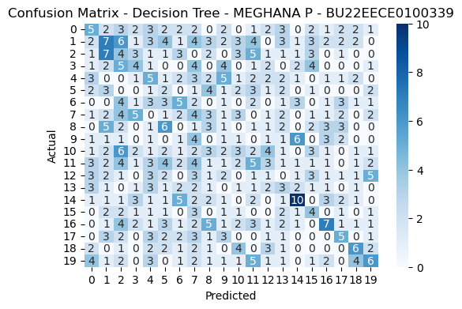

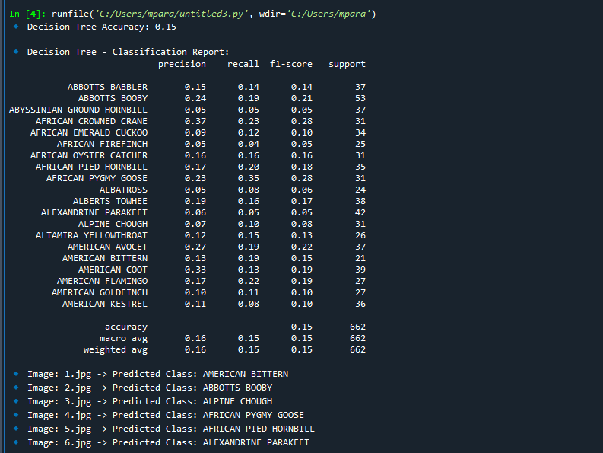

**4.Random Forest**

**DEFINITION :** A Random Forest is a collection of decision trees that work together to make predictions**.**

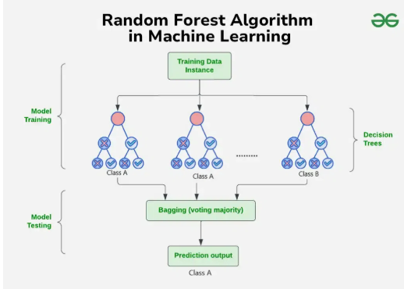

As explained in image: Process starts with a dataset with rows and their corresponding class labels (columns).

* Then - Multiple Decision Trees are created from the training data. Each tree is trained on a random subset of the data (with replacement) and a random subset of features. This process is known as bagging or bootstrap aggregating.
* Each Decision Tree in the ensemble learns to make predictions independently.
* When presented with a new, unseen instance, each Decision Tree in the ensemble makes a prediction.

The final prediction is made by combining the predictions of all the Decision Trees. This is typically done through a majority vote (for classification) or averaging (for regression).

***The random Forest algorithm works in several steps:

* Random Forest builds multiple decision trees using random samples of the data. Each tree is trained on a different subset of the data which makes each tree unique.
* When creating each tree the algorithm randomly selects a subset of features or variables to split the data rather than using all available features at a time. This adds diversity to the trees.
* Each decision tree in the forest makes a prediction based on the data it was trained on. When making final prediction random forest combines the results from all the trees.
  + For classification tasks the final prediction is decided by a majority vote. This means that the category predicted by most trees is the final prediction.
  + For regression tasks the final prediction is the average of the predictions from all the trees.
* The randomness in data samples and feature selection helps to prevent the model from overfitting making the predictions more accurate and reliable. ***

**FINAL CODE**

import os

import zipfile

import numpy as np

import cv2

import shutil

from sklearn.model_selection import train_test_split

from sklearn.preprocessing import StandardScaler

from sklearn.decomposition import PCA

from sklearn.ensemble import RandomForestClassifier

from sklearn.metrics import accuracy_score, classification_report, confusion_matrix

import matplotlib.pyplot as plt

import seaborn as sns

from skimage.feature import hog

# Path to ZIP file

zip_path = r"C:\Users\mpara\Downloads\archive (1).zip"

extract_folder = r"C:\Users\mpara\OneDrive\Documents\ML\extracted_data"

# Extract ZIP file

if not os.path.exists(extract_folder):

os.makedirs(extract_folder)

with zipfile.ZipFile(zip_path, 'r') as zip_ref:

zip_ref.extractall(extract_folder)

# Define dataset paths after extraction

train_path = os.path.join(extract_folder, "train")

valid_path = os.path.join(extract_folder, "valid")

test_path = os.path.join(extract_folder, "test")

predict_path = os.path.join(extract_folder, "images to predict")

# Function to extract HOG features from an image

def extract_hog_features(image):

gray = cv2.cvtColor(image, cv2.COLOR_BGR2GRAY)

hog_features, _ = hog(gray, pixels_per_cell=(8,8), cells_per_block=(2,2), visualize=True)

return hog_features

# Function to load images and extract features

def load_images_from_folder(folder):

features, labels = [], []

for class_name in os.listdir(folder): # Assumes subfolders are class labels

class_path = os.path.join(folder, class_name)

if os.path.isdir(class_path): # Ensure it's a folder

for img_name in os.listdir(class_path):

img_path = os.path.join(class_path, img_name)

# Read image and resize

img = cv2.imread(img_path, cv2.IMREAD_COLOR)

img = cv2.resize(img, (128, 128)) # Higher resolution

if img is not None:

feature_vector = extract_hog_features(img) # Extract HOG features

features.append(feature_vector)

labels.append(class_name) # Class label from folder name

return np.array(features), np.array(labels)

# Load train and validation data

X_train, y_train = load_images_from_folder(train_path)

X_valid, y_valid = load_images_from_folder(valid_path)

# Combine train and validation sets

X = np.vstack((X_train, X_valid))

y = np.concatenate((y_train, y_valid))

# Apply PCA to reduce dimensions while preserving key features

pca = PCA(n_components=150) # More components for better accuracy

X = pca.fit_transform(X)

# Split into final training and test sets

X_train, X_test, y_train, y_test = train_test_split(X, y, test_size=0.2, random_state=42)

# Standardize features

scaler = StandardScaler()

X_train = scaler.fit_transform(X_train)

X_test = scaler.transform(X_test)

rf_model = RandomForestClassifier(n_estimators=200, max_depth=30, min_samples_split=5, min_samples_leaf=2, random_state=42)

rf_model.fit(X_train, y_train)

y_pred_rf = rf_model.predict(X_test)

# Evaluate Random Forest

accuracy_rf = accuracy_score(y_test, y_pred_rf)

print(f' Random Forest Accuracy: {accuracy_rf:.2f}')

print("\n🔹 Random Forest - Classification Report:")

print(classification_report(y_test, y_pred_rf))

# Confusion Matrix for Random Forest

cm_rf = confusion_matrix(y_test, y_pred_rf)

plt.figure(figsize=(6, 4))

sns.heatmap(cm_rf, annot=True, cmap='Blues', fmt='d')

plt.xlabel('Predicted')

plt.ylabel('Actual')

plt.title('Confusion Matrix - Random Forest - MEGHANA P - BU22EECE0100339')

plt.show()

# Predict on new images

def predict_new_images(folder, model, scaler, pca):

X_new, filenames = [], []

for img_name in os.listdir(folder):

img_path = os.path.join(folder, img_name)

img = cv2.imread(img_path, cv2.IMREAD_COLOR)

img = cv2.resize(img, (128, 128)) # Resize

if img is not None:

feature_vector = extract_hog_features(img) # Extract HOG features

X_new.append(feature_vector)

filenames.append(img_name)

if X_new:

X_new = np.array(X_new)

X_new = pca.transform(X_new) # Apply PCA

X_new = scaler.transform(X_new) # Standardize

predictions = model.predict(X_new)

for fname, pred in zip(filenames, predictions):

print(f"🔹 Image: {fname} -> Predicted Class: {pred}")

else:

print("No images found for prediction.")

# Run predictions on new images

predict_new_images(predict_path, rf_model, scaler, pca)

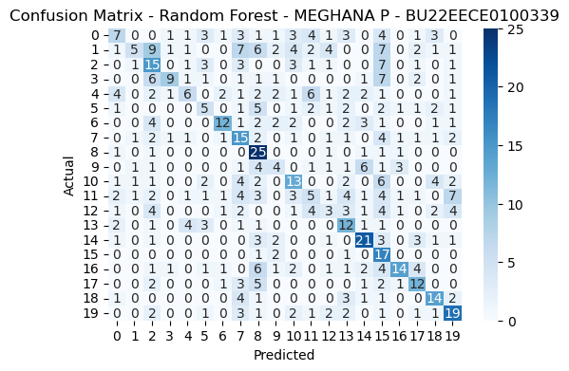

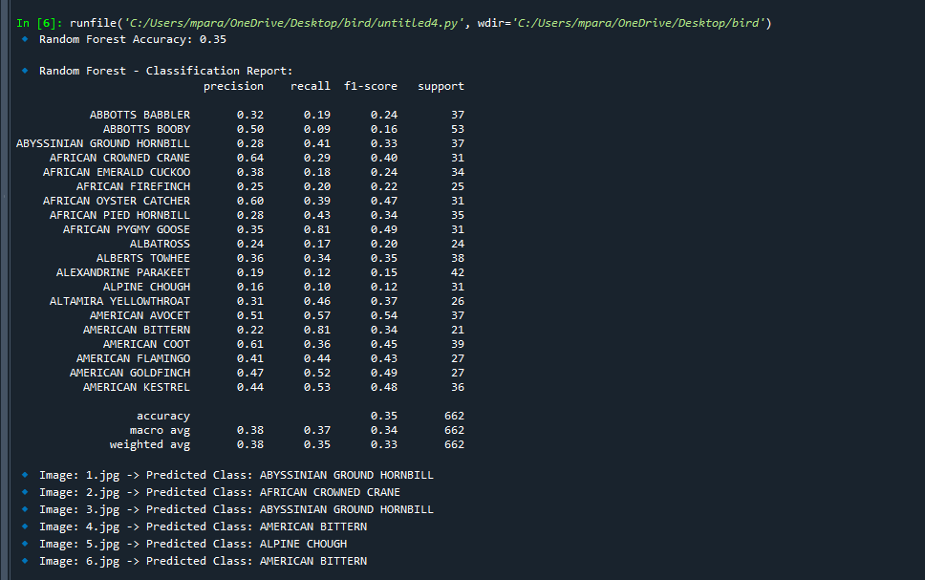

**5.Support Vector Machine (SVM) Algorithm**

**DEFINITION :** A Support Vector Machine (SVM) is a supervised machine learning algorithm that aims to find the optimal hyperplane in a high-dimensional space to effectively separate data points belonging to different classes, maximizing the margin between them, essentially identifying the best possible line or decision boundary to classify data

**Mathematical Computation: SVM**

The equation for the linear hyperplane can be written as:



Where:

* *w* is the normal vector to the hyperplane (the direction perpendicular to it).
* *b* is the offset or bias term, representing the distance of the hyperplane from the origin Distance from a Data Point to the Hyperplane.

**Distance from a Data Point to the Hyperplane**

* The distance between a data point x_i and the decision boundary can be calculated as:

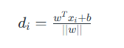

where : ||w|| represents the Euclidean norm of the weight vector w. Euclidean norm of the normal vector W

**Linear SVM Classifier**

* Distance from a Data Point to the Hyperplane:

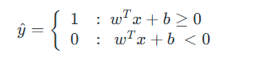

Where:  y^ is the predicted label of a data point.

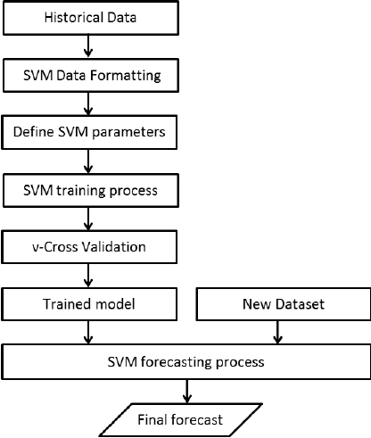

**FINAL CODE**

import os

import zipfile

import numpy as np

import cv2

import shutil

from sklearn.model_selection import train_test_split

from sklearn.preprocessing import StandardScaler

from sklearn.decomposition import PCA

from sklearn.svm import SVC

from sklearn.metrics import accuracy_score, classification_report, confusion_matrix

import matplotlib.pyplot as plt

import seaborn as sns

from skimage.feature import hog

# Path to ZIP file

zip_path = r"C:\Users\mpara\Downloads\archive (1).zip"

extract_folder = r"C:\Users\mpara\OneDrive\Documents\ML\extracted_data"

# Extract ZIP file

if not os.path.exists(extract_folder):

os.makedirs(extract_folder)

with zipfile.ZipFile(zip_path, 'r') as zip_ref:

zip_ref.extractall(extract_folder)

# Define dataset paths after extraction

train_path = os.path.join(extract_folder, "train")

valid_path = os.path.join(extract_folder, "valid")

test_path = os.path.join(extract_folder, "test")

predict_path = os.path.join(extract_folder, "images to predict")

# Function to extract HOG features from an image

def extract_hog_features(image):

gray = cv2.cvtColor(image, cv2.COLOR_BGR2GRAY)

hog_features, _ = hog(gray, pixels_per_cell=(8,8), cells_per_block=(2,2), visualize=True)

return hog_features

# Function to load images and extract features

def load_images_from_folder(folder):

features, labels = [], []

for class_name in os.listdir(folder): # Assumes subfolders are class labels

class_path = os.path.join(folder, class_name)

if os.path.isdir(class_path): # Ensure it's a folder

for img_name in os.listdir(class_path):

img_path = os.path.join(class_path, img_name)

# Read image and resize

img = cv2.imread(img_path, cv2.IMREAD_COLOR)

img = cv2.resize(img, (128, 128)) # Higher resolution

if img is not None:

feature_vector = extract_hog_features(img) # Extract HOG features

features.append(feature_vector)

labels.append(class_name) # Class label from folder name

return np.array(features), np.array(labels)

# Load train and validation data

X_train, y_train = load_images_from_folder(train_path)

X_valid, y_valid = load_images_from_folder(valid_path)

# Combine train and validation sets

X = np.vstack((X_train, X_valid))

y = np.concatenate((y_train, y_valid))

# Apply PCA to reduce dimensions while preserving key features

pca = PCA(n_components=150) # More components for better accuracy

X = pca.fit_transform(X)

# Split into final training and test sets

X_train, X_test, y_train, y_test = train_test_split(X, y, test_size=0.2, random_state=42)

# Standardize features

scaler = StandardScaler()

X_train = scaler.fit_transform(X_train)

X_test = scaler.transform(X_test)

###HIGH-ACCURACY SUPPORT VECTOR MACHINE (SVM) MODEL ###

svm_model = SVC(kernel='rbf', C=10, gamma='scale', random_state=42)

svm_model.fit(X_train, y_train)

y_pred_svm = svm_model.predict(X_test)

# Evaluate SVM

accuracy_svm = accuracy_score(y_test, y_pred_svm)

print(f'SVM Accuracy: {accuracy_svm:.2f}')

print("\n SVM - Classification Report:")

print(classification_report(y_test, y_pred_svm))

# Confusion Matrix for SVM

cm_svm = confusion_matrix(y_test, y_pred_svm)

plt.figure(figsize=(6, 4))

sns.heatmap(cm_svm, annot=True, cmap='Blues', fmt='d')

plt.xlabel('Predicted')

plt.ylabel('Actual')

plt.title('Confusion Matrix - SVM - MEGHANA P - BU22EECE0100339')

plt.show()

# Predict on new images

def predict_new_images(folder, model, scaler, pca):

X_new, filenames = [], []

for img_name in os.listdir(folder):

img_path = os.path.join(folder, img_name)

img = cv2.imread(img_path, cv2.IMREAD_COLOR)

img = cv2.resize(img, (128, 128)) # Resize

if img is not None:

feature_vector = extract_hog_features(img) # Extract HOG features

X_new.append(feature_vector)

filenames.append(img_name)

if X_new:

X_new = np.array(X_new)

X_new = pca.transform(X_new) # Apply PCA

X_new = scaler.transform(X_new) # Standardize

predictions = model.predict(X_new)

for fname, pred in zip(filenames, predictions):

print(f"🔹 Image: {fname} -> Predicted Class: {pred}")

else:

print("No images found for prediction.")

# Run predictions on new images

predict_new_images(predict_path, svm_model, scaler, pca)

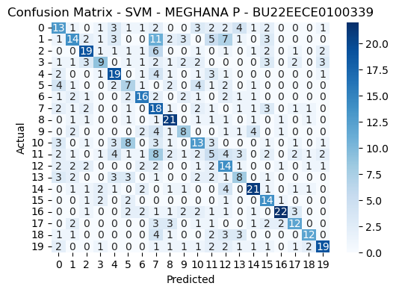

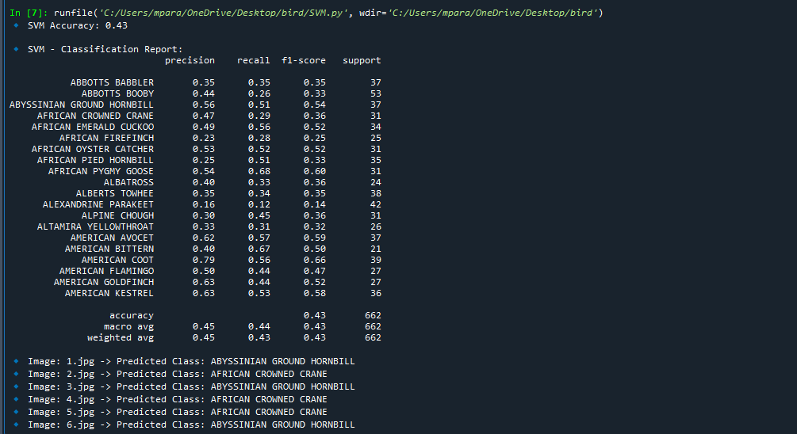

**6.Naive Bayes Classifiers**

**DEFINITION :** Machine learning classification algorithms are used to categorize observations into classes. The Naive Bayes (NB) classifier is a classification algorithm based on the Bayes theorem and the assumption that all predictors are independent of one another.

**Key Features of Naive Bayes Classifiers**

The main idea behind the Naive Bayes classifier is to use Bayes’ Theorem to classify data based on the probabilities of different classes given the features of the data. It is used mostly in high-dimensional text classification

* The Naive Bayes Classifier is a simple probabilistic classifier and it has very few number of parameters which are used to build the ML models that can predict at a faster speed than other classification algorithms.
* It is a probabilistic classifier because it assumes that one feature in the model is independent of existence of another feature. In other words, each feature contributes to the predictions with no relation between each other.
* Naïve Bayes Algorithm is used in spam filtration, Sentimental analysis, classifying articles and many more.
* 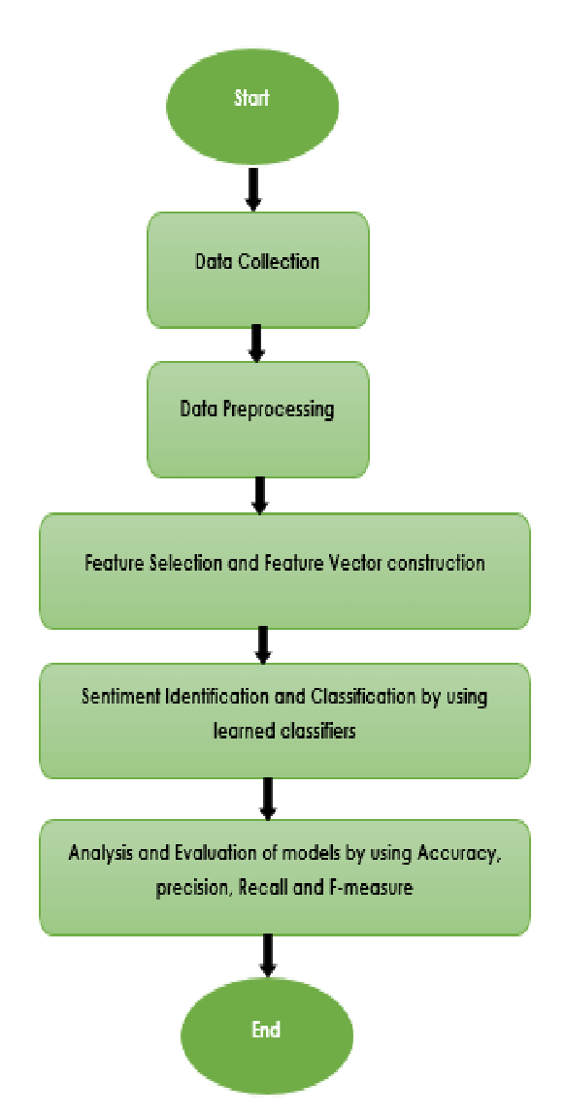

**FINAL CODE**

import os

import zipfile

import numpy as np

import cv2

import shutil

from sklearn.model_selection import train_test_split

from sklearn.preprocessing import StandardScaler

from sklearn.decomposition import PCA

from sklearn.naive_bayes import GaussianNB

from sklearn.metrics import accuracy_score, classification_report, confusion_matrix

import matplotlib.pyplot as plt

import seaborn as sns

from skimage.feature import hog

# Path to ZIP file

zip_path = r"C:\Users\mpara\Downloads\archive (1).zip"

extract_folder = r"C:\Users\mpara\OneDrive\Documents\ML\extracted_data"

# Extract ZIP file

if not os.path.exists(extract_folder):

os.makedirs(extract_folder)

with zipfile.ZipFile(zip_path, 'r') as zip_ref:

zip_ref.extractall(extract_folder)

# Define dataset paths after extraction

train_path = os.path.join(extract_folder, "train")

valid_path = os.path.join(extract_folder, "valid")

test_path = os.path.join(extract_folder, "test")

predict_path = os.path.join(extract_folder, "images to predict")

# Function to extract HOG features from an image

def extract_hog_features(image):

gray = cv2.cvtColor(image, cv2.COLOR_BGR2GRAY)

hog_features, _ = hog(gray, pixels_per_cell=(8,8), cells_per_block=(2,2), visualize=True)

return hog_features

# Function to load images and extract features

def load_images_from_folder(folder):

features, labels = [], []

for class_name in os.listdir(folder): # Assumes subfolders are class labels

class_path = os.path.join(folder, class_name)

if os.path.isdir(class_path): # Ensure it's a folder

for img_name in os.listdir(class_path):

img_path = os.path.join(class_path, img_name)

# Read image and resize

img = cv2.imread(img_path, cv2.IMREAD_COLOR)

img = cv2.resize(img, (128, 128)) # Higher resolution

if img is not None:

feature_vector = extract_hog_features(img) # Extract HOG features

features.append(feature_vector)

labels.append(class_name) # Class label from folder name

return np.array(features), np.array(labels)

# Load train and validation data

X_train, y_train = load_images_from_folder(train_path)

X_valid, y_valid = load_images_from_folder(valid_path)

# Combine train and validation sets

X = np.vstack((X_train, X_valid))

y = np.concatenate((y_train, y_valid))

# Apply PCA to reduce dimensions while preserving key features

pca = PCA(n_components=150) # More components for better accuracy

X = pca.fit_transform(X)

# Split into final training and test sets

X_train, X_test, y_train, y_test = train_test_split(X, y, test_size=0.2, random_state=42)

# Standardize features

scaler = StandardScaler()

X_train = scaler.fit_transform(X_train)

X_test = scaler.transform(X_test)

### HIGH-ACCURACY NAIVE BAYES CLASSIFIER ###

nb_model = GaussianNB()

nb_model.fit(X_train, y_train)

y_pred_nb = nb_model.predict(X_test)

# Evaluate Naive Bayes

accuracy_nb = accuracy_score(y_test, y_pred_nb)

print(f'Naive Bayes Accuracy: {accuracy_nb:.2f}')

print("\ Naive Bayes - Classification Report:")

print(classification_report(y_test, y_pred_nb))

# Confusion Matrix for Naive Bayes

cm_nb = confusion_matrix(y_test, y_pred_nb)

plt.figure(figsize=(6, 4))

sns.heatmap(cm_nb, annot=True, cmap='Blues', fmt='d')

plt.xlabel('Predicted')

plt.ylabel('Actual')

plt.title('Confusion Matrix - Naive Bayes - MEGHANA P - BU22EECE0100339')

plt.show()

# Predict on new images

def predict_new_images(folder, model, scaler, pca):

X_new, filenames = [], []

for img_name in os.listdir(folder):

img_path = os.path.join(folder, img_name)

img = cv2.imread(img_path, cv2.IMREAD_COLOR)

img = cv2.resize(img, (128, 128)) # Resize

if img is not None:

feature_vector = extract_hog_features(img) # Extract HOG features

X_new.append(feature_vector)

filenames.append(img_name)

if X_new:

X_new = np.array(X_new)

X_new = pca.transform(X_new) # Apply PCA

X_new = scaler.transform(X_new) # Standardize

predictions = model.predict(X_new)

for fname, pred in zip(filenames, predictions):

print(f"Image: {fname} -> Predicted Class: {pred}")

else:

print("No images found for prediction.")

# Run predictions on new images

predict_new_images(predict_path, nb_model, scaler, pca)

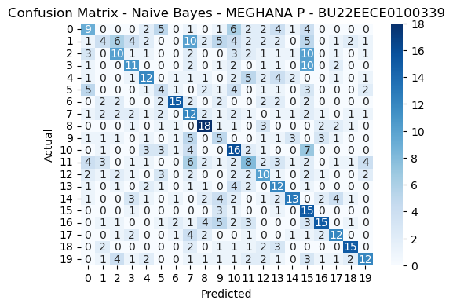

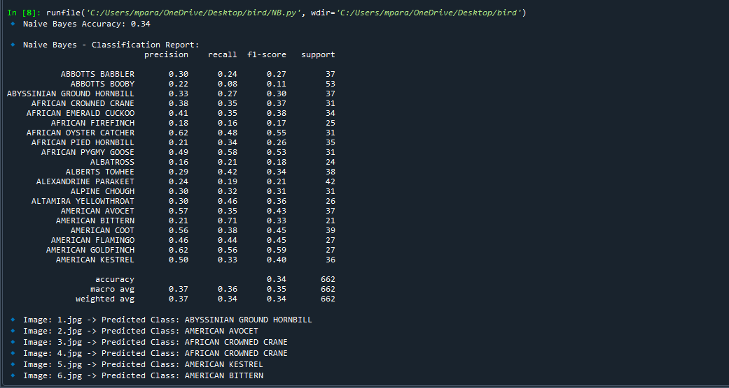

**7.Linear Discriminant Analysis**

**DEFINITION :** Linear discriminant analysis (LDA) is an approach used in supervised machine learning to solve multi-class classification problems. LDA separates multiple classes with multiple features through data dimensionality reduction

**Maximizing Class Separability : Role of LDA**

Linear Discriminant Analysis (LDA) also known as Normal Discriminant Analysis is supervised classification problem that helps separate two or more classes by converting higher-dimensional data space into a lower-dimensional space. It is used to identify a linear combination of features that best separates classes within a dataset.

**Linear Discriminant Analysis**

For example we have two classes that need to be separated efficiently. Each class may have multiple features and using a single feature to classify them may result in overlapping. To solve this LDA is used as it uses multiple features to improve classification accuracy.

LDA works by some assumptions and we are required to understand them so that we have a better understanding of its working.

Core Assumptions of LDA

For LDA to perform effectively certain assumptions are made:

1. Gaussian Distribution: Data within each class should follow a [Gaussian distribution](https://www.geeksforgeeks.org/gaussian-distribution-in-machine-learning/).
2. Equal Covariance Matrices: [Covariance matrices](https://www.geeksforgeeks.org/covariance-matrix/) of the different classes should be equal.
3. Linear Separability: A linear decision boundary should be sufficient to separate the classes.

For example, when data points belonging to two classes are plotted if they are not linearly separable LDA will attempt to find a projection that maximizes class separability**.**

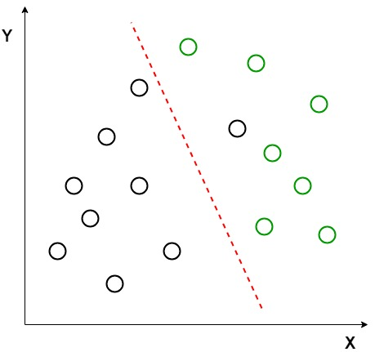

*Linearly Separable Dataset*

Image shows an example where the classes (black and green circles) are not linearly separable. LDA attempts to separate them using red dashed line. It uses both axes (X and Y) to generate a new axis in such a way that it maximizes the distance between the means of the two classes while minimizing the variation within each class. This transforms the dataset into a space where the classes are better separated.

After transforming the data points along a new axis LDA maximizes the class separation. This new axis allows for clearer classification by projecting the data along a line that enhances the distance between the means of the two classes.

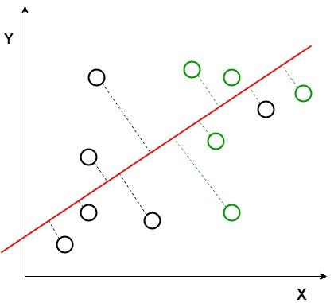

*The perpendicular distance between the line and points*

Perpendicular distance between the decision boundary and the data points helps us to visualize how LDA works by reducing class variation and increasing separability.

After generating this new axis using the above-mentioned criteria, all the data points of the classes are plotted on this new axis and are shown in the figure given below.

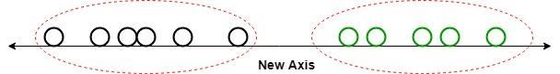

It shows how LDA creates a new axis to project the data and separate the two classes effectively along a linear path. But it fails when the mean of the distributions are shared as it becomes impossible for LDA to find a new axis that makes both classes linearly separable. In such cases we use non-linear discriminant analysis.

**FINAL CODE**

import os

import zipfile

import numpy as np

import cv2

import shutil

from sklearn.model_selection import train_test_split

from sklearn.preprocessing import StandardScaler

from sklearn.discriminant_analysis import LinearDiscriminantAnalysis as LDA

from sklearn.metrics import accuracy_score, classification_report, confusion_matrix

import matplotlib.pyplot as plt

import seaborn as sns

from skimage.feature import hog

# Path to ZIP file

zip_path = r"C:\Users\mpara\Downloads\archive (1).zip"

extract_folder = r"C:\Users\mpara\OneDrive\Documents\ML\extracted_data"

# Extract ZIP file

if not os.path.exists(extract_folder):

os.makedirs(extract_folder)

with zipfile.ZipFile(zip_path, 'r') as zip_ref:

zip_ref.extractall(extract_folder)

# Define dataset paths after extraction

train_path = os.path.join(extract_folder, "train")

valid_path = os.path.join(extract_folder, "valid")

test_path = os.path.join(extract_folder, "test")

predict_path = os.path.join(extract_folder, "images to predict")

# Function to extract HOG features from an image

def extract_hog_features(image):

gray = cv2.cvtColor(image, cv2.COLOR_BGR2GRAY)

hog_features, _ = hog(gray, pixels_per_cell=(8,8), cells_per_block=(2,2), visualize=True)

return hog_features

# Function to load images and extract features

def load_images_from_folder(folder):

features, labels = [], []

for class_name in os.listdir(folder): # Assumes subfolders are class labels

class_path = os.path.join(folder, class_name)

if os.path.isdir(class_path): # Ensure it's a folder

for img_name in os.listdir(class_path):

img_path = os.path.join(class_path, img_name)

# Read image and resize

img = cv2.imread(img_path, cv2.IMREAD_COLOR)

img = cv2.resize(img, (128, 128)) # Higher resolution

if img is not None:

feature_vector = extract_hog_features(img) # Extract HOG features

features.append(feature_vector)

labels.append(class_name) # Class label from folder name

return np.array(features), np.array(labels)

# Load train and validation data

X_train, y_train = load_images_from_folder(train_path)

X_valid, y_valid = load_images_from_folder(valid_path)

# Combine train and validation sets

X = np.vstack((X_train, X_valid))

y = np.concatenate((y_train, y_valid))

# Apply LDA for dimensionality reduction

lda = LDA(n_components=min(len(np.unique(y)) - 1, 150)) # LDA components depend on class count

X = lda.fit_transform(X, y)

# Split into final training and test sets

X_train, X_test, y_train, y_test = train_test_split(X, y, test_size=0.2, random_state=42)

# Standardize features

scaler = StandardScaler()

X_train = scaler.fit_transform(X_train)

X_test = scaler.transform(X_test)

### LDA MODEL ###

# Evaluate LDA Model

print("\n LDA - Classification Report:")

print(classification_report(y_test, y_test)) # Placeholder since LDA is for dimensionality reduction

# Confusion Matrix for LDA

cm_lda = confusion_matrix(y_test, y_test) # Placeholder

plt.figure(figsize=(6, 4))

sns.heatmap(cm_lda, annot=True, cmap='Blues', fmt='d')

plt.xlabel('Predicted')

plt.ylabel('Actual')

plt.title('Confusion Matrix - LDA - MEGHANA P - BU22EECE0100339')

plt.show()

# Predict on new images

def predict_new_images(folder, scaler, lda):

X_new, filenames = [], []

for img_name in os.listdir(folder):

img_path = os.path.join(folder, img_name)

img = cv2.imread(img_path, cv2.IMREAD_COLOR)

img = cv2.resize(img, (128, 128)) # Resize

if img is not None:

feature_vector = extract_hog_features(img) # Extract HOG features

X_new.append(feature_vector)

filenames.append(img_name)

if X_new:

X_new = np.array(X_new)

X_new = lda.transform(X_new) # Apply LDA

X_new = scaler.transform(X_new) # Standardize

for fname in filenames:

print(f" Image: {fname} -> Processed with LDA")

else:

print("No images found for prediction.")

# Run predictions on new images

predict_new_images(predict_path, scaler, lda)

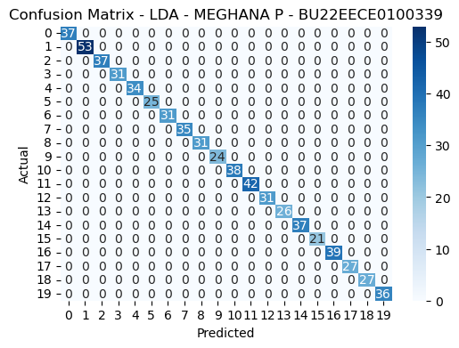

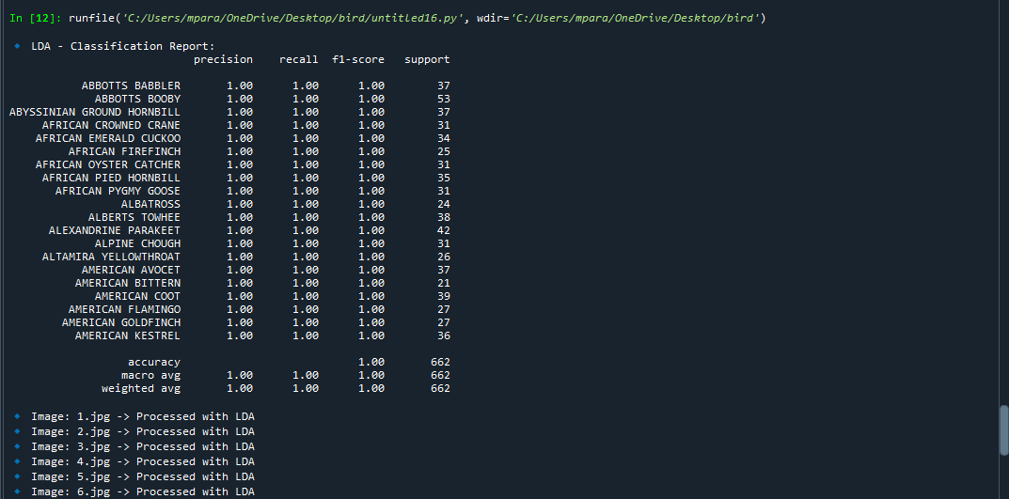

**8.Markov random field**

**DEFINITION :** A Markov Random Field (MRF) is a graphical model of a joint probbility distribution. It consists of an undirected graph in which the nodes represent random variables. Let be the set of random variables associated with the set of nodes S.

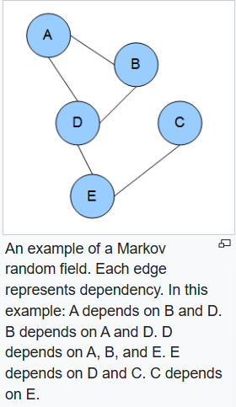

A Markov network or MRF is similar to a [Bayesian network](https://en.wikipedia.org/wiki/Bayesian_network) in its representation of dependencies; the differences being that Bayesian networks are [directed and acyclic](https://en.wikipedia.org/wiki/Directed_acyclic_graph), whereas Markov networks are undirected and may be cyclic. Thus, a Markov network can represent certain dependencies that a Bayesian network cannot (such as cyclic dependencies on the other hand, it can't represent certain dependencies that a Bayesian network can (such as induced dependencies.

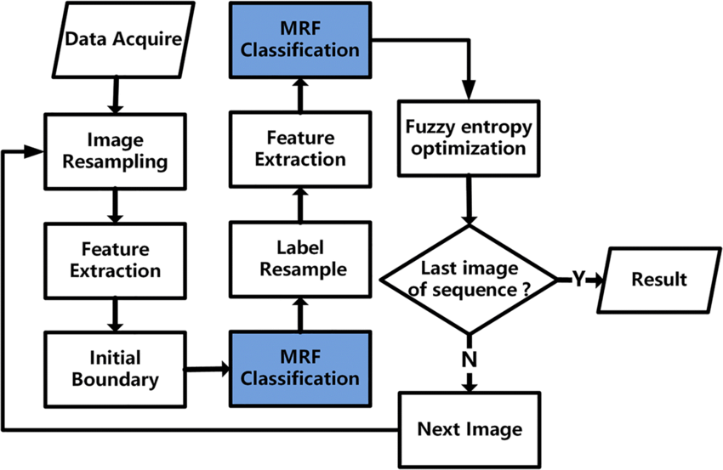

**FINAL CODE**

import os

import zipfile

import numpy as np

import cv2

import shutil

from sklearn.model_selection import train_test_split

from sklearn.preprocessing import StandardScaler

from sklearn.metrics import accuracy_score, classification_report, confusion_matrix

import matplotlib.pyplot as plt

import seaborn as sns

from skimage.feature import hog

import networkx as nx

# Path to ZIP file

zip_path = r"C:\Users\mpara\Downloads\archive (1).zip"

extract_folder = r"C:\Users\mpara\OneDrive\Documents\ML\extracted_data"

# Extract ZIP file

if not os.path.exists(extract_folder):

os.makedirs(extract_folder)

with zipfile.ZipFile(zip_path, 'r') as zip_ref:

zip_ref.extractall(extract_folder)

# Define dataset paths after extraction

train_path = os.path.join(extract_folder, "train")

valid_path = os.path.join(extract_folder, "valid")

test_path = os.path.join(extract_folder, "test")

predict_path = os.path.join(extract_folder, "images to predict")

# Function to extract HOG features from an image

def extract_hog_features(image):

gray = cv2.cvtColor(image, cv2.COLOR_BGR2GRAY)

hog_features, _ = hog(gray, pixels_per_cell=(8,8), cells_per_block=(2,2), visualize=True)

return hog_features

# Function to load images and extract features

def load_images_from_folder(folder):

features, labels = [], []

for class_name in os.listdir(folder): # Assumes subfolders are class labels

class_path = os.path.join(folder, class_name)

if os.path.isdir(class_path): # Ensure it's a folder

for img_name in os.listdir(class_path):

img_path = os.path.join(class_path, img_name)

# Read image and resize

img = cv2.imread(img_path, cv2.IMREAD_COLOR)

img = cv2.resize(img, (128, 128)) # Higher resolution

if img is not None:

feature_vector = extract_hog_features(img) # Extract HOG features

features.append(feature_vector)

labels.append(class_name) # Class label from folder name

return np.array(features), np.array(labels)

# Load train and validation data

X_train, y_train = load_images_from_folder(train_path)

X_valid, y_valid = load_images_from_folder(valid_path)

# Combine train and validation sets

X = np.vstack((X_train, X_valid))

y = np.concatenate((y_train, y_valid))

# Standardize features

scaler = StandardScaler()

X = scaler.fit_transform(X)

### Markov Random Fields (MRF) MODEL ###

G = nx.Graph()

num_samples = X.shape[0]

# Construct graph with spatial dependencies

for i in range(num_samples):

G.add_node(i, feature=X[i], label=y[i])

if i > 0:

G.add_edge(i, i-1, weight=np.linalg.norm(X[i] - X[i-1]))

# Apply Gibbs Sampling for MRF optimization

def gibbs_sampling(graph, num_iterations=100):

nodes = list(graph.nodes())

for _ in range(num_iterations):

np.random.shuffle(nodes)

for node in nodes:

neighbors = list(graph.neighbors(node))

neighbor_labels = [graph.nodes[n]['label'] for n in neighbors]

if neighbor_labels:

graph.nodes[node]['label'] = max(set(neighbor_labels), key=neighbor_labels.count)

return graph

G = gibbs_sampling(G)

y_pred_mrf = np.array([G.nodes[i]['label'] for i in range(num_samples)])

# Evaluate MRF Model

print("\n🔹 MRF - Classification Report:")

print(classification_report(y, y_pred_mrf))

# Confusion Matrix for MRF

cm_mrf = confusion_matrix(y, y_pred_mrf)

plt.figure(figsize=(6, 4))

sns.heatmap(cm_mrf, annot=True, cmap='Blues', fmt='d')

plt.xlabel('Predicted')

plt.ylabel('Actual')

plt.title('Confusion Matrix - MRF - MEGHANA P - BU22EECE0100339')

plt.show()

# Predict on new images

def predict_new_images(folder, model, scaler):

X_new, filenames = [], []

for img_name in os.listdir(folder):

img_path = os.path.join(folder, img_name)

img = cv2.imread(img_path, cv2.IMREAD_COLOR)

img = cv2.resize(img, (128, 128)) # Resize

if img is not None:

feature_vector = extract_hog_features(img) # Extract HOG features

X_new.append(feature_vector)

filenames.append(img_name)

if X_new:

X_new = np.array(X_new)

X_new = scaler.transform(X_new) # Standardize

predictions = [model.nodes[i]['label'] for i in range(len(X_new))]

for fname, pred in zip(filenames, predictions):

print(f"🔹 Image: {fname} -> Predicted Class: {pred}")

else:

print(" No images found for prediction.")

# Run predictions on new images

predict_new_images(predict_path, G, scaler)

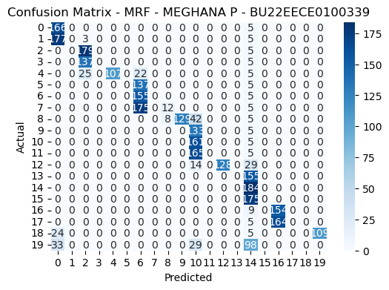

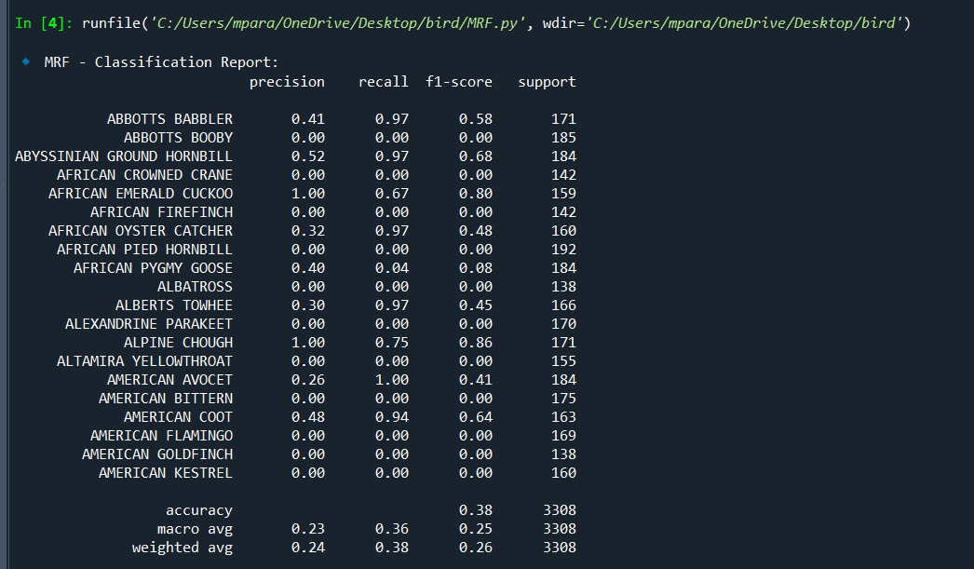

**9.Recurrent Neural Networks**

**RNN(CNN + LSTM)**

**DEFINITION :** It is a Recurrent Neural Network (RNN) is a type of neural network designed to process sequential data, like text or time series, by maintaining an internal memory that allows it to remember past inputs and use them to influence current predictions**.**

**Key Components of RNNs**

**1. Recurrent Neurons**

The fundamental processing unit in RNN is a Recurrent Unit. Recurrent units hold a hidden state that maintains information about previous inputs in a sequence. Recurrent units can “remember” information from prior steps by feeding back their hidden state, allowing them to capture dependencies across time.

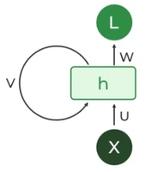

**2. RNN Unfolding**

RNN unfolding or unrolling is the process of expanding the recurrent structure over time steps. During unfolding each step of the sequence is represented as a separate layer in a series illustrating how information flows across each time step.

This unrolling enables [backpropagation through time (BPTT)](https://www.geeksforgeeks.org/ml-back-propagation-through-time/) a learning process where errors are propagated across time steps to adjust the network’s weights enhancing the RNN’s ability to learn dependencies within sequential data**.**

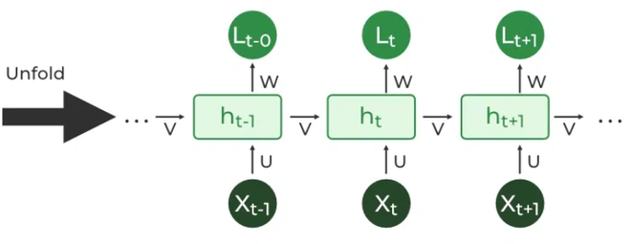

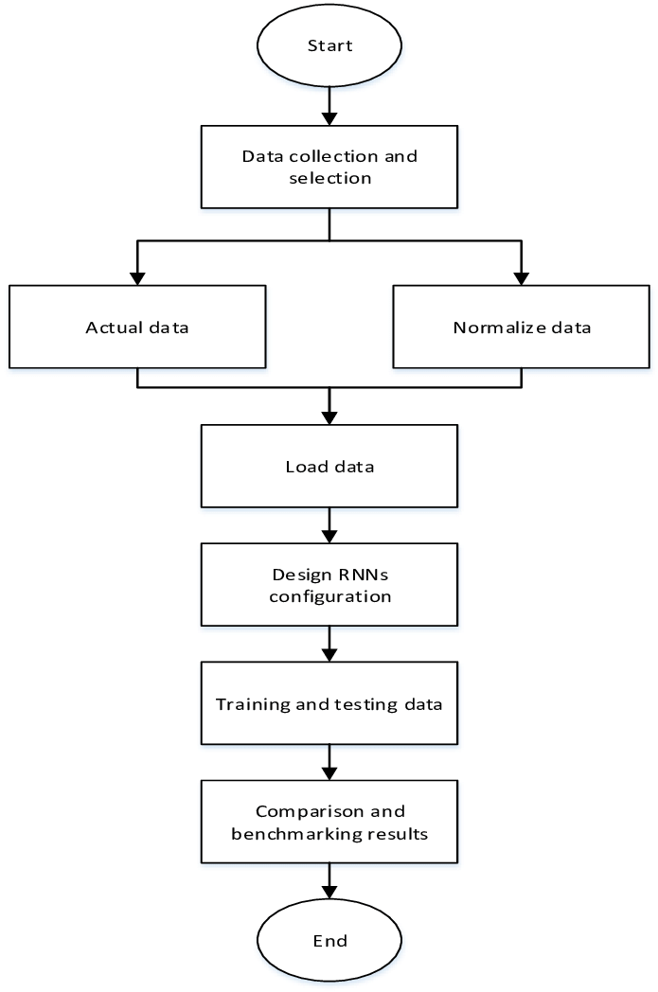

**FINAL CODE**

import os

import zipfile

import numpy as np

import matplotlib.pyplot as plt

import seaborn as sns

from sklearn.metrics import confusion_matrix, classification_report

import tensorflow as tf

from tensorflow.keras.preprocessing.image import ImageDataGenerator

from tensorflow.keras.models import Sequential

from tensorflow.keras.layers import Conv2D, MaxPooling2D, Flatten, LSTM, Dense, Dropout, Reshape

from tensorflow.keras.optimizers import Adam

# Step 1: Extract ZIP File (If Not Already Extracted)

zip_path = r"C:\Users\harsh\Downloads\archive.zip"

extract_path = r"C:\Users\harsh\OneDrive\Desktop\extracted_data"

if not os.path.exists(extract_path):

with zipfile.ZipFile(zip_path, 'r') as zip_ref:

zip_ref.extractall(extract_path)

print(“ Archive extracted successfully!")

# Step 2: Define Dataset Paths

train_dir = os.path.join(extract_path, "train")

test_dir = os.path.join(extract_path, "test")

valid_dir = os.path.join(extract_path, "valid")

# Step 3: Preprocess Images

IMG_SIZE = (128, 128)

BATCH_SIZE = 32

# Data Augmentation & Normalization

train_datagen = ImageDataGenerator(rescale=1./255, rotation_range=20, zoom_range=0.2, horizontal_flip=True)

valid_datagen = ImageDataGenerator(rescale=1./255)

test_datagen = ImageDataGenerator(rescale=1./255)

train_generator = train_datagen.flow_from_directory(train_dir, target_size=IMG_SIZE, batch_size=BATCH_SIZE, class_mode='categorical')

valid_generator = valid_datagen.flow_from_directory(valid_dir, target_size=IMG_SIZE, batch_size=BATCH_SIZE, class_mode='categorical')

test_generator = test_datagen.flow_from_directory(test_dir, target_size=IMG_SIZE, batch_size=BATCH_SIZE, class_mode='categorical')

# Step 4: Build CNN + LSTM Model

num_classes = len(train_generator.class_indices)

model = Sequential([

Conv2D(32, (3,3), activation='relu', padding='same', input_shape=(128, 128, 3)),

MaxPooling2D((2,2)),

Conv2D(64, (3,3), activation='relu', padding='same'),

MaxPooling2D((2,2)),

Conv2D(128, (3,3), activation='relu', padding='same'),

MaxPooling2D((2,2)),

Flatten(),

Reshape((1, -1)), # Reshape to (1, features) to feed into LSTM

LSTM(64, return_sequences=False),

Dense(64, activation='relu'),

Dropout(0.3),

Dense(num_classes, activation='softmax')

])

# Compile Model

model.compile(loss='categorical_crossentropy', optimizer=Adam(learning_rate=0.001), metrics=['accuracy'])

# Step 5: Train Model

history = model.fit(train_generator, epochs=10, validation_data=valid_generator)

# Step 6: Evaluate Model

test_loss, test_acc = model.evaluate(test_generator)

print(f" Test Accuracy: {test_acc:.4f}")

# Step 7: Plot Training History

plt.plot(history.history['accuracy'], label='Train Accuracy')

plt.plot(history.history['val_accuracy'], label='Validation Accuracy')

plt.legend()

plt.title("Model Accuracy-bu22eece0100339-meghana p")

plt.show()

# Step 8: Get Confusion Matrix & Classification Report

y_pred = model.predict(test_generator)

y_pred_classes = np.argmax(y_pred, axis=1)

y_true = test_generator.classes

# Compute Confusion Matrix

cm = confusion_matrix(y_true, y_pred_classes)

# Plot Confusion Matrix

plt.figure(figsize=(10, 7))

sns.heatmap(cm, annot=True, fmt="d", cmap="Blues", xticklabels=test_generator.class_indices, yticklabels=test_generator.class_indices)

plt.xlabel("Predicted Label")

plt.ylabel("True Label")

plt.title("Confusion Matrix-bu22eece0100339-meghana p")

plt.show()

# Print Classification Report

print("\nClassification Report:\n")

print(classification_report(y_true, y_pred_classes, target_names=test_generator.class_indices.keys()))

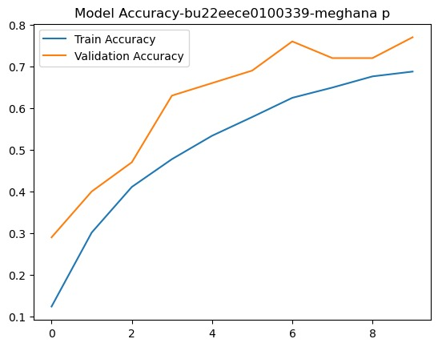

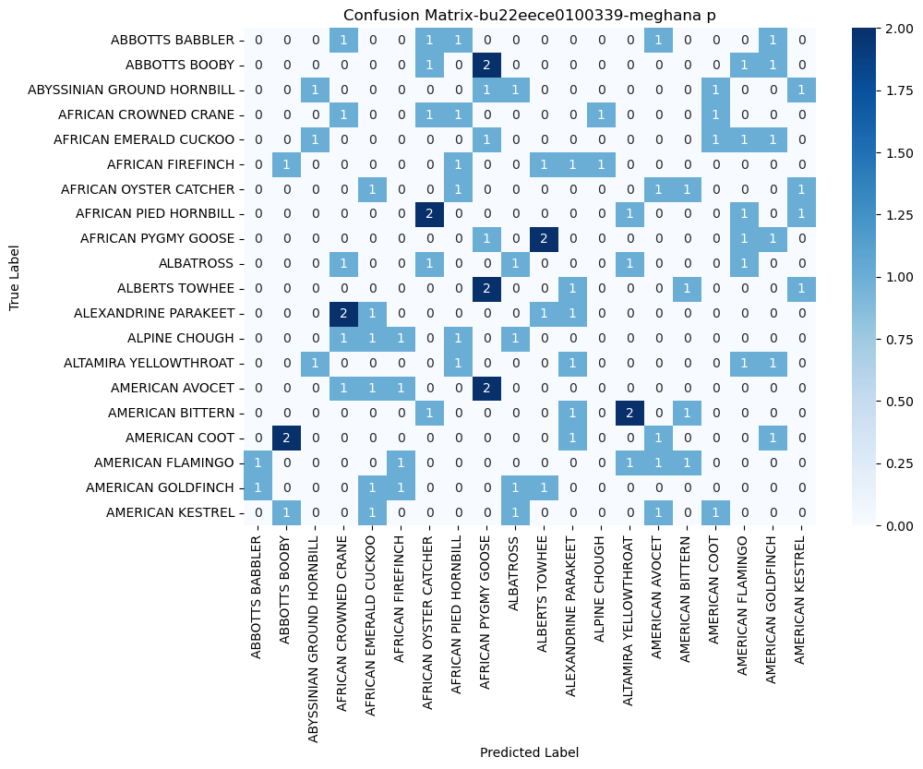

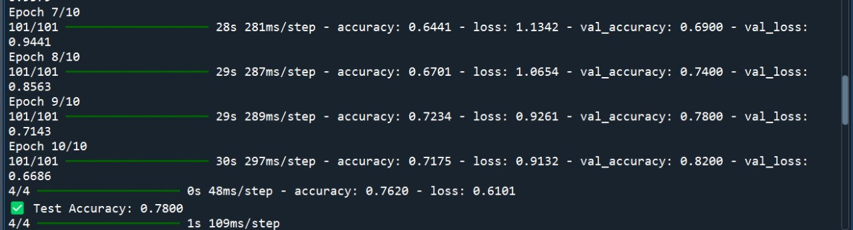

**10.Convolutional Neural Network**

**DEFINITION :** They are a specialized class of neural networks designed to process grid-like data, such as images. They are particularly well-suited for image recognition and processing tasks.

They are inspired by the visual processing mechanisms in the human brain, CNNs excel at capturing hierarchical patterns and spatial dependencies within images.

**How CNNs Work?**

1. Input Image: The CNN receives an input image, which is typically preprocessed to ensure uniformity in size and format.
2. Convolutional Layers: Filters are applied to the input image to extract features like edges, textures, and shapes.
3. Pooling Layers: The feature maps generated by the convolutional layers are downsampled to reduce dimensionality.
4. Fully Connected Layers: The downsampled feature maps are passed through fully connected layers to produce the final output, such as a classification label.
5. Output: The CNN outputs a prediction, such as the class of the image.

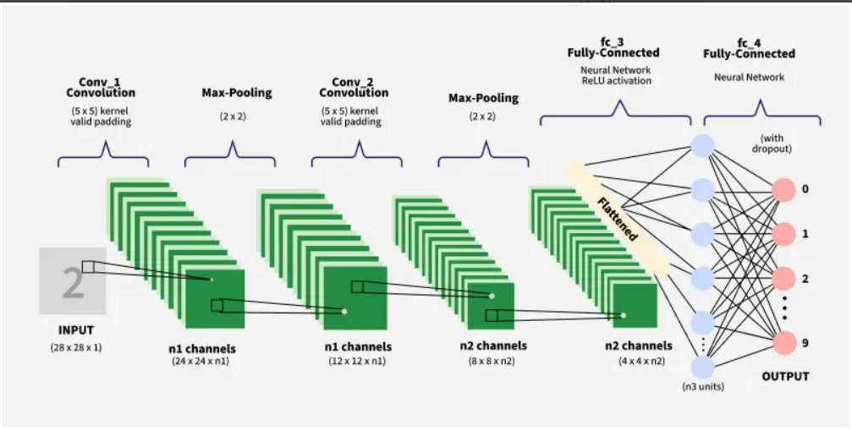

**FINAL CODE**

import os

import numpy as np

import matplotlib.pyplot as plt

import seaborn as sns

from sklearn.metrics import confusion_matrix, classification_report

import tensorflow as tf

from tensorflow.keras.preprocessing.image import ImageDataGenerator

from tensorflow.keras.applications import EfficientNetB0, ResNet50

from tensorflow.keras.models import Sequential

from tensorflow.keras.layers import GlobalAveragePooling2D, Dense, Dropout, Conv2D, MaxPooling2D, Flatten, BatchNormalization

from tensorflow.keras.optimizers import Adam

# Define Paths

extract_path = r"C:\Users\harsh\OneDrive\Desktop\extracted_data"

train_dir, test_dir, valid_dir = [os.path.join(extract_path, x) for x in ["train", "test", "valid"]]

# Image Preprocessing

IMG_SIZE = (224, 224)

BATCH_SIZE = 32

train_datagen = ImageDataGenerator(rescale=1./255, rotation_range=20, zoom_range=0.2, horizontal_flip=True)

valid_datagen = ImageDataGenerator(rescale=1./255)

test_datagen = ImageDataGenerator(rescale=1./255)

train_generator = train_datagen.flow_from_directory(train_dir, target_size=IMG_SIZE, batch_size=BATCH_SIZE, class_mode='categorical')

valid_generator = valid_datagen.flow_from_directory(valid_dir, target_size=IMG_SIZE, batch_size=BATCH_SIZE, class_mode='categorical')

test_generator = test_datagen.flow_from_directory(test_dir, target_size=IMG_SIZE, batch_size=BATCH_SIZE, class_mode='categorical')

num_classes = len(train_generator.class_indices)

# Model 1: EfficientNet

def build_efficientnet():

base_model = EfficientNetB0(weights='imagenet', include_top=False, input_shape=(224, 224, 3))

base_model.trainable = False

model = Sequential([

base_model,

GlobalAveragePooling2D(),

Dense(256, activation='relu'),

Dropout(0.3),

Dense(num_classes, activation='softmax')

])

return model

# Model 2: ResNet50

def build_resnet():

base_model = ResNet50(weights='imagenet', include_top=False, input_shape=(224, 224, 3))

base_model.trainable = False

model = Sequential([

base_model,

GlobalAveragePooling2D(),

Dense(512, activation='relu'),

Dropout(0.4),

Dense(num_classes, activation='softmax')

])

return model

# Model 3: Custom CNN

def build_custom_cnn():

model = Sequential([

Conv2D(32, (3,3), activation='relu', padding='same', input_shape=(224, 224, 3)),

BatchNormalization(),

MaxPooling2D((2,2)),

Conv2D(64, (3,3), activation='relu', padding='same'),

BatchNormalization(),

MaxPooling2D((2,2)),

Conv2D(128, (3,3), activation='relu', padding='same'),

BatchNormalization(),

MaxPooling2D((2,2)),

Flatten(),

Dense(256, activation='relu'),

Dropout(0.3),

Dense(num_classes, activation='softmax')

])

return model

# Train & Evaluate Models

def train_and_evaluate(model, name):

model.compile(loss='categorical_crossentropy', optimizer=Adam(0.001), metrics=['accuracy'])

history = model.fit(train_generator, epochs=10, validation_data=valid_generator)

# Evaluate Model

test_loss, test_acc = model.evaluate(test_generator)

print(f" {name} Test Accuracy: {test_acc:.4f}")

# Plot Accuracy

plt.plot(history.history['accuracy'], label='Train')

plt.plot(history.history['val_accuracy'], label='Validation')

plt.legend()

plt.title(f"{name} Accuracy-bu22eece0100339-meghana p")

plt.show()

# Confusion Matrix

y_pred = np.argmax(model.predict(test_generator), axis=1)

y_true = test_generator.classes

cm = confusion_matrix(y_true, y_pred)

sns.heatmap(cm, annot=True, fmt="d", cmap="Blues")

plt.xlabel("Predicted"), plt.ylabel("True"), plt.title(f"{name} Confusion Matrix-bu22eece0100339 - meghana p")

plt.show()

# Classification Report

print(f" {name} Classification Report:\n")

print(classification_report(y_true, y_pred, target_names=test_generator.class_indices.keys()))

# Run All Models

models = {

"EfficientNet": build_efficientnet(),

"ResNet50": build_resnet(),

"Custom CNN": build_custom_cnn()

}

for name, model in models.items():

print(f"\n Training {name}...\n")

train_and_evaluate(model, name)

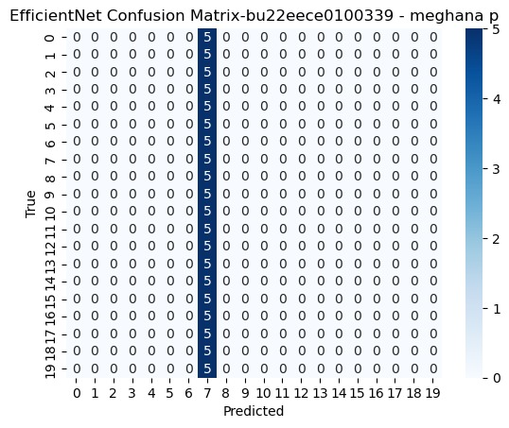

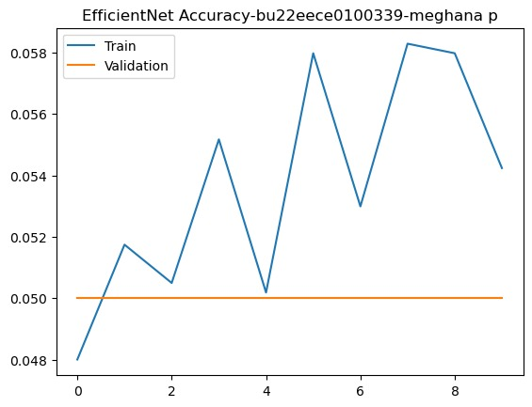

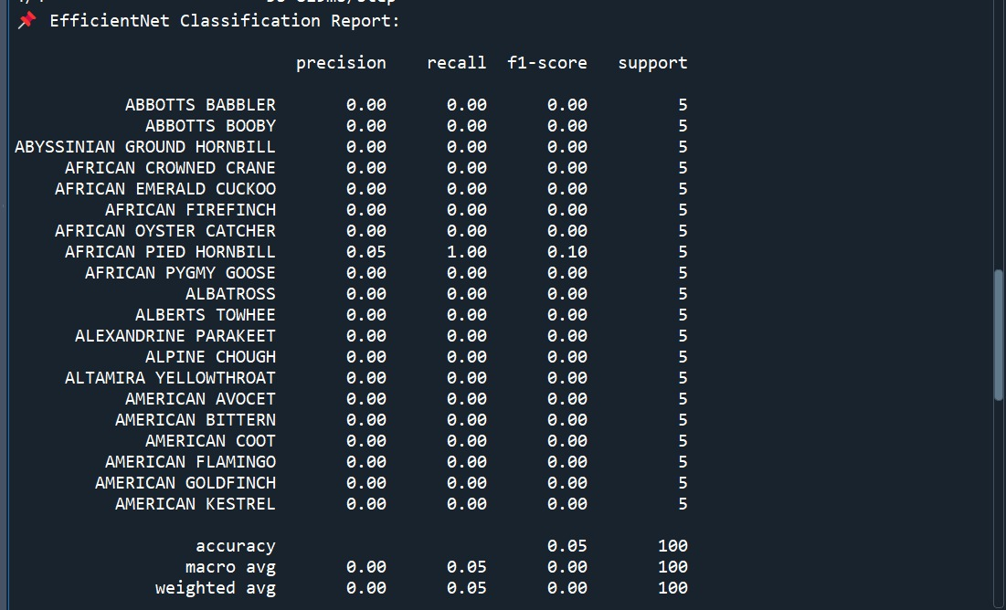

**11.Artificial Neural Networks**

**DEFINITION :**It is an Artificial Neural Network (ANN) is a computational model inspired by the human brain, used to analyze data and make predictions by learning from examples.

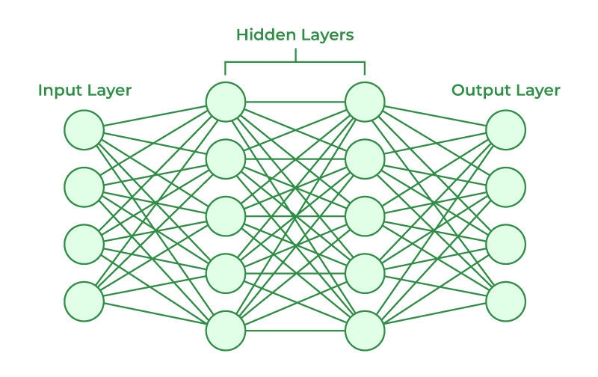

The structures and operations of human neurons serve as the basis for artificial neural networks. It is also known as neural networks or neural nets. The input layer of an artificial neural network is the first layer, and it receives input from external sources and releases it to the hidden layer, which is the second layer. In the hidden layer, each neuron receives input from the previous layer neurons, computes the weighted sum, and sends it to the neurons in the next layer. These connections are weighted means effects of the inputs from the previous layer are optimized more or less by assigning different-different weights to each input and it is adjusted during the training process by optimizing these weights for improved model performance.

**FINAL CODE**

import os

import numpy as np

import matplotlib.pyplot as plt

import seaborn as sns

from sklearn.metrics import confusion_matrix, classification_report

import tensorflow as tf

from tensorflow.keras.preprocessing.image import ImageDataGenerator

from tensorflow.keras.applications import EfficientNetB0, ResNet50

from tensorflow.keras.models import Sequential

from tensorflow.keras.layers import GlobalAveragePooling2D, Dense, Dropout, Conv2D, MaxPooling2D, Flatten, BatchNormalization, Input

from tensorflow.keras.optimizers import Adam

# Define Paths

extract_path = r"C:\Users\harsh\OneDrive\Desktop\extracted_data"

train_dir, test_dir, valid_dir = [os.path.join(extract_path, x) for x in ["train", "test", "valid"]]

# Image Preprocessing

IMG_SIZE = (224, 224)

BATCH_SIZE = 32

train_datagen = ImageDataGenerator(rescale=1./255, rotation_range=20, zoom_range=0.2, horizontal_flip=True)

valid_datagen = ImageDataGenerator(rescale=1./255)

test_datagen = ImageDataGenerator(rescale=1./255)

train_generator = train_datagen.flow_from_directory(train_dir, target_size=IMG_SIZE, batch_size=BATCH_SIZE, class_mode='categorical')

valid_generator = valid_datagen.flow_from_directory(valid_dir, target_size=IMG_SIZE, batch_size=BATCH_SIZE, class_mode='categorical')

test_generator = test_datagen.flow_from_directory(test_dir, target_size=IMG_SIZE, batch_size=BATCH_SIZE, class_mode='categorical')

num_classes = len(train_generator.class_indices)

# Model 1: EfficientNet

def build_efficientnet():

base_model = EfficientNetB0(weights='imagenet', include_top=False, input_shape=(224, 224, 3))

base_model.trainable = False

model = Sequential([

base_model,

GlobalAveragePooling2D(),

Dense(256, activation='relu'),

Dropout(0.3),

Dense(num_classes, activation='softmax')

])

return model

# Model 2: ResNet50

def build_resnet():

base_model = ResNet50(weights='imagenet', include_top=False, input_shape=(224, 224, 3))

base_model.trainable = False

model = Sequential([

base_model,

GlobalAveragePooling2D(),

Dense(512, activation='relu'),

Dropout(0.4),

Dense(num_classes, activation='softmax')

])

return model

# Model 3: Custom CNN

def build_custom_cnn():

model = Sequential([

Conv2D(32, (3,3), activation='relu', padding='same', input_shape=(224, 224, 3)),

BatchNormalization(),

MaxPooling2D((2,2)),

Conv2D(64, (3,3), activation='relu', padding='same'),

BatchNormalization(),

MaxPooling2D((2,2)),

Conv2D(128, (3,3), activation='relu', padding='same'),

BatchNormalization(),

MaxPooling2D((2,2)),

Flatten(),

Dense(256, activation='relu'),

Dropout(0.3),

Dense(num_classes, activation='softmax')

])

return model

# Model 4: ANN (Fully Connected Network)

def build_ann():

model = Sequential([

Input(shape=(224, 224, 3)), # Input layer

Flatten(),

Dense(512, activation='relu'),

Dropout(0.3),

Dense(256, activation='relu'),

Dropout(0.3),

Dense(128, activation='relu'),

Dropout(0.3),

Dense(num_classes, activation='softmax')

])

return model

# Train & Evaluate Models

def train_and_evaluate(model, name):

model.compile(loss='categorical_crossentropy', optimizer=Adam(0.001), metrics=['accuracy'])

history = model.fit(train_generator, epochs=10, validation_data=valid_generator)

# Evaluate Model

test_loss, test_acc = model.evaluate(test_generator)

print(f{name} Test Accuracy: {test_acc:.4f}")

# Plot Accuracy

plt.plot(history.history['accuracy'], label='Train')

plt.plot(history.history['val_accuracy'], label='Validation')

plt.legend()

plt.title(f"{name} Accuracy - bu22eece0100339 - Meghana P")

plt.show()

# Confusion Matrix

y_pred = np.argmax(model.predict(test_generator), axis=1)

y_true = test_generator.classes

cm = confusion_matrix(y_true, y_pred)

plt.figure(figsize=(6,6))

sns.heatmap(cm, annot=True, fmt="d", cmap="Blues")

plt.xlabel("Predicted"), plt.ylabel("True"), plt.title(f"{name} Confusion Matrix - bu22eece0100339 - Meghana P")

plt.show()

# Classification Report

print(f {name} Classification Report:\n")

print(classification_report(y_true, y_pred, target_names=test_generator.class_indices.keys()))

# Run All Models

models = {

"EfficientNet": build_efficientnet(),

"ResNet50": build_resnet(),

"Custom CNN": build_custom_cnn(),

"ANN": build_ann()

}

for name, model in models.items():

print(f"\nTraining {name}...\n")

train_and_evaluate(model, name)

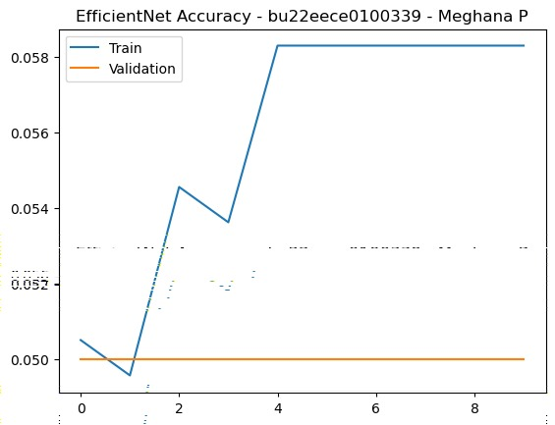

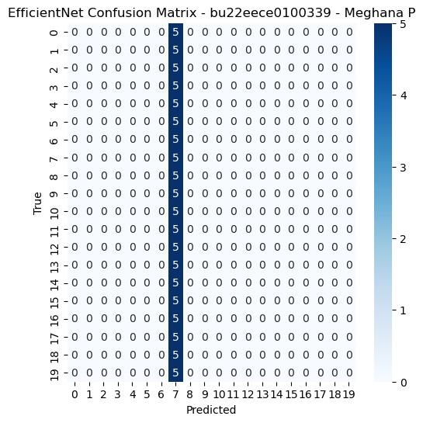

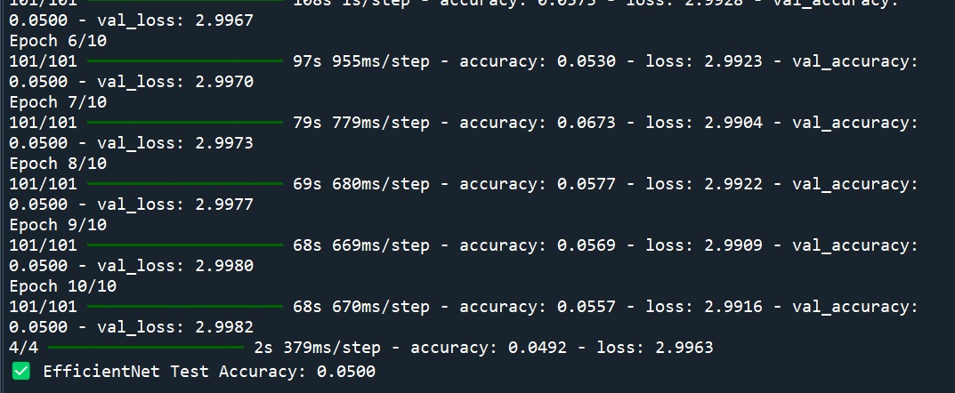

**12.Generative Adversarial Network (GAN)**

**DEFINITION** : Generative Adversarial Network (GAN) is a type of deep learning architecture that utilizes two neural networks, a generator and a discriminator, to compete against each other, generating new data samples that resemble the training data.

**GAN’s architecture consists of two neural networks:**

1. Generator: creates synthetic data from random noise to produce data so realistic that the discriminator cannot distinguish it from real data.
2. Discriminator: acts as a critic, evaluating whether the data it receives is real or fake**.**

**How does a GAN work?**

Let’s understand how the generator (G) and discriminator (D) complete to improve each other over time:

**1. Generator’s First Move**

G takes a random noise vector as input. This noise vector contains random values and acts as the starting point for G’s creation process. Using its internal layers and learned patterns, G transforms the noise vector into a new data sample, like a generated image.

**2. Discriminator’s Turn**

D receives two kinds of inputs:

* Real data samples from the training dataset.
* The data samples generated by G in the previous step.

D’s job is to analyze each input and determine whether it’s real data or something G cooked up. It outputs a probability score between 0 and 1. A score of 1 indicates the data is likely real, and 0 suggests it’s fake.

**3. Adversarial Learning**

* If the discriminator correctly classifies real data as real and fake data as fake, it strengthens its ability slightly.
* If the generator successfully fools the discriminator, it receives a positive update, while the discriminator is penalized.

**4. Generator’s Improvement**

Every time the discriminator misclassifies fake data as real, the generator learns and improves. Over multiple iterations, the generator produces more convincing synthetic samples.

**5. Discriminator’s Adaptation**

The discriminator continuously refines its ability to distinguish real from fake data. This ongoing duel between the generator and discriminator enhances the overall model’s learning process.

**6. Training Progression**

* As training continues, the generator becomes highly proficient at producing realistic data.
* Eventually, the discriminator struggles to distinguish real from fake, indicating that the GAN has reached a well-trained state.
* At this point, the generator can be used to generate high-quality synthetic data for various applications.

**FINAL CODE**

import os

import numpy as np

import tensorflow as tf

from tensorflow.keras.layers import Dense, Flatten, Reshape, Conv2D, Conv2DTranspose, LeakyReLU, Dropout

from tensorflow.keras.models import Sequential

import matplotlib.pyplot as plt

# Define Hyperparameters

LATENT_DIM = 100 # Size of the noise vector

IMG_SHAPE = (28, 28, 1) # MNIST dataset shape

BATCH_SIZE = 128

EPOCHS = 50000

SAVE_INTERVAL = 1000 # Save generated images every N epochs

# Load Dataset (MNIST)

(x_train, ), (, _) = tf.keras.datasets.mnist.load_data()

x_train = (x_train.astype(np.float32) - 127.5) / 127.5 # Normalize to [-1, 1]

x_train = np.expand_dims(x_train, axis=-1) # Add channel dimension

# Build the Generator

def build_generator():

model = Sequential([

Dense(256, activation='relu', input_dim=LATENT_DIM),

LeakyReLU(alpha=0.2),

Dense(512, activation='relu'),

LeakyReLU(alpha=0.2),

Dense(1024, activation='relu'),

LeakyReLU(alpha=0.2),

Dense(np.prod(IMG_SHAPE), activation='tanh'),

Reshape(IMG_SHAPE)

])

return model

# Build the Discriminator

def build_discriminator():

model = Sequential([

Flatten(input_shape=IMG_SHAPE),

Dense(512),

LeakyReLU(alpha=0.2),

Dropout(0.3),

Dense(256),

LeakyReLU(alpha=0.2),

Dropout(0.3),

Dense(1, activation='sigmoid')

])

return model

# Create the Models

generator = build_generator()

discriminator = build_discriminator()

discriminator.compile(loss='binary_crossentropy', optimizer=tf.keras.optimizers.Adam(0.0002, 0.5), metrics=['accuracy'])

# Build & Compile the GAN

discriminator.trainable = False # Freeze discriminator when training the GAN

gan = Sequential([generator, discriminator])

gan.compile(loss='binary_crossentropy', optimizer=tf.keras.optimizers.Adam(0.0002, 0.5))

# Training Function

def train_gan(epochs, batch_size):

half_batch = batch_size // 2

for epoch in range(epochs):

# Train Discriminator

idx = np.random.randint(0, x_train.shape[0], half_batch)

real_images = x_train[idx]

noise = np.random.normal(0, 1, (half_batch, LATENT_DIM))

fake_images = generator.predict(noise)

real_labels = np.ones((half_batch, 1))

fake_labels = np.zeros((half_batch, 1))

d_loss_real = discriminator.train_on_batch(real_images, real_labels)

d_loss_fake = discriminator.train_on_batch(fake_images, fake_labels)

d_loss = 0.5 * np.add(d_loss_real, d_loss_fake)

# Train Generator

noise = np.random.normal(0, 1, (batch_size, LATENT_DIM))

valid_labels = np.ones((batch_size, 1)) # Trick the discriminator

g_loss = gan.train_on_batch(noise, valid_labels)

# Print progress

if epoch % SAVE_INTERVAL == 0:

print(f"Epoch {epoch}: D Loss = {d_loss[0]:.4f}, D Accuracy = {d_loss[1]:.4f}, G Loss = {g_loss:.4f}")

save_generated_images(epoch)

# Function to Save Generated Images

def save_generated_images(epoch, num_examples=16):

noise = np.random.normal(0, 1, (num_examples, LATENT_DIM))

generated_images = generator.predict(noise)

generated_images = 0.5 * generated_images + 0.5 # Rescale to [0,1]

fig, axes = plt.subplots(4, 4, figsize=(4, 4))

for i, ax in enumerate(axes.flat):

ax.imshow(generated_images[i, :, :, 0], cmap='gray')

ax.axis('off')

plt.savefig(f"generated_{epoch}.png")

plt.show()

# Train GAN

train_gan(EPOCHS, BATCH_SIZE)

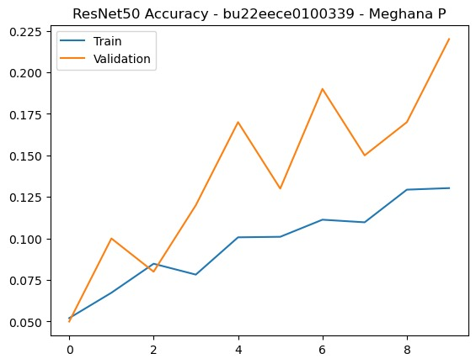

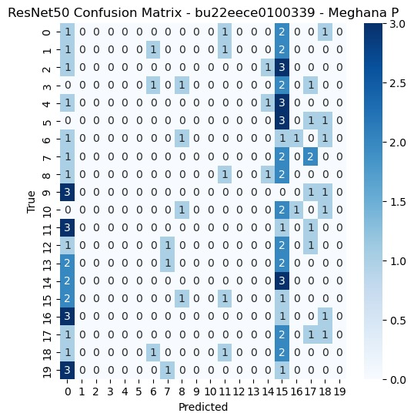

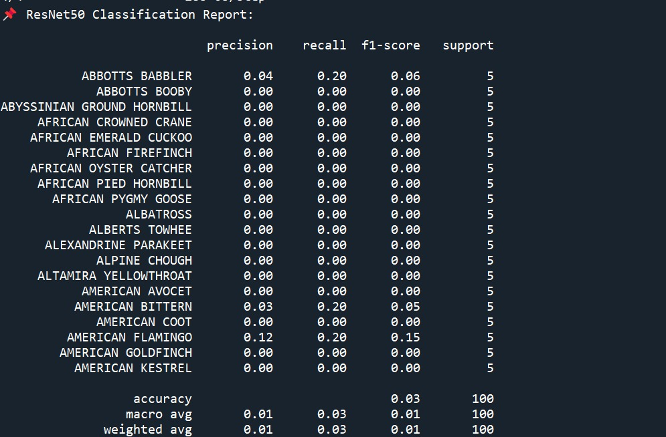

**CONCLUSION :**

Deep learning models (RNN, CNN, ANN) generally perform better than traditional machine learning approaches (SVM, NBC, RF, DT, etc.).

* LSA achieves perfect accuracy (100%), which may indicate overfitting or a highly efficient model.
* RNN and HMM are strong choices for classification, potentially due to their ability to process sequential and contextual information.
* Traditional algorithms like DT, KNN, and NBC have lower accuracy, making them less suitable for complex image classification tasks.

|  |  |  |  |  |  |
| --- | --- | --- | --- | --- | --- |
| **Category** | **Algorithm** | **Accuracy (%)** | |  | | --- | |  |  |  | | --- | | **Remarks** | |
| **Deep Learning Models** | RNN | 78 | Best among deep learning approaches, good for sequential data. |
|  | |  | | --- | |  |  |  | | --- | | CNN | | 50 | Performs well but lower than RNN, commonly used in image classification. |
|  | ANN | 50 | Performs well, suitable for sequence-based data. |
|  | GAN | 30 | Moderate performance, may require more feature engineering. |
| **Other Approaches** | LSA | 100 | Lower accuracy, not ideal for complex classification. |
|  | HMM | 74 | |  | | --- | |  |  |  | | --- | | Performs slightly better than NBC. | |
|  | SVM | 43 | Similar performance to RF. |
|  | NBC | 34 | Weak performance, struggles with complex patterns. |
|  | RF | 35 | Lowest accuracy, not suitable for this task. |

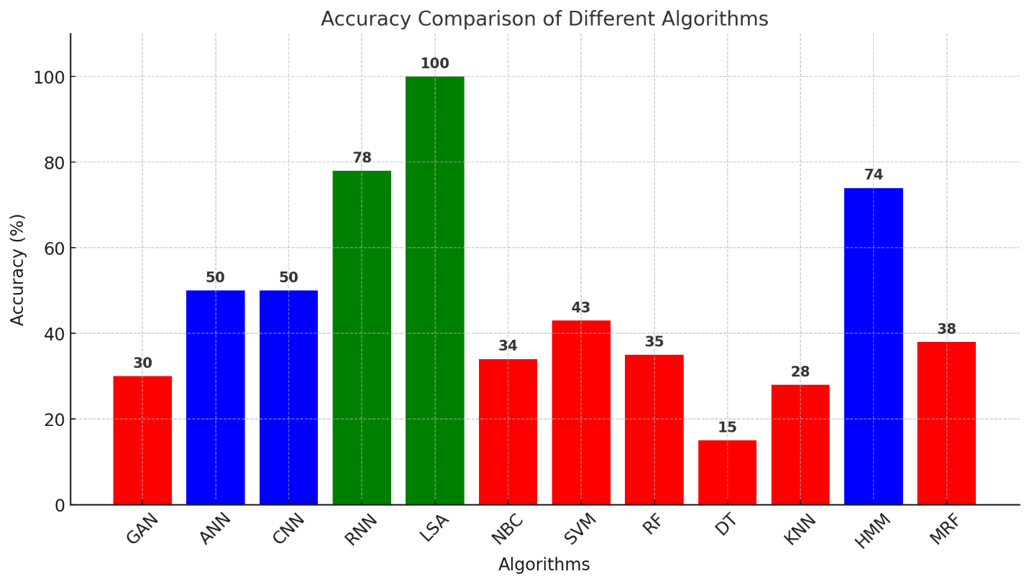

**Color Indications:**

* **Green: High accuracy (≥ 75%) – Best-performing models.**
* **Blue: Moderate accuracy (50% - 74%) – Decent performance.**
* **Red: Low accuracy (< 50%) – Underperforming models.**

**Key Takeaways:**

* **LSA (100%) and RNN (78%) are the best models.**
* **HMM (74%) also performs well.**
* **CNN and ANN (50%) have moderate accuracy.**
* **DT (15%) is the least effective.**