Visualization Report for Internship OIBSIP - Third Project

  - Purpose:
  - To present cleaned relational dataset insights through visualizations.
  - Each section contains chart headings and short insights. Insert chart images under each heading.

Section 1: Category Exploration
Chart 1: Category wise App Count + Review Count (Bar Chart)
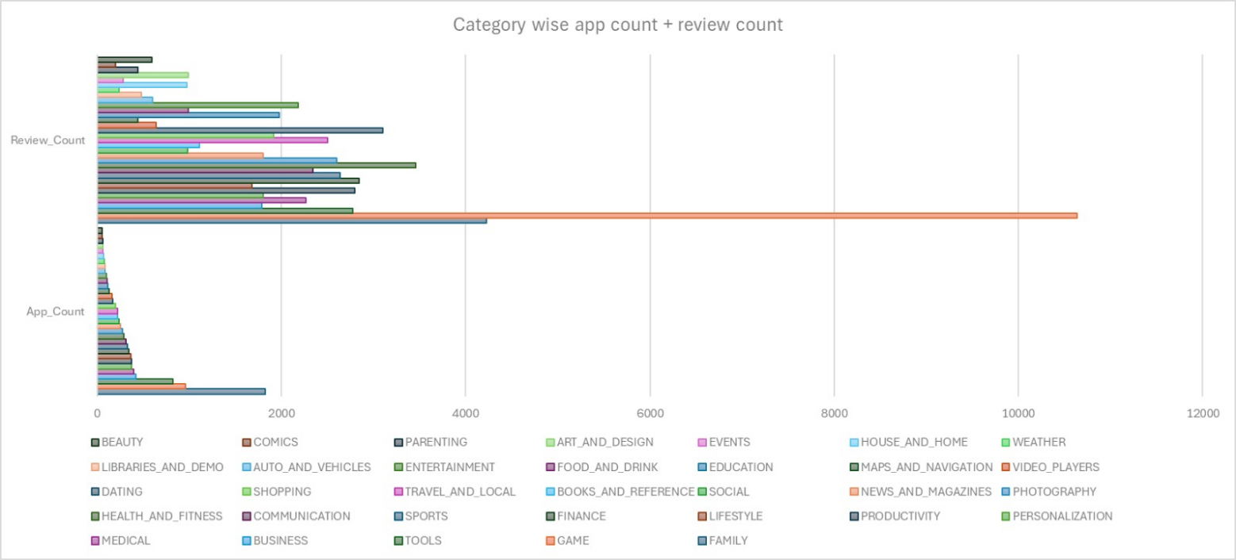
Insight: Shows which categories dominate app distribution and engagement.

Chart 2: Avg Rating per Category + Avg Sentiment Polarity (Bar Chart)
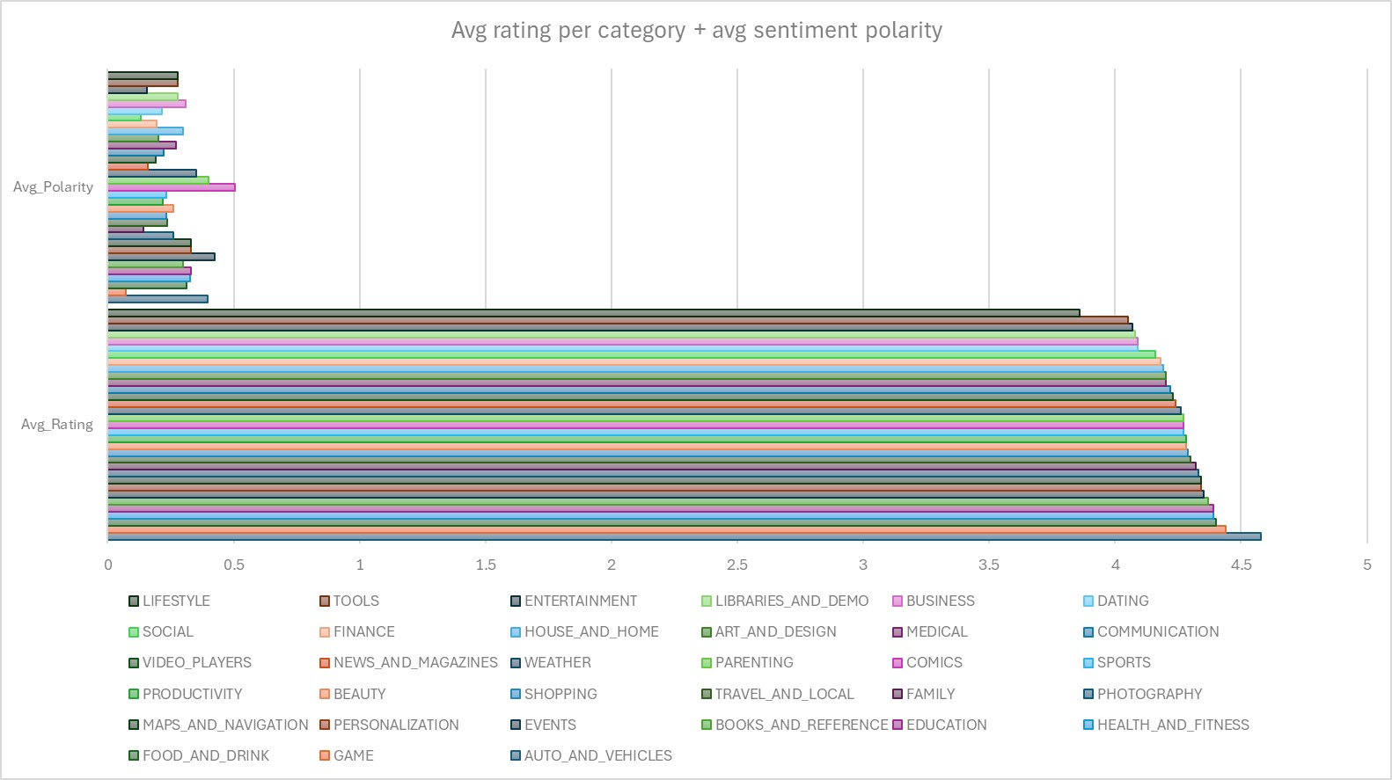
Insight: Highlights whether highly rated categories also have positive sentiment.

Chart 3: Free vs Paid Apps Sentiment Distribution (Pie Chart)
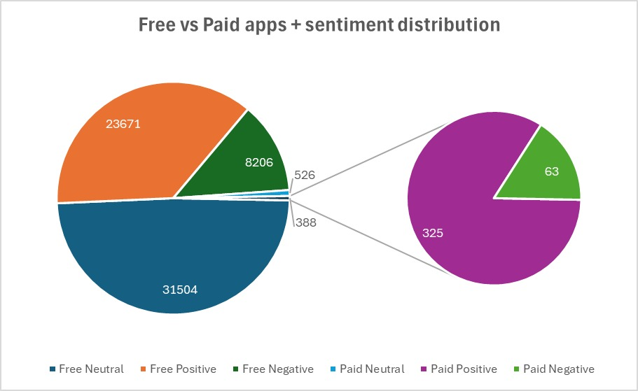
Insight: Compares monetization type with user satisfaction levels.

Section 2: Metrics Analysis
Chart 1: Rating vs Installs (Scatter Plot)
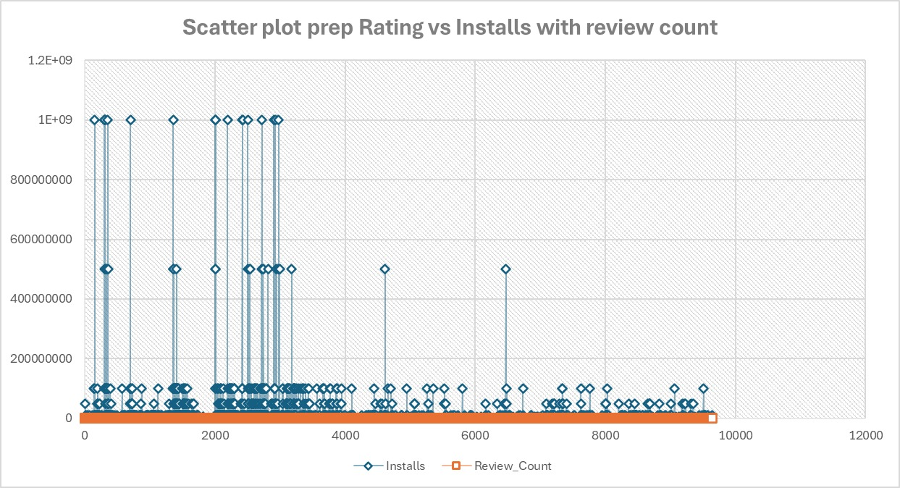
Insight: Shows popularity trend and engagement correlation.

Chart 2: Top 10 Apps by Reviews (Bar Chart)
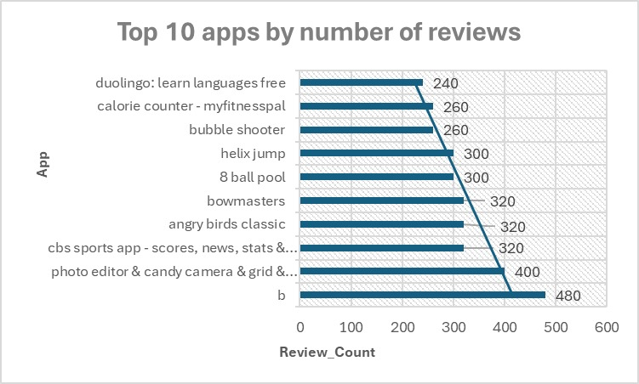
Insight: Highlights the most discussed apps.

Chart 3: Avg Price per Category (Bar Chart)
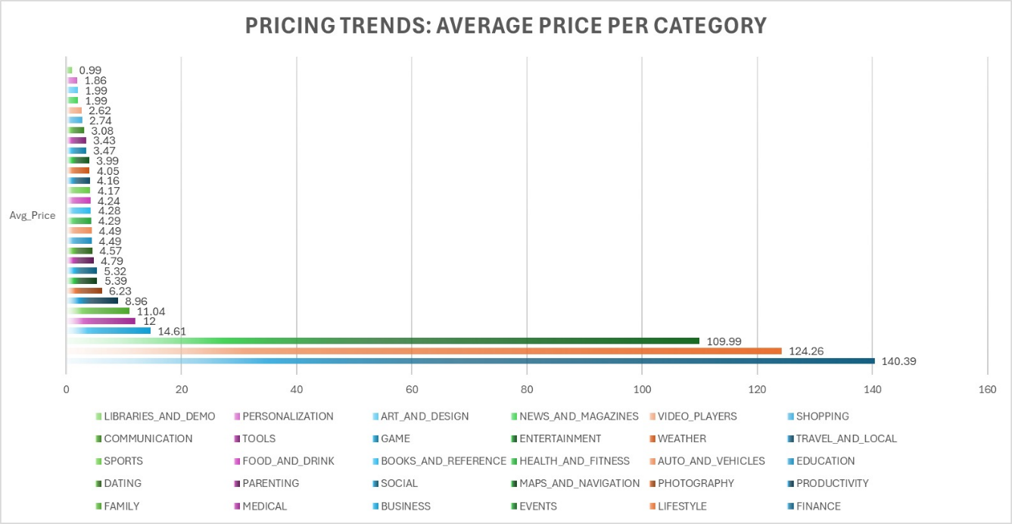
Insight: Shows pricing trends across categories.\
Chart 4: Size vs Rating (Line Chart)
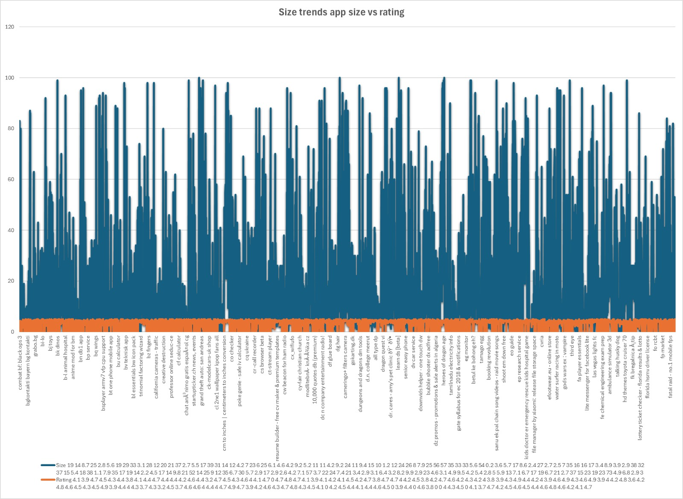Insight: Explores whether larger apps get better ratings.

Chart 5: Category wise Paid Apps Ratio (Pie Chart)
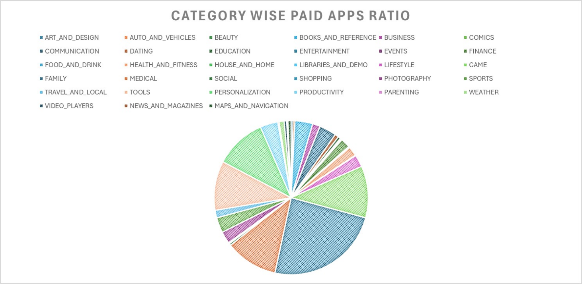
Insight: Shows monetization strategy across categories.

Section 3: Sentiment Analysis
Chart 1: Overall Sentiment Distribution (Pie Chart)
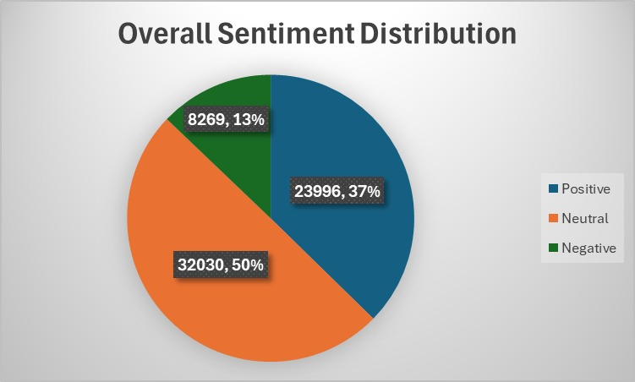
Insight: Shows Positive vs Neutral vs Negative share across all reviews.

Chart 2: Avg Polarity & Subjectivity per Category (Bar Chart)
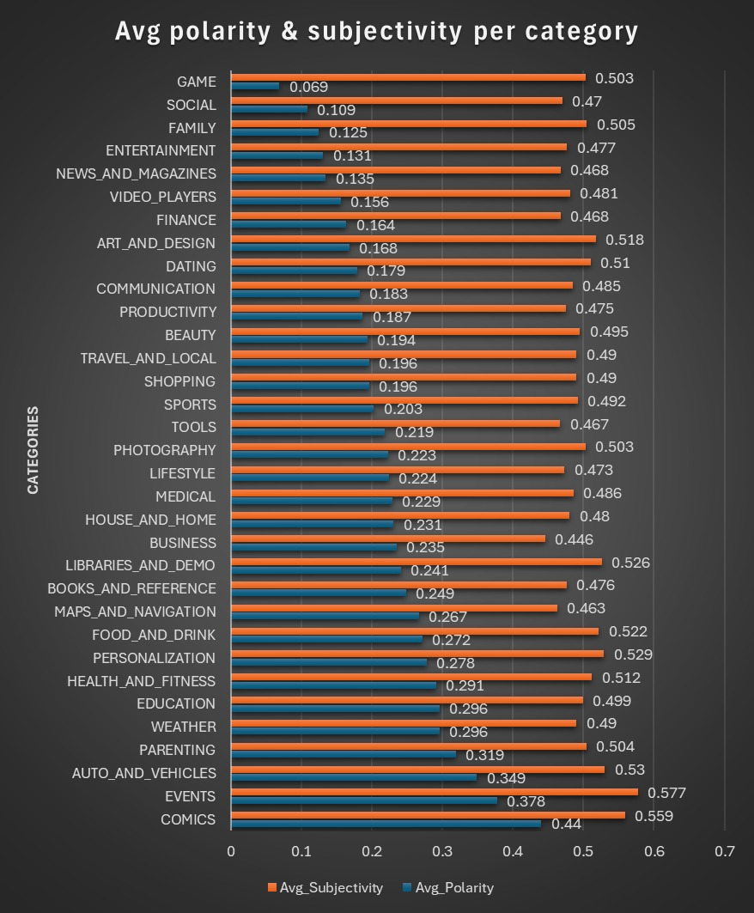
Insight: Highlights positivity and opinion‑heaviness by category.

Chart 3: Reviews vs Installs Correlation (Heatmap)
The heatmap has been exported as PDF and is available in the Visualization folder on the main branch for reference.
Insight: Shows if popular apps (high installs) attract more reviews and positivity.

