# Loading of model and dataset in google colab

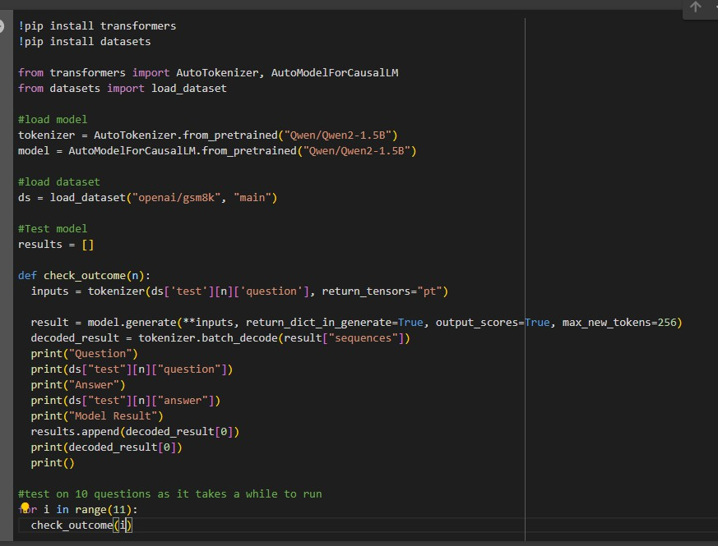

# Problems & Solutions:

1. The model occasionally misses out steps in the questions

In question 2, the model saves the value increase variable but does not use it in its calculations, resulting in a wrong answer.

# Solution

Implement multi-step reasoning to reduce the probability of steps being done wrongly or missed out by breaking down the question into individual small

steps and get the question to each one slowly. For example, instead of 6x5/8, tell the model to find 6x5, then with the output of the previous prompt, ask the model to calculate 30/8 and verify if it is right at each individual step.

1. The model misinterprets the numbers it obtains from the solution

In question 2, the model arrives at 50,000 but outputs an answer of 15,000 instead, likely because it missed up 15 and 50. In question 5, it calculated 128 but outputs 100.

# Solution

Firstly, the model can be trained with more numeric data to reduce the probability of the model mixing up questions. For example, train the model with solving more mathematical equations.

Secondly, rounding results to a fixed precision (3.00000000000000000000004 to 3.00) would reduce the possibility of digits being flipped.

1. The model does calculations wrongly.

In question 7, it miscalculated 40% of 200 multiplied by 2 as 20.

# Solution

Use an external library, such as the math library to verify the result of mathematical calculations.

1. The model sometimes misinterprets the questions and uses the wrong steps to solve the question.

In question 8, it uses the wrong equations, likely because the question was very long and complicated.

# Solution

Use step-by-step prompts to guide the model to solve the problem instead of feeding the entire question at once. For example, in question 8, give it the first line and tell it to calculate the distance travelled away from the house before continuing with the next line.

# References

[GitHub - QwenLM/Qwen2.5: Qwen2.5 is the large language model series](https://github.com/QwenLM/Qwen2.5) [developed by Qwen team, Alibaba Cloud.](https://github.com/QwenLM/Qwen2.5)