**1. List the last name, name, employee number, type of employee of all employees ordered by last**

**name.**

select emp_lname, emp_fname, emp_id, e_type

from employee as e

JOIN emp_type et on et.type_id = e.type_id

order by emp_lname asc

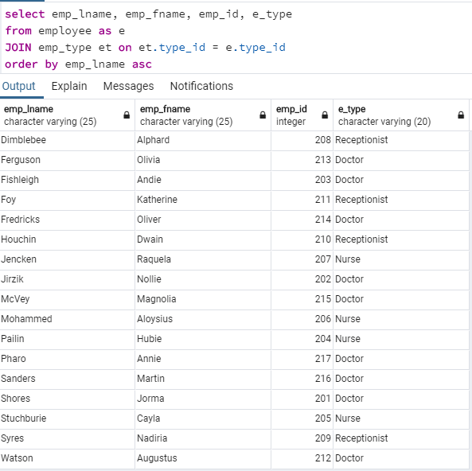

**2. List the last name, name, employee number, type of employee of all employees ordered by last**

**name grouped by employee type.**

select emp_lname, emp_fname, emp_id, e_type

from employee as e

JOIN emp_type et on et.type_id = e.type_id

order by e_type, emp_lname asc

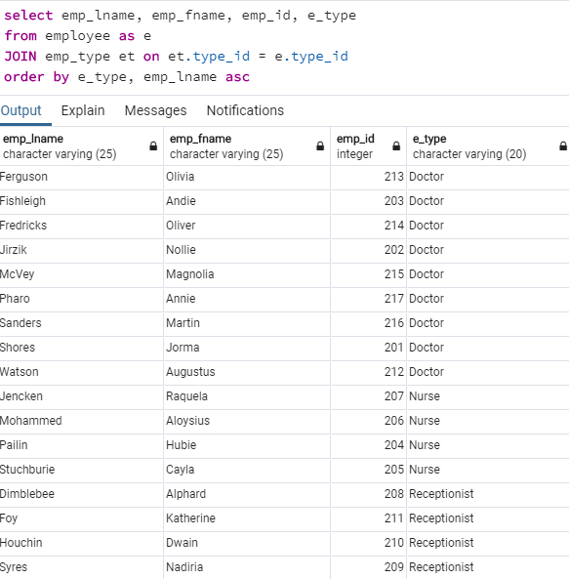

**3. List the name, last name, employee number, Specialty of doctors. Group by specialty and order by last name.**

select emp_fname, emp_lname, e.emp_id, spec_type

from employee as e

JOIN specialty s on s.emp_id = e.emp_id

order by spec_type, emp_lname asc

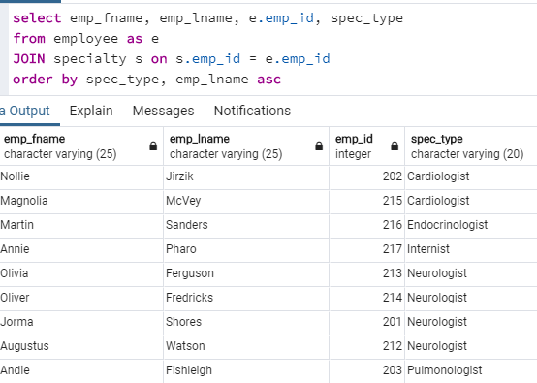

**4. List the count of doctors per specialty order the list by specialty name.**

select count(e.emp_id), spec_type

from employee as e

JOIN specialty s on s.emp_id = e.emp_id

group by spec_type

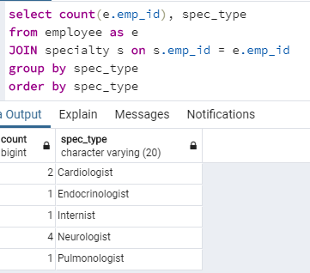order by spec_type

**5. List the name, last name, employee number of all the nurses.**

select emp_fname, emp_lname, emp_id

from employee as e

where type_id = 2

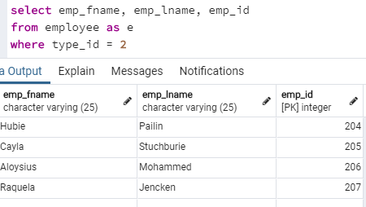

**6. List the employees name, last name, employee type, salary with salaries greater than 85K.**

select emp_fname, emp_lname, e_type, emp_salary

from employee as e

join emp_type et on et.type_id = e.type_id

where emp_salary > 85000

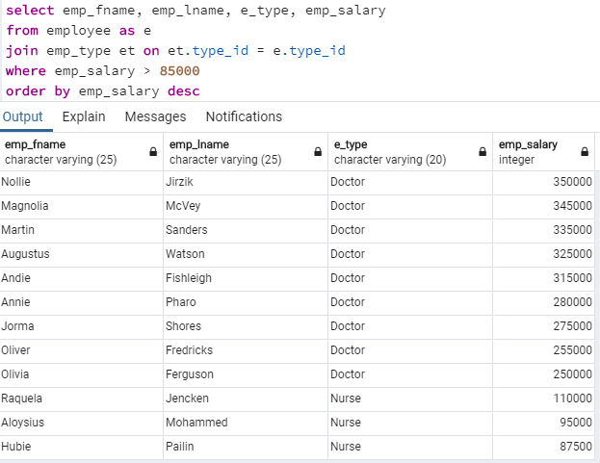order by emp_salary desc

**7. List the name, last name, sex, patient id and room number of all the patients not discharged yet and who are older than 65 years old.**

select distinct pt.p_fname, pt.p_lname, pt.p_sex, pt.p_id, ad.r_num

from patient as pt

join admittance ad on ad.p_id = pt.p_id

where pt.p_age > 65 AND

ad.date_disch IS NULL

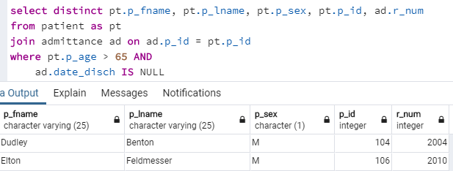

**8. List the patient name, last name, patient id of patients discharged in one specific month (specified the month based on the data you used to populate the database).**

select distinct pt.p_fname, pt.p_lname, pt.p_id

from patient as pt

join admittance ad on ad.p_id = pt.p_id

where EXTRACT(month FROM(ad.date_disch)) = 11

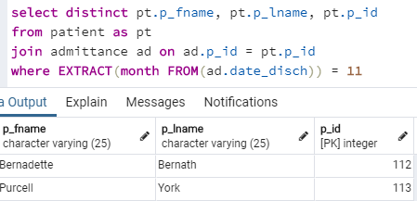

**9. List the name and last name and room number of patients admitted through the ER and already discharged**

select distinct pt.p_fname, pt.p_lname, ad.r_num, ad.date_admit, ad.date_disch

from patient as pt

join admittance ad on ad.p_id = pt.p_id

where ad.er_admit = '1' AND

ad.date_disch IS NOT NULL

order by r_num

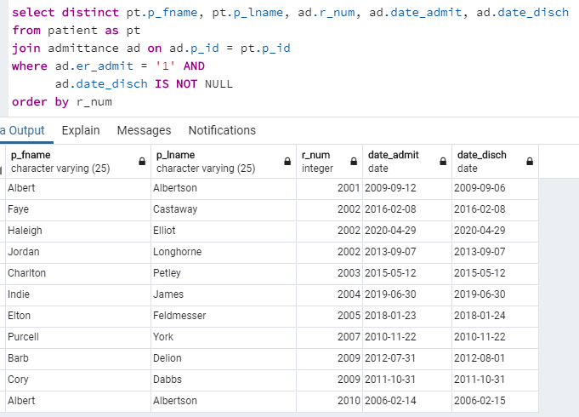

**10. List the name and last name, assigned room, room type and assigned nurse name and last name of patients not discharged yet.**

select distinct pt.p_fname, pt.p_lname, ad.r_num, rm.num_beds, rm.r_type, e.emp_fname, e.emp_lname

from patient as pt

join admittance ad on ad.p_id = pt.p_id

join room rm on rm.r_num = ad.r_num

join employee e on e.emp_id = rm.nurse_id

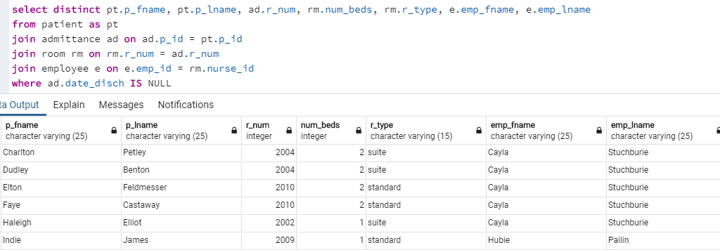where ad.date_disch IS NULL

**11. List the nurse name, nurse last name and average patient they took care per month.**

SELECT e.emp_fname, e.emp_lname, CAST(AVG(tbl.count) AS DECIMAL(3,2))

FROM (select em.emp_fname, em.emp_lname, em.emp_id, COUNT(ad.p_id),

EXTRACT(monthFROM(ad.date_admit)) as monthVal

from employee as em

join room rm on rm.nurse_id = em.emp_id

join admittance ad on ad.r_num = rm.r_num

join patient pt on pt.p_id = ad.p_id

group by EXTRACT(month FROM(ad.date_admit)), em.emp_fname, em.emp_lname, em.emp_id

order by em.emp_fname) as tbl

JOIN employee e on e.emp_id = tbl.emp_id

GROUP BY e.emp_fname, e.emp_lname

ORDER BY e.emp_fname

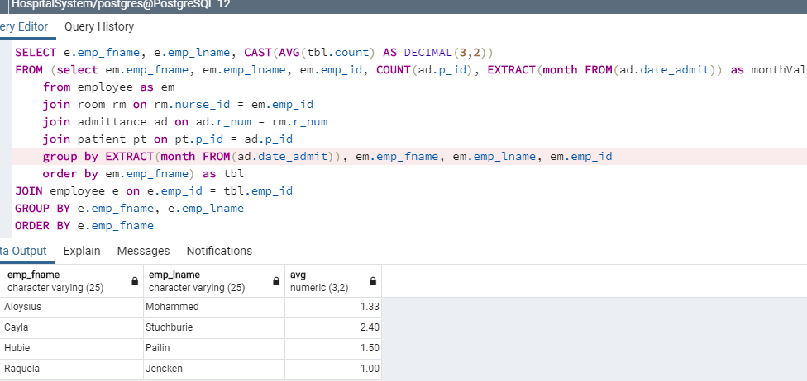

**12. List the doctor name and last name and average patient attended per month for all the doctors.**

SELECT e.emp_fname, e.emp_lname, CAST(AVG(tbl.count) AS DECIMAL(3,2))

FROM (select em.emp_fname, em.emp_lname, em.emp_id, COUNT(ad.p_id), EXTRACT(month FROM(ad.date_admit)) as monthVal

from employee as em

join admittance ad on ad.doctor_id = em.emp_id

join patient pt on pt.p_id = ad.p_id

group by EXTRACT(month FROM(ad.date_admit)), em.emp_fname, em.emp_lname, em.emp_id

order by em.emp_fname) as tbl

JOIN employee e on e.emp_id = tbl.emp_id

GROUP BY e.emp_fname, e.emp_lname

ORDER BY e.emp_fname

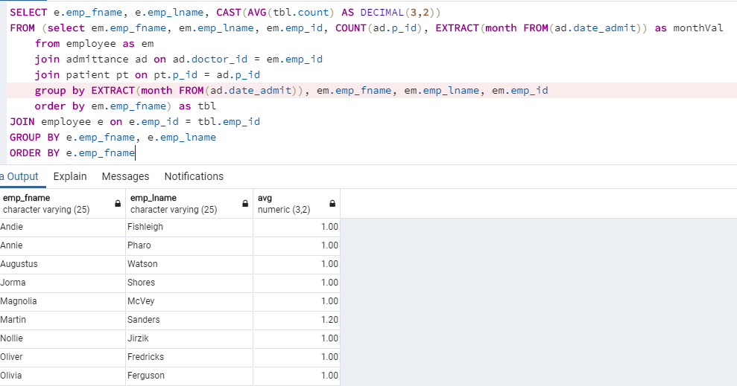

**13. List the specialty and number of doctors for the specialty that has more than 3 doctors that make**

**more than 100K a year.**

select distinct sp.spec_type

from (select s.spec_type, COUNT(e.emp_id) as cnt

from SPECIALTY s

join EMPLOYEE e on e.emp_id = s.emp_id

where e.emp_salary > 100000

group by spec_type ) as tbl

join specialty sp on sp.spec_type = tbl.spec_type

where tbl.cnt > 3

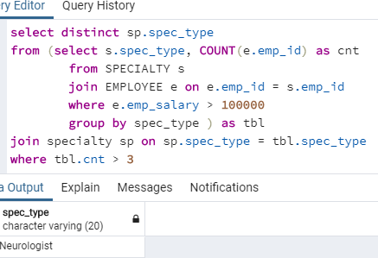

**14. List the room number of any empty room.**

SELECT DISTINCT r.r_num

FROM ROOM r

WHERE r.r_num NOT IN (select distinct ad.r_num

from admittance as ad

where ad.date_disch IS NULL)

ORDER BY r_num

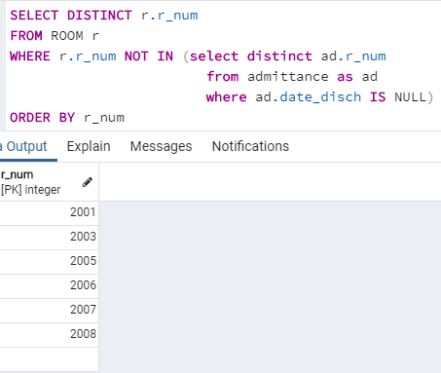

**15. List the average cost of a treatment.**

SELECT CAST(AVG(costs) AS DECIMAL(5,2)) as avgcosttreatment

FROM (select distinct mc.med_id, mc.costs, trmt.p_id

from MEDICINE_COST mc

join TREATMENT trmt on trmt.med_id = mc.med_id AND trmt.quantity = mc.quantity) as mcs