1.1) Retrieve the name and address of each employee that works in the Research department.

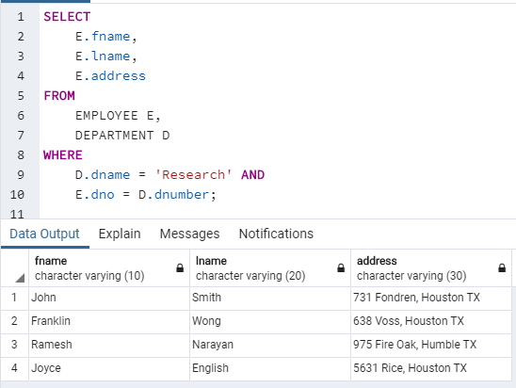

1.2) Retrieve the name and SSN of each employee that either works in department 4 or has a salary lower or equal to $30,000. You can use only one condition term in any WHERE clause; i.e., don't use AND/OR Boolean operations.

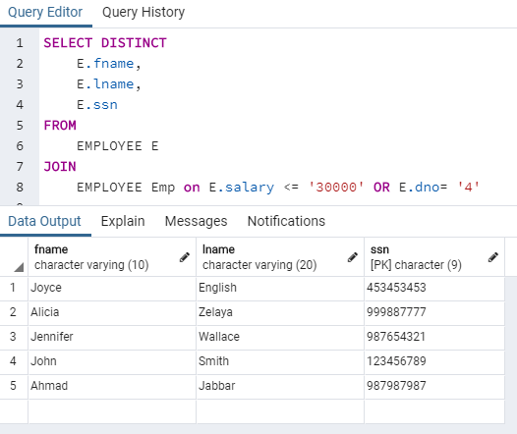

1.3) List the name and SSN of each employee that works on at least one of the projects 1, 2, and 3. You

can use only one condition term in any WHERE clause.

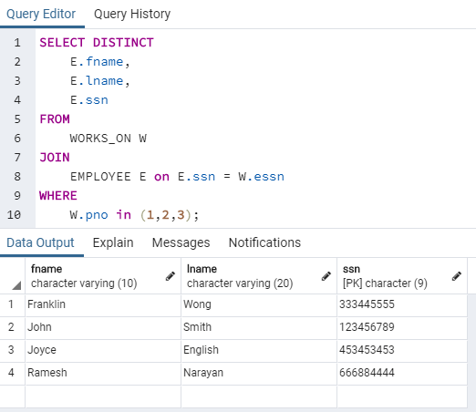

1.4). Retrieve the names of all employees of the Research department who work more than 10 hours per week on the ProductX project.

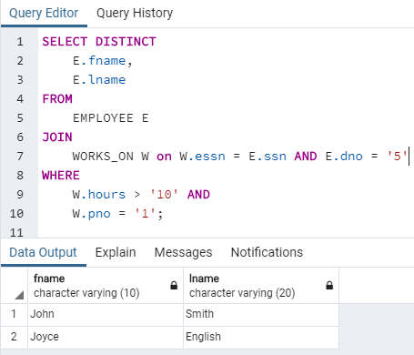

1.5) Retrieve the names of all employees who work on all projects [every project] located in either

Bellaire or Sugarland. That is, if p1, p2, and p3 are in Bellaire; and p4 and p5 are located in Sugarland;

then I want an employee who works on p1, p2, p3, p4, and p5.

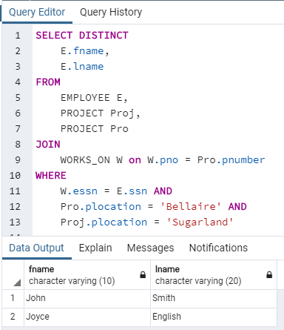

1.6) Find the names of all employees who work on at least one project located in Houston but whose

department has no location in Houston.

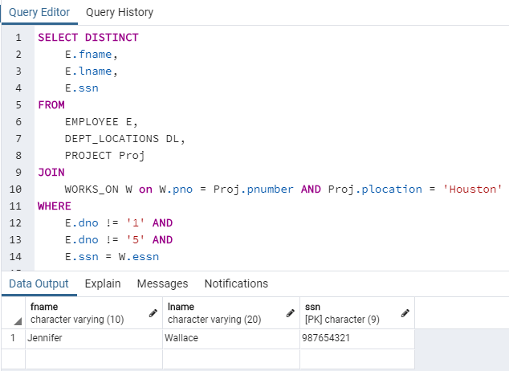

1.7) For each department whose average employee salary is more than $30,000, retrieve the department name and the number of male employees working for that department.

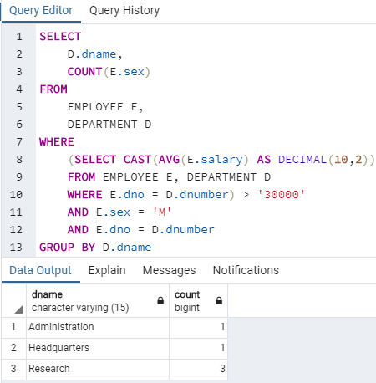

1.8) Retrieve the names of all employees who work in the department that has the employee with the

highest salary among all employees.

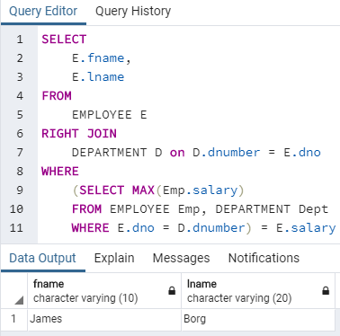

1.9) [9A] Create a View ProjectInfo that has the project name, controlling department name, number of

employees, and total hours worked per week on the project for each project with more than one

employee working on it. [9B] Show the content of this view.

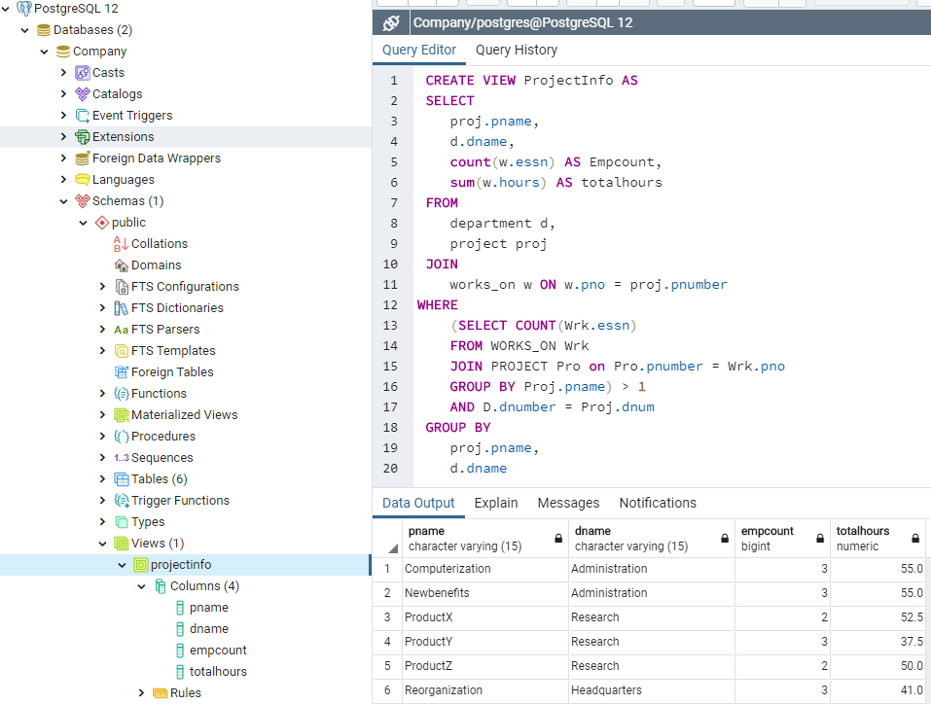

1.10) [10A] Create a View DepartmentInfo that has the department name, manager name for each

department. [10B] Show the content of this view.

