4. Answer the following questions using SQL queries and show the results via postgreSQL (psql or

pgAdmin):

a. List the passenger first name and last name, car make, car model, car color, driver name and

last name, pickup date and time of the passengers with bookings.

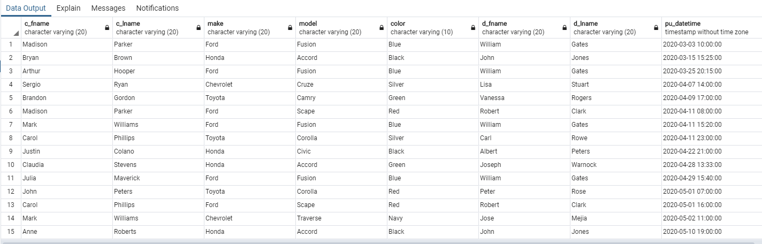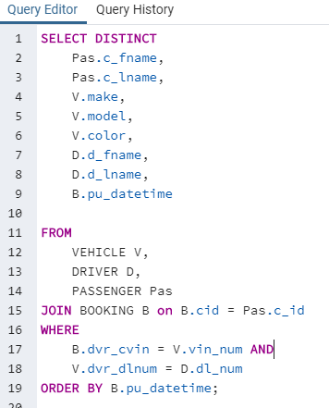

b. List the name and last name, email and cellphone number of passengers that have not used

the service yet.

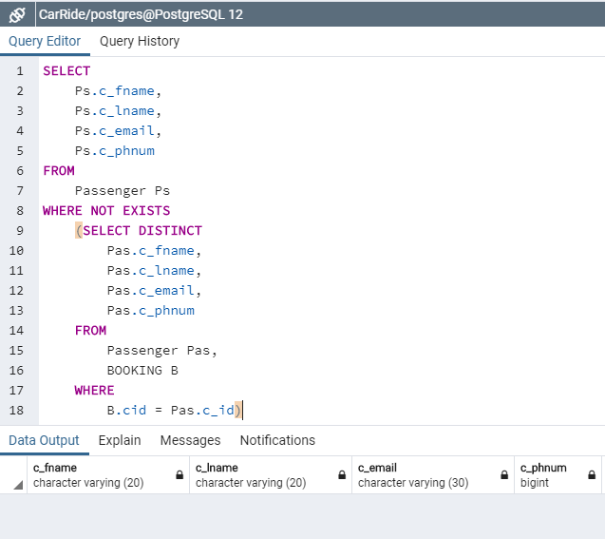

c. List the first name and last name of the drivers that have not worked at all.

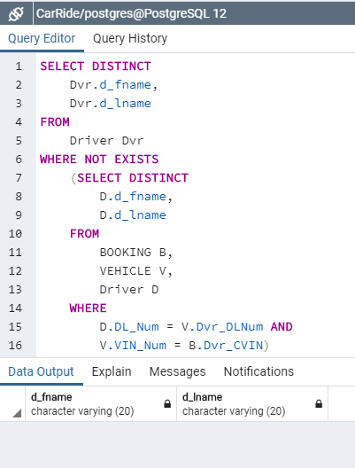

d. List the origin and destination of the most popular trip.

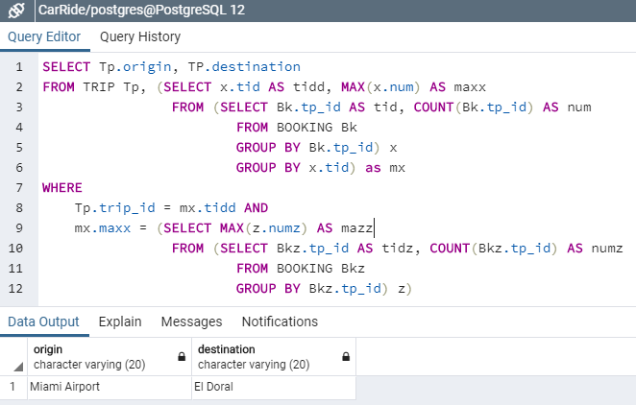

5. Create 5 queries that will be useful for retrieving data from this database. Specify the queries and

get a screenshot of the results.

1. 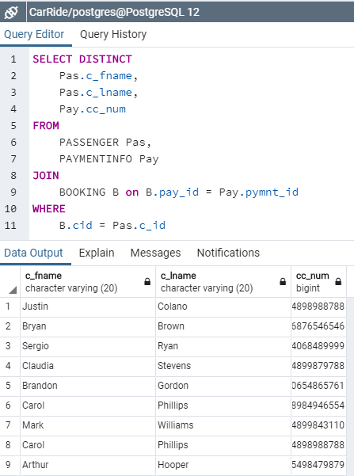
2. 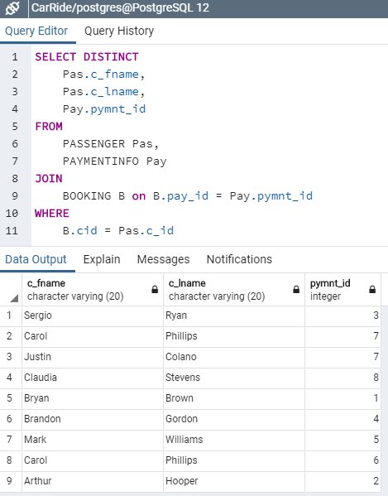
3. 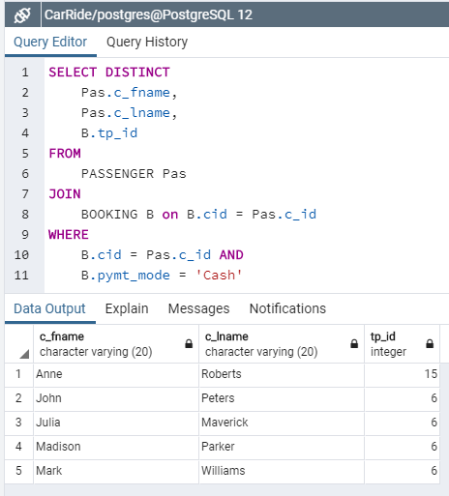
4. 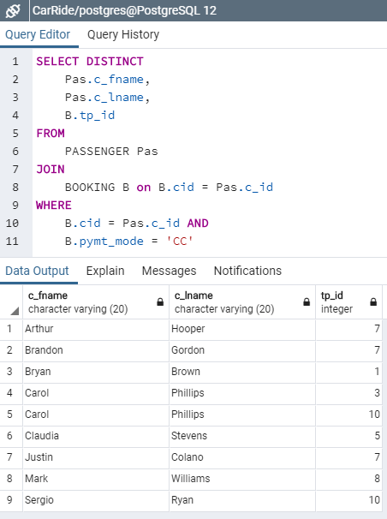
5. 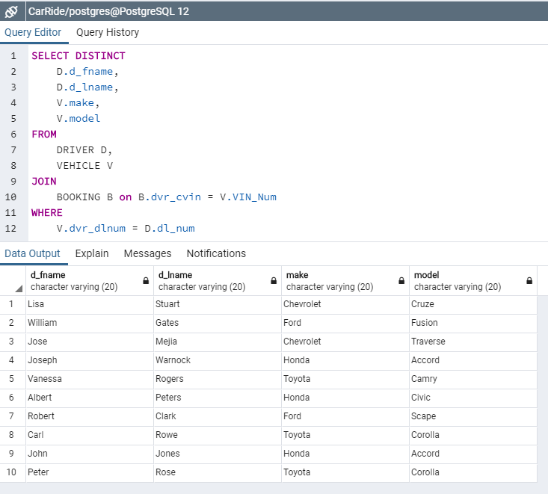

6. Other questions:

a. How can you improve the database in order to keep the original price paid per ride in case

that the prices of trips change in the future? can optionally implement this.

Include a separate entity for reservations that locks in the price with the customer id and trip id

b. How can you improve the database in order to handle drivers that drive more than one car?

You can optionally implement this.

The database could be improved to handle drivers with multiple cars by including a field as a FK in VEHICLES, the PK of DRIVERS