Assignment 2.1

Meg Kellenberger

Prof Sampson CSD340

Screenshots

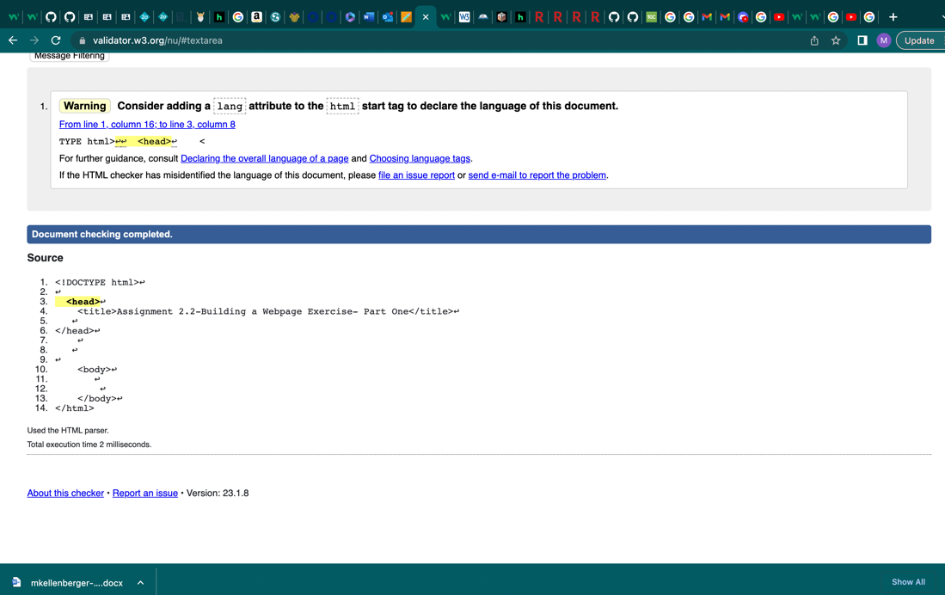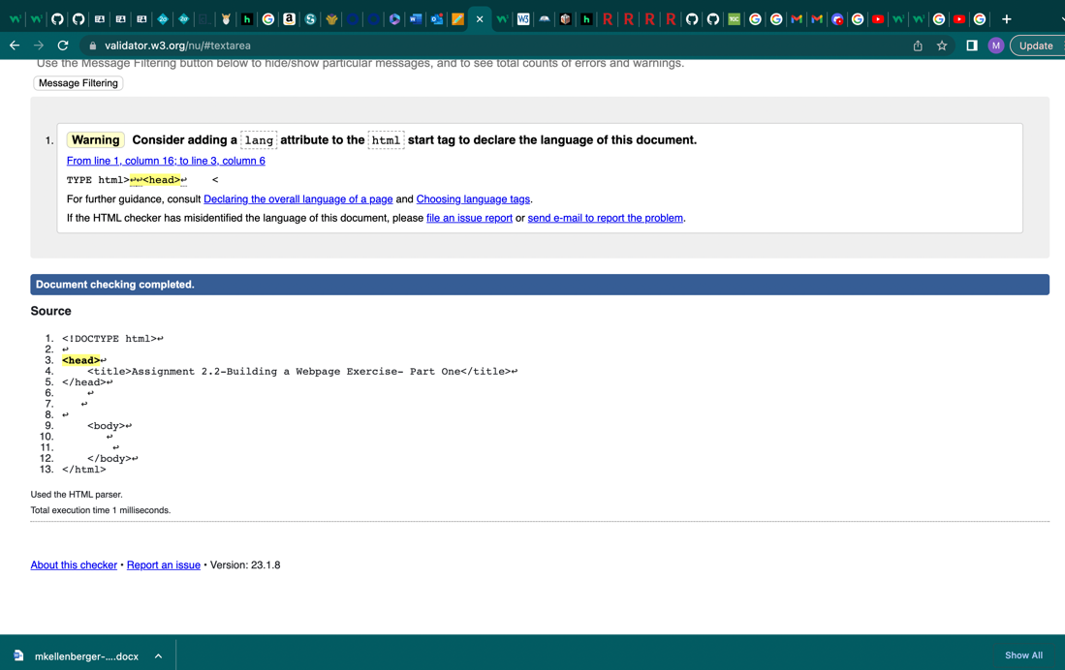

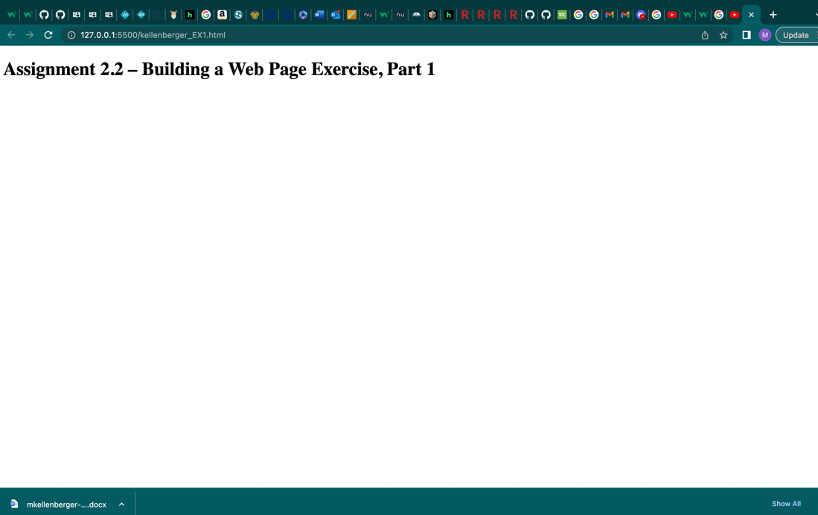

Github Link

https://github.com/megk2/csd-340