Student: Marceia Egler

Class: Fundamentals of Web Development

**Strategy:**

**Site Name:** Houndhaven, Inc

**Current Site**(the one being re-designed)**:** <http://houndhaven.org>

**Purpose:** Houndhaven is a no-kill dog shelter whose mission is to find forever homes for the dogs it rescues. The website is a central portal where visitors can see dogs available for adoption, read about available volunteer opportunities and also donate money or goods to the shelter.

The primary audience is families or individuals looking to adopt a dog and seeking information. The average adopter is middle class ($100k+ a year annual household income), homeowner, has a fenced yard, and all children are over the age of 5. They also are not first time dog owners and have excellent veterinary references.

The secondary audience is people looking to support Houndhaven either through monetary donations or supplies such as dog food, toys, blankets, beds, etc. These individuals are middle class ($100k a year annual household income), either currently own or have previously owned a Houndhaven dog (these people are called “alumni”), or are related to someone who is alumni and are looking to donate in that person’s name.

**Scope and Structure:**

After interviewing the president of Houndhaven and also frequent users of the site, the following priorities were identified for the redesign:

* Dogs available for adoption
  + Easy access to the adoption form
* How to contribute to Houndhaven (volunteer or donate)
* Success stories of adopted dogs

Secondary priorities were:

* Quick links to popular inner pages
* A “where are they now” section
* Inclusion of video
* Easy access to upcoming adoption events

Steps I followed to determine the re-design layout:

* Interviewed the stakeholder (president) and multiple users of the current site to find what they liked and didn’t like.
* Sketched out what a redesign could look like to include the interview feedback
* Partnered back with the site users whom I had interviewed with the sketch to see if it captured what they wanted.
* Made changes as necessary and moved to next step.

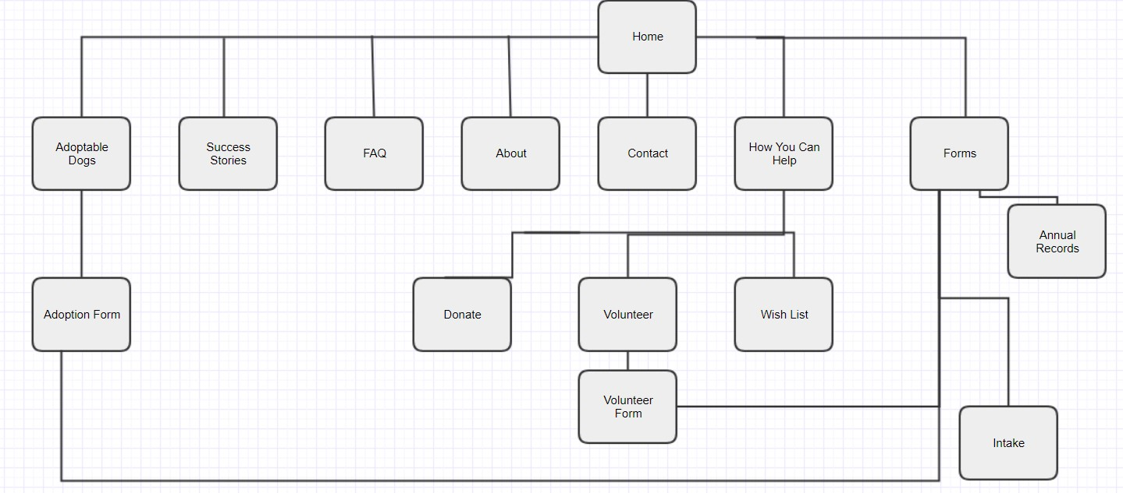

**Skeleton:**

Here is a first draft sketch that shows how these priorities could be laid out:

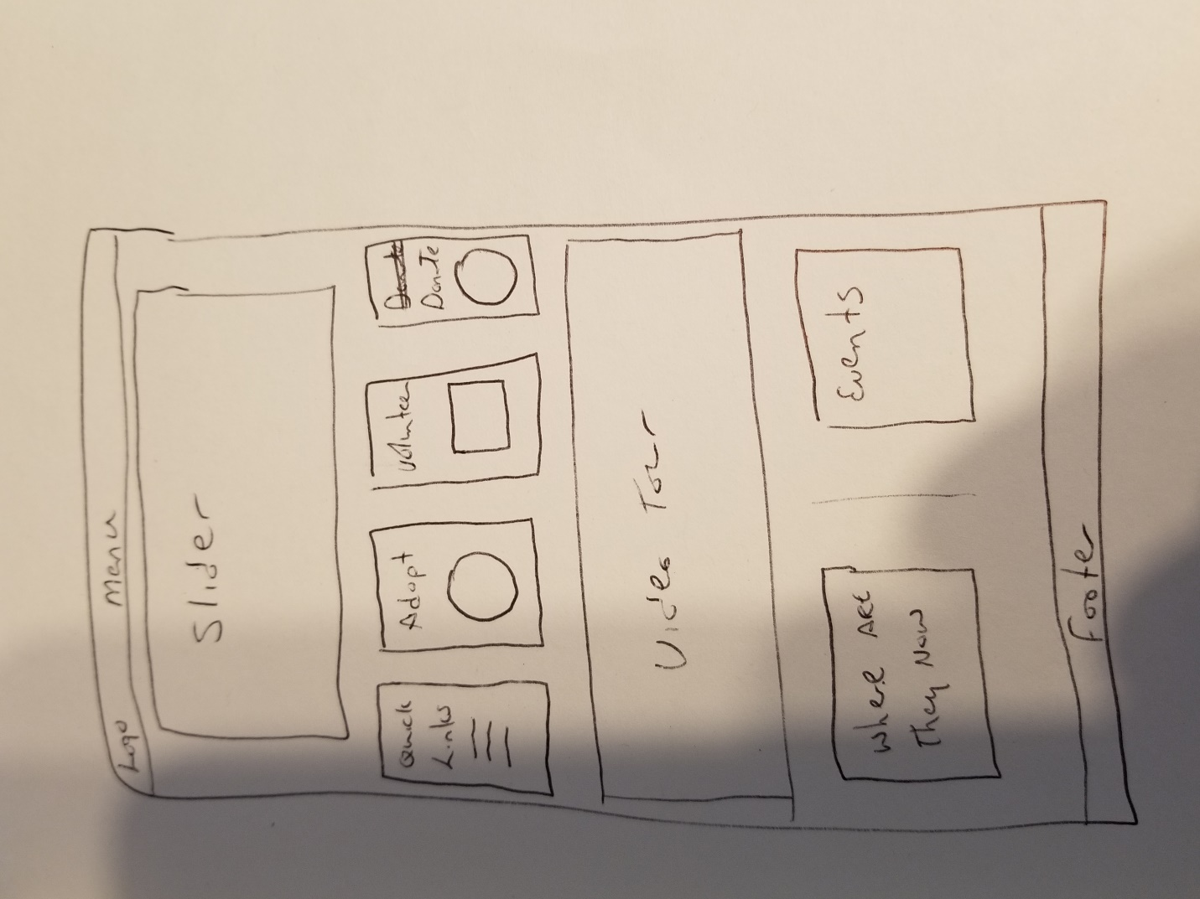

**Surface:**

**Site Redesign:** <http://rutledgewebdev.com/portfolio/houndhaven>

Page 2: <http://rutledgewebdev.com/portfolio/houndhaven/adoptable.php>

Page 3: <http://rutledgewebdev.com/portfolio/houndhaven/adoption-form.php>

There is also a custom 404 page and the FAQ has content because I had already created it for another page and realized it was better suited on the FAQ.

**Implementation and Reflection:**

This redesign was built using HTML, CSS, and Javascript (jQuery). To make the site responsive, Bootstrap was used as a CSS framework. A few JavaScript plugins were used to add functionality. Ekko Lightbox created a photo gallery on the hompage as well as the slider. Validate JS was used for a portion of the form validation on the adoption form and I also created a standalone function to format the phone number field into a standard output. Finally, a code snippet from [John Morrison Online](https://www.johnmorrisonline.com/add-active-navigation-class-to-menu-item-based-on-url-using-jquery/) was used to add an active class to navigation so the user would know where they were at any given time.

**Future Direction**

As you can see, the final page layout differed from the first draft sketch. Future work on the site will include:

* Adding the secondary priorities to the site
* Adding breadcrumb navigation so pages not immediately visible on the header menu will still show you where you are in relation to the home page. (priority)
* Having a way for the organization to easily add adoptable dogs and other content.
* Creating a usable Success Stories section based on user feedback.

**Reflections:**

I thoroughly enjoyed building this site as I’ve been working in WordPress for years and haven’t hand coded a site from beginning to end. Things I’m proud of:

* Optimized images for page speed
* Utilized Bootstrap (I’ve never used it before) for responsiveness.
* Took the original Houndhaven site from an F grade (4 out of 100) on Pingdom to an A grade (84 out of 100).
* Implemented php templates for the header, footer, meta, and nav so code was easily reusable and also easier to maintain and update.
* Tried to use as much as reasonable of “Don’t Make Me Think” for UX layout.

**Final:**

There are things I would have liked to have done better:

* I would have liked to have had true breadcrumbs vs how I did it in the header menu. That would have provided more flexibility and allowed me to use dropdowns in the header nav.
* A nicer design. I recognize this is basic. I focused on high usability because I’m not artistic in the slightest. If this had been a commercial production site, I would have outsourced design to a pro then implemented the design along with UX best practices. The idea being a site that is both pretty and super functional.

If I were to do this project again, I would have followed the same basic steps outlined above to determine layout and priorities. I would focus more on the JS functionality (breadcrumbs) and possibly try and create a nicer design. Finally, I would switch to CSS Grid instead of Bootstrap because it’s less bloated and is pure CSS.

**End Notes:**

Here are the interview questions and answers I received:

**Stakeholder**:

1. Why do you have a website?

 We have a website because this technology age demands it.  We need to be visible to adopt our dogs and to get the donations needed to support them, so having a website is important.

1. What do you want the website to accomplish?  In other words, when people visit the site, what is it you want them to do?

      a.  If there are multiple things you want visitors to do (submit an application, give HH money, etc) - what is the order of importance?  If it's only 1 thing, that's fine.

When people visit the site, we want them to become engaged with Houndhaven.  Whether that means adopting a dog, making a donation or becoming a volunteer, we are happy with any of those results.  It is hard to prioritize them because all of are equal importance, but I think the website results in adoptions most often, so I would put that as number one.  Number two would be making a donation because viewers may not be local and able to volunteer.

1. What is it about the HH site you want that will set you apart from other rescues?  eg. When someone goes to the HH site, why should they take an action with us vs SPCA, Judy, etc?

I want them to know that our dogs are the best!  Good photos, cute videos, compelling stories all help to tell that tale.

1. If you could change 1 thing about the current site, what would it be?

I would add videos of the dogs so people can see them in action.  We get such good response to that on our facebook page.

**User Questions:**

As someone who goes to the HH site frequently, what would you like to see different on the homepage? Would you like to see the layout done a different way? If so, how? Finally, when you go to the HH site, what specific information are you looking to see?

**User Jennifer:**

I would make the adoptables appear on the home page in some way - don't like having to search for them. Another thing would be redoing the success stories to be maybe by year so u can look back easier. Also would maybe include a feed from our social media & a prominent link to Volunteering. Still have menus but quick links to the items people look for most frequently & way less links to advertisers - mostly Amazon & their recommendations...

**User Marcie:**

Mine is more formatting. I agree with Jen’s input, too. I would standardize the info about the dog’s age, weight, and then have the heart killing story. Also would be cool if success story owners could post stuff. A “Where are they now?”

**User Elaine**:

The areas I go to the most are adoptable dogs, success stories and events.  I write a lot of the bios and stories, but often go back to them to refresh my memory on things and then check on where the dogs will be on the weekend—often it’s to get info to relay to people interested in adopting from us, have put in an application, etc.

Being on the adoption team, people ask all the time what our adoption fee is, so one suggestion I have is to make the fee easy to find—not have it on the home page, but just somewhere they can go to and see it.  The other thing would be to make the annual exam submission so it stands out more and maybe people would send in their annuals more regularly if it stood out on the site.  I’m not tech savvy like you and Jennifer—but those are some of my thoughts!