**Lab 1**

**Objective: An Introduction to Web API - Part I**

**Theory:**

A web API is a programmatic interface consisting of one or more publicly exposed endpoints to a defined request–response message system, typically expressed in JSON or XML, which is exposed via the web—most commonly by means of an HTTP-based web server.  It works more or less the same way as ASP.NET MVC web application except that it sends data as a response instead of html view. A Web API is an application programming interface for the Web. A Browser API can extend the functionality of a web browser. A Server API can extend the functionality of a web server.

**Code:**

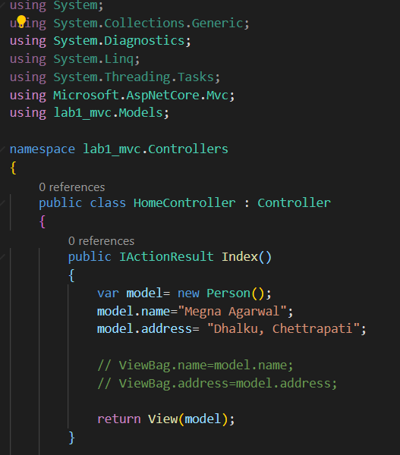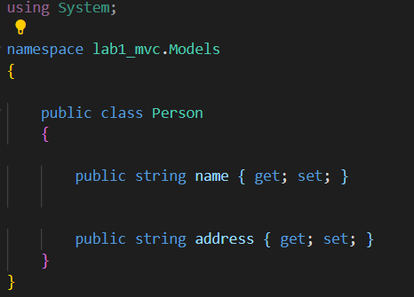Model Controller

View

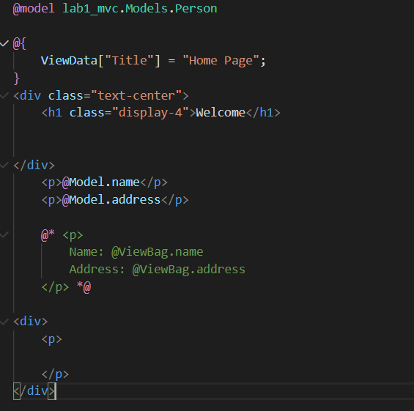

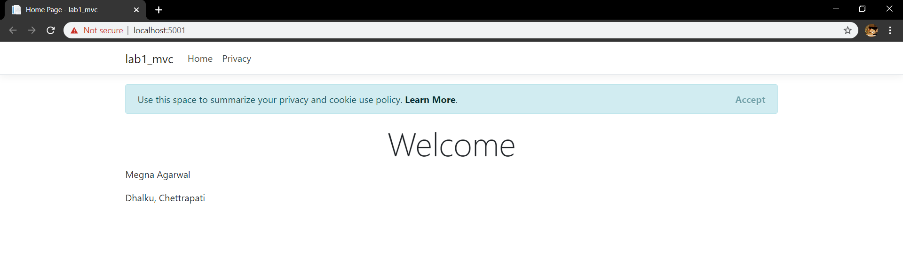**Output:**

**Conclusion:**

In this way the environment setup was done along with introduction to Web API.