**Lab 2**

**Objective: An Introduction to Web API - Part II**

**Theory:**

A web API can help you develop ASP.NET application via AJAX. Using a web API framework, one can easily create services that can run on various entities. Web API makes it easier for the developers to build an ASP.NET application that is compatible with any browser and almost any device.

Web API Features

1. Supports convention-based CRUD actions, since it works with HTTP verbs GET,POST,PUT and DELETE.
2. Responses have an Accept header and HTTP status code.
3. Supports multiple text formats like XML, JSON etc. or you can use your custom MediaTypeFormatter.
4. May accepts and generates the content which may not be object oriented like images, PDF files etc.
5. Automatic support for OData. Hence by placing the new [Queryable] attribute on a controller method that returns IQueryable, clients can use the method for OData query composition.
6. Supports Self-hosting or IIS Hosting.
7. Supports the [ASP.NET MVC features](https://www.dotnettricks.com/learn/mvc) such as routing, controllers, action results, filter, model binders, IOC container or dependency injection.

**Code:**

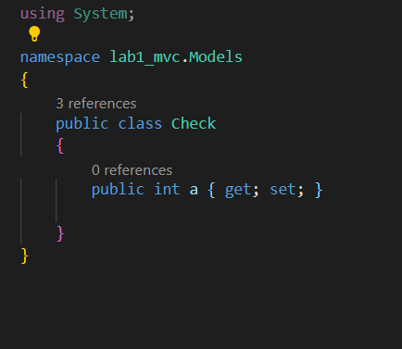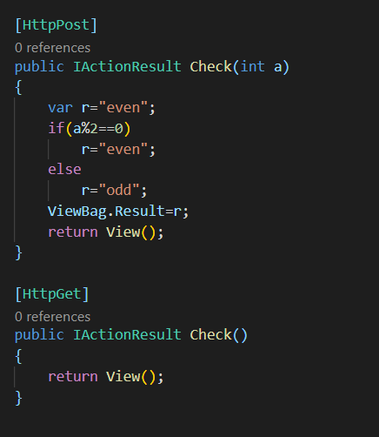Model Controller

View

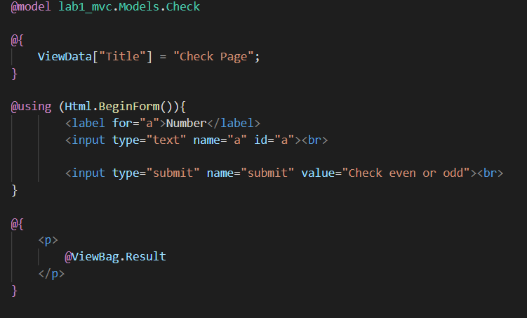

**Output:** 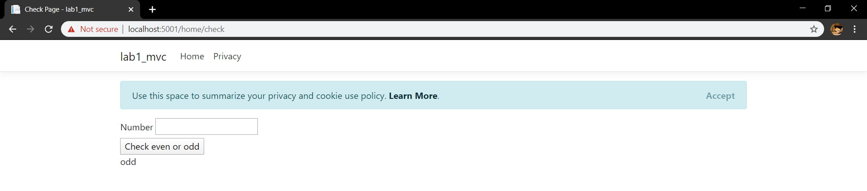

**Conclusion:**

A Web API services are preferable over other services to use with a native application that does not support SOAP but require web services. For creating resource-oriented services, the web API services are the best to choose. By using HTTP or restful service, these services are established. If you want good performance and fast development of services, the web API services are very helpful.