Lab 3: Initializing Project Structure

Controller

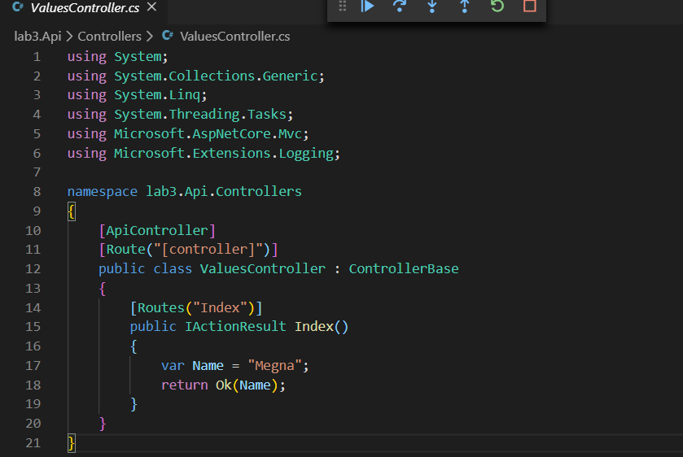

Output

