**Final Lab**

**Objective: Project API Testing via Postman**

**Theory:**

API testing is a type of software testing that involves testing application programming interfaces (APIs) directly and as part of integration testing to determine if they meet expectations for functionality, reliability, performance, and security. Since APIs lack a GUI, API testing is performed at the message layer.

Postman is an application for testing APIs, by sending request to the web server and getting the response back. It allows users to set up all the headers and cookies the API expects, and checks the response. With over 4 million users nowadays, Postman has become a tool of choice for the following reasons:

1. Accessibility - To use Postman, one would just need to log-in to their own accounts making it easy to access files anytime, anywhere as long as a Postman application is installed on the computer.
2. Use of Collections - Postman lets users create collections for their API calls. Each collection can create subfolders and multiple requests. This helps in organizing your test suites.
3. Collaboration - Collections and environments can be imported or exported making it easy to share files. A direct link can also be used to share collections.
4. Creating Environments - Having multiple environments aids in less repetition of tests as one can use the same collection but for a different environment. This is where parameterization will take place which we will discuss in further lessons.
5. Creation of Tests - Test checkpoints such as verifying for successful HTTP response status can be added to each API calls which help ensure test coverage.
6. Debugging - Postman console helps to check what data has been retrieved making it easy to debug tests.
7. Continuous Integration - With its ability to support continuous integration, development practices are maintained

**Code:**

Customer Create

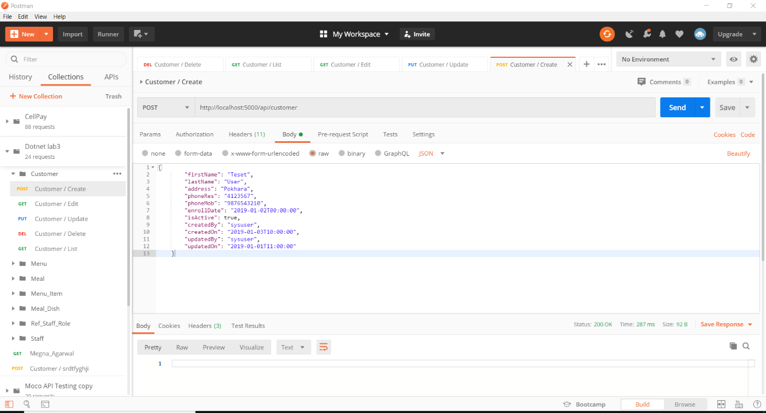

Customer List

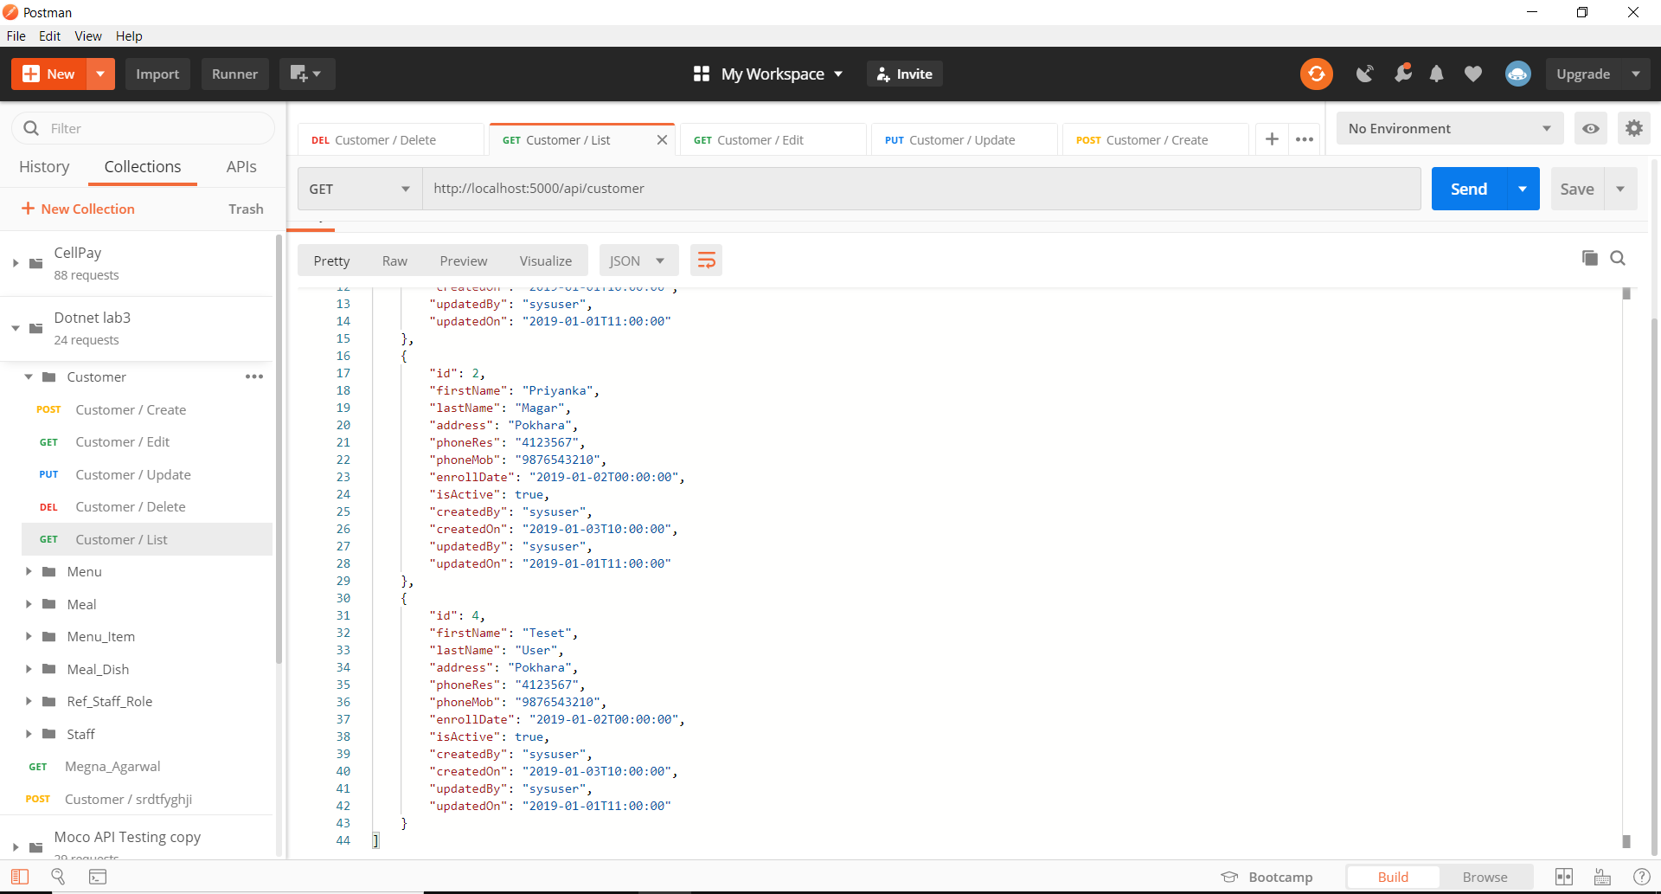

Customer Edit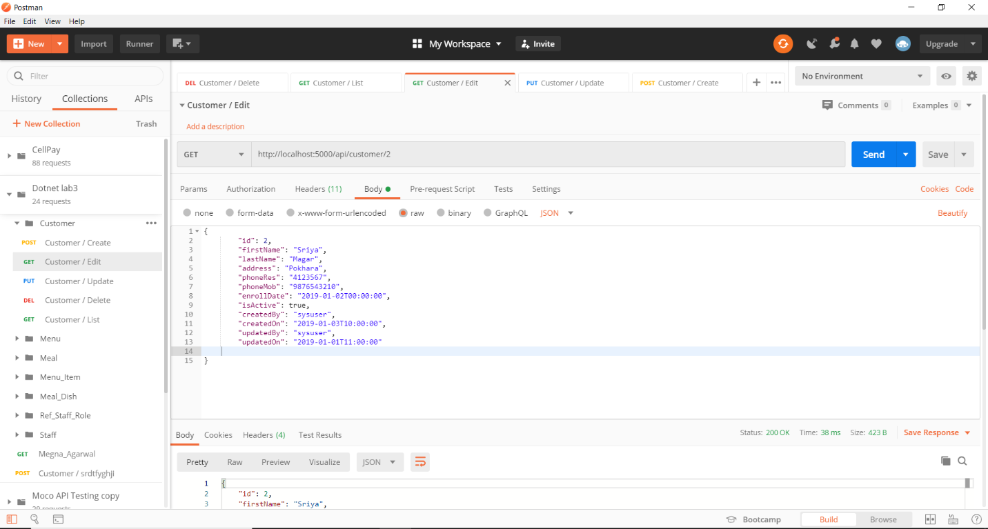

Customer Update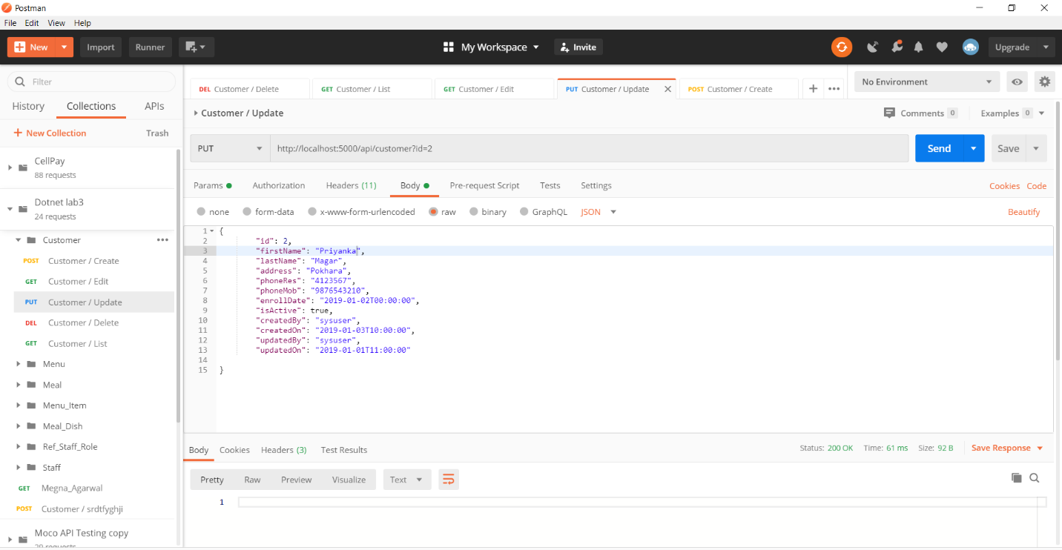

Customer Updated Result

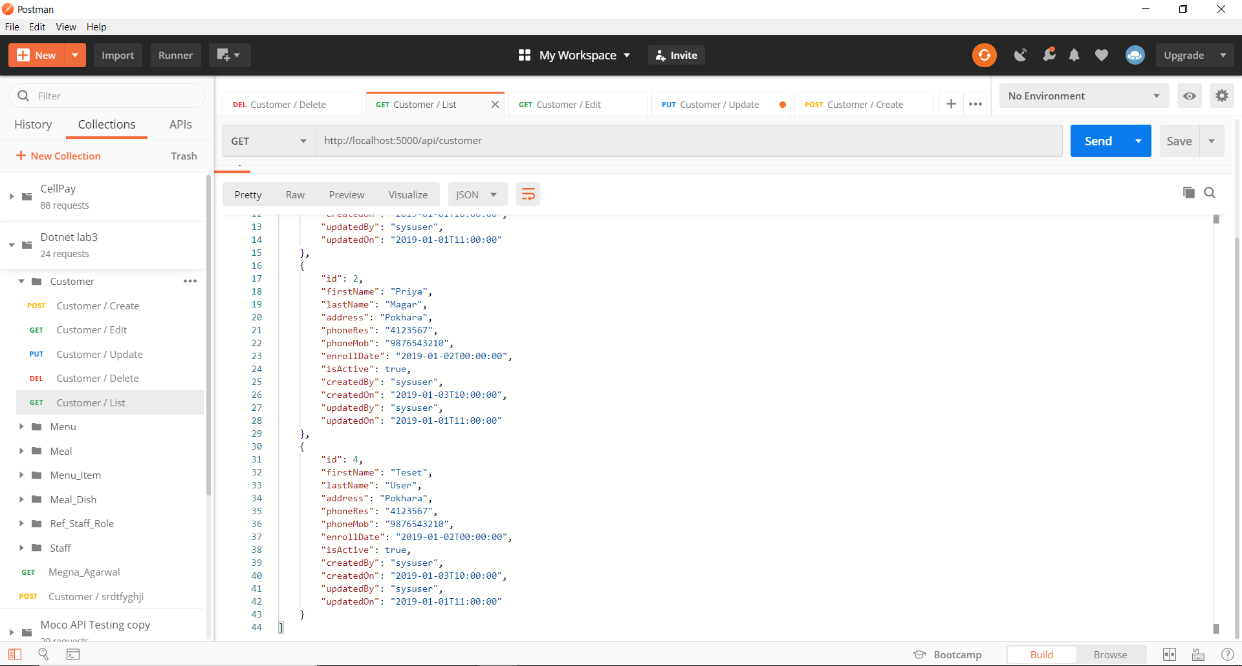

Customer Delete

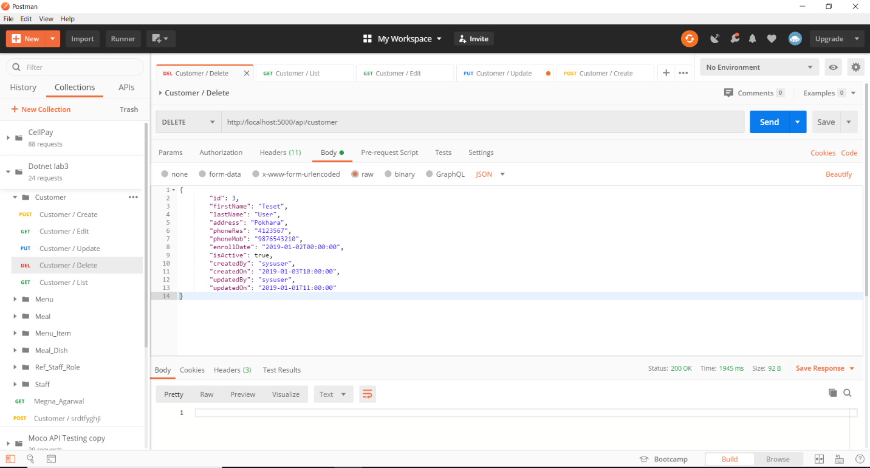

Output:

In this way, various operations for API Testing of different models were done using Postman.