

**SCHOOL OF MATHEMATICS AND ACTURUAL SCIENCE**

**DEPARTMENT OF PURE AND APPLIED MATHEMATICS**

**MATHEMATICAL MODELLING OF GARBAGE COLLECTION**

**AND REMOVAL IN AN URBUN AREA**

**BY**

**MARGARET NYAKENO ONYANGO**

**SMMQ/04044/2013S**

**A Project is submitted for the study leading to a partial fulﬁllment of the requirements for the award of Bachelor of Science in Mathematics at Technical University of Kenya.**

**Supervisor,**

**PROF ONYANGO T.T.**

**DATE: 20th June 2017.**

# DECLARATION

This project is my original work and has not been presented for examination in any other university, institution of higher learning or award. Where the words of others have been used, acknowledgment has been made.

**Margaret Onyango***:* Admission No.: **SMMQ/04044/2013S**

Signature*: Date:*

This project has been submitted for examination with my approval as the University supervisor.

*Supervisor:*

*Signature: Date:*

# DEDICATION

I dedicate this paper to the county government of Nairobi and other major cities with estates because they will find it very resourceful in managing waste which has become a nightmare in our country.

# ACKNOWLEDGEMENTS

First and foremost, I thank the Almighty God for granting me knowledge, strength and good health as I tirelessly wrote and researched on this project. My heartfelt gratitude goes to my supervisor Professor Thomas Onyango, for his professional guidance which ensured the successful completion of this project. Lastly my sincere gratitude goes to my lovely family and friends for their consistent and continuous support

# ABSTRACT

Garbage collection, is a serious challenge faced by the modern urban centers around the world. The following project seeks to create a mathematical model for garbage collection and removal. The conditions under which these models will function efficiently and effectively is determined. A model for garbage collection is created and garbage removal strategy is also made. Finally, a recommendation is made on the best time for collection to avoid pillage of garbage in the garbage holds.

**Table of** **Contents**

DECLARATION 1

DEDICATION 2

ACKNOWLEDGEMENTS 3

ABSTRACT 4

CHAPTER ONE 7

INTRODUCTION 7

1.1 Background to the study 7

1.2 Problem Statement 8

1.3 Objectives of the study 9

1.3.1 General Objectives 9

1.3.2 Specific Objectives 9

1.4 Significance of the study 9

1.5 Scope of the study 10

1.6 Assumptions of the Study 10

CHAPTER TWO 11

LITERATURE RIVIEW 11

2.1 Introduction 11

CHAPTER THREE 15

METHODOLOGY 15

3.1 Model Formulation 15

3.2 Problem Variables 15

3.3 The Mathematical Model 16

3.3.1 Determining the Value $NT$ 17

3.3.2 Choice of $P(T)$ 20

CHAPTER FOUR 21

RESULTS AND DISCUSSIONS 21

4.1 Graphical Solutions 21

CHAPTER FIVE 25

CONCLUSION AND RECCOMENDATIONS 25

# CHAPTER ONE

# INTRODUCTION

## 1.1 Background to the study

Many civic bodies are faced by the problem of determining an effective and efficient garbage collection and removal system. Looking at Kenya and precisely Nairobi, the county government solid waste management involves the collection of waste from its resources to processing plants where it is processed or recycled. The garbage collection systems operate in two parts. First is the garbage collection, where residents throw garbage into a common garbage hold and second is garbage removal, where the civic bodies use a suitable mechanism to collect the garbage from the hold [1].Garbage collection is based on the practices of residents in area. This is a difficult stage to manipulate due to its nature. The assumption we make is that residents stick to the instructions they are given by the civic body which is the county government. In garbage removal, one can implement several types of techniques and this is the space we will use for mathematical manipulation.

This process as well add costs and managerial factors in the waste management scheme making it complex and expensive. So, as the city grows economically and there is increase of business activities, consumption patterns and waste quantities increase. At the same time, increased traffic congestion affects the productivity of fleet since the land for disposal(Dandora) is far from different residential where the collection is done. A careful planning is required to execute the activities in an optimal and efficient way.

## 1.2 Problem Statement

According to the 2009 census, Nairobi has a population of 3,138,295 inhabitants living within 696 km2. About half of the waste generated by this population is collected and deposited at Dandora which is a 30-acre piece of land [2]. The current city population is estimated to generates 2000 tons of waste per day[3], and statistics show that by 2030 the population will be around 6 million and the total waste generated will be approximately 6000 tons per day. When waste is not managed, life quality reduces, the land quality is compromised by presence of wastes and pollution is at its peak [4]. Effects due to improper management are felt at various levels and is an issue not to be left out. The local government is becoming aware of the mediocre quality of services provided and is adjusting improve in this sector. Therefore, there is an increasing demand for greater efficiency. This problem can be modelled mathematically and solved using analytical procedure. The process involves garbage collection and removal system over a seventy-four-hour period considering all factors and variables. This will ensure pillage in the estates is minimized and resources are utilized correctly.

## 1.3 Objectives of the study

### 1.3.1 General Objectives

The main objective is to minimize garbage in garbage holds

### 1.3.2 Specific Objectives

* To present a detailed description of the model to be used in waste management
* To give best timing to collect garbage in residential areas to ensure efficiency

## 1.4 Significance of the study

Waste management is important for every country since it directly affects environment and the health of the people. Municipal waste in developing countries is such a problem. Plastic waste has already become a serious environmental dilemma even causing a burn of its production by legislation 2017. Municipal Solid waste also serves as a breeding zone for disease vectors such as rodents. By allowing rotting municipal waste to enter water channels, our water sources lose value and no-longer become useful [5].This impairs the economy of the state. Also, gases from rotting garbage end up in the atmosphere and causes foul smell and can cause effect on both plant and animal life. With growth of population, garbage removal becomes even more difficult due to its increasing mass[4]. The concern has been expressed from the public and stakeholders of both governmental and non-governmental organizations. It then becomes crucial to put in place mechanisms for removal of garbage. This project then aims to create an efficient and effective way to solve this problem.

## 1.5 Scope of the study

Waste Management is a complex problem worldwide. The focus of this project is to be able to minimize garbage and have a working model on waste removal. This then helps management of waste in urban areas.

## 1.6 Assumptions of the Study

* Every household deposits their garbage in the garbage hold at a collection time.
* Mass of garbage produced by each household is the same.
* Despite the constraints, the track which is the removal unit does not miss collection time that is once after every 72 hours
* Amount of garbage left after every collection is minimum or more preferably zero.
* The amount of garbage should be less than the maximum limit in a garbage hold
* The garbage removal system should not keep operating even when there is not much garbage.

# CHAPTER TWO

# LITERATURE RIVIEW

## 2.1 Introduction

Mathematical modeling is the process of using mathematical concepts to describe a system and solve problems. According to [6], Models describe world functions. In mathematical modelling, we translate beliefs to language of mathematics. Some of the benefits of mathematical modeling include: First, Mathematics is a very precise language. This helps us to formulate ideas and identify underlying assumptions. Secondly, Mathematics is a concise language, with well-defined rules for manipulations. Thirdly, All the results that mathematicians have proved over hundreds of years are at our disposal and lastly computers can be used to perform numerical calculations. [6]The most essential reason for mathematical modelling is to be able to formulate and solve mathematical problems. It is a great method of solving problems and most solutions have become quite efficient and effective.

Different types of phenomena’s such as electric current flow, projectile motion, projection of chemical reactions and many more are well described by equations that relate changing quantities. As the derivative of a function provides the rate at which a function is changing with respect to an independent variable, the equations which describe them often involves one or more derivatives. [7]

Different people have tried forming models for garbage collection problem. Different model using different mathematical concepts have been used to try solving this problem. Some of the concepts include:

1. Linear Models and Non-Linear Models
2. Multi-objective models and Linear Objective Models
3. Static Models and Dynamic Models
4. Stochastic and Deterministic Models
5. Using Ordinary Differential Equations

According to[8], they presented a mixed integer nonlinear programming problem. They gave a description with detailed environmental constraints and stabilized organic material. Their model consists decision variables used which are fractions of wasted that has to be sent to various plants and landfills. The interaction between these percentages generate their products that are used in the objective function, technical constraints and in the regulatory constraints. The choice of their variables makes it non-linearly inevitable and thus it makes it a linear model which may require a change of variables.

[9] present to us a mixed integer linear programming model whose main objective is to cover collection costs that is transportation cost from the points of collection to the stations of disposal. He considers the benefit from the sale of compost recyclable material and a variable from this is incorporated in the objective function. The binary variables are used to decide the existence of collection stations, in crenation recycling and refused drive fuel.

[10] presents to us a survey on applications of operational research with environmental problems such as water resource waste management, solid waste operation and design cost allocation for environmental facilities and water quality management. He says that operational research problems are challenged since in a system the problems described include simultaneous siting and efficiency, determination of waste power treatment plants, design in solid waste collection, rationality in resource allocation and design of rationing strategies. Such a statement gives opportunity to explore other models which do not optimize rather try to minimize the problem at hand. With this knowledge, I decided to use ordinary differential equations to approach this problem in a different angle to find a unique a different solution considering also the state of residents of Nairobi and the structures at hand.

When A problem leads to a differential equation, we always have conditions in the problem that determine the specific values for the constants. For a first order equation, the single arbitrary constant can be determined by specifying the value of the unknown function y(x) at an arbitrary value x0 and say y(x0) = y0. This is called the initial condition[11].

[1] created different models of the garbage collection and removal problem. Using these two models he created he analyzed and came up with two giving different options depending on the area and number of people.

Having determined the system to be modelled, a basic framework of the model needs to be constructed. This reflects on how we consider the system operations. This can be stated using the underlying assumptions.[6]. Some of the assumptions Mitul Islam made include:

1. Amount of garbage left after every 24 hours is minimum or more preferably zero.
2. The amount of garbage should be less than the maximum limit in a garbage hold
3. The garbage removal system should not keep operating with full force even when there is not much garbage.

His two models try to describe the situation using both dimensional and non-dimensional model on how removal function and collection function relate with a change of time (t) which is stipulated as 24hours. His analysis is well stated and depending on a population the best model is chosen for the above. He considered an area which is well resourced and garbage can be collected at least within 24 hours. Considering our case in Nairobi, this cannot be true since our resources cannot manage to collect garbage every single day. This is due to limitations of traffic jam, a single dumpsite which is far from major estates, over populated regions ‘Slums ’such as Kibera, Mukuru kwa Njega and Mathare. Also, we consider that the tracks also serve neighboring counties such as Kiambu and Machakos. This gives it a Large area to cover thus a limiting constraint. Without forgetting corruption, people need to maintenance fee and sometimes this is not the issue. So, this brings lots of problems thus the trucks become un- operational and may take so much time to collect garbage regions of the city. Using his model simulations, we will try to fit this in our situation in Nairobi considering time, resources, population and Amount of garbage collected in area or estate.

# CHAPTER THREE

# METHODOLOGY

## 3.1 Model Formulation

The are under consideration is Nairobi and we will take a case study of Calcutta which data we have from the internet. We pick this because the garbage condition of most estates there can be compared to Nairobi effectively.

Some of the assumptions we make include:

* Every household deposits their garbage in the garbage hold at a collection time.
* Mass of garbage produced by each household is the same.
* Despite the constraints, the track which is the removal unit does not miss collection time that is once after every 72 hours
* Amount of garbage left after every collection is minimum or more preferably zero.
* The amount of garbage should be less than the maximum limit in a garbage hold
* The garbage removal system should not keep operating with full force even when there is not much garbage.

## 3.2 Problem Variables

We assume that the urban area under consideration has n garbage holds.

$C(T)$ denotes the amount of garbage in a hold at a time T where $0≤T≤72$ The mass of the garbage is measured in kilograms.

$N(T)$ denotes the number of people that deposit garbage in a hold at a change in time represented as $T+⍍T$.

$P(T)$ denotes the number of active garbage removal units at a time $T$.

$k_{1}$ is the mass of garbage deposited per unit time and the unit is measured as mass/time.

$k_{2}$ is the mass of garbage removed per unit time.

## 3.3 The Mathematical Model

Garbage which is left in the hold after the collection and removal function act is given by the formulae:

$C\left(T+∆T\right)=C\left(T\right)+k_{1}N\left(T\right)∆T+k_{2}P(T)$ (1)

Representing this equation using Ordinary differential equation is

$\frac{dC}{dt}=k_{1}N\left(T\right)-k_{2}P(T)$ (2)

Subject to initial $C\left(0\right)=0$

The main aim is to minimize the amount of garbage in the holds and thus we need to attain

$C\left(T\right)=0$ where $T$ is close to 72. Therefore $C\left(72\right)=0$ is acceptable, that is based by our assumption (iv).

To continue, we need to determine the nature of the collection function $N(T)$ and the nature of the removal function $P(T)$.

Finding $P(T)$ depending upon the choice $C\left(T_{1}\right)=0$ where $T_{1}$ is not far from $T=72$

Introducing non-dimensional variables $\frac{T}{T_{0}}=t$ and $\frac{C}{C_{0}}=c$ and $T_{0}=72$ where $C_{0}$ denotes a chosen unit of mass.

Replacing in equation 2 we get

$\frac{dC}{dt}=k_{1}\frac{72}{C_{0}}-k_{2}\frac{72}{C_{0}}$ (3)

Where $n\left(t\right)=N\left(T\right), P\left(T\right)=p\left(t \right) and C\left(0\right)=0$

### 3.3.1 Determining the Value $N\left(T\right)$

Determine the value of $N\left(T\right)$ is difficult to capture analytically. This is because it depends on the lifestyle of the people in that area and thus will vary for various locations. Considering our case study, we will give a generalized model giving some realistic assumptions.

Using the data that we have, we can determine $N\left(T\right)$ by plotting the variables.

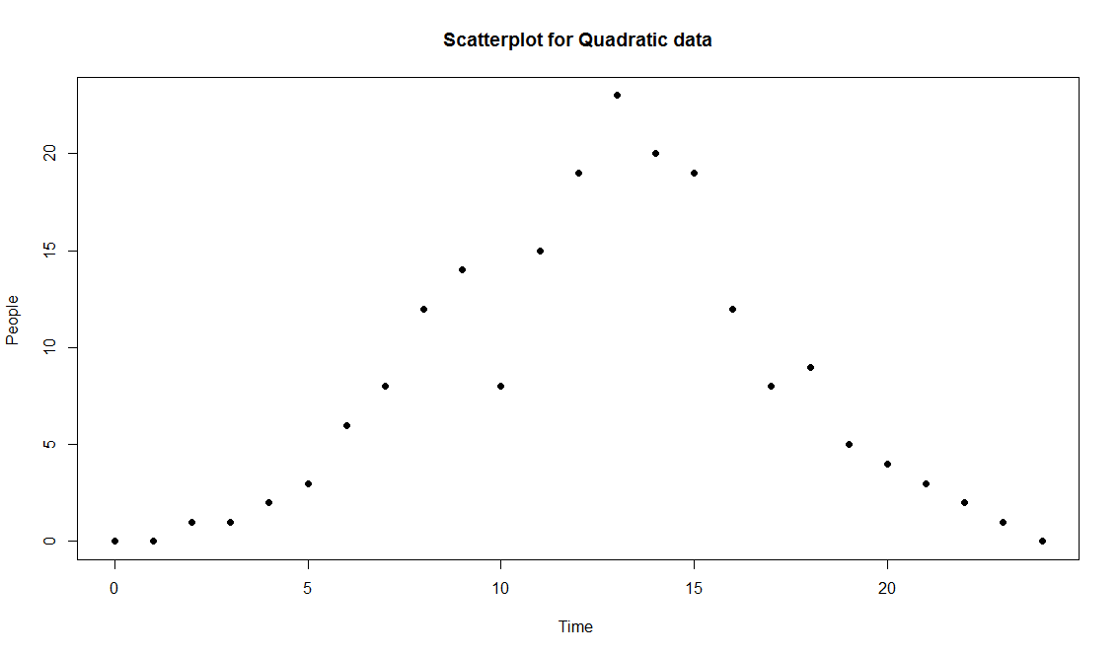

Figure 1

The graph above represents the scatter plot of the lifestyle of the people and how they dispose garbage with respect to time. We note that $N\left(T\right)$ increases from zero to a maximum at $T=12$ and then falls back to zero.

The behavior can be represented by a quadratic function of the form

$$N\left(T\right)=A_{1}T^{2}+B_{1}T+D_{1}$$

Subject to the conditions $N\left(0\right)=N\left(72\right)=0$

Since when we draw a smooth line it forms a curve like that of a parabola.

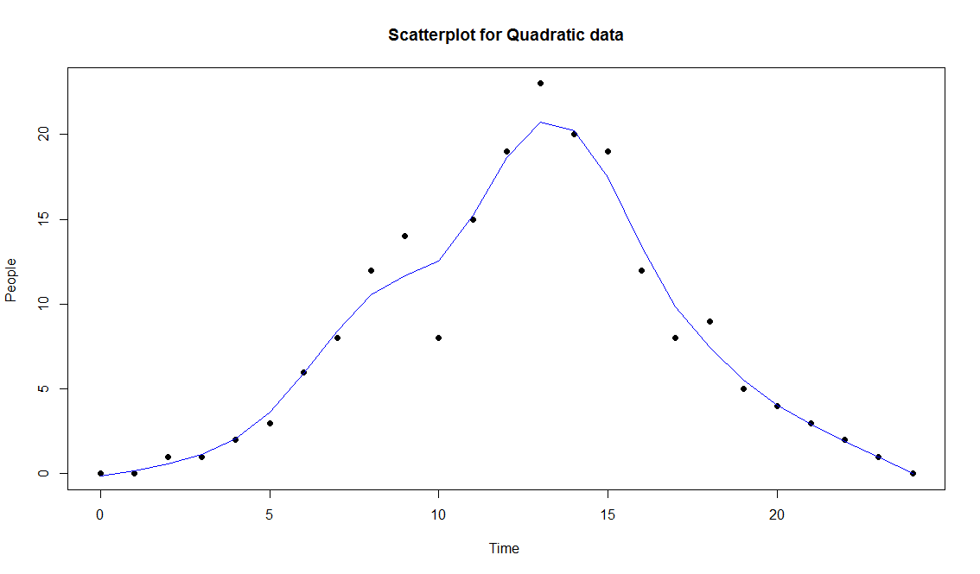

This equation is like that of a parabola. We choose to use this form because of its simplicity.

Using the least square method we get $N\left(T\right)={-A}_{1}(72-t)$. The choice gives maxima of $N\left(T\right) at T=12=24=48=72$

We let $t=\frac{T}{72}$ to be able to solve the equation.

$-A_{1}72+A_{1}t$ where $t=\frac{T}{72}$

therefore, when we solve this we get

$N\left(T\right)=n\left(t\right)=at(1-t)$ (4)

Where $a={-{72}^{2}A}_{1}$ which a dimensional constant.

We now define $a$ in terms of measurable parameters of the system.

Let $N_{0}$ be the total number of people living in an area under consideration.

We assume that a person throws garbage out in the 72 hours’ time limit. Therefore

$$N_{0}=\int_{0}^{72}{N\left(T\right) dt}$$

Calculating this while replacing (4) we get

$4a=N_{0}$

Thus

$$a={\frac{1}{4}N}_{0}$$

We have $C_{0}$ as the maximum amount of garbage a hold contain as we said in equation 5.

This represents a fraction of the total garbage that is thrown out.

Mathematically, we represent

$$C_{0=}{xk}_{1 }\int_{0}^{72}{N\left(T\right) dt}$$

Where x is a normalizer and non-dimensional constant

Which gives $C_{0}=4axk_{1}$

where $x∈\left(0,1\right)$ is a real number.

Therefore $x=\frac{C_{0}}{{4k}_{1}a}$

### 3.3.2 Choice of $P(T)$

We will use a model whereby the removal rate is directly proportional to the collection rate.

Mathematically, we represent this as

$P\left(t\right)=∝c(t)$

where $0≤∝≤1$ which is a constant and a normalizer.

$$k_{2}=∝k_{1}a$$

$∝=\frac{k_{2}}{k_{1}a}$

Replacing values in equation 4 we get that

$\frac{dc}{dt}=\frac{6}{x}\{t\left(1-t\right)-∝p(t)\}$ (5)

Where $∝=\frac{k_{2}}{k_{1}a}$ is a dimensional constant determined from the systems actual parameters and $x=\frac{C_{0}}{{4k}_{1}a}$ where $x∈\left(0,1\right)$

# CHAPTER FOUR

# RESULTS AND DISCUSSIONS

## 4.1 Graphical Solutions

We solve equation 5 and two scenarios will be plotted, one using the $k_{2}$ which is the removal function in relation with $C\left(t\right)$ and $t$ and the other using $x$ which is the constant of removal function in relation with $C\left(t\right)$ and $t$.

The constants and values are as follows from the data we have:

$a=250$, $k_{1}=0.5$, $C\left(0\right)=0$

Case 1: $k_{2}=100 , 150 and 250$

Figure 3



The most evident feature of this graph is that its monotone increasing. The graph increases gradually in a more constant manner. As it increases from $C\left(0\right)=0$ it poses a positive value which is small since the order is of ${10}^{-3}$. We see that as $C(1)>0$ the values grow to be extremely small but does not become negative.

From this result, we have seen we can note that

* Some garbage is left in the garbage hold but it’s extremely small and thus we can conclude that its of little or no consequence.
* Increasing values of $k_{2}$ which is the removal unit, reduces the amount of garbage left in the garbage hold.
* The Amount of Garbage is never negative; hence we can state that resources are not wasted.

Case 2: $x=0.2, 0.3,0.5$



Figure 4

Like case one, the graph is monotone increasing. As $C(t)>0$ and as time goes on, the value or mass of garbage becomes smaller and smaller as the order is of ${10}^{-4}$. Secondly the value of $C(t)$ does not become negative hence the model is efficient.

From this we can conclude that

* Amount of Garbage left in the garbage hold is non-consequential
* Lower values of $x$ lead to lower garbage accumulation

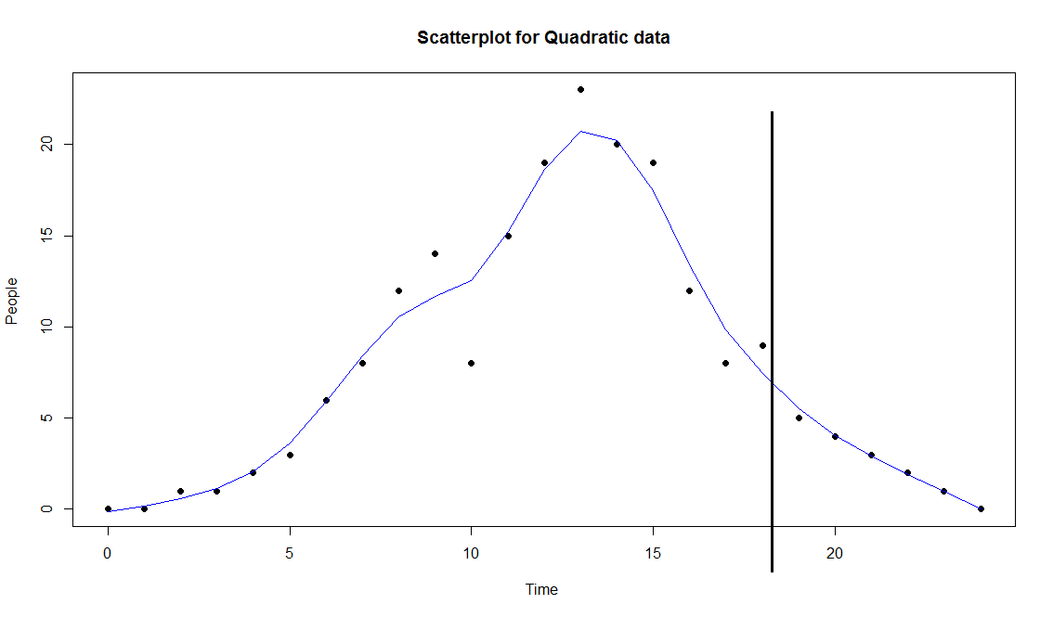

Figure 5

Using this, we see that between 3pm and 4pm very few people dispose garbage at that time. So, collecting garbage at that time is efficient since minimal garbage is disposed and has negligible effect on the total amount of garbage.

# CHAPTER FIVE

# CONCLUSION AND RECCOMENDATIONS

Our Main aim in the project was to design appropriate removal strategies, explain them properly, get best collection time for garbage and identify the barriers.

For the removal strategies, the model depends on the amount of garbage which is in a garbage hold at a time. Using the removal function which we created, $P(t)$ is mainly dependent on $C(t)$. lowering the value of $x$, which is a removal constant lowers the value of $C(t)$. $x$ is a representation of the size of garbage hold and we have calculated is as $x=\frac{C_{0}}{N_{0}k_{1}}$. So, to reduce the value of $x$ we must be able to reduce $N_{0}k_{1}$ to make $x$ as ***small*** as possible. Practically this means that we create more garbage holds.

Secondly, removal units with high carrying capacity $k_{2}$ should be assigned with areas whose $x$ are very low and removal units with low carrying capacity should be placed in areas whose $x$ is very high.

Thirdly, garbage should be collected in the evening between 3pm to 4pm when most deposit of garbage has been done by the people. Since we are using the 72hr system we recommend garbage to be collected at time

$$T=15hrs=30hrs=45hrs=60hrs$$

Lastly, we have not been able make $C\left(t\right)=0$ unless $C\left(0\right)=0$.We have tried to minimize it into some very small values and this is when the value of $k_{2}$ is high. Therefore, we should consider increasing $k_{2}$ which is the removal function.

The model is effective and can be used by most urban areas in Africa and Nairobi as well since the data used to compute this reflects a population of an average urban area of a developing country. The beauty of the model is that it does not allow wastage of resources and that is a key issue.

I therefore recommend that despite Challenges, we can consider from moving out of a collection time of 72 hours and move it to either 48 or 24. This will make the model more efficient. We can also hence try to make

$$C\left(0\right)=C\left(12\right)=C\left(24\right)=C\left(0\right)=C\left(36\right)=C\left(48\right)=C\left(60\right)=C\left(72\right)=0$$

to make it possible that a garbage hold can be empty at midday. This then can help improve the model.

**REFRENCES**

[1] Mitul Islam, “Mathematical Modeling of Garbage Collection Problem,” vol. 4, no. 1, pp. 29–38, 2013.

[2] K. (Nema) National Environment Management Authority, “The National Solid Waste Management Strategy,” pp. 1–85, 2015.

[3] “NAIROBI CITY WASTE MANAGEMENT INNOVATIONS.”

[4] G. O. M. M, “University of Nairobi Department of Real Estate and Construction Management Solid Waste Management in Urban Areas Kenya : A case study of Lamu Town . A Research Study in partial fulfillment of PGD in,” 2013.

[5] M. K. Nganda, “Mathematical Models in Municipal Solid Waste Management,” 2007.

[6] G. Marion, “An Introduction to Mathematical Modelling,” *An Introd. to Math. Model.*, 2008.

[7] P. Howard, “Modeling with ODE,” pp. 1–26, 2009.

[8] P. Costi, R. Minciardi, M. Robba, M. Rovatti, and R. Sacile, “An environmentally sustainable decision model for urban solid waste management.,” *An Environ. Sustain. Decis. Model urban solid waste Manag. Manag.*, pp. 24, 277–295, 2004.

[9] M. F. Badran and S.M. El-Haggar, “Optimization of Municipal Solid Waste Management in Port Said - Egypt. Waste Management,” pp. 26, 534–545., 2006.

[10] C. ReVelle, “Research challenges in environmental management.,” *Eur. J. Oper. Res.*, pp. 121, 218–231, 2000.

[11] “Mathematical Modeling with Differential Equations,” no. x, pp. 372–396.

**APENDIX**

This code was used for analysis of N(T)

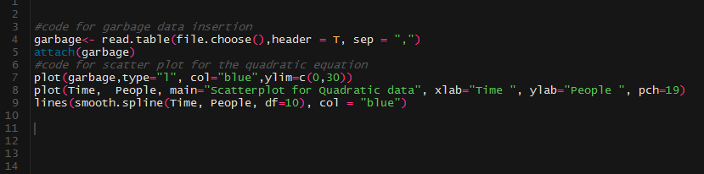

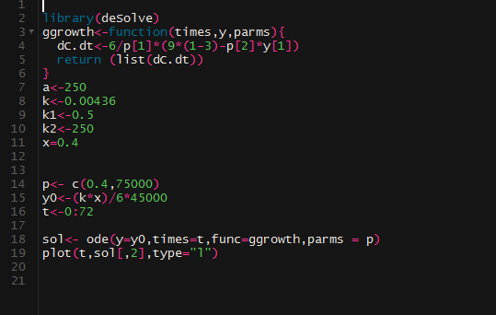

The code above was used to solve the ode after analysis and plot the two graphs of k and x

