Table of Contents

[Network Motif Comparison 1](#_Toc473817935)

[Motifs vs. number of samples 2](#_Toc473817936)

[Conclustions 4](#_Toc473817937)

[IndeCUT results on Drosophila network 6](#_Toc473817938)

[TF->miRNA layer 6](#_Toc473817939)

[TF->TF layer 7](#_Toc473817940)

[miRNA-> TF layer 8](#_Toc473817941)

[References 8](#_Toc473817942)

# Network Motif Comparison

Table . Comparing WaRSwap motif outcome with originally published network motifs. WaRSwap (parameter tuned/no permutation version) executed to produce 4000 random networks. The original paper used FANMOD to get network motif outcome. The highlighted motifs are not detected by WaRSwap. Data is stored at /nfs0/BPP/Megraw\_Lab/mitra/Projects/NetMotif/netwmotif\_analyses/drosophila\_modeEncode\_motif\_comparision

|  |  |
| --- | --- |
| WaRSwap  (4000 iterations) | /Users/mitra/.Trash/000101110.png/Users/mitra/.Trash/010101101.png/Users/mitra/.Trash/011011002.png/Users/mitra/.Trash/011101001.png/Users/mitra/.Trash/011101002.png/Users/mitra/.Trash/011101110.png |
| modeEncode  FANMOD  100 iterations | /Users/mitra/.Trash/000101110.png/Users/mitra/.Trash/010101101.png/Users/mitra/.Trash/011011002.png/Users/mitra/.Trash/011101001.png/Users/mitra/.Trash/011101002.png/Users/mitra/.Trash/011101110.png../../../../../../../Downloads/motifs_output_molly/01010../../../../../../../Downloads/outfile-images/00110 |
| FANMOD  100 iteration | ../../../../../../../Downloads/motifs_output_molly/00010../../../../../../../Downloads/motifs_output_molly/01010../../../../../../../Downloads/motifs_output_molly/01101../../../../../../../Downloads/motifs_output_molly/01110../../../../../../../Downloads/motifs_output_molly/01110../../../../../../../Downloads/motifs_output_molly/01110../../../../../../../Downloads/motifs_output_molly/01010../../../../../../../Downloads/motifs_output_molly/00110 |
| FANMOD  500 iterations | ../../../../../../../Downloads/motifs_output_molly/00010../../../../../../../Downloads/motifs_output_molly/01010../../../../../../../Downloads/motifs_output_molly/01101../../../../../../../Downloads/motifs_output_molly/01110../../../../../../../Downloads/motifs_output_molly/01110../../../../../../../Downloads/motifs_output_molly/01110../../../../../../../Downloads/motifs_output_molly/01010 |
| FANMOD  1000 iterations | ../../../../../../../Downloads/motifs_output_molly/00010../../../../../../../Downloads/motifs_output_molly/01010../../../../../../../Downloads/motifs_output_molly/01101../../../../../../../Downloads/motifs_output_molly/01110../../../../../../../Downloads/motifs_output_molly/01110../../../../../../../Downloads/motifs_output_molly/01110../../../../../../../Downloads/motifs_output_molly/01010 |
| FANMOD  2500 iterations | ../../../../../../../Downloads/motifs_output_molly/00010../../../../../../../Downloads/motifs_output_molly/01010../../../../../../../Downloads/motifs_output_molly/01101../../../../../../../Downloads/motifs_output_molly/01110../../../../../../../Downloads/motifs_output_molly/01110../../../../../../../Downloads/motifs_output_molly/01110../../../../../../../Downloads/motifs_output_molly/01010../../../../../../../Downloads/motifs_output_molly/00110 |
|  |  |

# Motifs vs. number of samples

FANMOD’s random graphs are sampled randomly 50 times with different sample sizes. The following plot shows the frequency of observation of each motif at with given sample size.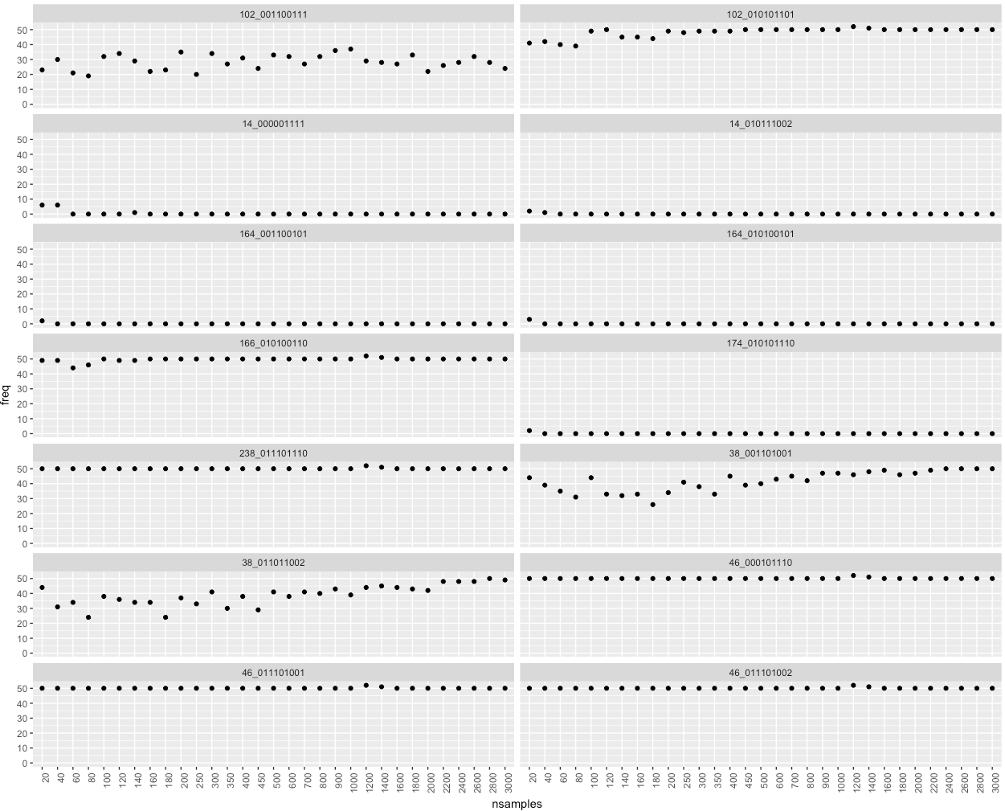

Figure

## Conclusions

|  |  |
| --- | --- |
| 1-Reported in paper and stable motifs | /Users/mitra/.Trash/010101101.png102\_010101101  ../../../../../../../Downloads/motifs_output_molly/01010166\_010100110  /Users/mitra/.Trash/011101110.png238\_011101110  /Users/mitra/.Trash/000101110.png46\_000101110  /Users/mitra/.Trash/011101001.png46\_011101001  /Users/mitra/.Trash/011101002.png46\_011101002 |
| 2-Reported in paper, shaky | motif_images/sampling_results/38_011011002.png38\_011011002 |
| 3- Not reported in paper, significant observation | motif_images/sampling_results/38_001101001.png38\_001101001  motif_images/sampling_results/102_001100111.png102\_001100111 |
| 4- reported in paper, No observation at all | ../../../../../../../Downloads/outfile-images/00110 |
| 5- not reported in paper, few observations | motif_images/sampling_results/164_010100101.png164\_010100101  motif_images/sampling_results/164_001100101.png164\_001100101  motif_images/sampling_results/14_000001111.png14\_000001111  motif_images/sampling_results/14_010111002.png14\_010111002  motif_images/sampling_results/174_010101110.png174\_010101110 |

# IndeCUT results on Drosophila network

## TF->miRNA layer

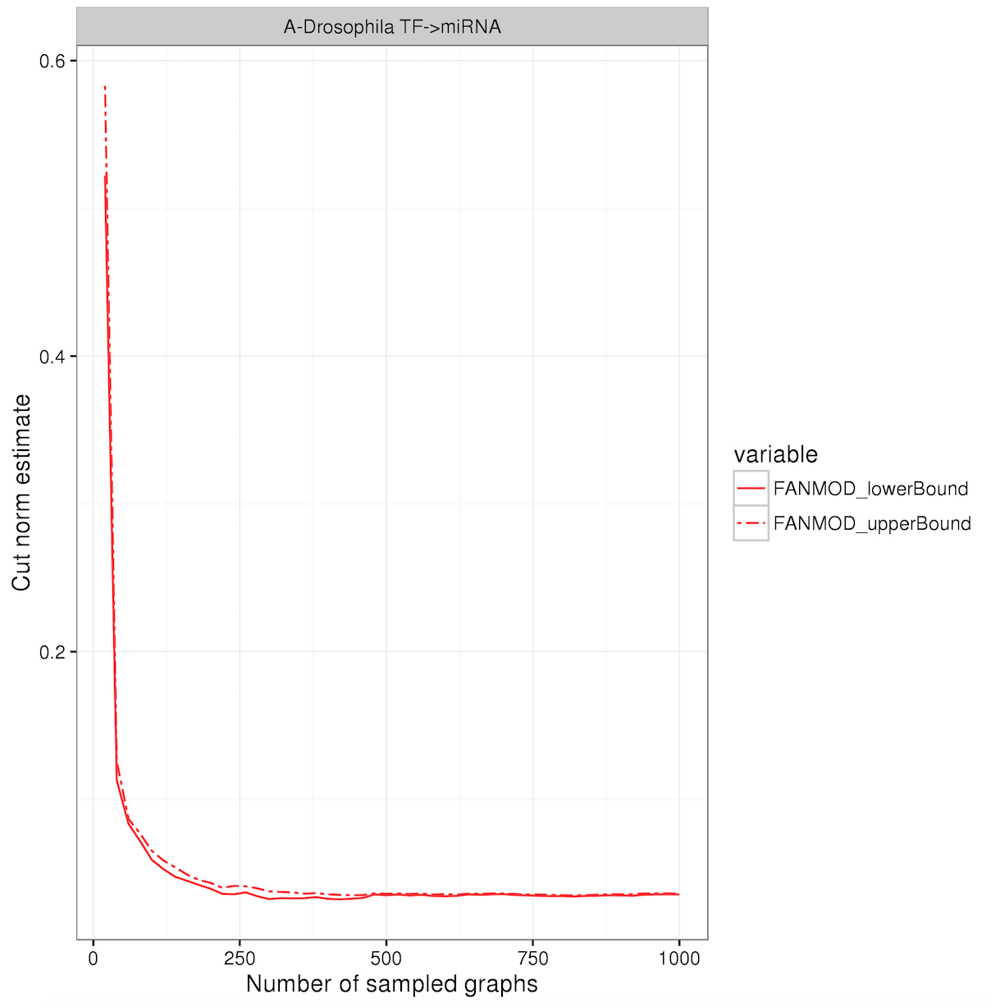

## TF->TF layer

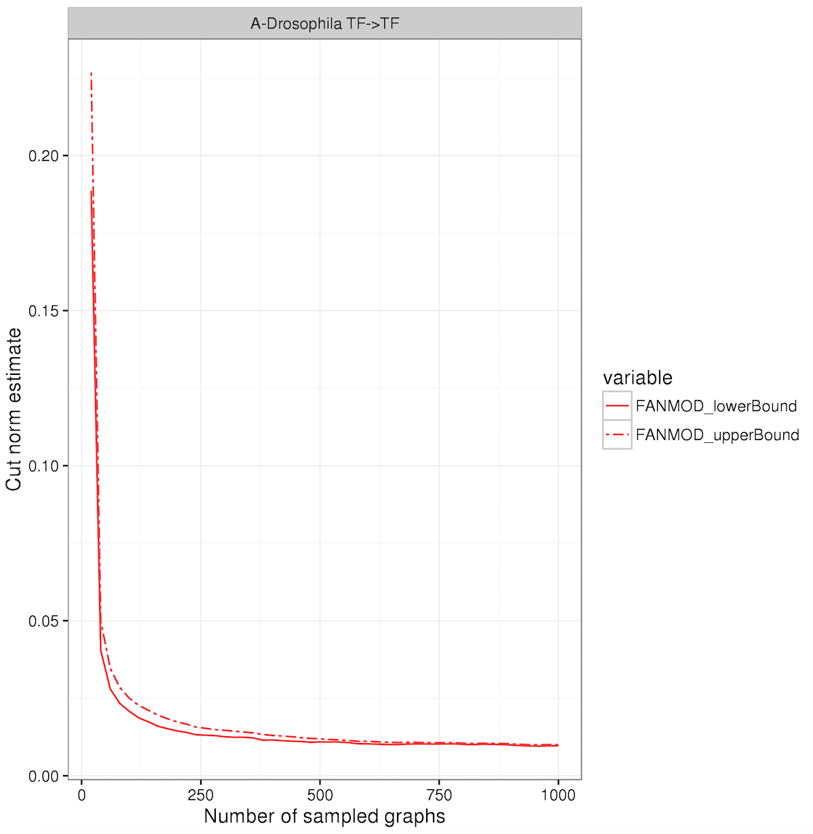

## miRNA-> TF layer

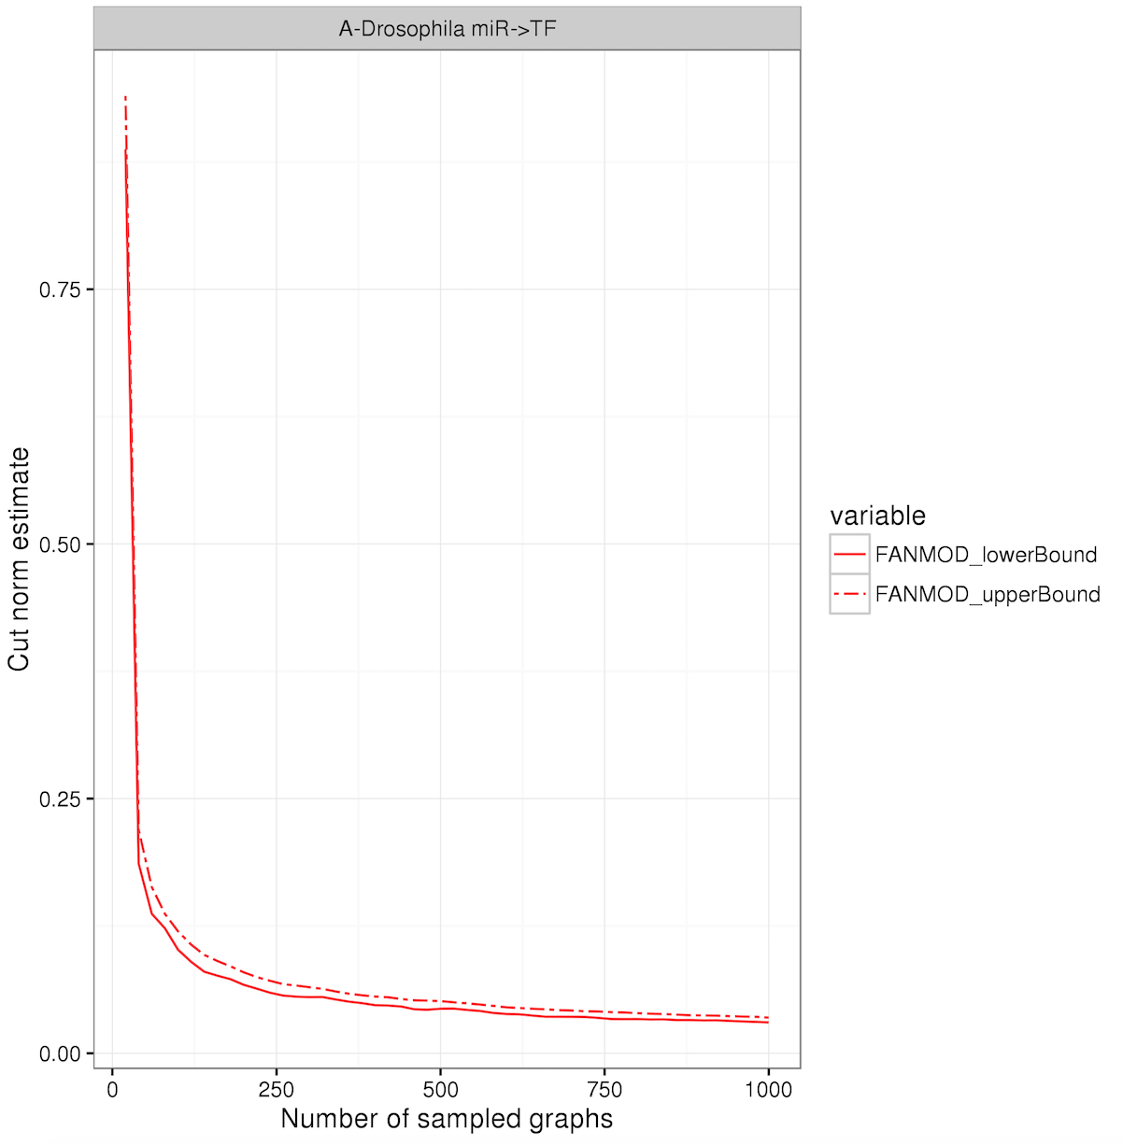

# miRNA->Gene layer

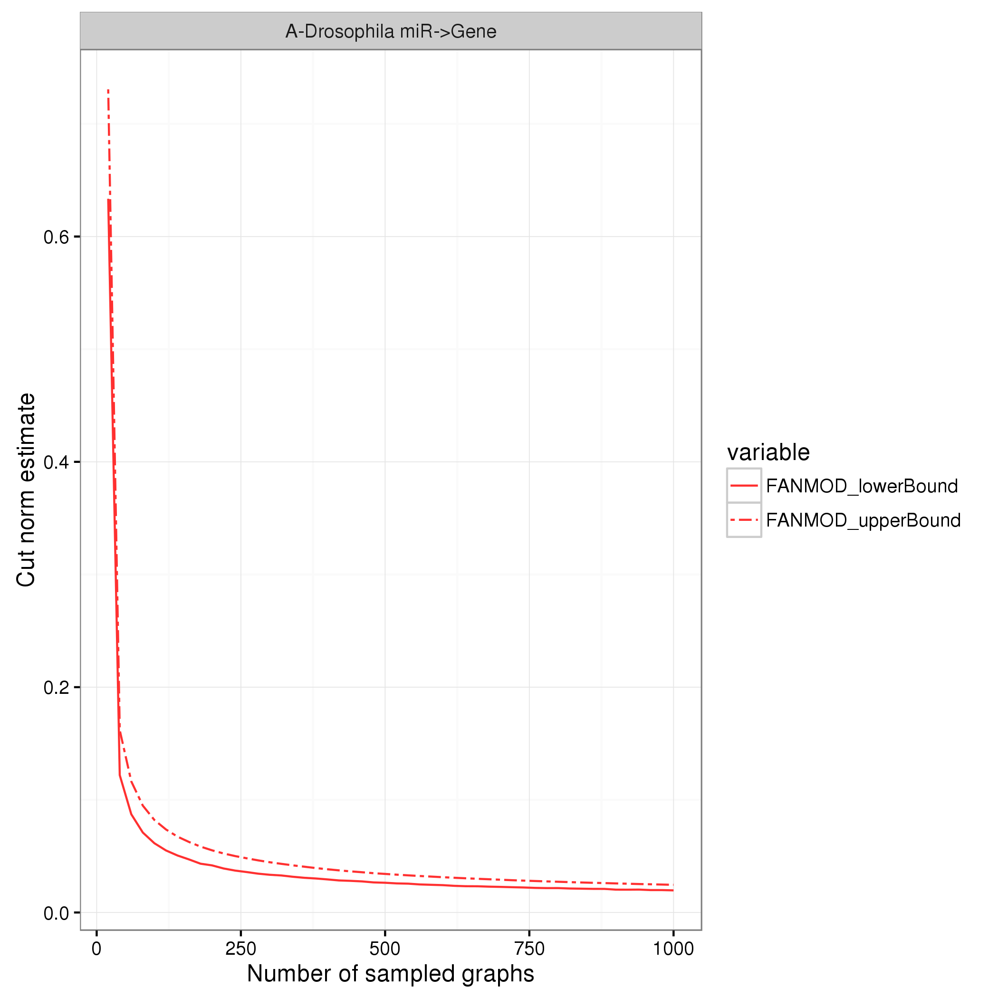

# References

modENCODE: Drosophila network <http://science.sciencemag.org/content/330/6012/1787.long>