**ITMD 563- Final Project 7**

The url that have to be used it “**localhost/Home/Index**”.

**Step 1:**

I started the project by creating the table “Mortgag” in Local SQL Server. I have attached the screenshot for the same.

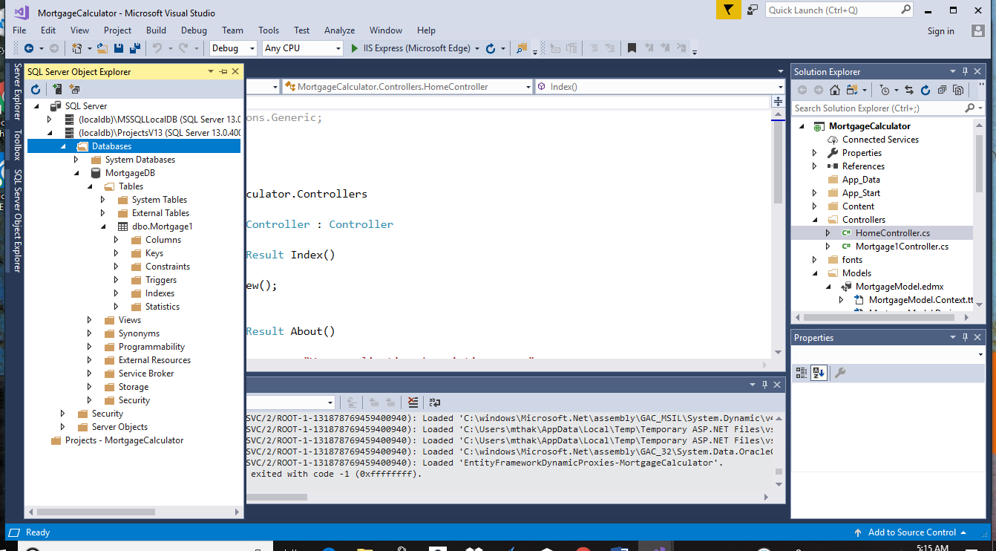

**Step 2:**

After that I have attached it to the project by adding the ADO.NET Entity Data Model in the model folder.

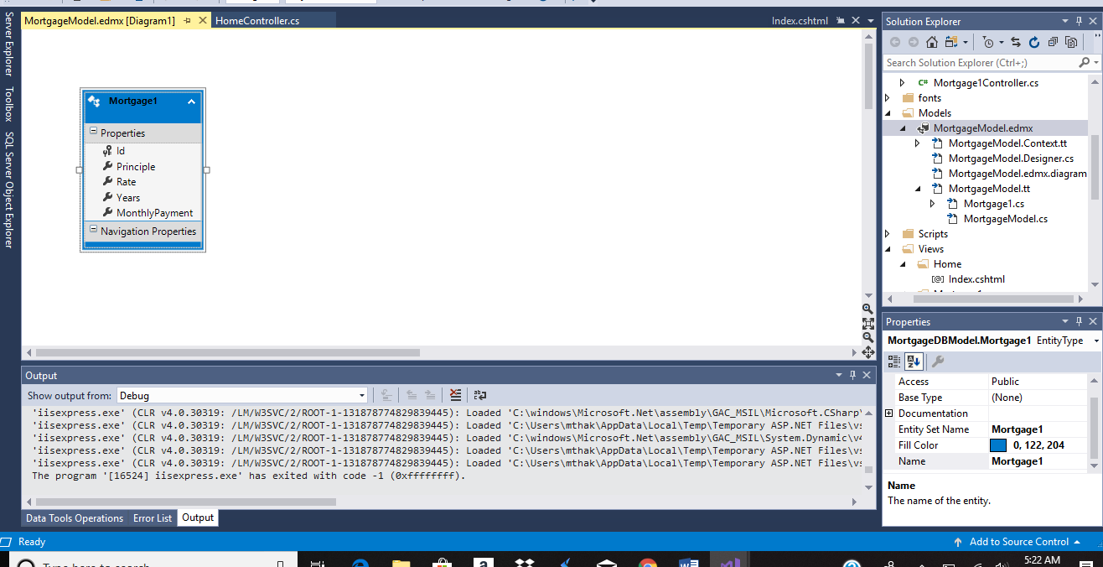

**Step 3:**

After that I have created the controller with view and edit it. And later on I have generated the views for the same.