CIS 41B Assignment 3: GUI and OOP

Write 2 classes for 2 GUI windows that let a user add CIS student records.

The Dialog class

The Dialog class is in the file dialog.py. It is a base class for a Dialog window that has a title, a body, and 2 buttons: OK and Cancel.

title

body

OK

Cancel

* The title can be passed in when instantiating the class.
* The body is empty and is meant to be implemented by the derived class to interact (or dialog) with the user in order to get user input.
* The 2 buttons work in expected ways: OK to save the user input and quit, Cancel to quit without saving.
* See more detailed documentation in the Dialog class, and answer the 4 questions in the comments part of the file.

The AddStudentDialog class

Write the AddStudentDialog class, which is derived from the Dialog class. You need to implement the following methods:

1. Implement the body() method

This method builds the body of the Dialog window with for 3 user input fields: ID, name, favorite programming language.

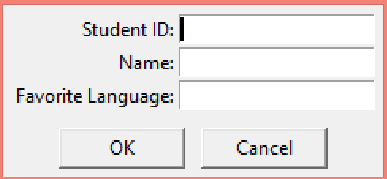

1. Implement the validate() method

This method checks that:

* all 3 fields have been filled out or return False
* the ID field has exactly 3 digits or return False
* the favorite language field has Python (case insensitive) or pop up a message box with a message of your choice
* If all 3 fields are filled out and the ID field has 3 digits, return True

1. Override the apply() method

Set the Dialog class' result variable with a data structure of your choice, which can store the 3 data items that the user entered.

1. Add private support methods as you see the need.

The MainWindow class

Write the MainWindow class, which is the main window for the GUI. The main window has 2 methods.

1. A constructor which sets up the following:

* A title "Lab 3"
* Allow sizing on the horizontal or x-axis only
* A description label for what the window is used for
* A button that the user clicks to add one student
* A label that prints the current count of student records in the list.
* A listbox with a scrollbar that shows all the student records that have been added. The listbox displays only 3 lines of data in its view.
* Example output:

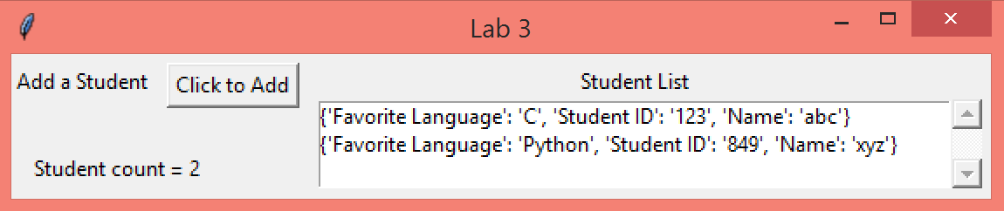

1. An addStudent method which:

* instantiates the AddStudentDialog object to interact with the user and get data for one student
* gets the data from the AddStudentDialog object and displays it in the listbox

The lab3.py file

The lab3.py file has the main function which instantiates the MainWindow object and runs its mainloop.

The mainloop causes the user to be able to add student until the user closes the window.

The 2 window classes are fairly short so even though they should be in their own .py file, for this assignment you can put both classes in the lab3.py file, above main.

Turn in

lab3.py: with both classes above main

dialog.py: with the 4 questions answered