CS 457 Fall 2016

Assignment 1

**Due by 09/26/2016 by 11:59 PM**

**The link for the submission:** [**https://goo.gl/forms/w7LfN74sQJsIn4kq1**](https://goo.gl/forms/w7LfN74sQJsIn4kq1)

1. We chose to base our architecture off of the Cloud Computing Architecture. Some of the advantages to this architecture in which our application can benefit from are its reliability, manageability, scalability, storage for data, device independence and location independence.

Our architecture is shown below and includes the following components:

Servers: hold data needed for application, servers will include our own application server used for user data and will bring data from the other servers into it for access in the application. Other servers needed will include google geo location, google places, and weather. These servers will be used for accessing google maps/locations, attractions near the destination, and weather conditions at the destination, respectively.

Tablets and Phones: represent the devices the application will be used on

Location Services: will use Google Geo Location API, will hold the libraries that are able to access the GPS to determine the devices current location

Attraction Search: will use Google Places API, will have information regarding what attractions are near the destination location

Weather: will use Weather API, will have information regarding weather conditions at the destination location

GPS: hardware of the operating system for GPS application, location services will access

Identity: used for user authentication and identity to track user information and storage

Object Storage: server side storage, stores user data, tokens, history of user searching, will hold all user data in the database

Runtime: runtime will include application launches, service calls, such as authentication, location, weather, attractions to find results, accessing storage, display results to user

Compute: not all hardware and software application will use will be on device or in device’s network, will be provided as a service by application and accessed over the internet in a seamless way

Block Storage: local caching, keeps track of session tokens, will cache server data in case user closes application, the application will not have to recall server when user opens application again

Network: calls to servers on other networks, used to transfer data to and from application

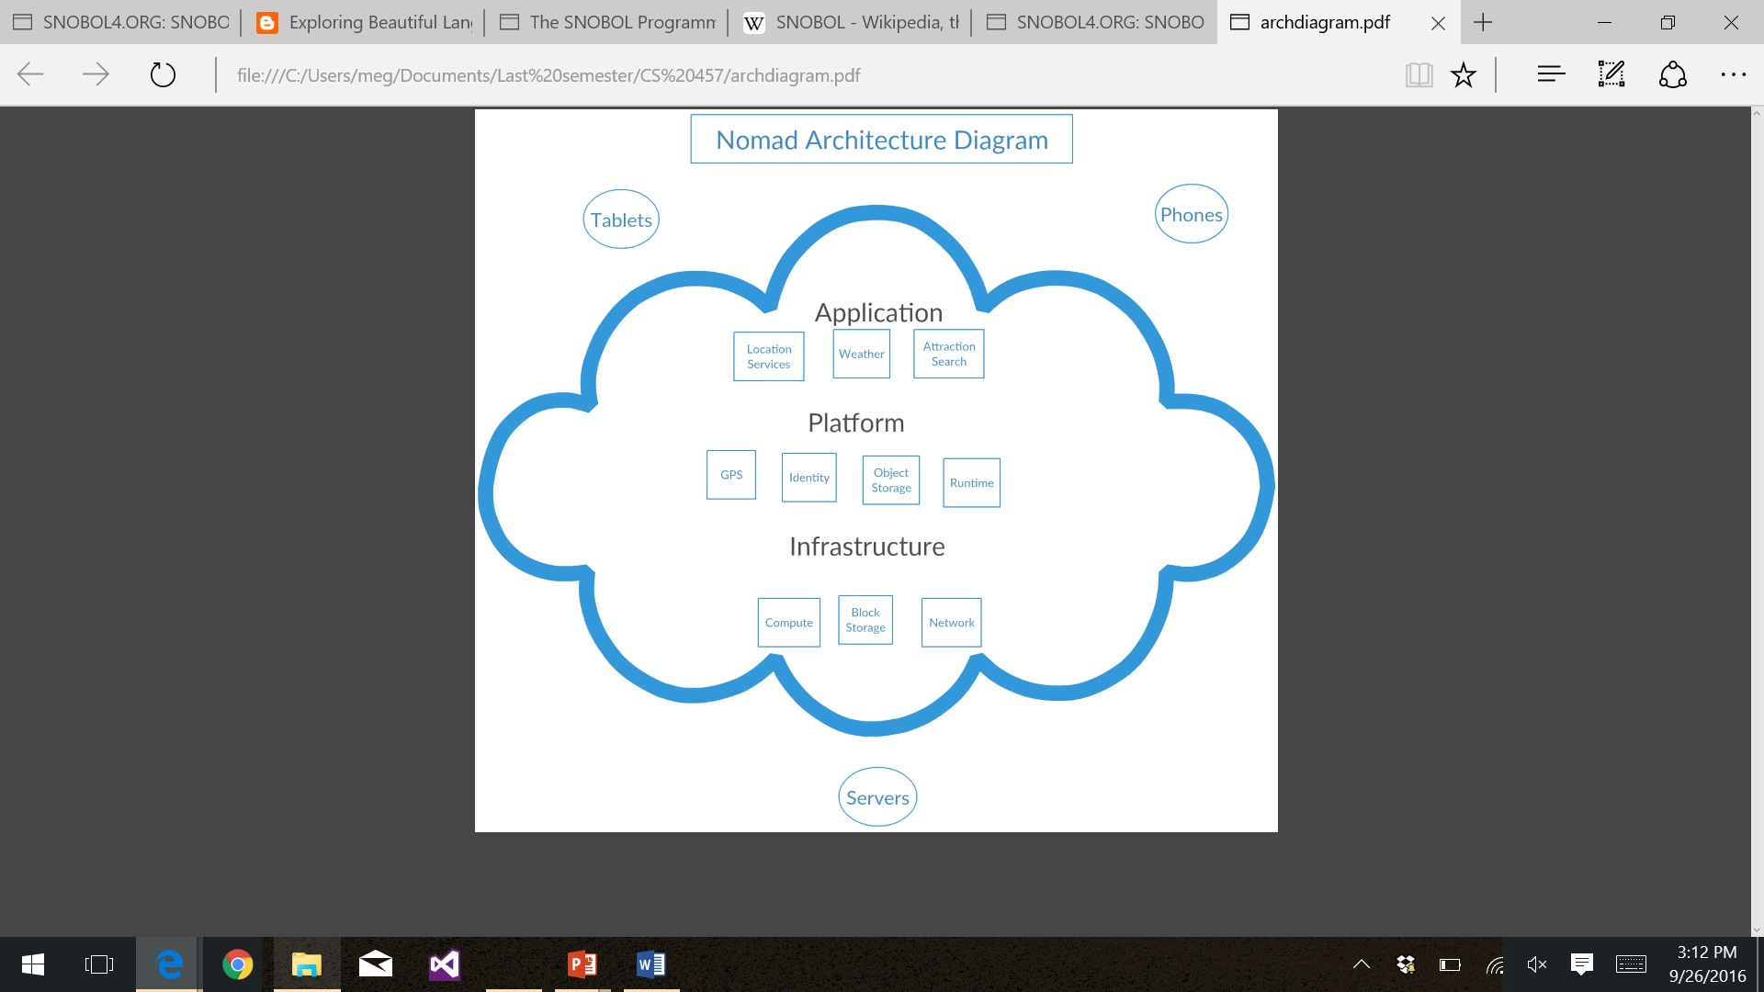

1. We have chosen the Pipe and Filter style for our ‘Nomad’ use case. We felt like this style would work well for ‘Nomad’ due to the style’s incremental design. For our application, independent components will process data in this fashion, so Pipe and Filter is a compatible style choice. Some of the advantages of Pipe and Filter style that also make it appealing are its simplicity, concurrent execution abilities and its ease of maintenance, enhancement and evolution. Pipe ad Filter allows designers to understand the input and output behavior of the system by its filters. Also each filter can be implemented as a separate task and be executed in parallel with other filters if that is desired.