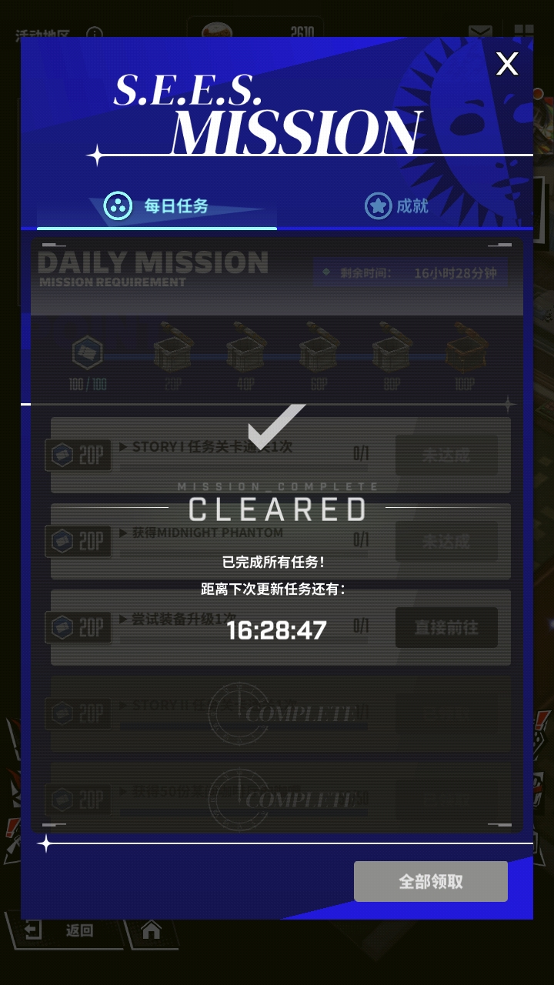
在此位置卡住，附近日志如下：
03:31:30DEBUGButton: REWARD_CHALLENGE_HIDDEN, color1: (38.01808785529716, 77.59173126614988, 153.54134366925067), color2: (37, 71, 154), similarity: 7, threshold: 5, hit: False
03:31:30DEBUGButton: REWARD_MISSION_CHECK, color1: (56.89665071770335, 112.82966507177034, 170.89473684210526), color2: (54, 111, 172), similarity: 4, threshold: 5, hit: True
03:31:30DEBUGButton: REWARD_RECEIVE_DONE, color1: (169.99592592592592, 169.84296296296296, 168.47074074074072), color2: (170, 170, 168), similarity: 1, threshold: 5, hit: True
03:31:30DEBUGButton: REWARD_CHALLENGE_HIDDEN, color1: (38.01808785529716, 77.59173126614988, 153.54134366925067), color2: (37, 71, 154), similarity: 7, threshold: 5, hit: False
03:31:31DEBUGButton: EVENT_CHECK, similarity: 0.37270715832710266, threshold: 0.74, hit: False
03:31:31DEBUGButton: REWARD_CHALLENGE_CHECK, color1: (37.67809057527539, 76.47368421052632, 152.99265605875152), color2: (68, 147, 191), similarity: 71, threshold: 5, hit: False
03:31:31DEBUGButton: REWARD_RECEIVE, color1: (169.30514705882354, 169.1793300653595, 167.75980392156862), color2: (112, 173, 196), similarity: 86, threshold: 10, hit: False
03:31:31DEBUGButton: RECEIVE, similarity: 0.3790312111377716, threshold: 0.74, hit: False
03:31:31DEBUGButton: RECEIVE_REWARD, similarity: 0.182029590010643, threshold: 0.74, hit: False
03:31:31DEBUGButton: REWARD_MISSION_CHECK, color1: (56.89665071770335, 112.82966507177034, 170.89473684210526), color2: (54, 111, 172), similarity: 4, threshold: 5, hit: True
03:31:31DEBUGButton: REWARD_MISSION_CLEARED, similarity: 0.9527055025100708, threshold: 0.74, hit: True
03:31:31DEBUGButton: REWARD_CHALLENGE_HIDDEN, color1: (38.01808785529716, 77.59173126614988, 153.54134366925067), color2: (37, 71, 154), similarity: 7, threshold: 5, hit: False
03:31:31DEBUGButton: REWARD_MISSION_CHECK, color1: (56.89665071770335, 112.82966507177034, 170.89473684210526), color2: (54, 111, 172), similarity: 4, threshold: 5, hit: True
03:31:31DEBUGButton: REWARD_RECEIVE_DONE, color1: (169.99592592592592, 169.84296296296296, 168.47074074074072), color2: (170, 170, 168), similarity: 1, threshold: 5, hit: True
03:31:31DEBUGButton: REWARD_CHALLENGE_HIDDEN, color1: (38.01808785529716, 77.59173126614988, 153.54134366925067), color2: (37, 71, 154), similarity: 7, threshold: 5, hit: False
03:31:31DEBUGButton: EVENT_CHECK, similarity: 0.37270715832710266, threshold: 0.74, hit: False
03:31:31DEBUGButton: REWARD_CHALLENGE_CHECK, color1: (37.67809057527539, 76.47368421052632, 152.99265605875152), color2: (68, 147, 191), similarity: 71, threshold: 5, hit: False
03:31:31DEBUGButton: REWARD_RECEIVE, color1: (169.30514705882354, 169.1793300653595, 167.75980392156862), color2: (112, 173, 196), similarity: 86, threshold: 10, hit: False
03:31:31DEBUGButton: RECEIVE, similarity: 0.3790318965911865, threshold: 0.74, hit: False
03:31:31DEBUGButton: RECEIVE_REWARD, similarity: 0.1815175712108612, threshold: 0.74, hit: False
03:31:31DEBUGButton: REWARD_MISSION_CHECK, color1: (56.89665071770335, 112.82966507177034, 170.89473684210526), color2: (54, 111, 172), similarity: 4, threshold: 5, hit: True
03:31:31DEBUGButton: REWARD_MISSION_CLEARED, similarity: 0.9615858197212219, threshold: 0.74, hit: True
03:31:31DEBUGButton: REWARD_CHALLENGE_HIDDEN, color1: (38.01808785529716, 77.59173126614988, 153.54134366925067), color2: (37, 71, 154), similarity: 7, threshold: 5, hit: False
03:31:31DEBUGButton: REWARD_MISSION_CHECK, color1: (56.89665071770335, 112.82966507177034, 170.89473684210526), color2: (54, 111, 172), similarity: 4, threshold: 5, hit: True
03:31:31DEBUGButton: REWARD_RECEIVE_DONE, color1: (169.99592592592592, 169.84296296296296, 168.47074074074072), color2: (170, 170, 168), similarity: 1, threshold: 5, hit: True
03:31:31DEBUGButton: REWARD_CHALLENGE_HIDDEN, color1: (38.01808785529716, 77.59173126614988, 153.54134366925067), color2: (37, 71, 154), similarity: 7, threshold: 5, hit: False
另外发现控制高版本安卓时会出问题，无法启动报错如下：
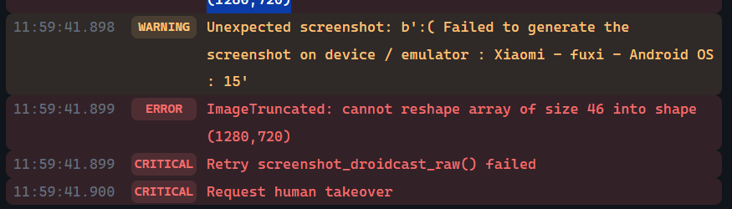
这是正常的windows版控制安卓15的mumu模拟器的报错，而且控制高安卓版本真机报错相同

