**T.C.**

**Doğuş Üniversitesi**

**Work Study and Ergonomics**

**Group Project**

*Human Information Processing Skills*

*IE 252*

Erol Umut

Oğuz İçin - 202003001075

Mehmet Emin Güvercin - 202003001058

Mina Yağmur Poyraz-202103002016

Ebru Nur Efendioğlu-202103002024

# Abstract

This scientific report explores the mechanisms of human information processing, examining how individuals perceive, store, retrieve, and act upon information in various contexts. The report delves into cognitive functions such as attention, perception, memory, and decision-making to reveal their influence on task performance and behavioral outcomes. Drawing from theoretical models and academic sources, this study aims to identify key cognitive processes that underlie efficient information handling and to evaluate their practical implications in real-world environments, such as education, work performance, and human-computer interaction.

# Table of Contents

Contents

i. Abstract 2

ii. Table of Contents 3

iii. List of Figures 4

iv. List of Tables 5

1. Introduction 6

2. Purpose of the Study 7

3. Significance of the Study 8

4. Human Information Proccessing 9

5. Application 12

6. Conclusion 13

7. References 14

# List of Figures

1. Figure 1 12

# List of Tables

1. Table 1 9
2. Table 2 10

# Introduction

In today's information-driven work and learning environments, success is not solely determined by what individuals know, but by how effectively they process and use that information. Human information processing refers to the cognitive mechanisms through which individuals perceive, interpret, store, and recall information. This process involves critical functions such as attention, perception, memory, and decision-making, all of which play a vital role in shaping an individual’s ability to interact with and respond to their environment.

# Purpose of the Study

The primary purpose of this study is to examine how human information processing skills influence performance in work, learning, and daily life contexts. This report explores the underlying cognitive functions—such as attention control, perception, memory, and executive functioning—and their relationship to task execution, accuracy, learning efficiency, and adaptability to unexpected situations.

Furthermore, the study aims to highlight how different environments and design elements can either hinder or enhance these cognitive processes. By identifying the factors that support or limit cognitive performance, this study provides a foundation for optimizing human-system interaction, improving ergonomics, and guiding the development of more effective training programs and user interfaces.

# Significance of the Study

Understanding human information processing is crucial in today’s fast-paced and cognitively demanding settings. As tasks become more complex and information loads increase, the ability to process information quickly, accurately, and without mental overload becomes a key differentiator of performance.

This study is particularly significant for areas such as ergonomics, human-computer interaction, safety systems, and education, where cognitive overload, poor decision-making, or miscommunication can lead to reduced productivity or even critical failures. By integrating cognitive principles into system design and training approaches, organizations can increase user satisfaction, reduce error rates, and enhance overall efficiency.

Moreover, emphasizing the importance of emotional regulation and social cognition provides valuable insights into team collaboration, leadership, and effective workplace communication. This study underscores the need for a holistic view that considers both physical and mental aspects of performance.

# Human Information Proccessing

Perception, the process by which sensory input is interpreted and given meaning, is not purely passive. It is shaped by prior experiences, expectations, and contextual cues. In time-sensitive operations—such as piloting, medical diagnostics, or military coordination—rapid and accurate perception of visual or auditory stimuli can determine success or failure. Studies in applied cognitive science reveal that perceptual errors often stem from "expectation bias," where the brain fills in incomplete or ambiguous information based on past patterns (Endsley, 1995). Designers of high-reliability systems are now incorporating principles like perceptual distinctiveness and redundancy to minimize such errors.

Memory, both short-term and long-term, plays a crucial role in human performance. Short-term memory supports immediate reasoning and task execution, while long-term memory allows the retrieval of learned patterns, procedural knowledge, and rules. Effective memory processes enable individuals to consistently apply learned procedures, adapt to novel problems, and transfer learning across domains. However, memory is vulnerable to interference and decay. Cognitive load theory suggests that excessive information presented simultaneously overwhelms working memory, resulting in incomplete encoding and recall (Sweller et al., 2019). To mitigate this, strategies such as information chunking, multimodal encoding (visual + auditory), and spaced repetition are recommended—especially in instructional and system design contexts (Mayer, 2020).

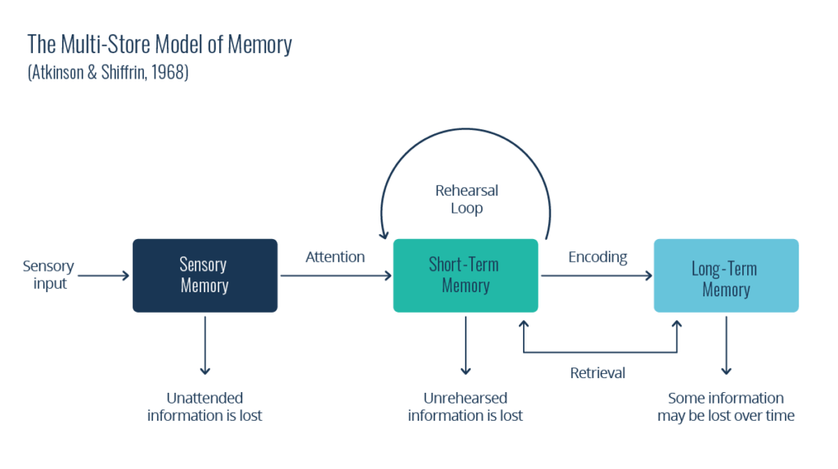

Table 1

Environmental factors significantly influence the efficiency of human information processing. Physical conditions such as ambient noise, lighting, temperature, screen glare, and seating posture can impair attention, perception, and even memory recall. For example, research in environmental psychology has shown that noise levels above 70 dB can reduce task accuracy by up to 40%, particularly in tasks involving verbal memory or concentration (Sörqvist, 2010). Ergonomic mismatches—such as improper screen placement or inadequate seating—also induce physical discomfort that redirects cognitive resources away from the primary task, increasing fatigue and error likelihood.

Psychological states also play a critical role. Stress, anxiety, and mental fatigue can narrow attentional scope, bias perception, and impair working memory. One particularly important phenomenon is decision fatigue—the gradual deterioration in decision quality after a prolonged session of continuous choices. Originally identified by Baumeister et al. (1998), decision fatigue affects judges, physicians, and executives alike, leading to an over-reliance on defaults or avoidance strategies late in the day. This highlights the need to design workflows that limit excessive decision points or incorporate rest periods to restore cognitive resources.

[A diagram of process automation
](#_List_of_Tables)

Table 2

The implications for learning, system usability, and human-machine interaction are profound. In educational contexts, the application of cognitive principles has transformed digital learning platforms. For example, chunking complex topics into manageable units improves comprehension and retention (Miller, 1956), while adaptive systems that adjust difficulty based on user input support optimal learning conditions. Similarly, in software and interface design, minimalism, visual hierarchy, and real-time feedback are used to reduce cognitive friction and improve user experience (Norman, 2013).

In summary, human information processing is not merely a biological function but a critical determinant of successful performance across professional, educational, and technological domains. By recognizing and optimizing the cognitive, emotional, and environmental variables that influence this process, designers, educators, and leaders can build systems that enhance human capabilities rather than constrain them.

# Application

[](https://www.youtube.com/embed/vJG698U2Mvo?feature=oembed)

Figure 1

**1. Multitasking Challenge**

Objective: To observe how dividing attention between two tasks affects performance.

Application: Students were asked to perform two tasks simultaneously:

• Task 1: Write their name and date of birth five times

• Task 2: At the same time, write numbers spoken by another student in reverse order

Time was measured and the number of mistakes was recorded.

Conclusion: Multitasking reduces efficiency and increases the likelihood of making mistakes due to divided attention.

**2. Change Blindness Test**

Objective: To demonstrate how the brain can miss changes even when looking directly at them.

Application: Two versions of the same image were shown alternately. One image had a small addition or removal.

Students were asked to detect the change.

Conclusion: Attention is not only visual but also mental. The brain often fails to notice changes it is not focused on.

**3. Reaction Time Game**

Objective: To measure how information processing speed affects physical reactions.

Application: A simple color command game was played (e.g., jump when you hear “green”, stay still when you hear “red”).

Unexpected color switches were used to increase challenge.

Conclusion: While the brain processes information quickly, unexpected situations increase error rates. Reaction time reflects attention and readiness.

# Conclusion

Human information processing abilities are essential for learning, decision-making, and completing tasks effectively. When systems, environments, and training programs are designed with cognitive limitations in mind, both individual and organizational performance can be significantly improved. In the information age, success depends not just on what we know, but on how well we can process and apply that knowledge.

# References

1. Baumeister, R. F., et al. (1998). Ego depletion: Is the active self a limited resource? Journal of Personality and Social Psychology, 74(5), 1252–1265.
2. Endsley, M. R. (1995). Toward a theory of situation awareness in dynamic systems. Human Factors, 37(1), 32–64.
3. Gazzaley, A., & Rosen, L. D. (2016). The distracted mind: Ancient brains in a high-tech world. MIT Press.
4. Mayer, R. E. (2020). Multimedia learning (3rd ed.). Cambridge University Press.
5. Miller, G. A. (1956). The magical number seven, plus or minus two. Psychological Review, 63(2), 81–97.
6. Norman, D. A. (2013). The design of everyday things. Basic Books.
7. Posner, M. I., & Rothbart, M. K. (2007). Research on attention networks as a model for the integration of psychological science. Annual Review of Psychology, 58, 1–23.
8. Sörqvist, P. (2010). Effects of aircraft noise and speech on prose memory: What role for working memory capacity? Journal of Environmental Psychology, 30(1), 112–118.
9. Sweller, J., van Merriënboer, J. J., & Paas, F. (2019). Cognitive architecture and instructional design: 20 years later. Educational Psychology Review, 31, 261–292.