TITLE: FIT FLEX – Fitness Tracking System
A PROJECT REPORT
For
“SEC160: FULL STACK”
Submitted by
P. Dakshitha – AP23110010440
P. Hema Sri– AP23110010498
Mehrosh Sultana – AP23110011212
Tadipatri Shaik Juwairiya Tabassum – AP23110011231

SEM: V SECTION: J

BACHELOR OF TECHNOLOGY
in
COMPUTER SCIENCE AND ENGINEERING
of
SCHOOL OF ENGINEERING AND SCIENCES



SRM University-AP, Neerukonda, Andhra Pradesh 522240 December 2025

Introduction
The rapid growth of digital health technologies has significantly transformed the way individuals monitor, manage, and improve their fitness levels. Traditional methods of tracking workouts, steps, calories, or hydration often rely on manual entry or limited mobile tool. FIT FLEX is a modern, responsive, and fully interactive fitness‑tracking web application designed to offer a complete ecosystem for users seeking structured health monitoring.

FIT FLEX enables users to log daily activities, track water intake, record workouts, monitor calorie expenditure, manage personal profiles, and analyze weekly progress using dynamic graphical representations. The system integrates REST‑based API communication with a lightweight db.json backend, ensuring efficient CRUD operations. With features such as goal‑oriented tracking, instant data synchronization, personalized health insights, and an intuitive UI, FIT FLEX demonstrates how modern web technologies can be used to build a scalable, user‑centric fitness platform. The project highlights core full‑stack concepts and serves as an effective academic model for understanding interactive application development, data handling, and real‑world user experience design.

Scenario-Based Introduction

Imagine a young professional preparing for a healthier lifestyle while balancing work, studies, and daily responsibilities. She wants a fitness application that is simple, interactive, and capable of tracking her progress in real time. However, most existing fitness apps either:
• Feel overly complicated
• Do not offer personalized tracking
• Lack real‑time updates
• Do not allow users to record detailed activities
• Have limited UI/UX quality

FIT FLEX solves these gaps by delivering a seamless and engaging experience for anyone who wants to monitor their health consistently.

For example:
A user logs into FIT FLEX → views a clean dashboard → checks her step count, calories burned, and water intake → adds a new workout (like Running or Yoga) → instantly sees her updated stats → reviews her activity timeline → and monitors weekly progress through a visual chart.
Every action updates in real time and is stored securely in the system’s backend (JSON Server).

Target Audience :
The FIT FLEX Fitness Tracking System is thoughtfully designed to support a broad and diverse audience interested in health monitoring, productivity, daily activity tracking, and personal wellness. Each user group benefits uniquely from FIT FLEX’s real-time tracking, intuitive dashboards, goal-oriented insights, and responsive user interface. Below is a comprehensive explanation of the primary target users:
- Students, Fitness Beginners & Health-Conscious Individuals
FIT FLEX acts as a simple yet powerful platform for students and young adults who aim to maintain a healthier lifestyle while managing academic or work responsibilities. Even beginners can easily monitor their daily fitness activities.
- Ability to track essential daily metrics (steps, calories, water intake, active minutes)
- Add custom workouts such as running, cycling, yoga, strength training
- Instant visual feedback encourages motivation
- Weekly progress charts help measure improvement
- Activity timeline allows users to review daily habits

- Working Professionals & Busy Individuals
Adults managing hectic schedules need lightweight tools for monitoring wellness. FIT FLEX empowers them to remain consistent without requiring expensive wearable devices.
- Easy logging of daily activities
- water‑intake tracking
- Personalized dashboard to view overall health status
- Ability to maintain health without a smartwatch or complex app
- Helps promote a balanced work-life-health routine

- Fitness Trainers, Coaches & Wellness Mentors
Though FIT FLEX is primarily user‑centric, trainers and coaches can also utilize it to monitor client routines or demonstrate digital fitness tracking during training sessions.
- Ability to manually update client activities
- Data-driven insights that help in planning personalized routines
- A simple dashboard to track basic health progress
- Developers & Students Learning Full‑Stack Development
FIT FLEX is an excellent practical project for students exploring modern web development concepts.
What they learn:
- Frontend development with JavaScript
- Component‑based architecture using Vite
- Responsive UI design using TailwindCSS
- Data persistence and CRUD operations with JSON Server
- Creating RESTful API endpoints
- State management and modular programming
- Building dashboards, charts, interactive forms

- Health Enthusiasts & Lifestyle Improvers
For individuals who enjoy tracking wellness-related goals, FIT FLEX acts as a digital companion.

- E‑Health Platforms & Wellness Startups (Future Users)
With slight backend modifications, FIT FLEX has the potential to be integrated into commercial health and fitness ecosystems.
- Can be expanded with real backend (Node.js / MongoDB)
- Supports modular components for app integration
- Clean UI suitable for web or mobile versions
- Valuable starting point for product prototypes

Possible applications:
- Wellness coaching apps
- Fitness challenge platforms
- Hydration tracking apps
- Employee wellness program
Key Features:

User Features
- steps, calories, water intake
- Add custom workouts
- Real‑time dashboard updates
- Weekly progress charts
- View activity history
- Update profile details
- Simple and responsive UI
- Instant feedback for every update

Admin Features
- Add new users or fitness records
- Edit user profile details (height, weight, gender, goals)
- Delete user data if needed
- Add / Edit / Delete workout entries
- Add categories such as Running, Yoga, Cycling, etc.
- View dashboard statistics related to user activities
- Weekly progress analytics shown through charts
- JSON‑server‑based persistent storage for all fitness data

Technical Features
- Modular, component-driven architecture
- Fully responsive UI designed using Tailwind CSS
- JavaScript-based frontend with dynamic updates
- JSON Server provides realistic REST API simulation
- CRUD operations for workouts, water intake, and user data
- LocalStorage used for storing active user session
- Weekly fitness analytics displayed using chart libraries
- Smooth navigation and routing with a modern setup (Vite + JS)
- Easy backend expansion to Node.js / MongoDB if scaled in future

Pre-requisites:

Technical Knowledge

JavaScript (ES6+)

Tailwind CSS / Custom CSS

JSON Server for backend simulation

REST API communication patterns

State management and component-based architecture

Software Requirements

Node.js

Code Editor (VS Code)

Browser (Chrome/Edge)

NPM

Libraries Used
- Tailwind CSS – For responsive styling
- Chart.js or Recharts – For weekly progress graphs
- Vite – For project bundling and development
- JSON Server – For simulating backend
- React-router-dom

Project Structure

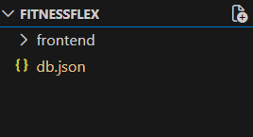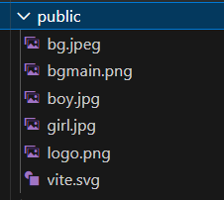

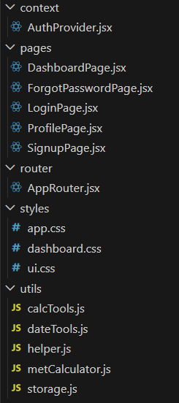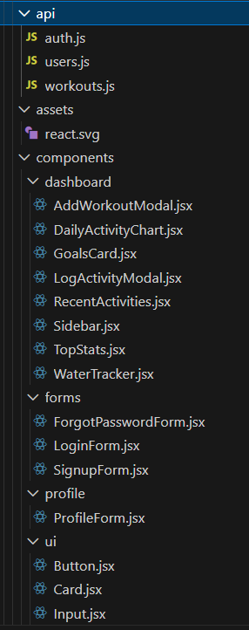

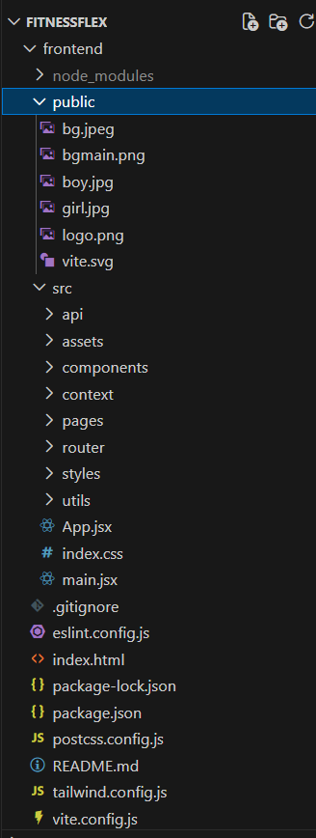

- fitflex/
This is the root directory of the FIT FLEX Fitness Tracking System.
It contains all frontend files, assets, scripts, and the JSON Server database.
Everything required to run the project — UI, logic, storage, and configuration — lives inside this folder. It serves as the central location for development and deployment.

2. HTML Files (Main User Interfaces)
These files define the structure and layout of the web pages viewed by the user. They contain the UI elements that are enhanced by JavaScript and styled with Tailwind/custom CSS.

➤ dashboard
This is the primary interface of the application, where users interact with all fitness‑tracking features.
This page handles:
Displaying steps, calories, water intake, active minutes
Showing charts and visual insights for weekly progress
Listing activity history in an organized timeline
Displaying user goals and current progress
Connecting with dashboard.js for real-time updates
It serves as the center of the application’s functionality.

➤ forgot page
This page manages the password finding workflow.
It includes:
A form for email input
A field to enter registered mobile number
UI feedback for displaying search password response
The page ensures that users can securely recover their accounts.

3. JavaScript Files (Core Application Logic)
These files control the dynamic behavior of FIT FLEX. They interact with db.json, update UI elements, and maintain application state.

➤ dashboard js part
This is the brain of the dashboard.
It performs critical tasks such as:
Fetching user details from db.json
Updating steps, calories, workouts, and water intake
Rendering charts for weekly insights
Updating the DOM for real‑time changes
Logging workout activities with timestamps
Managing goal tracking and computations
This script ensures a smooth, responsive, and interactive fitness experience.

➤ forgot js part
Handles the entire password-forget process.
Responsibilities include:
Verifying whether the entered email exists
Validating mobile number is valid
searching the user’s password in db.json
Showing appropriate success/error alerts

4. db.json (Simulated Backend Database)
db.json acts as the backend of FIT FLEX using JSON Server.
It stores all essential data, including:
User profiles: name, email, phone, password
Fitness metrics: steps, calories, water glasses
Workout logs: type, duration, calories burned
Activity timeline entries
User goals and personal health information
JSON Server automatically converts this file into REST API endpoints such as:
GET /users – Fetch user details
POST /users – Add a new user
PATCH /users/:id – Update existing user data
This makes db.json function like a real database in a full-stack application.

5. node_modules/
This folder stores all installed dependencies and third-party libraries.
Examples:
Tailwind CSS
JSON Server
Vite tools
It is automatically created during installation, and should never be edited manually.

6. Assets (Images & Media)
Contains all multimedia files that enhance the aesthetic and branding of the platform.
Includes:
bg.jpeg → Background image
boy.jpg girl.jpg → Illustration for UI
fitflex.png & fitflex_white.png → Brand logos

7. package.json & package-lock.json

➤ package.json
Defines the entire project configuration, including:
Project name, version, description
All required dependencies
Scripts such as:
"start": "json-server --watch db.json"
"dev": "vite"
This file acts as the blueprint for running and managing the application.

➤ package-lock.json
Automatically generated and ensures:
Exact dependency versions are locked
Project behaves consistently on any system

PROJECT FLOW:-
Demo link : https://github.com/meh2005/FITFLEX--Full-Stack-Development---CSE---J/blob/main/Fitflex%20(demo).mp4
Milestone 1: Project Setup and Configuration
To begin the development of the FIT FLEX Fitness Tracking System, several essential tools and software must be installed. These ensure smooth development, proper API simulation using JSON Server, and efficient UI creation.
- Install Required Tools and Software
- Node.js & npm: Required to install packages, run JSON Server, and manage project dependencies.
- JSON Server: Used to create a simulated REST API using the db.json file. This acts as the backend for fitness data (users, workouts, activities).
- Visual Studio Code: The main code editor
- Vite (optional for advanced setup)
- Web Browser (Chrome / Edge): Used to open and test the page and all features.
- Helpful Reference Resources
These resources support learning and troubleshooting during development:
- JavaScript & Web APIs Documentation (MDN Web Docs) : https://developer.mozilla.org : For understanding functions, DOM handling, events, arrays, async operations, etc.
- JSON Server Documentation: https://github.com/typicode/json-server :For setting up API routes, PATCH/POST usage, and customizing db.json.
- TailwindCSS Documentation: https://tailwindcss.com : For writing responsive styles.

Milestone 2: Web Development:
1. Setup React Application
The development of the FIT FLEX application begins with setting up the essential project environment and organizing the core files that form the foundation of the system. Since FIT FLEX is built using HTML, CSS, JavaScript, and JSON Server, the first step is to create the main project directory and add the required pages such as dashboard and forgot, sign up & sign in forms, along with their corresponding JavaScript files. These files are structured in a modular way to ensure clarity and smooth development. The dashboard file provides the main interface for displaying fitness metrics, activity logs, charts, and user goals, while forgot manages the password forgot flow. The JavaScript files connect these pages to the backend database (db.json) using JSON Server, enabling features like fetching data, updating fitness values, logging activities, and validating password resets. Together, this setup forms the core structure of FIT FLEX by linking the UI with application logic, ensuring real-time updates, smooth data flow, and preparing the system for further enhancements in upcoming milestones.

- A. Importing Required Modules (Updated for FIT FLEX Fitness Tracking System)
In the FIT FLEX application, the main JavaScript files such as dashboard.js, forgot.js, and server.js make use of essential modules and built‑in browser APIs required to run the system. These scripts manage the overall application flow, communication with the JSON Server backend, updating the user interface, and handling all fitness‑tracking logic.
- Core JavaScript Functions and Web APIs
The application uses DOM manipulation functions like document.getElementById(), document.querySelector(), innerText, innerHTML, and event listeners to interact with web page elements. These functions update steps, calories, and water intake, render charts, show activity history, and display messages or alerts to the user.
2. Fetch API for Backend Communication
FIT FLEX uses the Fetch API to communicate with JSON Server. The Fetch API sends requests to read or update user data stored in db.json. For example, it retrieves user details, updates steps or calories through PATCH requests, and creates new records when necessary. Fetch is also used in forgot.js to update passwords and save workout logs or activity entries.

3. Utility Functions Inside JavaScript Files
FIT FLEX includes internal helper functions for tasks such as calculating calorie totals, updating progress indicators, formatting dates for the activity timeline, and validating user email addresses during password reset. These functions help maintain clean structure and improve reusability.

