**Out of paper? Printer jammed?**

Scan the code below to report an issue.

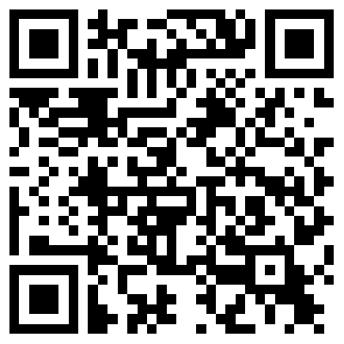

Just press a button and you’re done! No tedious forms.

See which printers are working around campus at

**mkumar77.pythonanywhere.com**