1. Write a program to read a character from the keyboard and display it at the next position of the same line.

.MODEL SMALL

.STACK 100H

.CODE

MAIN PROC

MOV AH, 1

INT 21H

MOV BL, AL

MOV AH, 2

MOV DL, BL

INT 21H

MOV AH, 4CH

INT 21H

MAIN ENDP

END MAIN

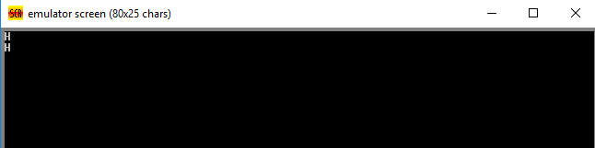Output:

2. Write a program to read a lower case character from the keyboard and display it at the beginning of the next line in uppercase.

.MODEL SMALL

.STACK 100H

.DATA

msg1 DB 'Enter the Lower Case Letter : $'

msg2 DB 'The Upper Case Letter is : $'

.CODE

MAIN PROC

MOV AX, @DATA

MOV DS, AX

LEA DX, msg1

MOV AH, 9

INT 21H

MOV AH, 1

INT 21H

MOV BL, AL

MOV AH, 2

MOV DL, 0DH

INT 21H

MOV DL, 0AH

INT 21H

LEA DX, msg2

MOV AH, 9

INT 21H

SUB BL, 20H

MOV AH, 2

MOV DL, BL

INT 21H

MOV AH, 4CH

INT 21H

MAIN ENDP

END MAIN

Output:

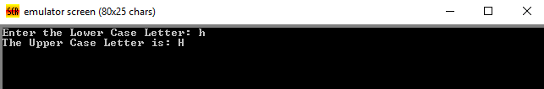

3. Write a program to prompt the user, and read first, middle and read last initials of a person’s name, and display them down the left margin. Sample execution: ENTER THREE INITIALS: ABC

A

B

C

.MODEL SMALL

.STACK 100H

.DATA

STR DB 'ENTER THRRE INITIALS: $'

STR1 DB '',0AH,0DH

FIRST DB ?

STR2 DB '',0AH,0DH

SECOND DB ?

STR3 DB '',0AH,0DH

THIRD DB ?

STR4 DB '$'

.CODE

MAIN PROC

MOV AX,@DATA

MOV DS,AX

MOV AH,9

LEA DX,STR

INT 21H

MOV AH,1

INT 21H

MOV FIRST,AL

INT 21H

MOV SECOND,AL

INT 21H

MOV THIRD,AL

MOV AH,9

LEA DX,STR1

INT 21H

MOV AH,4CH

INT 21H

MAIN ENDP

END MAIN

Output:

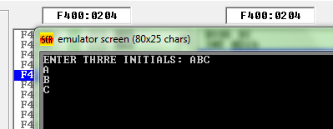

4. Write a program to display a ”?”, read two decimal digits whose sum is less than 10, display them and their sum on the next line, with an appropriate message. Sample execution: ? 3 5 THE SUM OF 3 AND 5 IS8

.model small

.stack 100h

.data

msg1 db 0Dh,0Ah,'THE SUM OF $'

msg2 db ' AND $'

msg3 db ' IS $'

.code

main proc

mov ax,@data

mov ds,ax

mov ah,2

mov dl,'?'

int 21h

mov ah,1

int 21h

mov bl,al

mov ah,1

int 21h

mov bh,al

lea dx,msg1

mov ah,9

int 21h

mov ah,2

mov dl,bl

int 21h

lea dx,msg2

mov ah,9

int 21h

mov ah,2

mov dl,bh

int 21h

lea dx,msg3

mov ah,9

int 21h

add bh,bl

sub bh,30h

mov ah,2

mov dl,bh

int 21h

mov ah,4ch

int 21h

main endp

end main

Output:

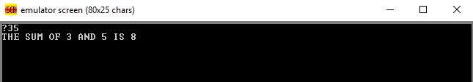

5. Write a program to display a ”?”, read three characters, and then display them in the middle of an 11×11 box of asterisks. Sample execution:

.MODEL SMALL

.STACK 100H

.DATA

msg DB 0DH,0AH,'Enter three initials : $'

msg1 DB '***********',0DH,0AH,'$'

msg2 DB 0DH,0AH,"$"

.CODE

MAIN PROC

MOV AX, @DATA

MOV DS, AX

MOV AH, 2

MOV DL, "?"

INT 21H

LEA DX, msg

MOV AH, 9

INT 21H

MOV AH, 1

INT 21H

MOV BL, AL

INT 21H

MOV BH, AL

INT 21H

MOV CL, AL

LEA DX, msg2

MOV AH, 9

INT 21H

INT 21H

LEA DX, msg1

MOV AH, 9

INT 21H

INT 21H

INT 21H

INT 21H

INT 21H

MOV msg1+4, BL

MOV msg1+5, BH

MOV msg1+6, CL

INT 21H

MOV msg1+4, "*"

MOV msg1+5, "*"

MOV msg1+6, "*"

INT 21H

INT 21H

INT 21H

INT 21H

INT 21H

MOV AH, 2

MOV DL, 7H

INT 21H

MOV AH, 4CH

INT 21H

MAIN ENDP

END MAIN

Output:

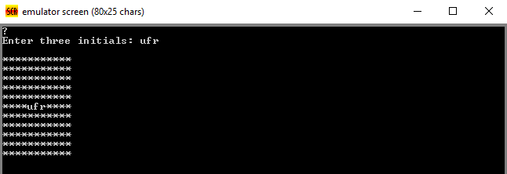

6. Write a program to prompt the user, read a character, and if it is an uppercase letter, display it at the beginning of the next line.

.MODEL SMALL

.STACK 100H

.DATA

PROMPT DB 'Enter the character : $'

MSG_1 DB 'The input letter is : $'

MSG_2 DB 'The input character is not an Upper Case Letter.$'

.CODE

MAIN PROC

MOV AX, @DATA

MOV DS, AX

LEA DX, PROMPT

MOV AH, 9

INT 21H

MOV AH, 1

INT 21H

MOV BL, AL

MOV AH, 2

MOV DL, 0DH

INT 21H

MOV DL, 0AH

INT 21H

CMP BL, "A"

JB @DISPLAY

CMP BL, "Z"

JA @DISPLAY

LEA DX,MSG_1

MOV AH, 9

INT 21H

MOV AH, 2

MOV DL, BL

INT 21H

JMP @EXIT

@DISPLAY:

LEA DX,MSG_2

MOV AH, 9

INT 21H

@EXIT:

MOV AH, 4CH

INT 21H

MAIN ENDP

END MAIN

Output:

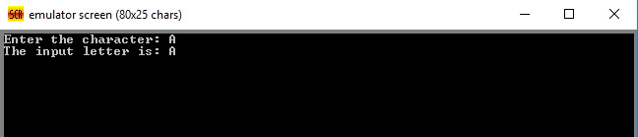

7. Write a program that will prompt the user to enter a hex digit character ( 0 – 9 or A – F ), display it on the next line in decimal. If the user enters an illegal character, prompt the use to try again.

Sample execution:

ENTER A HEX DIGIT: 9

IN DECIMAL IT IS 9

DO YOU WANT TO DO IT AGAIN? Y

ENTER A HEX DIGIT: c

ILLEGAL CHARACTER – ENTER 0…9 OR A…F: C

IN DECIMAL IT IS 12

DO YOU WANT TO DO IT AGAIN? N

.MODEL SMALL

.STACK 100H

.DATA

PROMPT_TRY_MSG DB 'TRY AGAIN.$'

PRMPT_MSG_1 DB 'ENTER A HEX DIGIT "0"..."9" OR "A".."F": $'

OUTPUT_PRMPT DB 0AH,0DH,'OUTPUT: $'

ASK_PROMPT DB 0AH,0DH,'DO YOU WANT ANOTHER INPUT: $'

.CODE

MAIN PROC

MOV AX,@DATA

MOV DS,AX

TOP:

MOV AH,9

LEA DX,PRMPT_MSG_1

INT 21H

MOV AH,1

INT 21H

MOV BL,AL

CMP BL,30H

JL TRY_MSG

CMP BL,46H

JG TRY_MSG

CMP BL,39H

JLE DIGIT

MOV AH,9

LEA DX,OUTPUT_PRMPT

INT 21H

SUB BL,11H

MOV AH,2

MOV DL,31H

INT 21H

MOV DL,BL

INT 21H

AGAIN:

MOV AH,9

LEA DX,ASK_PROMPT

INT 21H

MOV AH,1

INT 21H

MOV BH,AL

MOV AH,2

MOV DL,0AH

INT 21H

MOV DL,0DH

INT 21H

CMP BH,'Y'

JE TOP

CMP BH,'y'

JE TOP

JMP END_

DIGIT:

MOV AH,9

LEA DX,OUTPUT_PRMPT

INT 21H

MOV AH,2

MOV DL,BL

INT 21H

JMP AGAIN

TRY_MSG:

MOV AH,9

LEA DX,PROMPT_TRY_MSG

INT 21H

JMP TOP

END_:

MOV AH,4CH

INT 21H

MAIN ENDP

END MAIN

Output:

