

**Department of Computer Science and Engineering**

**CSE110(Object Oriented Programming)**

**Project Report**

**Submitted To:**

**Sadika Islam Sneha**

Lecturer  
 Department of Computer Science & Engineering

**Submitted By:**

### Mehadi Hasan Shameem (ID: 2022-1-60-229)

### Md. Touhidur Rahman Limon (ID:2022-1-60-272)

### Rahin Arefin Ahmed (ID: 2022-1-60-263)

### Maria Hasan(2022-1-60-070)

### Section:09

### Submission Date:12/1/2023

### 

### 

### 

### Concept of the project: Cafeteria Management System

**Introduction**

Digital canteen service system management can be useful for universities to provide food to their students more conveniently. We choose this project so we can use all the java OOP concepts more efficiently in one package. Working on this project will increase our knowledge of java OOP concepts and help us to gain experience which will be needed in the near future project tasks.

We tried to cover all the features of java but it was not possible for some difficulties using file text I/O that we face.

**Includes: Features of java we have used on this project**

1. Basic programming concepts (conditions, loop, data variable)
2. Class and Objects
3. Inheritance
4. Polymorphism
5. Abstraction
6. Interface
7. Java I/O

**1. Classes:** There are 6 classes that has implemented on the code.

a. Register

b. Student

c. AutomatedFoodandBraverage

d. CanteenManagement

e. FileReadnWrite

f. Start

**2. Interfaces:** There are 2 interfaces that has implemented on the code.

a. IStudents

b. ITransactions

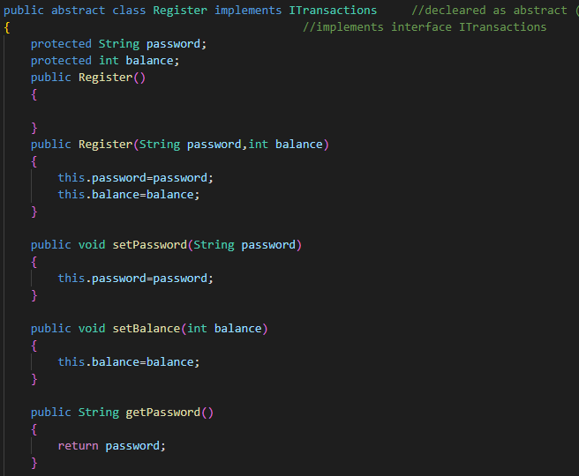

* Register is an abstract super class implemented ITransactions interface. We use this class to register students. buyAnItem and addMoney both method from ITransactions implements on this class.

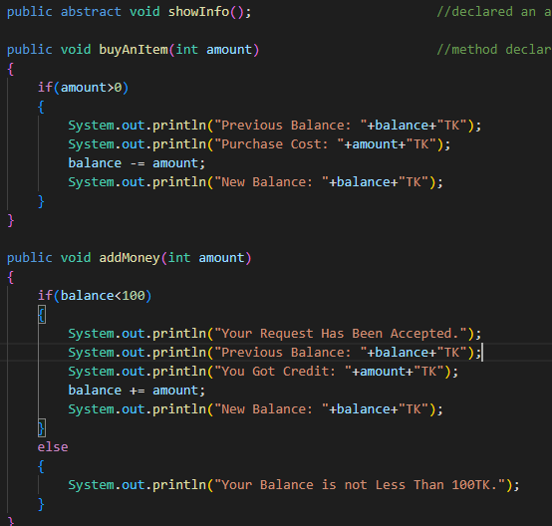

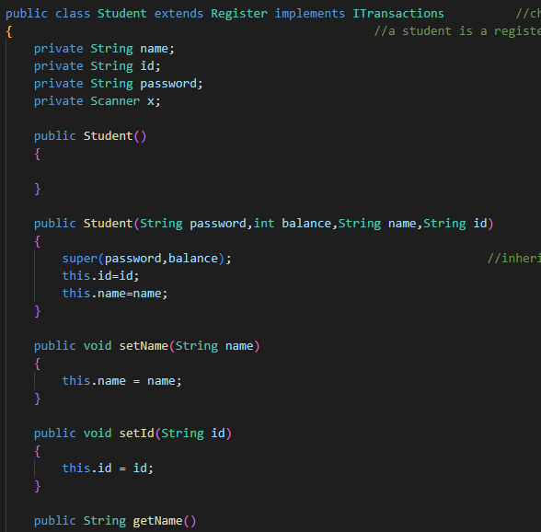

* Student class inherited Register class so we can use students registration information on this class. ShowInfo and ShowAllRegisters are two method on this class which will display student informatiom.

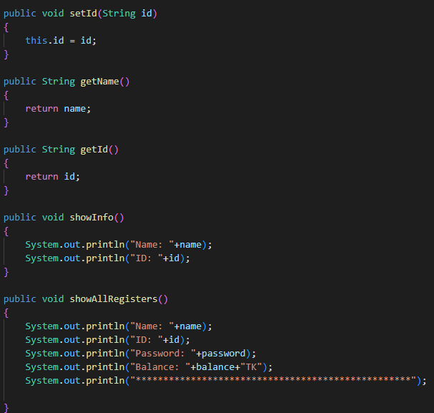

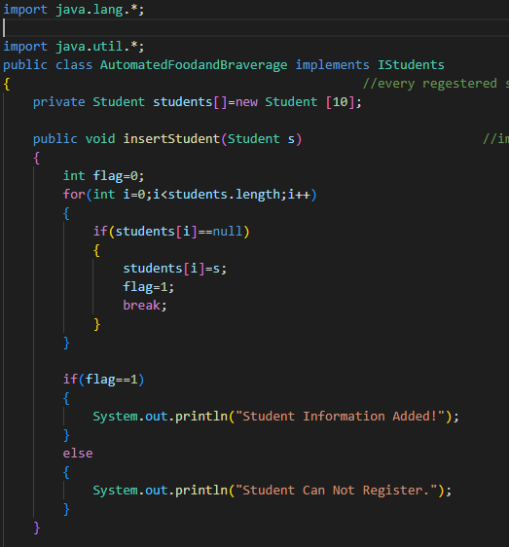

* AutomatedFoodandBraverage class implemented IStudent interface. In this we creat a student class object array to add and remove student. These method were in IStudents which we implemented here.

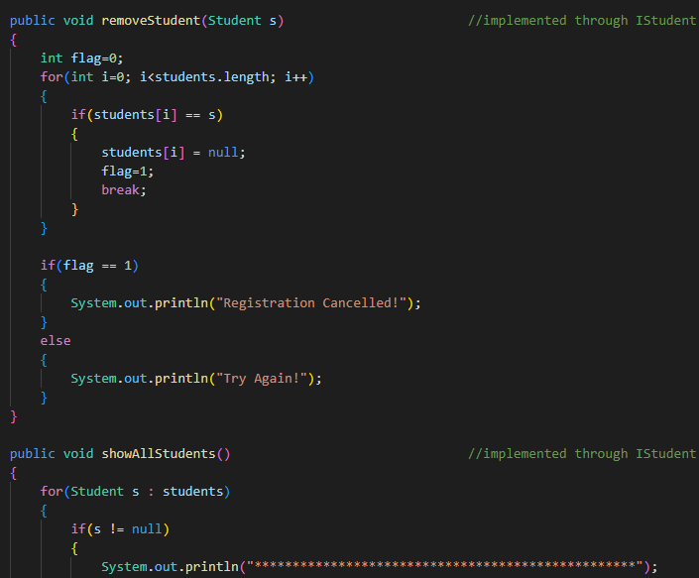

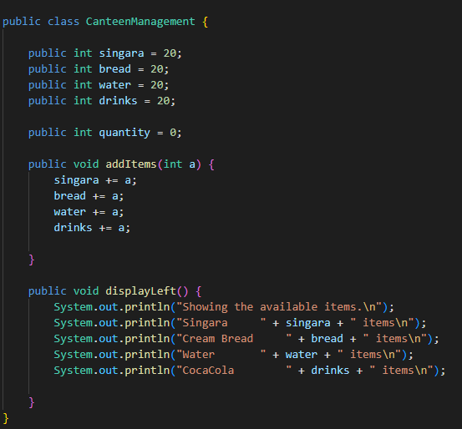

* CanteenManagement class was mainly used to manage food items (add and display) in the main class.

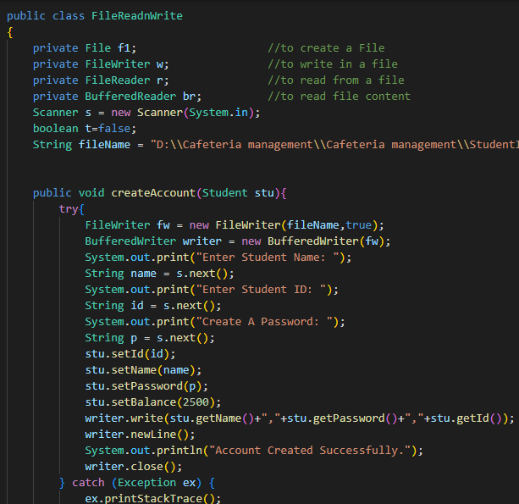

* In FileReadnWrite class we use text io to creat account of students. Also we read and write transaction history and student information in the file.

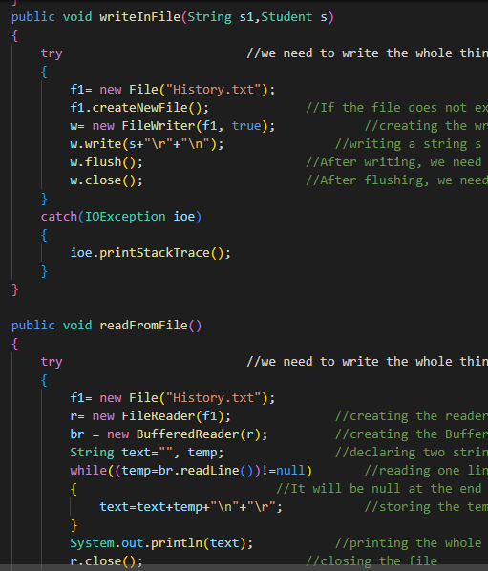

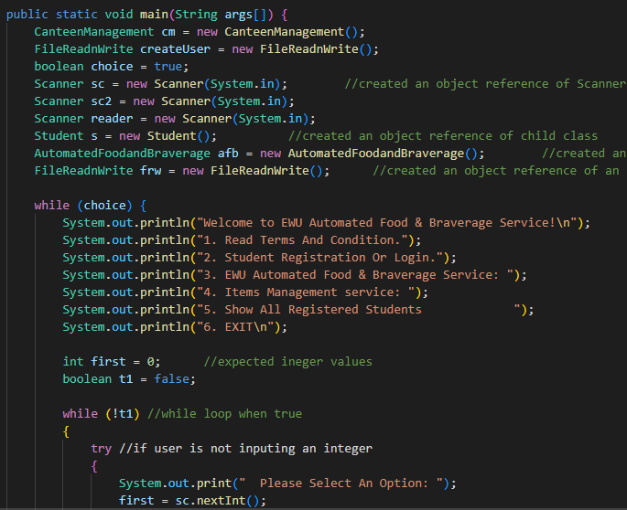

* Finally we used Start as a main class to run the code where we created all other classes object. And we used switch cases to choose the provided options to register, buy and manage canteen.

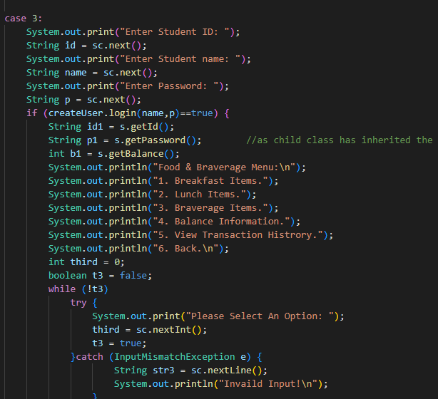

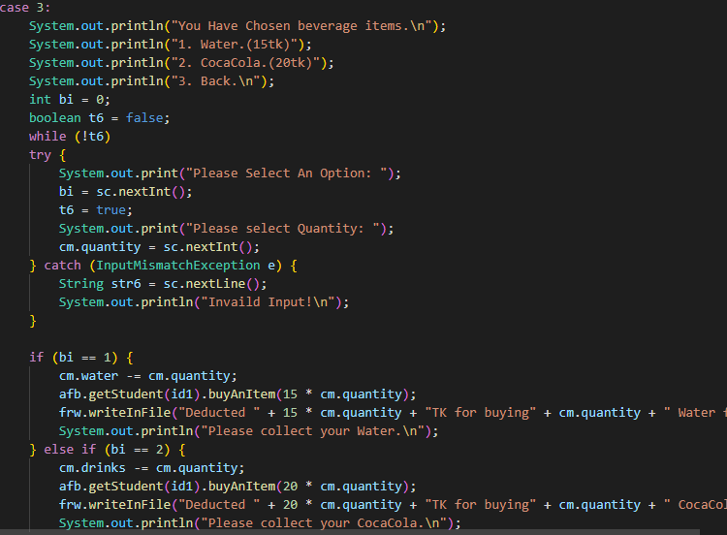

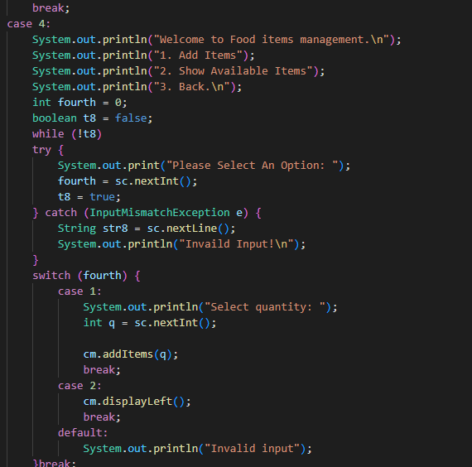

**Conclusion:** This project is very important to understand the OOP concepts of java and to use most of the features of JAVA in one package. Our project can be useful to others if they can developed this program more efficiently using other features like binary io, GUI etc.