**Multiple Choice/Fill in the blank/Open-ended questions**

Circle only one choice or fill in only one word for each question unless otherwise noted as an open-ended question.

1. Say I develop a linear model of the functional form y ~ x1 + x2 + x3. Can I use the linear model to do the following (4 points):
   1. Predict variable y based on variables x1, x2, and x3. TRUE/FALSE
   2. Examine the effect of a change in variable x1 on a change in y independent of the effect of variables x2 and x3. TRUE/FALSE
   3. Examine which variables x1, x2, and x3 are significantly associated with y after controlling for the other variables. TRUE/FALSE
   4. Identify the relative importance of x1, x2, and x3 in explaining variation in y when standardizing each x variable by its slope and intercept. TRUE/FALSE
2. Please draw your best estimate of the regression line through the scatter of points below (1 point):

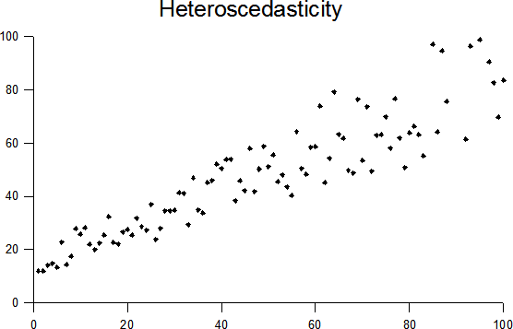

1. Does it seem appropriate to use a linear model to fit the data shown in Question 2? Why or why not (1 point; open-ended)? No, errors are heteroscedastic
2. Say that I develop a linear model that estimates bird diversity per m2 based on the diversity of trees in a forest per m2, the ratio of edge to total forest cover, and the mean amount of rainfall the forest receives per year using data from North American forests in the year 2015. The model would look like:

Bird diversity (per m2) ~ diversity of trees in a forest (per m2) + ratio of forest edge to total forest cover + mean rainfall (mm per year)

I now want to use this model to predict the amount of bird diversity for forest patches in South America where I have data on the diversity of trees per m2, the ratio of edge to total forest cover, and the mean amount of rainfall in the year 2016. What assumptions do I make when using the linear model I developed for North America to predict bird diversity in this new South American system (3 points)?

* 1. I assume that the relationship between my 3 predictor variables and bird diversity is the same in North and South America. TRUE/FALSE.
  2. I assume that the sample size of data I have for North and South America are the same. TRUE/FALSE.
  3. I assume that the total amount of rainfall experienced in 2016 is exactly the same as the total amount of rainfall experienced in 2015. TRUE/FALSE.

1. Do you think it is appropriate to use the linear model developed to predict bird diversity in North America to predict bird diversity in South America (the example described in question 4)? Why or why not (2 points)?

I lean towards saying no because there are probably lots of differences between these systems that cant be accounted for in the model but I think we should accept either answer as long as the students reasoning is sound.

1. Which of the following are true about a linear model and its assumptions. If helpful, you can assume the model takes the form of y ~ x (8 points)?
   1. There must be a linear relationship between your independent variable (x) and your dependent variable (y). TRUE/FALSE.
   2. The errors are heteroscedastic. TRUE/FALSE
   3. The errors must be statistically independent. TRUE/FALSE
   4. There must be a significant relationship between your independent variable (x) and your dependent variable (y). TRUE/FALSE.
   5. Your errors do not have to be normally distributed as long as your sample size is large enough. TRUE/FALSE.
   6. There is constant variance of the errors from your model. TRUE/FALSE
   7. The errors must be normally distributed. TRUE/FALSE
   8. If you violate the assumptions of a linear model it may result in inaccurate estimates of confidence intervals but your p values should be correct. TRUE/FALSE
2. Which of the following is true about statistical power (4 points)?
   1. It is a measure of Type I error. TRUE/FALSE
   2. One way to increase statistical power is by allowing for a smaller p value to determine significance (e.g. p < 0.01 instead of p < 0.05). TRUE/FALSE
   3. It increases as the effect size of your variable of interest decreases. TRUE/FALSE
   4. One way to increase statistical power is by increasing your sample size. TRUE/FALSE
3. Which of the following statements are true considering model selection (5 points)?
   1. You can use an F test to compare non-nested models. TRUE/FALSE
   2. If you select the best candidate modeling using AIC, you should select the model with the highest AIC score. TRUE/FALSE.
   3. You should select a few candidate models based on which variable combinations you think are important in theory and compare these models using model selection techniques TRUE/FALSE
   4. You should always use model selection in favor of using a full model. TRUE/FALSE.
   5. You do not have to worry about multicollinearity when doing model selection because model selection techniques pick the model with the least multicollinearity. TRUE/FALSE
4. Which of the following statements are true considering multicollinearity of predictor variables x1 and x2 in a linear model of the functional form (4 points):

y ~ x1 + x2

* 1. When you put two highly correlated variables, x1 and x2, in a linear model, the standard errors and p values for x1 and x2 are larger than they would be for x1 and x2 in two separate univariate (single variable) models. TRUE/FALSE
  2. When you put two highly correlated variables, x1 and x2, in a linear model, the beta coefficients for x1 and x2 will likely be the same when compared to beta coefficients produced in two separate univariate (single variable) models. TRUE/FALSE
  3. You will be unable to accurately predict y using your linear model if you include both x1 and x2. TRUE/FALSE
  4. It will be difficult to identify the true effect of x1 and x2 on y. TRUE/FALSE

**Open-ended Questions:**

1. Say that you are interested in designing a study to examine the impact of increased pollination on crop yields. How would you design an experimental study to test this? How would you design an observational study? Please address the following in each of your answers: (1) sampling strategy, (2) sample size and power, and (3) ways to reduce the effect of confounding factors (6 points total).
   1. Experimental (3 points)

I leave grading for this up to you, but I would give 1 point for a sound design, 1 point for saying something about how they would make sure they had enough sample size/power (e.g. they can say they will do a power test), and 3) say something about study design that addresses confounding factors (e.g. randomization in an experiment or including control variables in an observational study)

* 1. Observational (3 points)

1. Say I am interested in understanding the impact of different factors on test scores in elementary school children. As a measure of how well students are doing, I have average test scores for twenty students last year (testscore ranging from 0 to 100). I also collect several variables to see if they are useful in predicting test score. Specifically I collect data on the quality of the students’ elementary schools (a rank from 1 – 10 labeled as sq with 1 representing low quality and 10 representing high quality), the students’ family incomes as a measure of socio-economic status (income in $ per year labeled as ses), and each student’s gender (M or F). I run the following regressions. Please interpret the outputs of the following regressions. Each set of questions are only about the regression directly preceding it.

Regression 1. testscore ~ sq

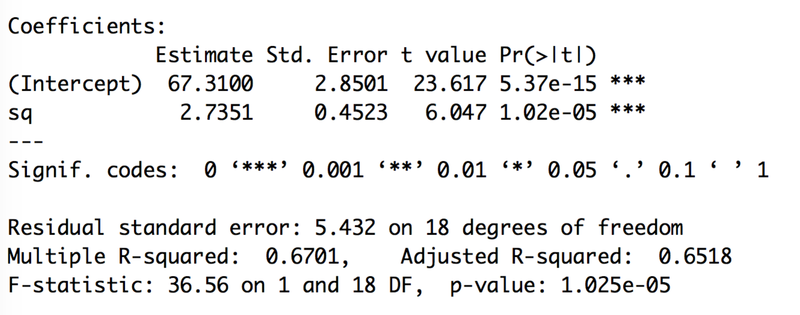

1. What is the effect of school quality on test scores? How much improvement in test score do you have for every increase in rank in school quality (1 point)? For every increase in rank there is a 2.7 increase in test score.
2. How well does the model we created fit the data? How can you tell (1 point)? Fits moderately well – look at R2

Regression 2. testscore ~ ses

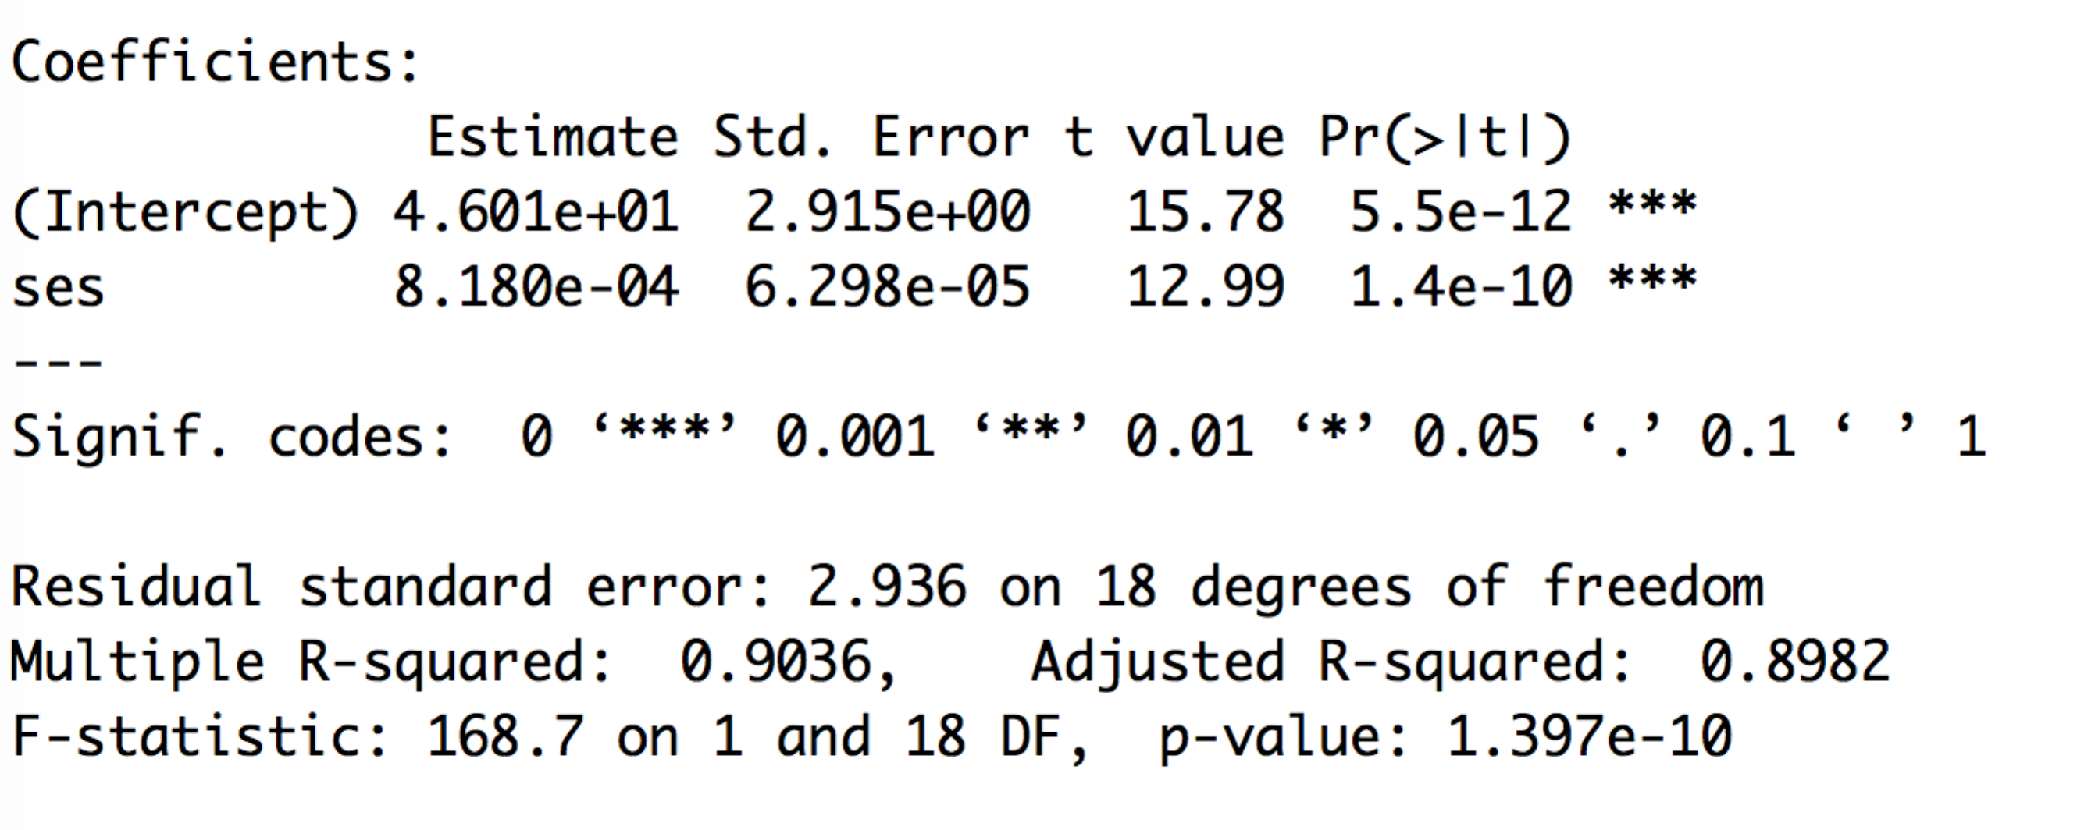

1. What is the effect of socio-economic status on test scores? How much improvement in test score do you have for every increase in dollar of family income (1 point)? For every increase in dollar income it results in increase of 8.18e-4 test score.
2. How well does the model we created fit the data? How can you tell (1 point)? The model fits very well – high R2

Regression 3. testscore ~ sq + ses

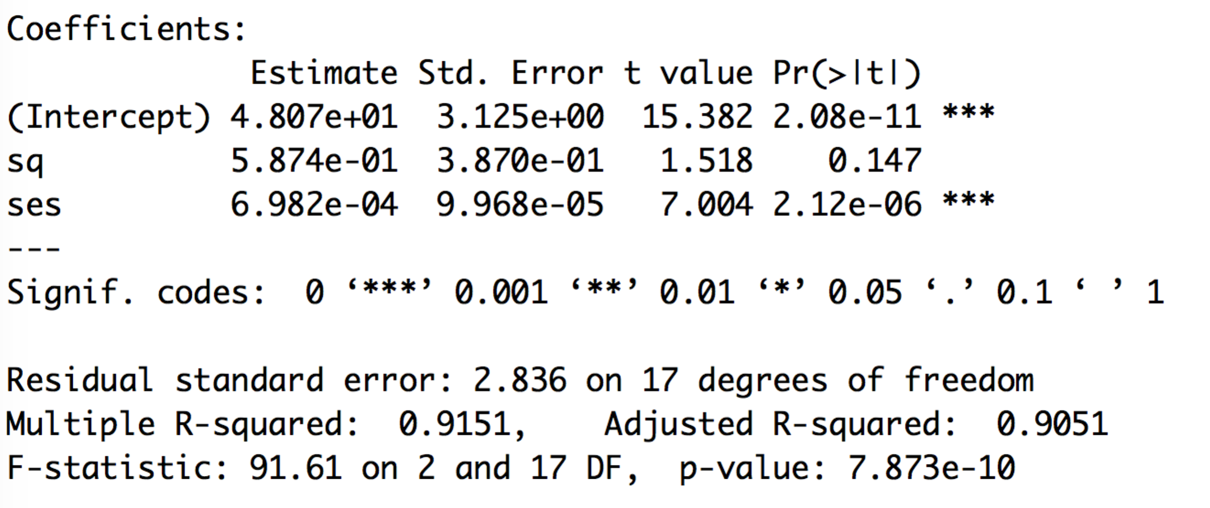

1. What is the effect of school quality on test scores? How much improvement in test score do you have for every increase in rank in school quality (1 point)? School quality isn’t significantly influencing test score. There should be no significant increase in test score with an increase in school quality
2. What is the effect of socio-economic status on test scores? How much improvement in test score do you have for every increase in dollar of family income (1 point)? For every increase in dollar income there is an increase in test score by 6.98e-4.
3. Look at the results of regressions 1, 2, and 3. Please discuss any potential differences in the regression results and why they may have occurred. If you had to choose only one model to understand the factors influencing test scores, which one would you choose – regression 1, regression 2, or regression 3? Why? (2 points) ½ point for saying that the effect of school quality disappears, 1 point for saying this is because of multicollinearity, ½ point for picking regression 2 and saying why (better R2 and significance, or maybe some previous theory says this is important). You can also accept regression 1 as an answer if they have good reasoning for it. They shouldn’t pick regression 3.

Regression 4. testscore ~ ses + gender

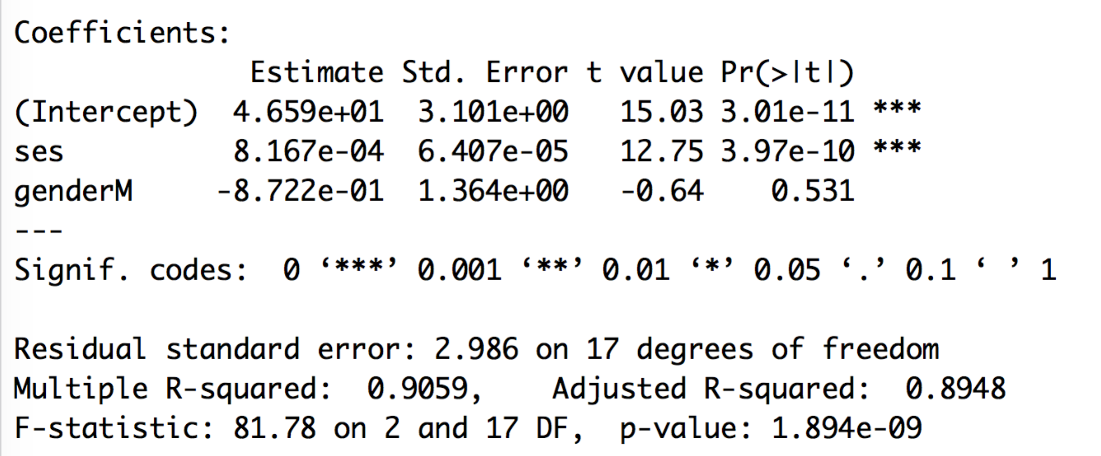

1. What is the effect of gender on test scores? Which gender is associated with higher test scores? (1 point). There is no association between gender and test score. Neither gender has a higher test score than the other.
2. Why is there no estimate and p value for genderF (representing females)? (1 point). Mean of Female is captured by the intercept.

Regression 5. testscore ~ ses + gender + ses*gender

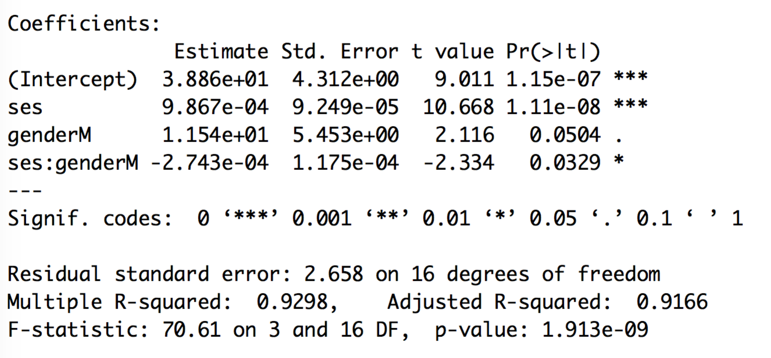

1. Please interpret the coefficient and its significant for ses. What does it mean? (1 point)

Use your judgment on this one and grade leniently – just make sure students understand that interpreting the main effect is more complicated/challenging when there is an interaction term.

Please interpret the coefficient and its significance for genderM. What does it mean? (1 point). Use your judgment on this one and grade leniently – just make sure students understand that interpreting the main effect is more complicated/challenging when there is an interaction term.

Please interpret the coefficient and its significance for ses:genderM. What does it mean? (1 point). Here they should state specifically that the increase in test score produced by increased ses is less for males than females (or something that indicates they understand this, like different slopes of ses vs test score for males + females).